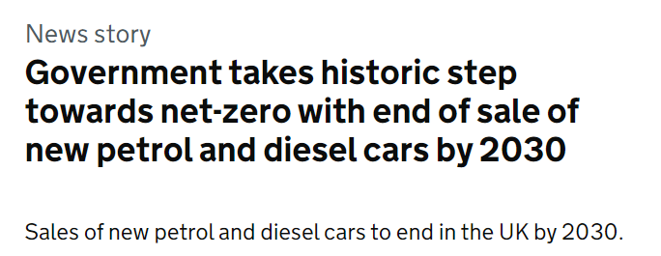
What do you think will happen to vehicle sales in the future, given the ban on petrol and diesel cars and vans by 2035?
Use the graph to complete the table for 2035. Use this to predict the missing information for 2030.
* This was subsequently put back to 2035
 | Total New Registrations | Petrol | Diesel | Hybrid | Electric
2005 | 2,400,000 | 63% | 37% | 0% | 0%
2010 | 2,000,000 | 53% | 46% | 1% | 0%
2015 | 2,600,000 | 49% | 48% | 2% | 1%
2020 | 1,600,000 | 61% | 18% | 14% | 7%
2030
2035

Why is it not 100% electric vehicles being sold by 2035?
What assumptions have you made in making your predictions for 2030?

