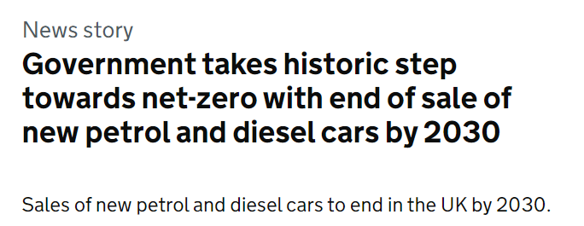
What do you think will happen to car sales by 2035? What will this mean for car sales in 2030?
Starting with 2035, predict the missing information in the table and the graph below.
* This was subsequently put back to 2035

 | Total New Registrations | Petrol | Diesel | Hybrid | Electric
2005 | 2,445,445 | 1,544,788 | 894,299 | 5,380 | 0
2010 | 1,996,324 | 1,060,847 | 913,119 | 21,760 | 0
2015 | 2,602,146 | 1,276,092 | 1,253,454 | 60,890 | 11,710
2020 | 1,619,957 | 986,878 | 295,156 | 230,358 | 106,755
2030
2035

What assumptions have you made in making your predictions?
What do you think the proportions of petrol, diesel, hybrid and electric vehicles would look like for all vehicles on the road, not just the newly registered ones?

