EVolution of vehicle sales in Great Britain teacher notes Key Stage 3 Maths
Brief overview of session ‘logic’ | Mathematical opportunities offered
- Explore the infographic – what can be worked out from this information and what questions does it raise?  - Look at trends in vehicle registrations  - Look at proportions of types of newly registered vehicles over time – why has the percentage of petrol cars being registered increased from 2015 to 2020?  - Do some calculations to show that the number of petrol cars being registered has decreased from 2015 to 2020.  - Reflect upon the implications for misleading representations of data  - Consider the implications of the ban on new petrol and diesel cars by 2035 – what affect will this ban have on the proportions of car types being registered?  - What questions does the increase in electric vehicles raise? | - Interpretation of data, statistics, graphs, infographics in context  - Critiquing graphs  - Reading scales  - Calculating percentages  - Exploring proportions of quantities over time  - Making conjectures about future proportions given available data  - Analysing and comparing data in order to develop and present a conclusion

Time for session: 30 minutes
Time | Slide | What to do… | Aims, additional info and comments
 | 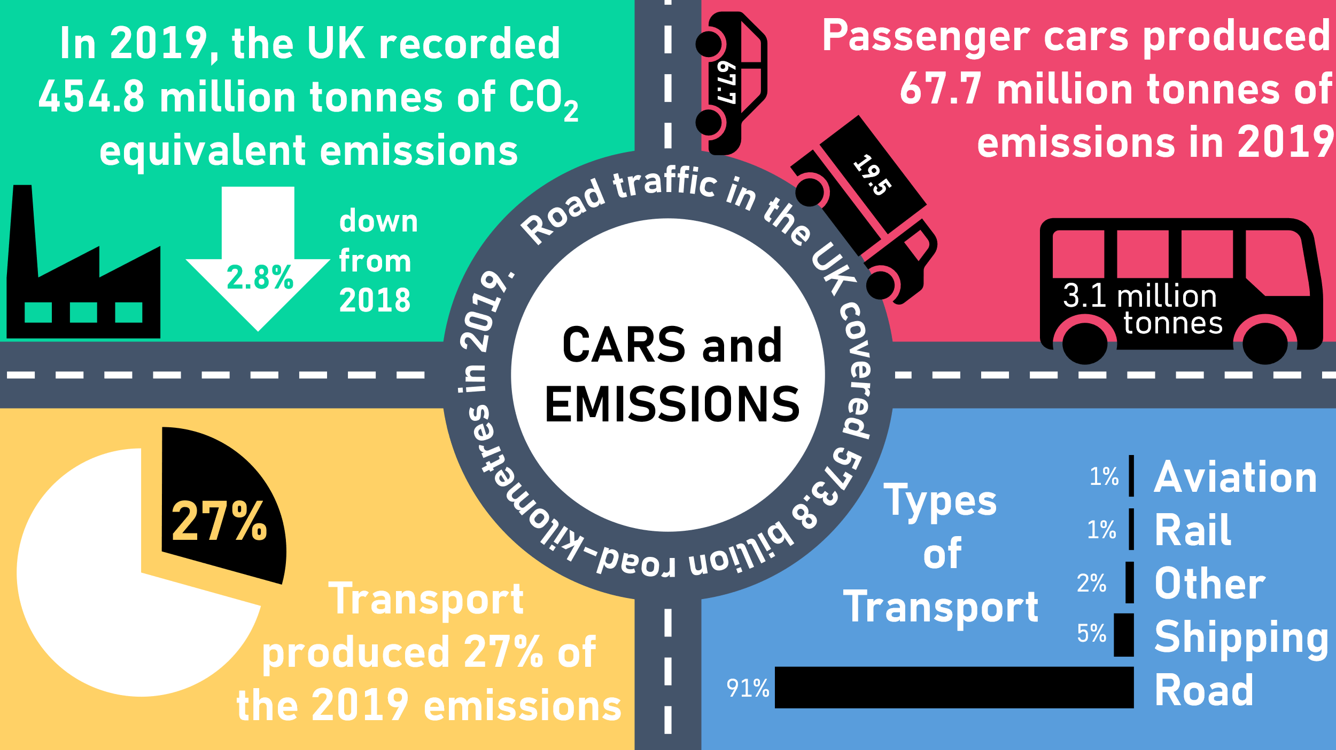 | Explore the infographic.  What other values/figures can be derived from the information presented? (e.g. total transport emissions from the 27%)  Ask students what the ‘Types of Transport’ percentages might mean. | The 91% in ‘Types of Transport’ could feasibly mean:  - 91% of all journeys are by road?  - 91% of all emissions are on the road?  - 91% of miles travelled are by road?  - 91% of vehicles are road vehicles?  Which of these is it likely to be? (it’s 91% of all emissions are on the road)  What do students think about the sizes of the car, van and bus in the red infographic? These sizes are potentially misleading – how could these be made more representative?  Example calculations:  If 2019 emissions were “down 2.8%” from 2018, a reverse percentage calculation can find the 2018 value.  97.2%=454,800,000 tonnes  100%=467,901,235 tonnes in 2018  If transport produced 27% of emissions in 2019, the value for transport can be calculated.  27% of 454,800,000 tonnes = 122,796,000 tonnes  If passenger cars produced 67.7 million tonnes of emission in 2019, what % is this of total emissions?  67.7/454.8=0.14885664…  So 14.9% of emissions in 2019 were from cars. This is open up an interesting comparison to the 27% for all transport types.  573.8 billion miles – how far is this? Is it difficult to imagine this distance?  For comparison, Pluto is, on average, around 5 billion miles away from Earth.  Data publicly available here and here
 | 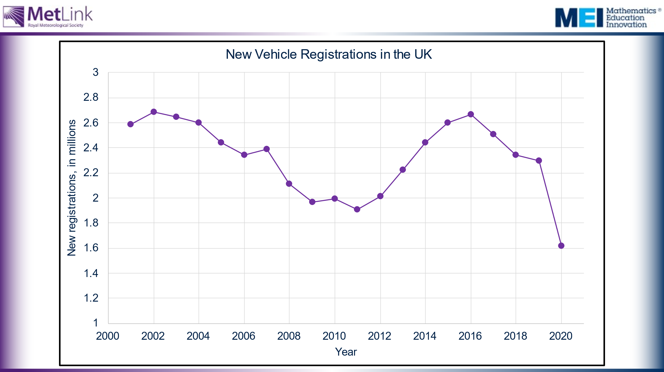 | New vehicle registrations from 2000 to 2022.  Invite commentary. Why the fluctuations?  Is this what you’d expect? Why? | Potential influencing factors include:  - Recession  - Car scrappage scheme (2008/2009)  - Economic recovery  - Covid-19  - Shortage of parts, war in Ukraine
 | 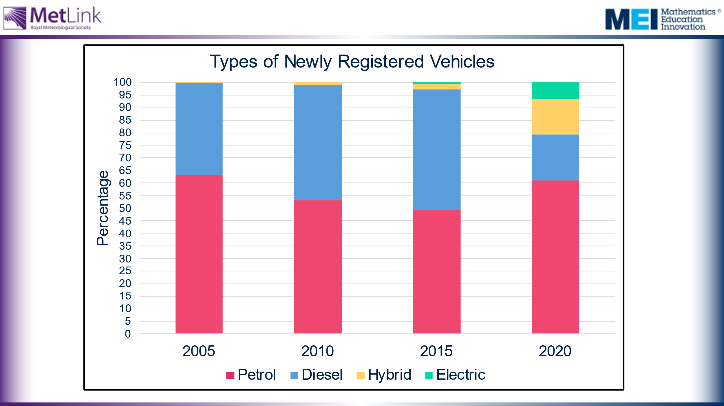 | What questions does this raise?  What is changing and why?  Encourage students to consider whether the number of petrol cars registered increased from 2015 to 2020? | Collect students’ intuitive responses in order to motivate doing the calculations on slide 6, which will answer the question.  Note that the bars make it appear that the number of petrol cars has increased, but they actually show that the proportion of petrol cars has increased.
 | 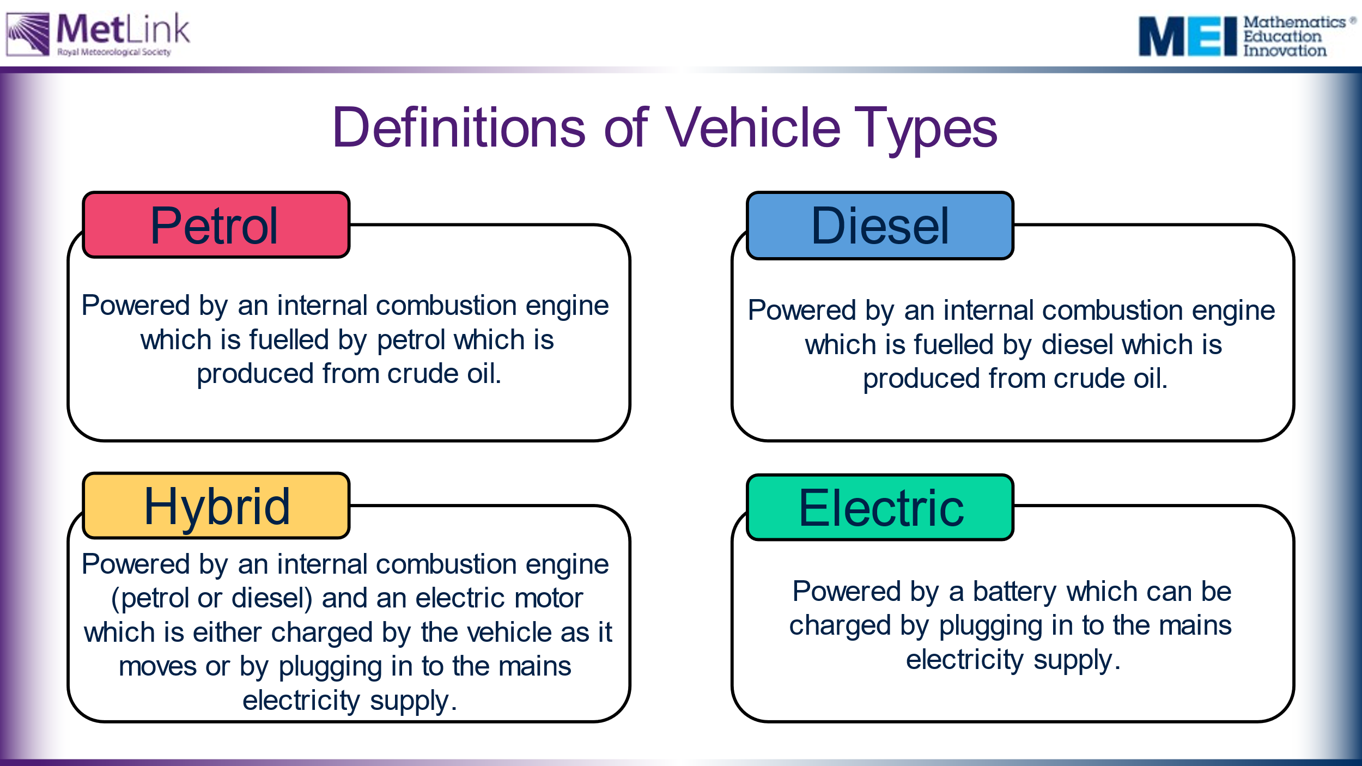 | Hidden slide, in case the definitions are needed. | Discussion opportunity here about different types of hybrid:  You might choose to ask the following question of your students: 'does anyone know the difference between a hybrid and a plug-in hybrid?' It's likely that some students will know and it feels like opportunity for them to offer their experience to the lesson in a positive way.  Hybrids and plug-in hybrids both have an internal combustion engine and electric motors and the difference is how the battery is charged. Hybrid vehicle batteries are charged by the internal combustion engine and with regenerative braking, whereas plug-in hybrids can also be charged at the mains
 | 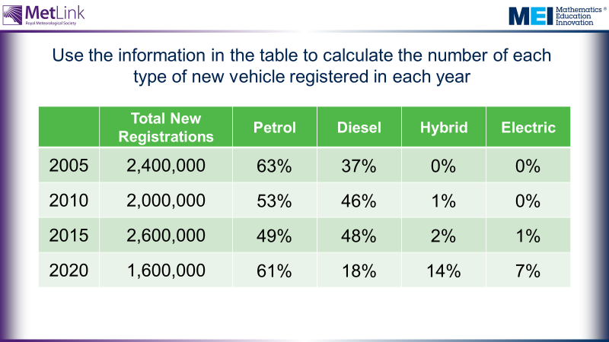 |  | Calculation of percentages using preferred, stage appropriate, methods – all work well here.  Students may find the use of millions difficult to calculate with. Discuss strategies for helping with this.
 | 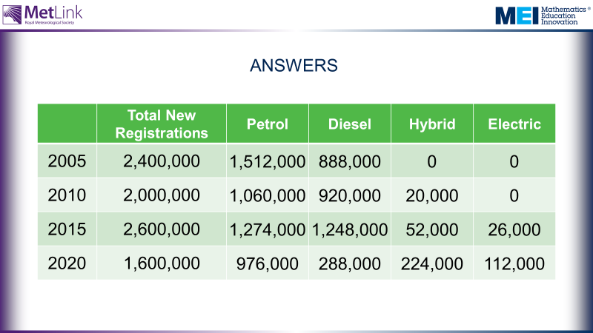 |  | Reflect upon the implications of graphs and tables presenting data in misleading ways – the graph on slide 4 made it look like the number of petrol car registrations had increased, but it had actually decreased.
 | 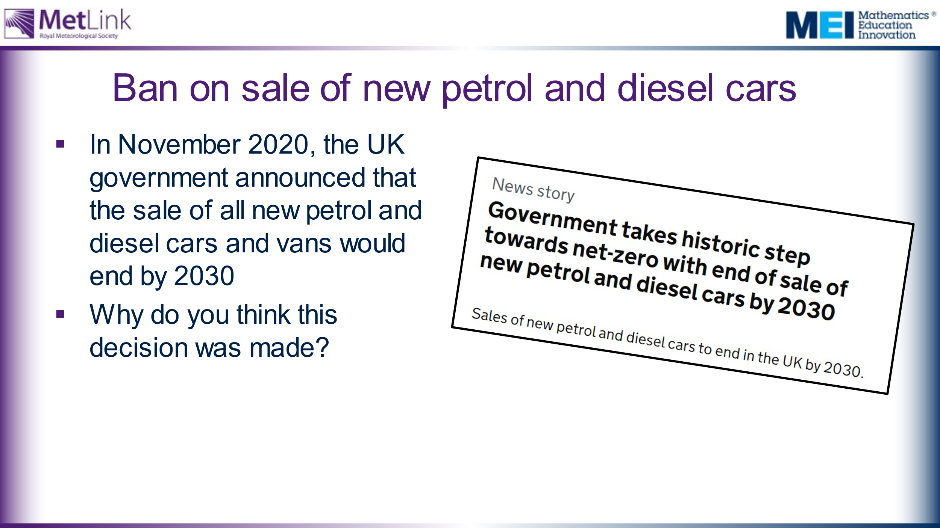 | Headline taken from here: https://www.gov.uk/government/news/government-takes-historic-step-towards-net-zero-with-end-of-sale-of-new-petrol-and-diesel-cars-by-2030  Ban on sale of new petrol and diesel cars by 2030. Why will this policy be introduced?  * In 2023 this was pushed back to 2035 (see, for example, https://www.bbc.co.uk/news/business-66863966 ) and this resource has been updated accordingly as far as is possible. | Note that, while the 2030 ban is intended to include hybrid vehicles, some hybrid vehicles will still be allowed to be sold until 2035.  Question prompts – this is all NEW cars and vans. What impact will this have?  What more information would we need to figure impact? Total vehicles each year? Number scrapped?  What do you think this means for hybrid vehicles?  What other kinds of vehicles are there, apart from cars and vans? 6% of vehicle registrations were NOT cars/vans in 2020.
 | 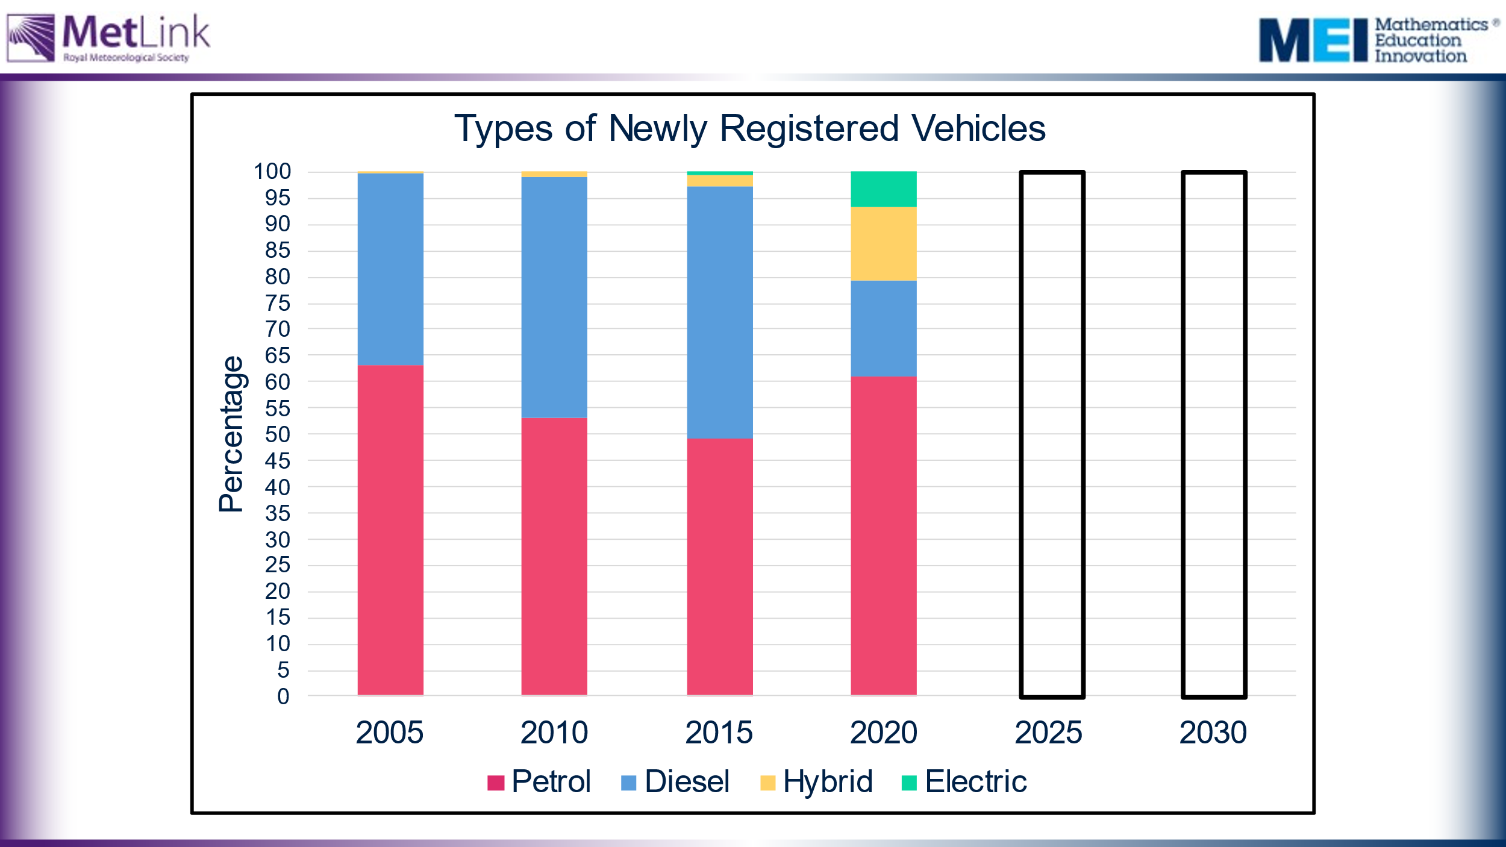 | What should the stack look like in 2035, given this information? Could we produce one at 2030? What would this one look like? | Students could differ with justification and assumptions – encourage students to be explicit about assumptions they make as they complete the stacks with their estimated proportions.
 | 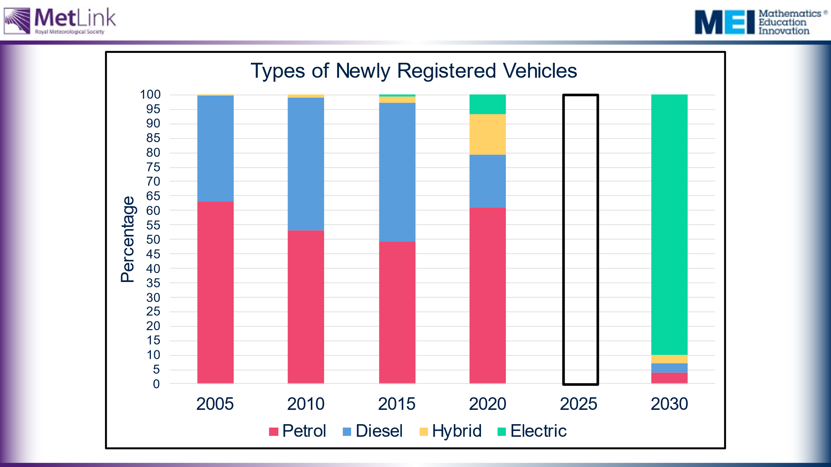 | What should the stack look like in 2035, given this information? Could we produce one at 2030? What would this one look like?  2035 estimations provided on this slide.  Why is the stack not 100% electric? | Not 100% electric because not all vehicle registrations are cars.  If we accept these proportions for 2035, what should our targets be for 2030? How could we interpolate between 2020 and 2030?  A worksheet is provided with a table of values and percentages to continue, and blank stack graphs to fill in with estimated proportions. Students work through this using the assumptions discussed previously.
 | 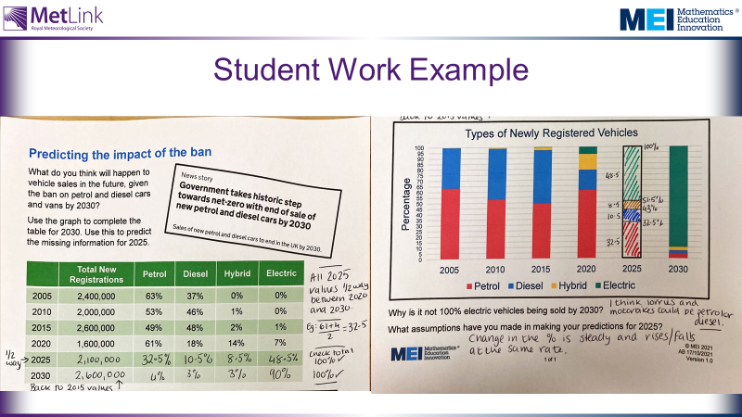 | Hidden slide in this section show examples of students work.  The justification for the maths is important. Your students’ figures may vary from those suggested with their different rationales. | It has not been possible to update all these slides following the announcement of the pushback to 2035 – please explain this to the class!
 | Hidden slide of extra statistics:  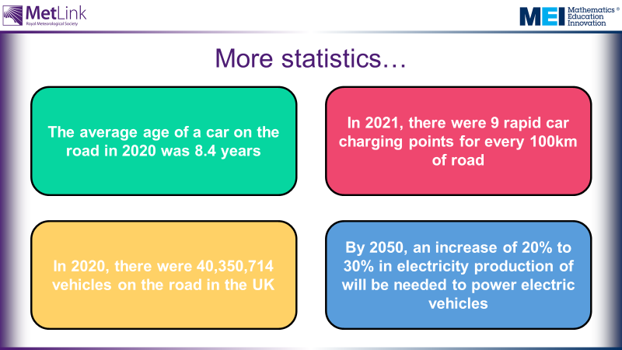 | Returning to infographic. What changes to the figures would you expect to see if this was made in 2031, a year after the ban is in place?  Potential for some wider questions here but also worked into the session earlier?  - If we are all moving to electric cars, what other questions does this raise?  - What will the increase in electricity consumption in the UK be?  - How will the electricity be generated?  - Will there be greater or fewer cars on the road?  - What is the GHG emissions cost for producing the vehicles? | Talk about car-sharing as a practical way of students acting upon the ideas in the session.  Possible extension task:  comparing a diesel and an electric car on this website: https://climobil.connecting-project.lu/  Consider showing where the other 73% of 2019 emissions came from?  In 2020, the total number of vehicles on the road was 40,350,714.  The number of new registrations in 2020 was 1,619,957.  What impact could the ban on the sale of NEW petrol and diesel cars have when these figures are taken into account?  For guidance, 1.6 million is 4% of 40 million. (number of vehicles source)  Car age source  Charging points source  Electricity demand source

