Past Climate Change
RECENT CHANGE

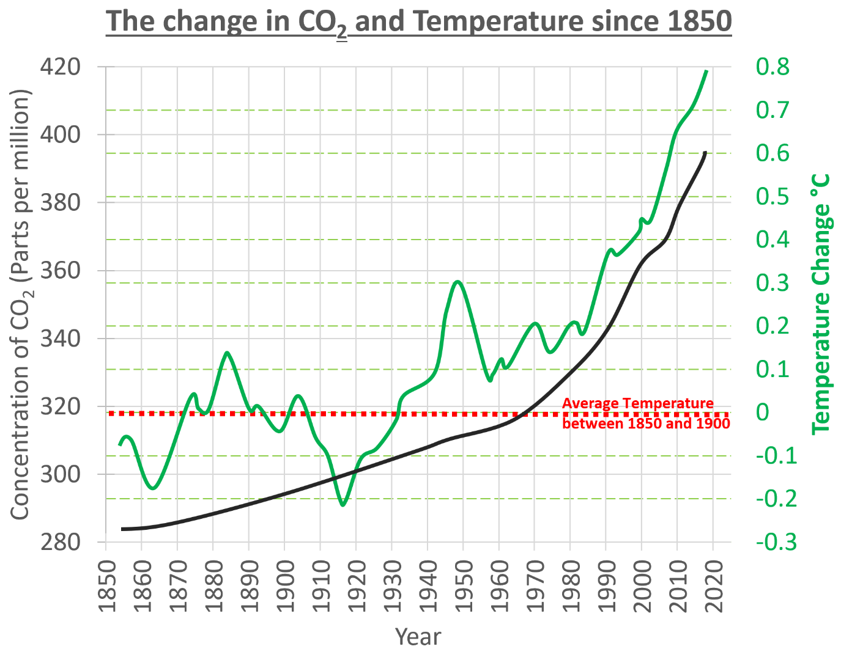
Describe the patterns on this graph.
- What happens to the temperature over time?
- Over time temperature
- The 1860 value for temperature is colder than the average by °C
- The most recent value for temperature is °C
- This shows that the temperature has changed by °C in years
- What happens to the CO₂ over time? What are the start and end values for CO₂?
- Over time CO₂
- The 1860 value for CO₂ is around parts per million
- The end value for CO₂ in 2020 is parts per million
- This shows that the CO₂ has changed by parts per million in years

CAUSES OF THE CHANGE
Using video 1 https://youtu.be/lrPS2HiYVp8:
- What drives the Earth’s climate system?
- What happens to the Sun’s energy when it reaches our atmosphere?
- What happens to the Earth’s heat?
- Without the Greenhouse gases would we be able to live on Earth?
Complete the diagram to show how the Greenhouse Effect works
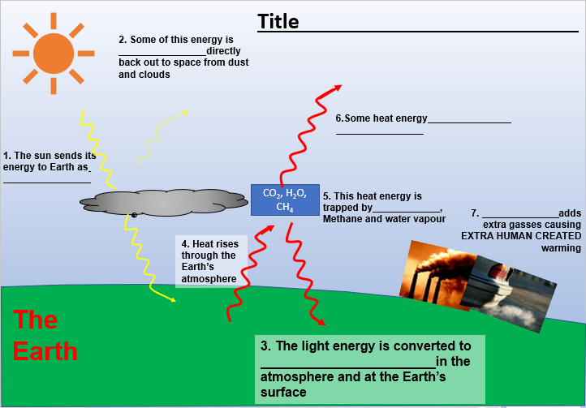
Key words to use

- Heat energy
- Carbon Dioxide
- Human activity
- Insolation
- Reflected
- Escapes to space
Using video 2 https://youtu.be/uHbxSYDqTR8 ;
- What has happened to temperature over the course of the last century?
- What has been the average global temperature?
- What does the evidence point to?
- What natural events can cause warming of our planet?
- What does most evidence suggest about the recent warming we have seen on planet Earth?
- Which activities increase the concentrations of greenhouse gases in the atmosphere?
- What sources of CO₂ are there?
- What sinks of CO₂ are there?

