Weather Taboo
You can find some ideas for a game of weather taboo below.
You could ask your class to play it in small groups or with two teams, possibly involving the labelling of a map or chart once the correct term has been guessed.
You could always set a homework exercise to write a good definition of each feature without using the banned words.
General guidelines for using taboo in a class can be found at https://www.geography.org.uk/write/MediaUploads/Teacher%20education/GA_ITE_SFT_Taboo.pdf .

Air Masses Taboo

Polar Maritime

You may not say:
Polar
Maritime
Atlantic
Cold
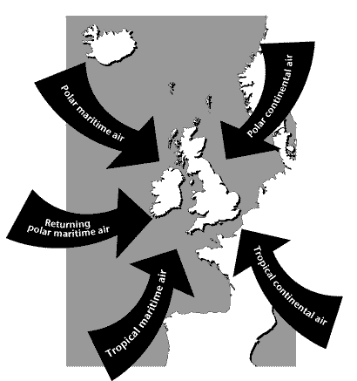
Northwest

Air Masses Taboo

Tropical Maritime

You may not say:
Tropical
Maritime
Atlantic
warm
dry

Air Masses Taboo

Tropical Continental

You may not say:
Tropical
Continental
Africa
Warm
South

Air Masses Taboo

Polar Continental

You may not say:
Polar
Continental
Scandinavia
North
cold

Air Masses Taboo

Arctic Maritime

You may not say:
Arctic
Maritime
north
cold
showers

Air Masses Taboo

Air Mass

You may not say:
Air
Mass
Atmosphere
Source
Characteristics

