Year 7 Weather and Climate Test
Name Form Score /40
- Contrast (what is the difference between) the terms weather and climate
(3 marks)

- Identify 3 ways that our school site and/or buildings can affect the weather. Label them accurately on the map.
(3 marks)

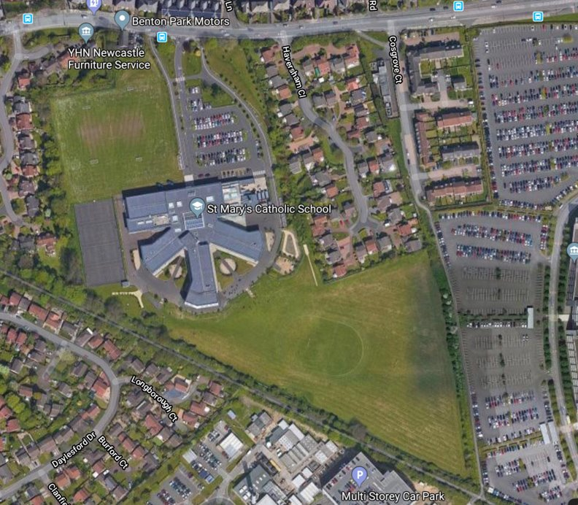

- Match the weather characteristic with the correct weather measurement instrument in the table. One has been done for you.
(3 marks)
Weather element |  | Instrument
Air pressure |  | Maximum and minimum thermometer
Cloud type |  | Rain gauge
Precipitation |  | Wind vane
Sunshine |  | Sunshine recorder
Temperature |  | Anemometer
Wind direction |  | Human sight and identification chart
Wind speed |  | Barometer

1
2
3
4
5 | Mountainous
6
7
Study carefully the map showing the World’s climate zones
- Identify the climate zones at each number on the Key using the names from the list below. One has been done for you.
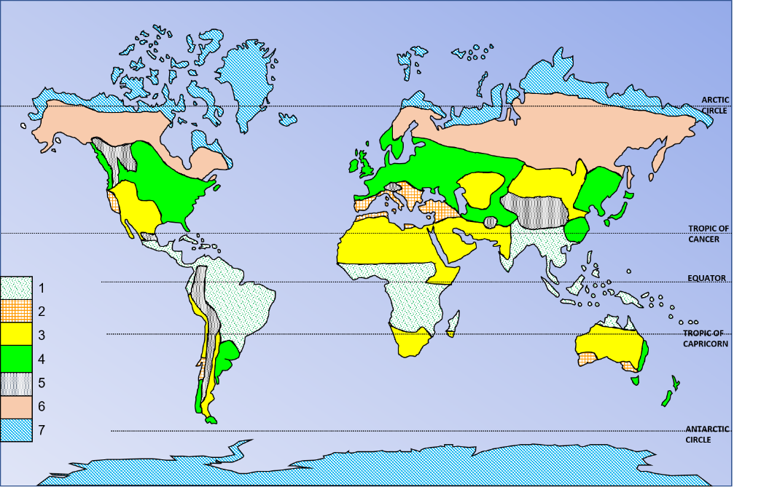
(3 Marks)
- Polar​
- Dry
- Mountainous​
- Tropical​
The UK
- Mediterranean​
- ​Temperate​
- Continental​

- Name the climate zone of the UK
(1 Mark)
- Complete the climate graph for London by:

- Completing the rainfall bars for October, November and December using the right-hand axis
(3 marks)
- Adding the 3 missing temperature values for October, November and December using the left-hand axis
(3 marks)
- Finishing the temperature curve freehand by joining the dots or crosses together
(1 Mark)
- Adding an appropriate title
(1 mark)
 | January | February | March | April | May | June | July | August | September | October | November | December
Avg. Temperature (°C) | 4.9 | 5.0 | 7.2 | 9.7 | 13.1 | 16.6 | 18.7 | 18.2 | 15.5 | 12.0 | 8.0 | 6.0
Precipitation (mm) | 56 | 39 | 46 | 45 | 49 | 50 | 48 | 53 | 56 | 60 | 61 | 58

Air masses that affect the UK
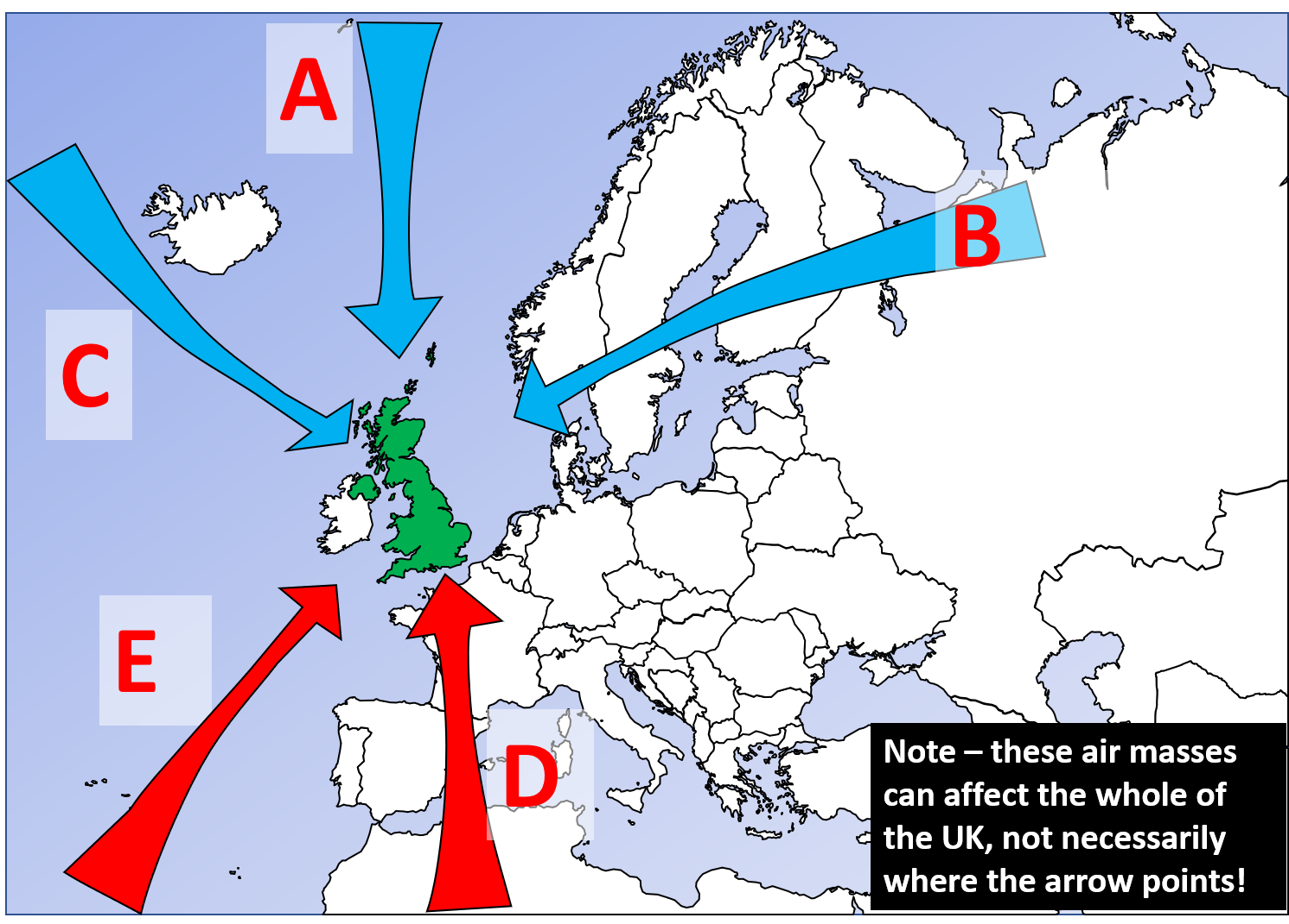
- Identify the Air masses that affect the UK in the table below.
(5 Marks)
Air mass | Letter
Tropical maritime
Tropical continental
Polar continental
Arctic maritime
Polar maritime

A map of UK Mean Temperature Annual Average 1991 - 2020
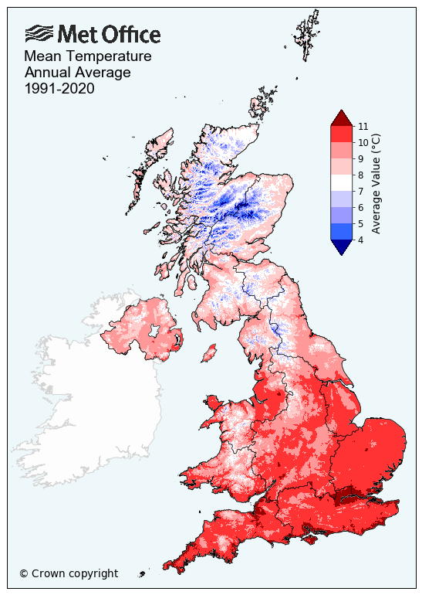
- Which statement about the temperature map is false? Tick the box.
- The upland or highland areas of the UK are colder.
- There is a big difference in temperature between the West and the East of the UK.
- The further south you are in the UK the warmer it generally gets.
- Coastal areas tend to be slightly warmer than inland areas for the same latitude.
- Major cities like London tend to be slightly warmer than the surrounding countryside areas.
(1 Mark)
- Explain (give reasons for) the patterns on the temperature map. You could mention air masses, ocean currents, the impact of latitude and/or prevailing winds in your response.
(5 Marks)
Study the figure below carefully, about the impact of climate change on the UK
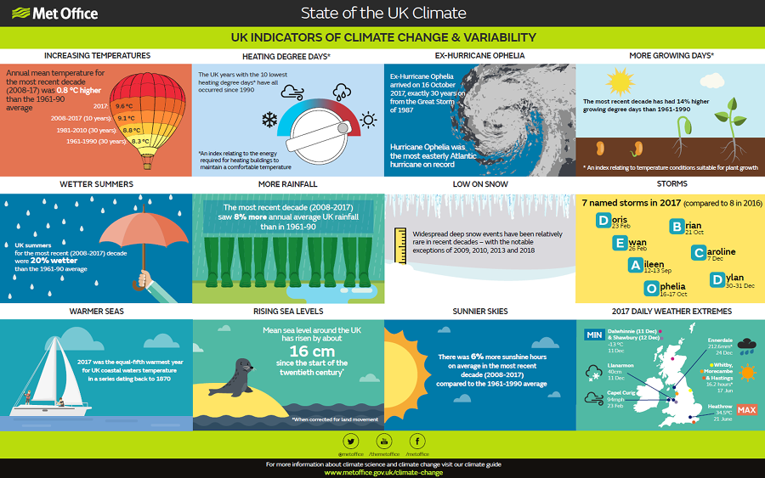
- Using the infographic and your own knowledge, will climate change offer the UK more opportunities than challenges? Justify your view with evidence.
(8 Marks)

