Year 7 Weather and Climate Test
Name Form Score /40
- Contrast (what is the difference between) the terms weather and climate
(3 marks)
Clear definition of weather – 1 mark
Clear definition of climate – 1 mark
Use of connectives or contrasts that show they student knows the difference – 1 mark
- Identify 3 ways that our school site and/or buildings can affect the weather. Label them accurately on the map.
(3 marks)
Any 3 ways that weather variables could be affected by the factors on the image. Point mark.

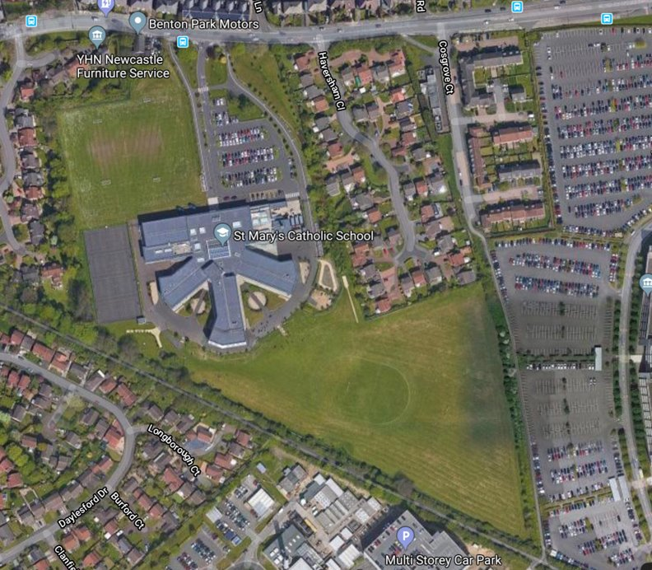

- Match the weather characteristic with the correct weather measurement instrument in the table. One has been done for you.
(3 marks)
Weather element |  | Instrument
Air pressure |  | Maximum and minimum thermometer
Cloud type |  | Rain gauge
Precipitation |  | Wind vane
Sunshine |  | Sunshine recorder
Temperature |  | Anemometer
Wind direction |  | Human sight and identification chart
Wind speed |  | Barometer

1 | Tropical
2 | Mediterranean
3 | Dry
4 | Temperate
5 | Mountainous
6 | Continental
7 | Polar
Study carefully the map showing the World’s climate zones
- Identify the climate zones at each number on the Key using the names from the list below. One has been done for you. 1 mark for every 2 correct
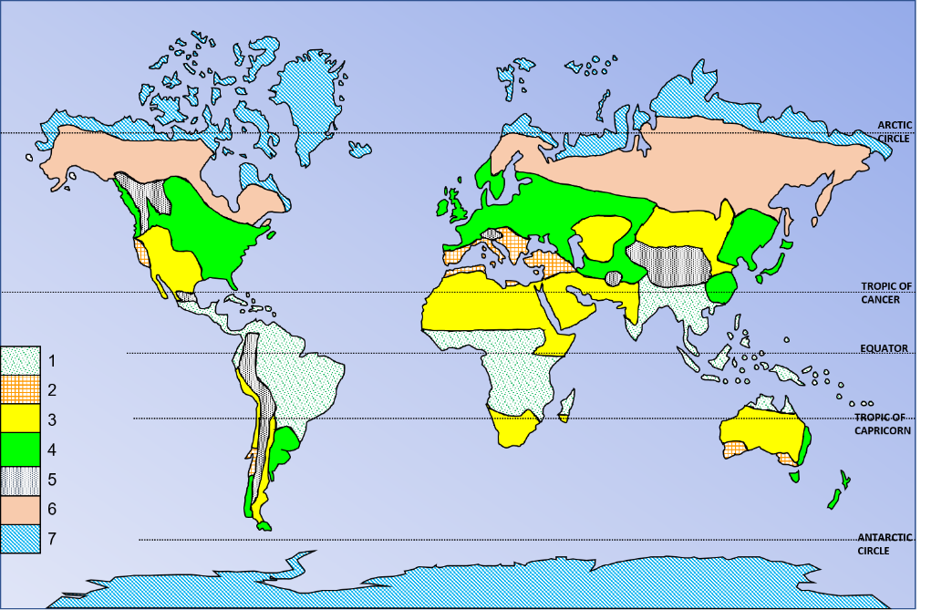
(3 Marks)
- Polar​
- Dry
- Mountainous​
- Tropical​
- Mediterranean​
- ​Temperate​
- Continental​

- Name the climate zone of the UK – Temperate (1 mark)
(1 Mark)
- Complete the climate graph for London by:

- Completing the rainfall bars for October, November and December using the right-hand axis
(3 marks)
- Adding the 3 missing temperature values for October, November and December using the left-hand axis
(3 marks)
- Finishing the temperature curve freehand by joining the dots or crosses together
(1 Mark)
- Adding an appropriate title
(1 mark)

As per marking criteria above, plotting must be accurate.
 | January | February | March | April | May | June | July | August | September | October | November | December
Avg. Temperature (°C) | 4.9 | 5 | 7.2 | 9.7 | 13.1 | 16.6 | 18.7 | 18.2 | 15.5 | 12 | 8 | 6
Precipitation (mm) | 56 | 39 | 46 | 45 | 49 | 50 | 48 | 53 | 56 | 60 | 61 | 58

Air masses that affect the UK
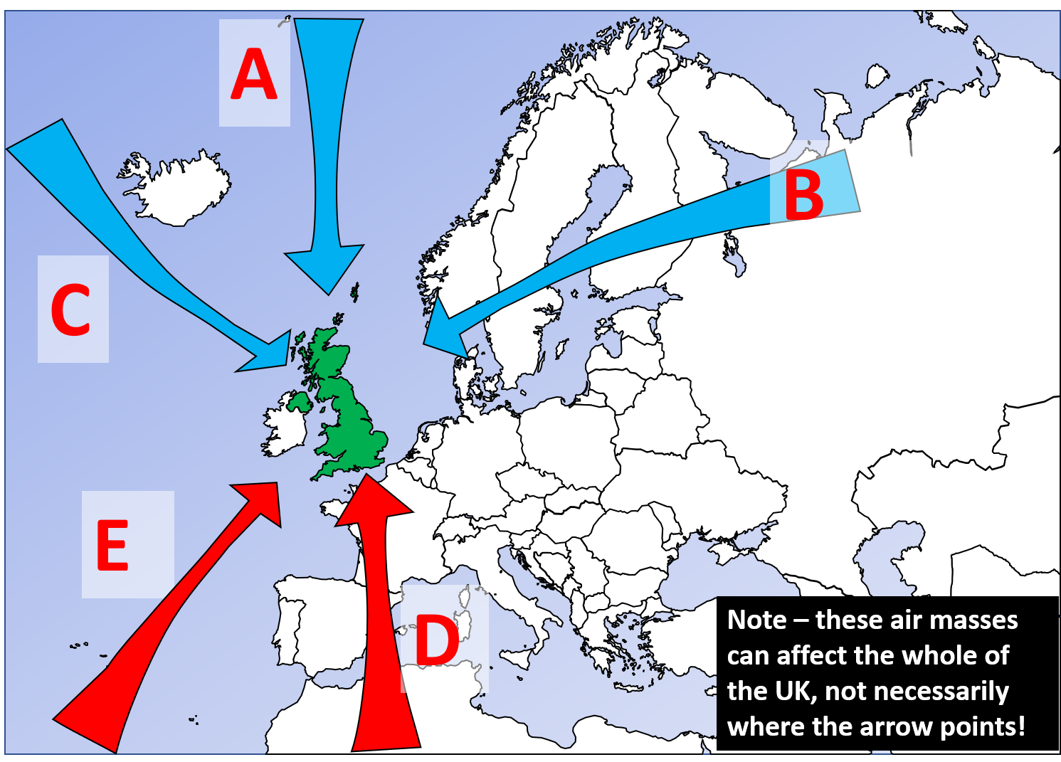
- Identify the Air masses that affect the UK in the table below.
(5 Marks)
Air mass | Letter
Tropical maritime | E
Tropical continental | D
Polar continental | B
Arctic maritime | A
Polar maritime | C

One mark each

A map of UK Mean Temperature Annual Average 1991 - 2020
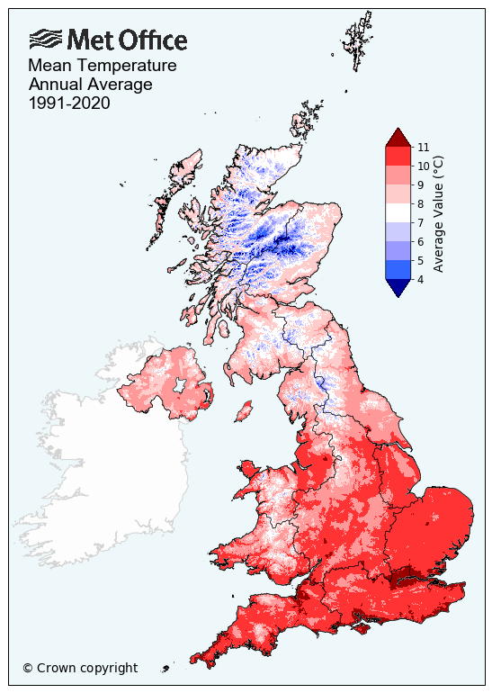
- Which statement about the temperature map is false? Tick the box.
- The upland or highland areas of the UK are colder.
- There is a big difference in temperature between the West and the East of the UK. | FALSE
- The further south you are in the UK the warmer it generally gets.
- Coastal areas tend to be slightly warmer than inland areas for the same latitude.
- Major cities like London tend to slightly warmer than the surrounding countryside areas.
(1 Mark)
- Explain (give reasons for) the patterns on the temperature map. You could mention air masses, ocean currents, the impact of latitude and/or prevailing winds in your response.
Level | Marks | Description
2 (Detailed) | 4-5 | Applies detailed knowledge of temperature differences in the UK to explain the pattern on the map.  Clearly relates the data shown on the map to reasons why temperatures vary in the UK, including 2 well explained points from air masses and prevailing wind, latitude, distance from the sea, altitude, ocean currents
1 (Basic) | 1-3 | Demonstrates limited knowledge of temperature differences in the UK  Makes limited use of the map. May have only one reason developed, or a list of not developed reasons air masses and prevailing wind, latitude, distance from the sea, altitude, ocean currents at the lower end
 | 0 | No relevant content.

(5 Marks)
Study carefully the figure below, about the impact of climate change on the UK
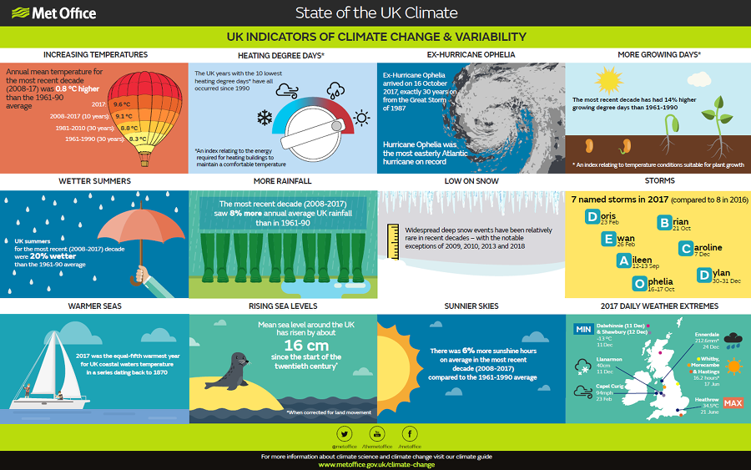
- Using the infographic and your own knowledge, will climate change offer the UK more opportunities than challenges? Justify your view with evidence.
Level | Marks | Description
3 (Detailed) | 6-8 | Applies detailed knowledge of the impacts of climate change to explain if the opportunities will outweigh the challenges or vice versa.  Might have links between own knowledge and the infographic  Clearly relates the evidence on the infographic to their argument on the opportunities will outweigh the challenges or vice versa.
2(Clear) | 3-5 | Demonstrates accurate but not detailed knowledge of the impacts of climate change to explain if the opportunities will outweigh the challenges or vice versa.  Makes clear and effective use of an element of the infographic.
1(Basic) | 1-2 | Demonstrates limited knowledge of climate change. Evidence of own knowledge is weak or absent.  Makes limited use of the evidence on the infographic to their argument on the opportunities will outweigh the challenges or vice versa. Items may simply be lifted from the text
 | 0 | No relevant content.

(8 Marks)

