Extreme Weather teacher notes for Core Maths
Brief overview of session ‘logic’ | Mathematical opportunities offered
- Do reports of extreme cold weather provide evidence that global warming is not happening?  - Show the New York Times graphs of summer temperature distributions for the Northern Hemisphere for different periods.  - Interrogate/critique these graphs  - The distributions of temperatures are approximately Normal distributions and the mean and standard deviation both increase as the time period becomes more recent.  - Use the dynamic bell curve to calculate probabilities of different temperatures in different time periods.  - Despite the mean temperature increasing, the standard deviation also increasing means that the probability of extreme low temperatures increases.  - Normal distributions and bell curves can explain a higher frequency of extreme cold weather despite global warming. | - Interpretation of data, statistics, graphs, infographics in context  - Critiquing graphs  - Reading scales  - Using standard form to write very large or very small numbers  - Fitting a Normal distribution or bell curve to a graph  - Exploring the effect of adjusting mean and standard deviation on a bell curve  - Understanding that probabilities can be represented and calculated using areas  - Analysing and comparing data in order to develop and present a conclusion

Desmos activity available here: https://teacher.desmos.com/activitybuilder/custom/6032e8d3f60b700ce9b36ebc
Brief instructions for getting started with Desmos can be found on the final page.

Time for session: 30 minutes
Time | Slide | What to do… | Aims, additional info and comments
00 | 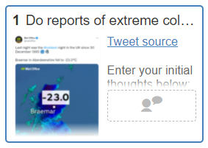 | Show students the tweet and ask what their initial reaction is.  Can students remember any particularly cold weather?  How cold is -23°C?  Do reports of extreme cold weather provide evidence that global warming is not happening? | Given that global warming is happening, this session will explain the potentially increasing frequency of extreme cold weather, which could intuitively feel contradictory.  Encourage students to share stories of their experiences of very cold weather, so that they become more personally invested in the activity.  Note that the temperature of a domestic freezer is usually around -18°C, while a fridge would be around 3-5°C.
5 | 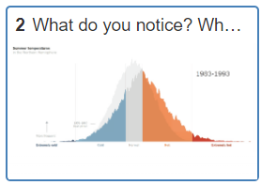 | What do these graphs show?  What questions do they raise?  What do you notice?  What do you wonder? | Things students may comment on or question:  - The mean temperature is increasing  - The peak is getting lower  - The curve is getting wider  - The amount of extremely hot weather is increasing  - The amount of extremely cold weather is staying about the same  - There isn’t a numerical scale on the horizontal axis  - What does ‘normal’ temperature mean, and can this change?  - What does the vertical axis measure?  - Why does it only look at the Northern Hemisphere?  - The ‘base period’ is 30 years but subsequent periods are 10 years.  It is normal for the average of 30 years’ worth of weather data to be referred to as the climate, so the base period shows 1951-1980 climate.  Graph from The New York Times  Explanations: PNAS – Perception of climate change  Data source: Global Historical Climatology Network data set (GHCNv2)
 | 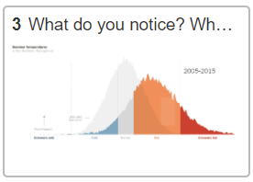
10 | 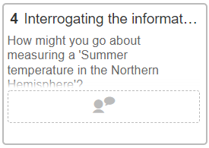 | Ask students how they might measure a ‘Summer temperature in the Northern Hemisphere’ and collect ideas.  Try to draw out the many decisions that could be made:  - Where would you take the measurement?  - What altitude would you choose?  - What time would you choose?  - What date would you choose?  Ask students: How could you make your measurement represent the whole of the Northern Hemisphere in summer?  This motivates the need for a distribution of temperatures, to help represent the variation in temperature across the Northern Hemisphere. | Some of the decisions made in creating the graphs from The New York Times include:  - Where would you take the measurement?  Many measurements were taken at a spatial resolution of 250km, so one place of measurement for every square 250km of land. Measurements were only taken on land, not over sea.  - What altitude would you choose?  The air temperature was measured at the surface of the Earth.  - What time would you choose?  The temperatures were averaged over different times of day  - What date would you choose?  The temperatures were measured in June, July and August.  Note also that these are graphs of temperature anomalies, meaning that they don’t show the absolute temperature readings. Instead, they show the difference between the absolute temperature reading and the average temperature for that location in the base period. So the centre of the ‘normal’ temperature for the base period on the x-axis should be labelled 0. Temperatures lower than the average base temperature for that location would have a negative temperature anomaly.  The reason for this is so that the variation in the graphs represents variation in temperature relative to the temperature of the location. It eliminates the variation in temperatures between different locations, which is inevitable, less interesting and would add ‘noise’ to the graphs.  The ‘height’ of the graph is calculated by counting the frequency of readings in a temperature anomaly range of 0.05.  Note also that, in reality, the data for this chart comes from a variety of sources, including weather stations and satellites, so is not evenly spaced over the surface of the Earth. To give the 250km resolution, all of the data is assimilated into a computer model and appropriately interpolated and averaged.  Avoid the misconception that the graph shows the range of temperatures for different places in the Northern Hemisphere (with the cold end of the curve showing data collected predominantly from the Arctic and the warm end of the curve showing data collected predominantly from the Tropics). By showing temperature anomalies, we have accounted for spatial variations in temperature.
15 | 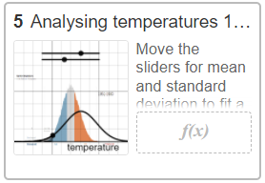 | Demonstrate the effect of moving the sliders for mean and standard deviation so that students can see.  Ask students to describe the effect of adjusting the mean, and adjusting the standard deviation, on the shape of the bell curve.  Invite a student to move the sliders to ‘fit’ the bell curve to the graph.  Invite another student to move point T such that it is on 22°C, the centre of the ‘normal’ range, on the x-axis. Read off together the probability of the temperature being less than 22°C. It should be close to 0.5.  Demonstrate how the probability changes as you move point T. Ask students how the probability relates to the graph.  Ask students to complete the remaining two probabilities. | We want students to notice that the probability is given by the area under the bell curve, where the total area is 1.  Answers should be approximately:  $$P(temp<22)=0.5$$  $$P(temp<17)=1.38×{10}^{-8}$$  $$P(temp>24)=1-0.98686585=0.0131$$  Students may ask what these probabilities actually mean and it is worth being aware that it is challenging, and beyond the scope of the Core Maths course, to interpret these probabilities accurately.  In designing this activity to make it more intuitive for students, we have chosen to apply the temperature anomaly distribution to a location where the mean temperature in the base period was 22°C. This feels more in line with what students would expect from an average Summer temperature in the Northern Hemisphere, than the 0°C which really belongs on these temperature anomaly distributions.  What this means for these probabilities is that they represent the probability of an average daily temperature reading, taken in the climate of the base period, being within a particular range for a location which had a mean temperature of 22°C in the base period.
20 | 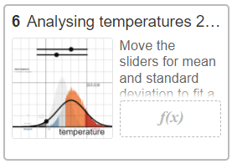 | Ask students to move the sliders to fit the bell curve to the period 2005-2015.  Use Desmos to calculate the probabilities. | Answers should be approximately:  $$P(temp<22)=0.126$$  $$P(temp<17)=4.00×{10}^{-8}$$  $$P(temp>24)=1-0.70543058=0.295$$  These are probabilities of an average daily temperature reading, in the 2005-2015 period, being within a particular range for a location which had a mean temperature of 22°C in the base period. This assumes that this location had the same increase in mean temperature, from the base period to 2005-2015, as the mean of the temperature increases across all locations.
25 | 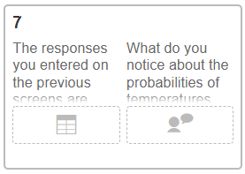 | Ask students to interpret their results, which should be close to:  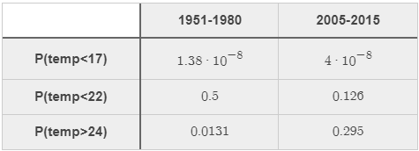  To support students in making sense of these probabilities, it may be worth asking some further questions, such as:  If the probability is 1/100 and there are 90 days in the summer, roughly how often would you expect the temperature to be over 24°C in the ten year period? What if the probability is 3/10? What if the probability is $4×{10}^{-8}$? | Note that the probability of the temperature being greater than 24°C has increased from approximately 1/100 to 3/10. This is a huge increase.  We want students to notice that despite the mean temperature increasing from the base period to 2005-2015, the probability of a temperature of less than 17°C is nearly three times greater, although still very small. This is due to the standard deviation of temperatures also increasing, which stretches out the tails of the distribution.  This helps to explain why, despite global warming, there are more instances of extreme cold weather.

Getting started with using Desmos classroom activities
There is a helpful guide to getting started with Desmos classroom activities available here: https://help.desmos.com/hc/en-us/articles/4405326707853-Getting-Started-Classroom-Activities
To use the Climate Change – Extreme Cold Temperatures Desmos activity, begin by clicking the link: https://teacher.desmos.com/activitybuilder/custom/6032e8d3f60b700ce9b36ebc
This drop-down menu allows you to ‘Copy and edit’ this activity, which allows you to save your own version in your Desmos account, editing any aspect of it to suit your own students and ways of working.

You may need to register and sign in to Desmos first, but this takes you to the activity page:
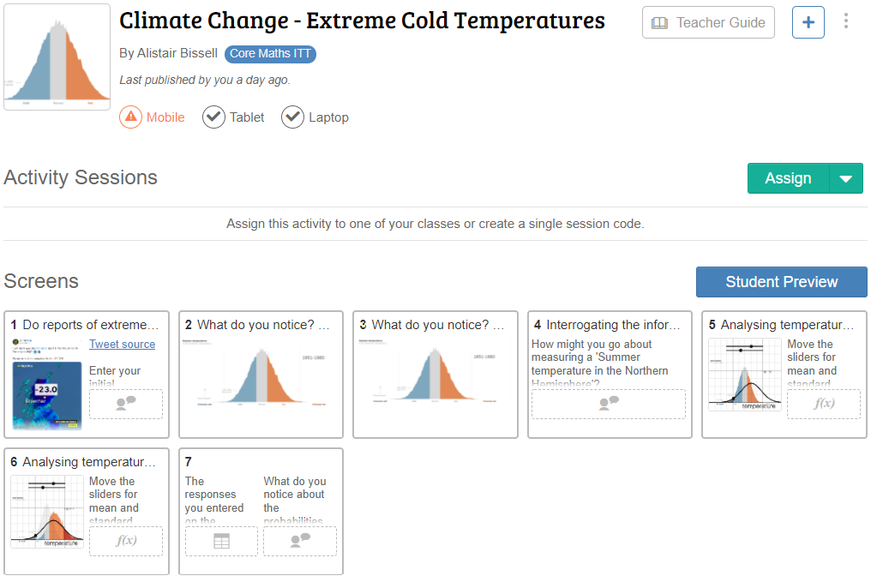
The ‘Assign’ drop-down menu offers two options:
- Assign to your classes, which allows you to offer this activity to groups with whom you regularly use Desmos activities, by setting up a class.
- Single session code, which allows you to offer the activity to groups of students who you will only work with once, without setting up a class.
Student Preview allows you to work through the activity as a student.

