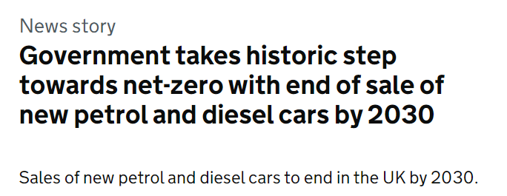
What do you think will happen to car sales by 2030? What will this mean for car sales in 2025?
Starting with 2030, predict the missing information in the table and the graph below.

 | Total New Registrations | Petrol | Diesel | Hybrid | Electric
2005 | 2,445,445 | 1,544,788 | 894,299 | 5,380 | 0
2010 | 1,996,324 | 1,060,847 | 913,119 | 21,760 | 0
2015 | 2,602,146 | 1,276,092 | 1,253,454 | 60,890 | 11,710
2020 | 1,619,957 | 986,878 | 295,156 | 230,358 | 106,755
2025
2030

What assumptions have you made in making your predictions?
What do you think the proportions of petrol, diesel, hybrid and electric vehicles would look like for all vehicles on the road, not just the newly registered ones?

