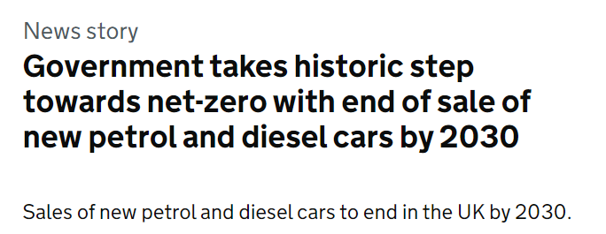
What do you think will happen to vehicle sales in the future, given the ban on petrol and diesel cars and vans by 2030?
Use the graph to complete the table for 2030. Use this to predict the missing information for 2025.

 | Total New Registrations | Petrol | Diesel | Hybrid | Electric
2005 | 2,400,000 | 63% | 37% | 0% | 0%
2010 | 2,000,000 | 53% | 46% | 1% | 0%
2015 | 2,600,000 | 49% | 48% | 2% | 1%
2020 | 1,600,000 | 61% | 18% | 14% | 7%
2025
2030

Why is it not 100% electric vehicles being sold by 2030?
What assumptions have you made in making your predictions for 2025?

