Trees for Net Zero session plan
Brief overview of session ‘logic’ | Mathematical opportunities offered
- Why trees are good  - People are planting trees – estimates around what the numbers look like in terms of land use  - Some companies encourage you to offset flights by planting trees - how many trees for one flight?  - How much carbon do trees sequester?  - How does the amount of carbon sequestered by a tree change during its lifecycle?  - What happens to that carbon when a tree dies?  - Can you plant a tree to offset a flight?  - What is Net Zero?  - Can trees be used to achieve Net Zero? | - Estimation and proportional reasoning  - Developing a sense of scale of large numbers  - Converting between m² and km²  - Interpretation of data, statistics, graphs, infographics in context  - Critiquing graphs  - Analysing and comparing data in order to develop and present a conclusion  - Making assumptions  - Making predictions  - Reading scales  - Plotting graphs

Time for session: 90 minutes
Time | Slide | What to do… | Aims, additional info and comments
00 | 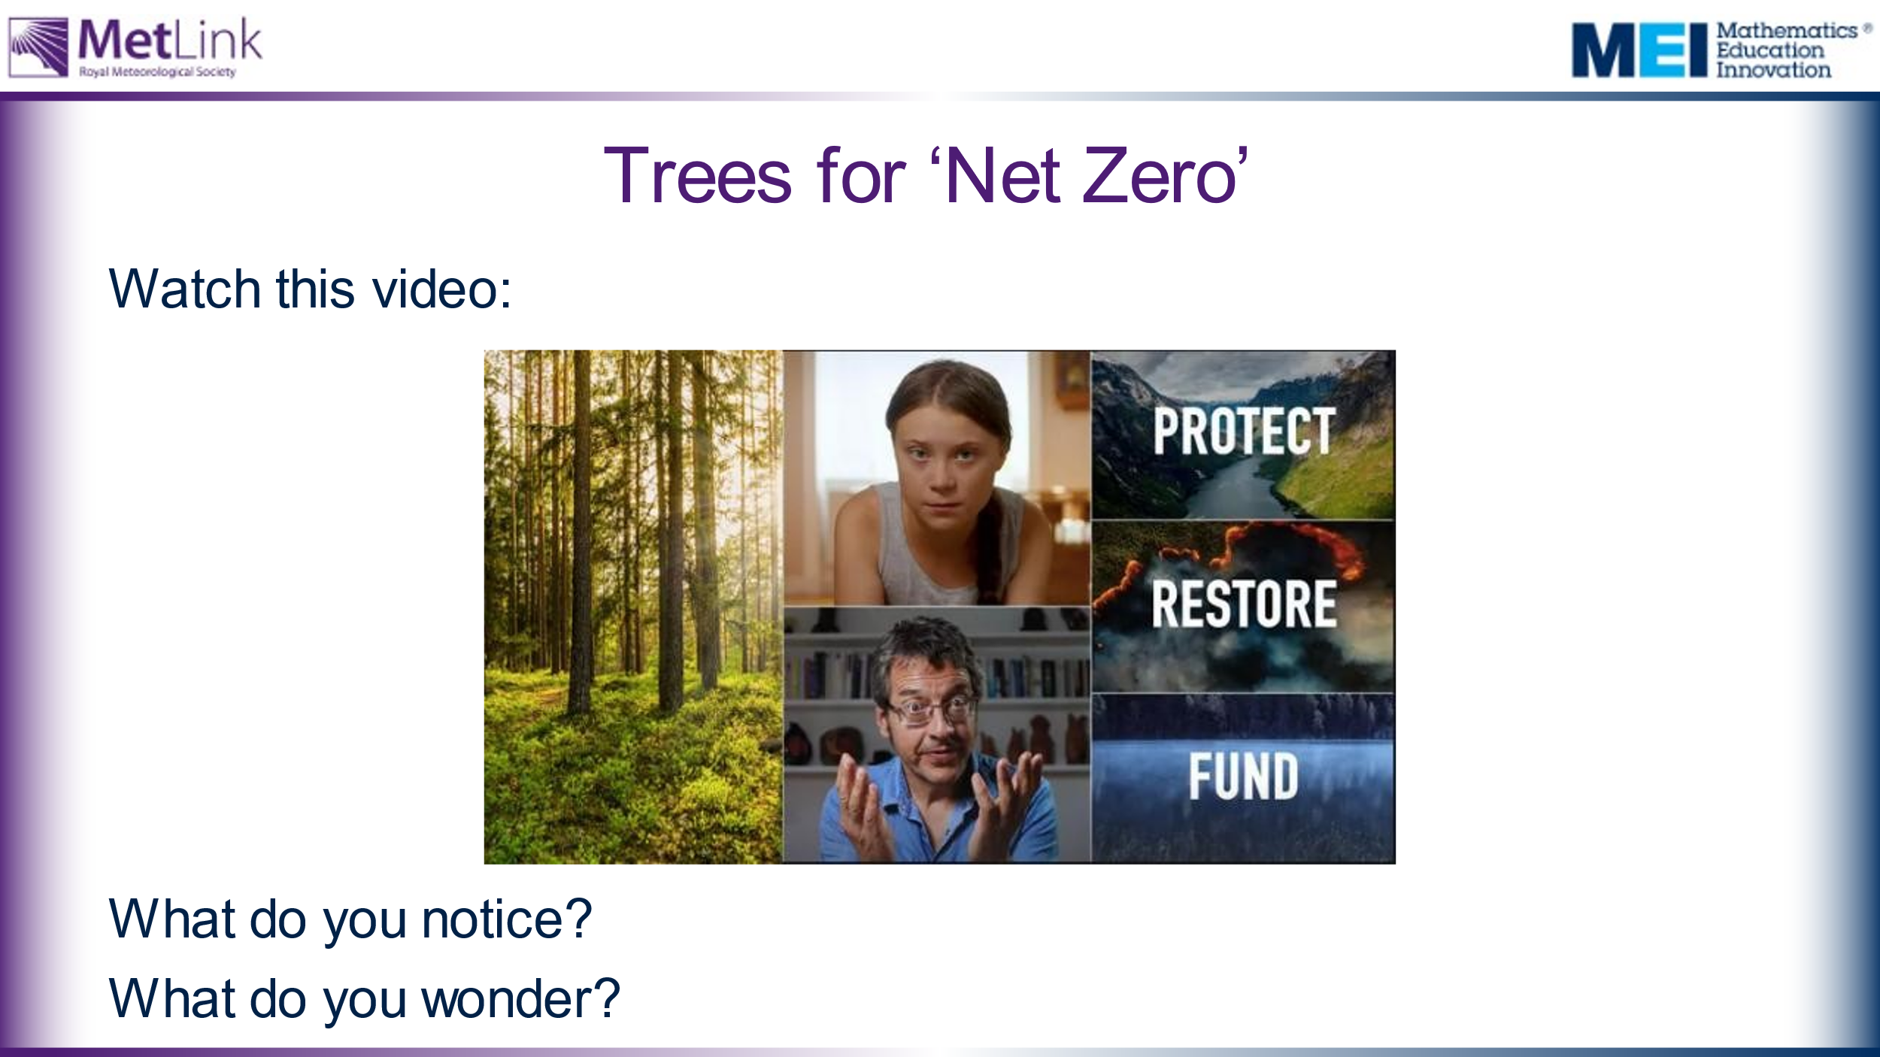 | Watch the video twice:  - On first viewing, ask students how it makes them feel. Do students agree or disagree with the statement: “What you do counts”?  - On second viewing, ask students to make a note of any facts or statistics they find interesting or surprising.  This session is about trees – what affect will this tree cutting have on the CO₂ in our atmosphere and to what extent can planting trees solve this problem? | This video introduces the idea that planting trees can help to absorb CO₂ from the atmosphere and potentially sets up a question to explore throughout the session:  To what extent can planting trees solve our climate crisis?  Tropical forests are being cut down at a rate of 30 football pitches per minute – what does this mean? How many trees is this? How significant is the carbon stored by a tree? What does this mean for CO₂ in the atmosphere? How does this compare to the numbers of trees being planted around the World? We will explore these questions in this session.
 | 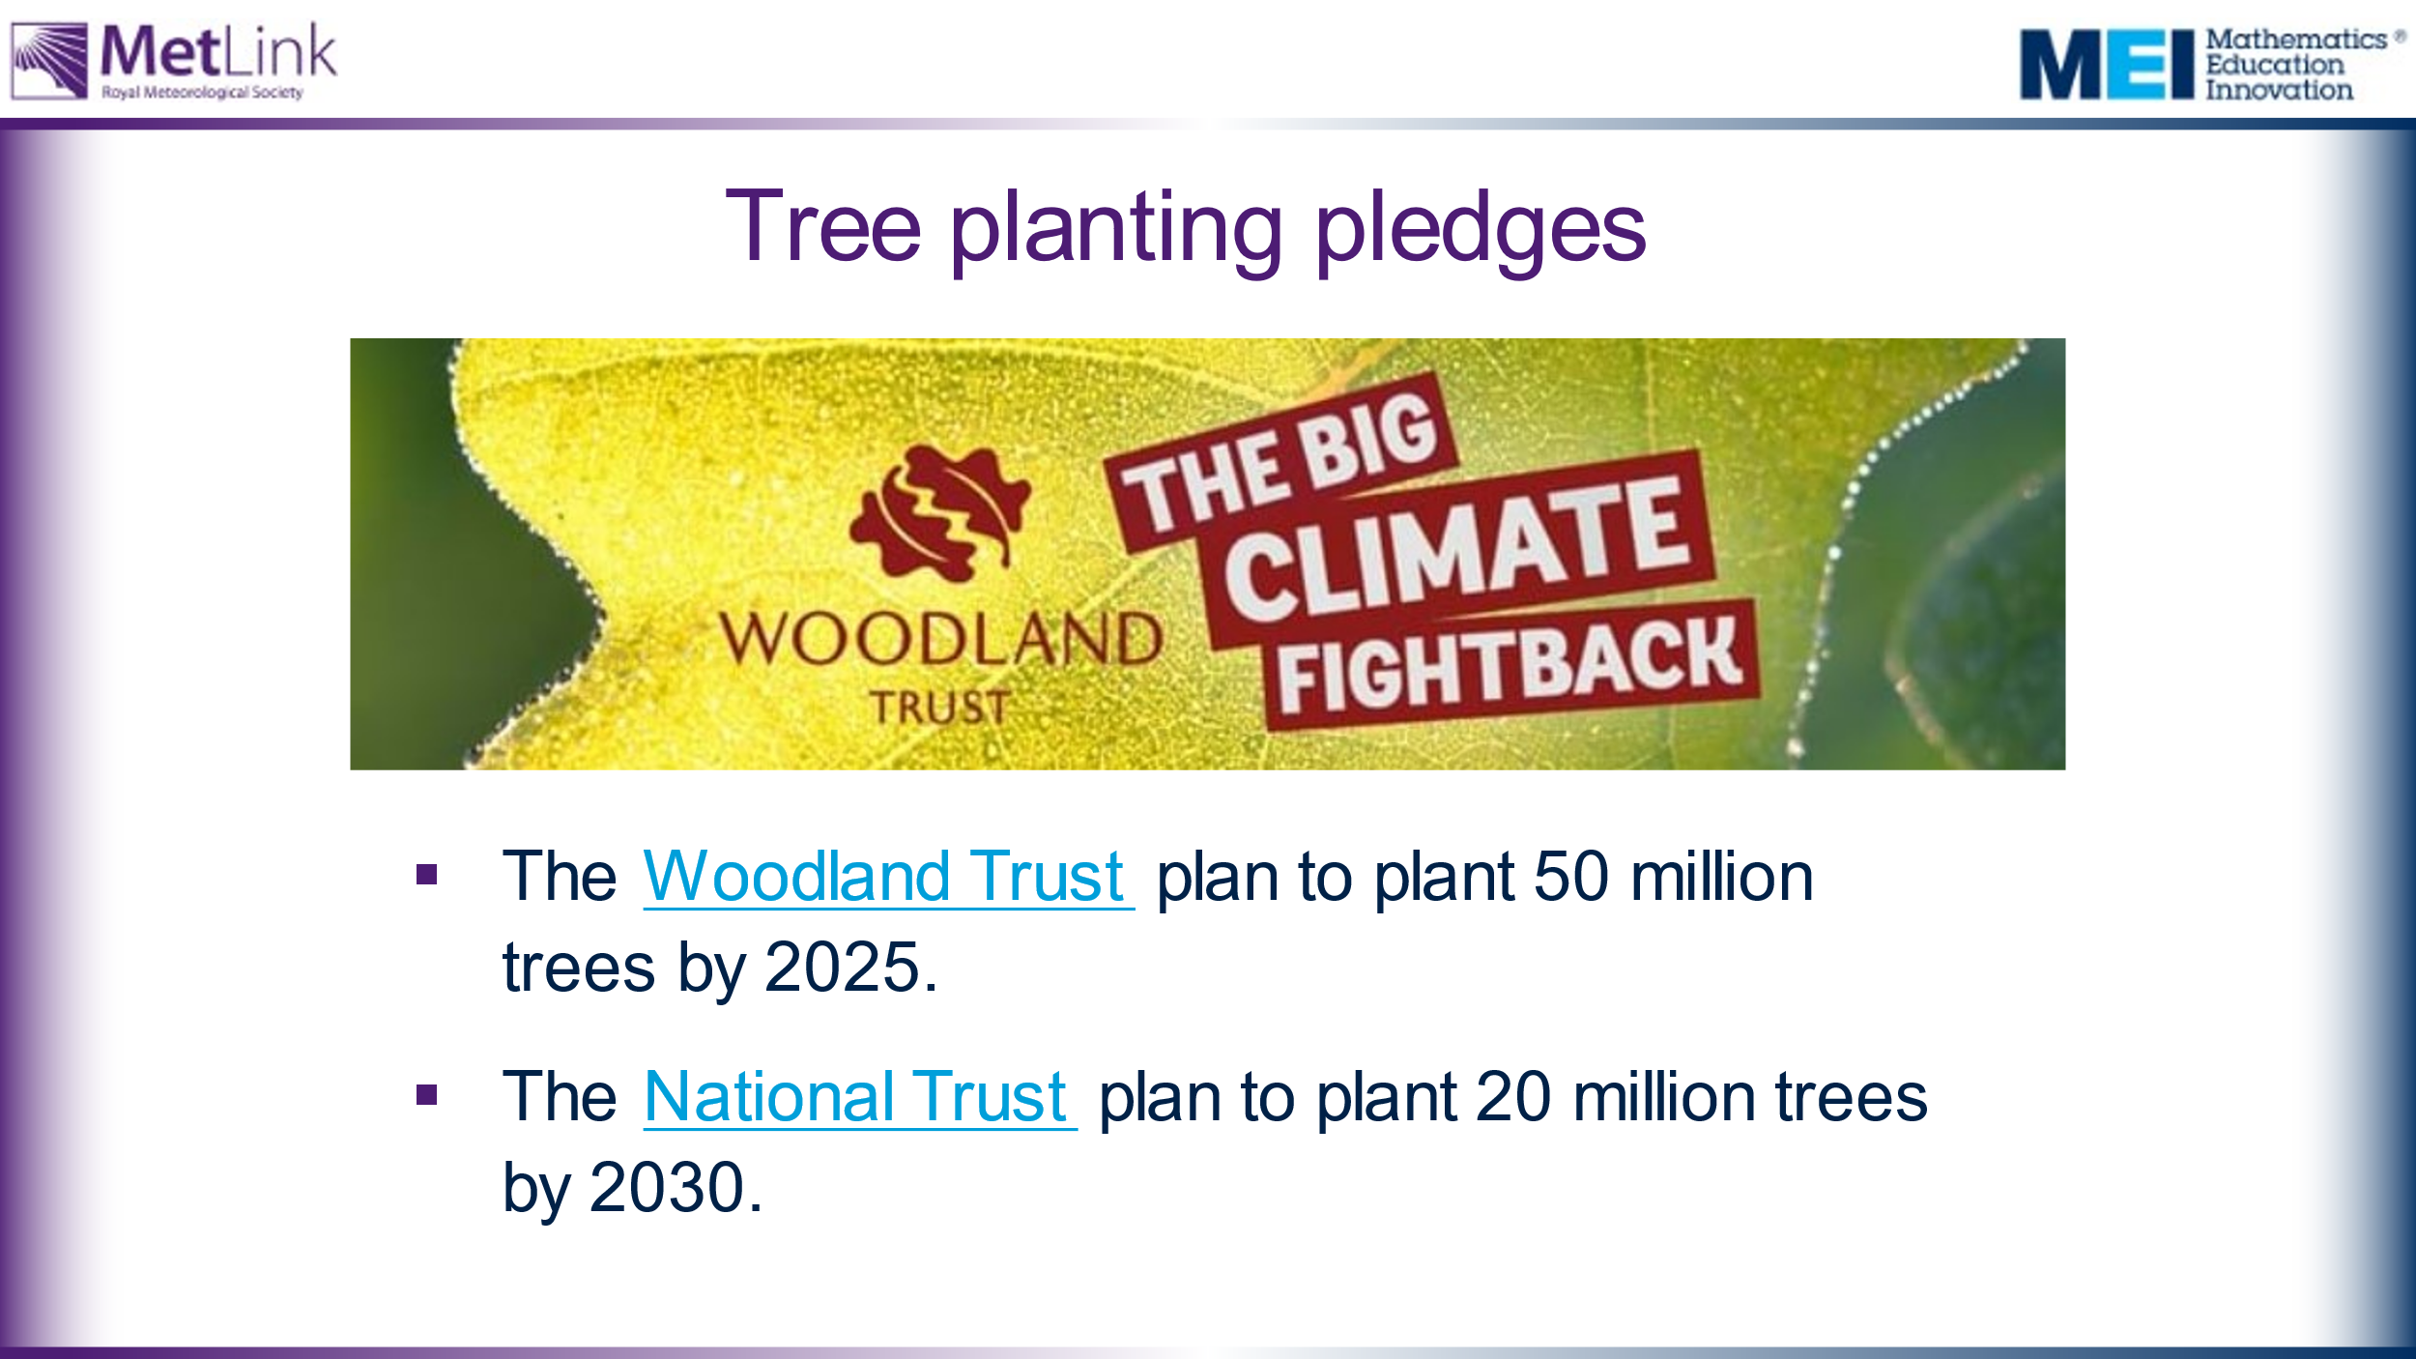 | Offer students some examples of positive ways forward and potential ways for students to contribute. | It might be worth exploring with students how 50 million trees compares with 30 football pitches of forest. This is explicitly mentioned on slide 9.
10 | 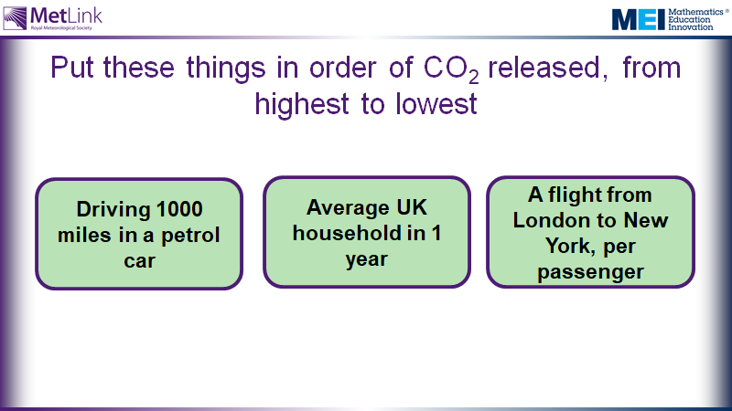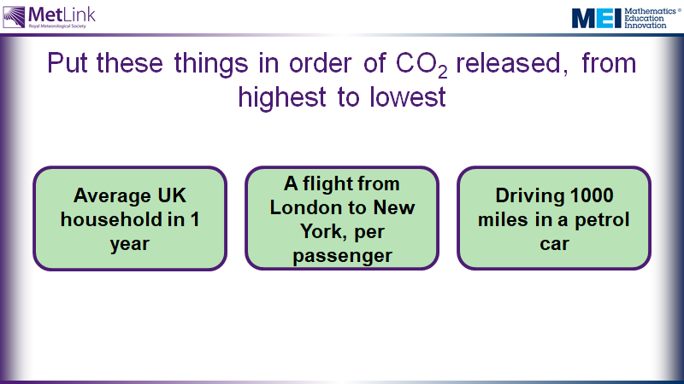 | Place the numbers in the correct position in the table.  Are there any surprises?  One implication of this is that what we do as individuals, and within our households, can have a big impact on our environment. | Initial engagement – making predictions and motivating a need for finding out about CO₂ absorption from trees. This also gives opportunity to put some of the large numbers in context, giving a sense of relative scale.  This session is on trees, so this allows students to compare the CO₂ stored by a tree with some other more meaningful and imaginable scenarios. One implication is that trees can potentially have a significant impact on the CO₂ in our atmosphere, but we will find out more about this throughout this lesson.  This potentially sets up a question later in the session about whether the CO₂ produced by a flight from London to New York could be offset by planting trees.  Answers: UK Household 17.1 tonnes, Driving 1000 miles 0.22 tonnes, Oak tree 7.5 tonnes, Flight London to New York (per passenger) 0.6 tonnes, 1 cow 0.6 tonnes.
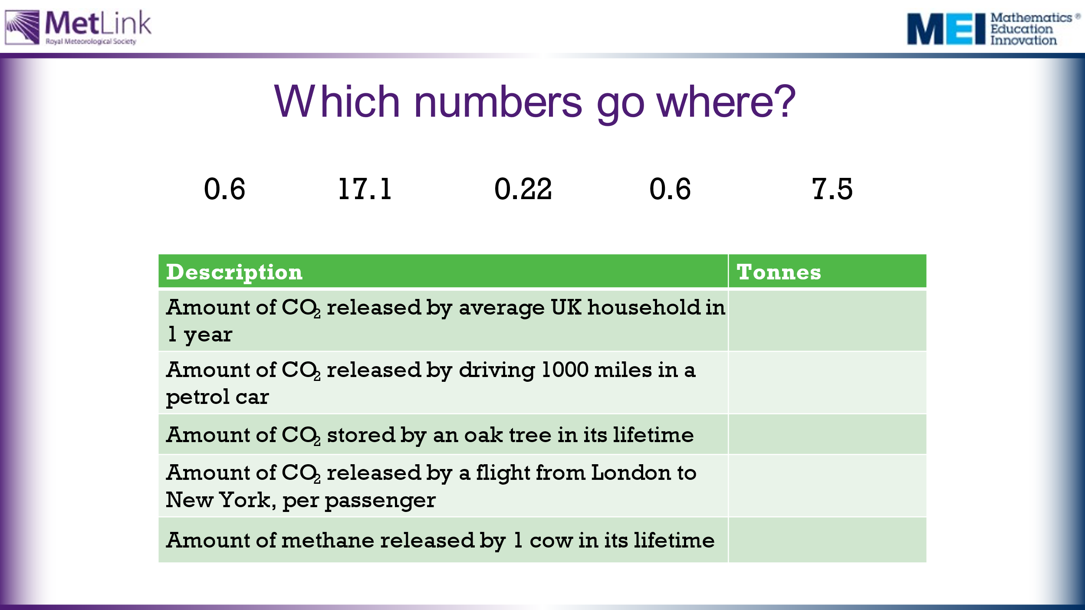

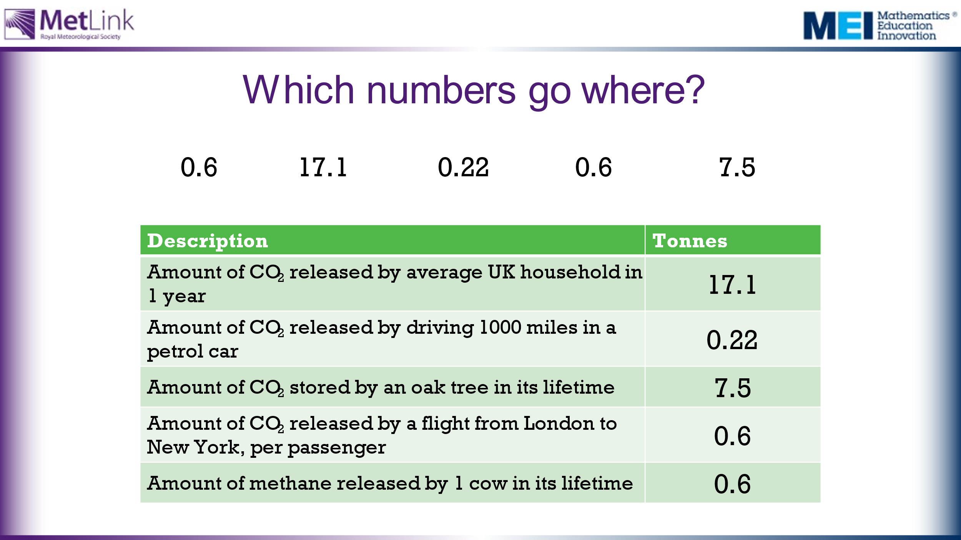
15 | 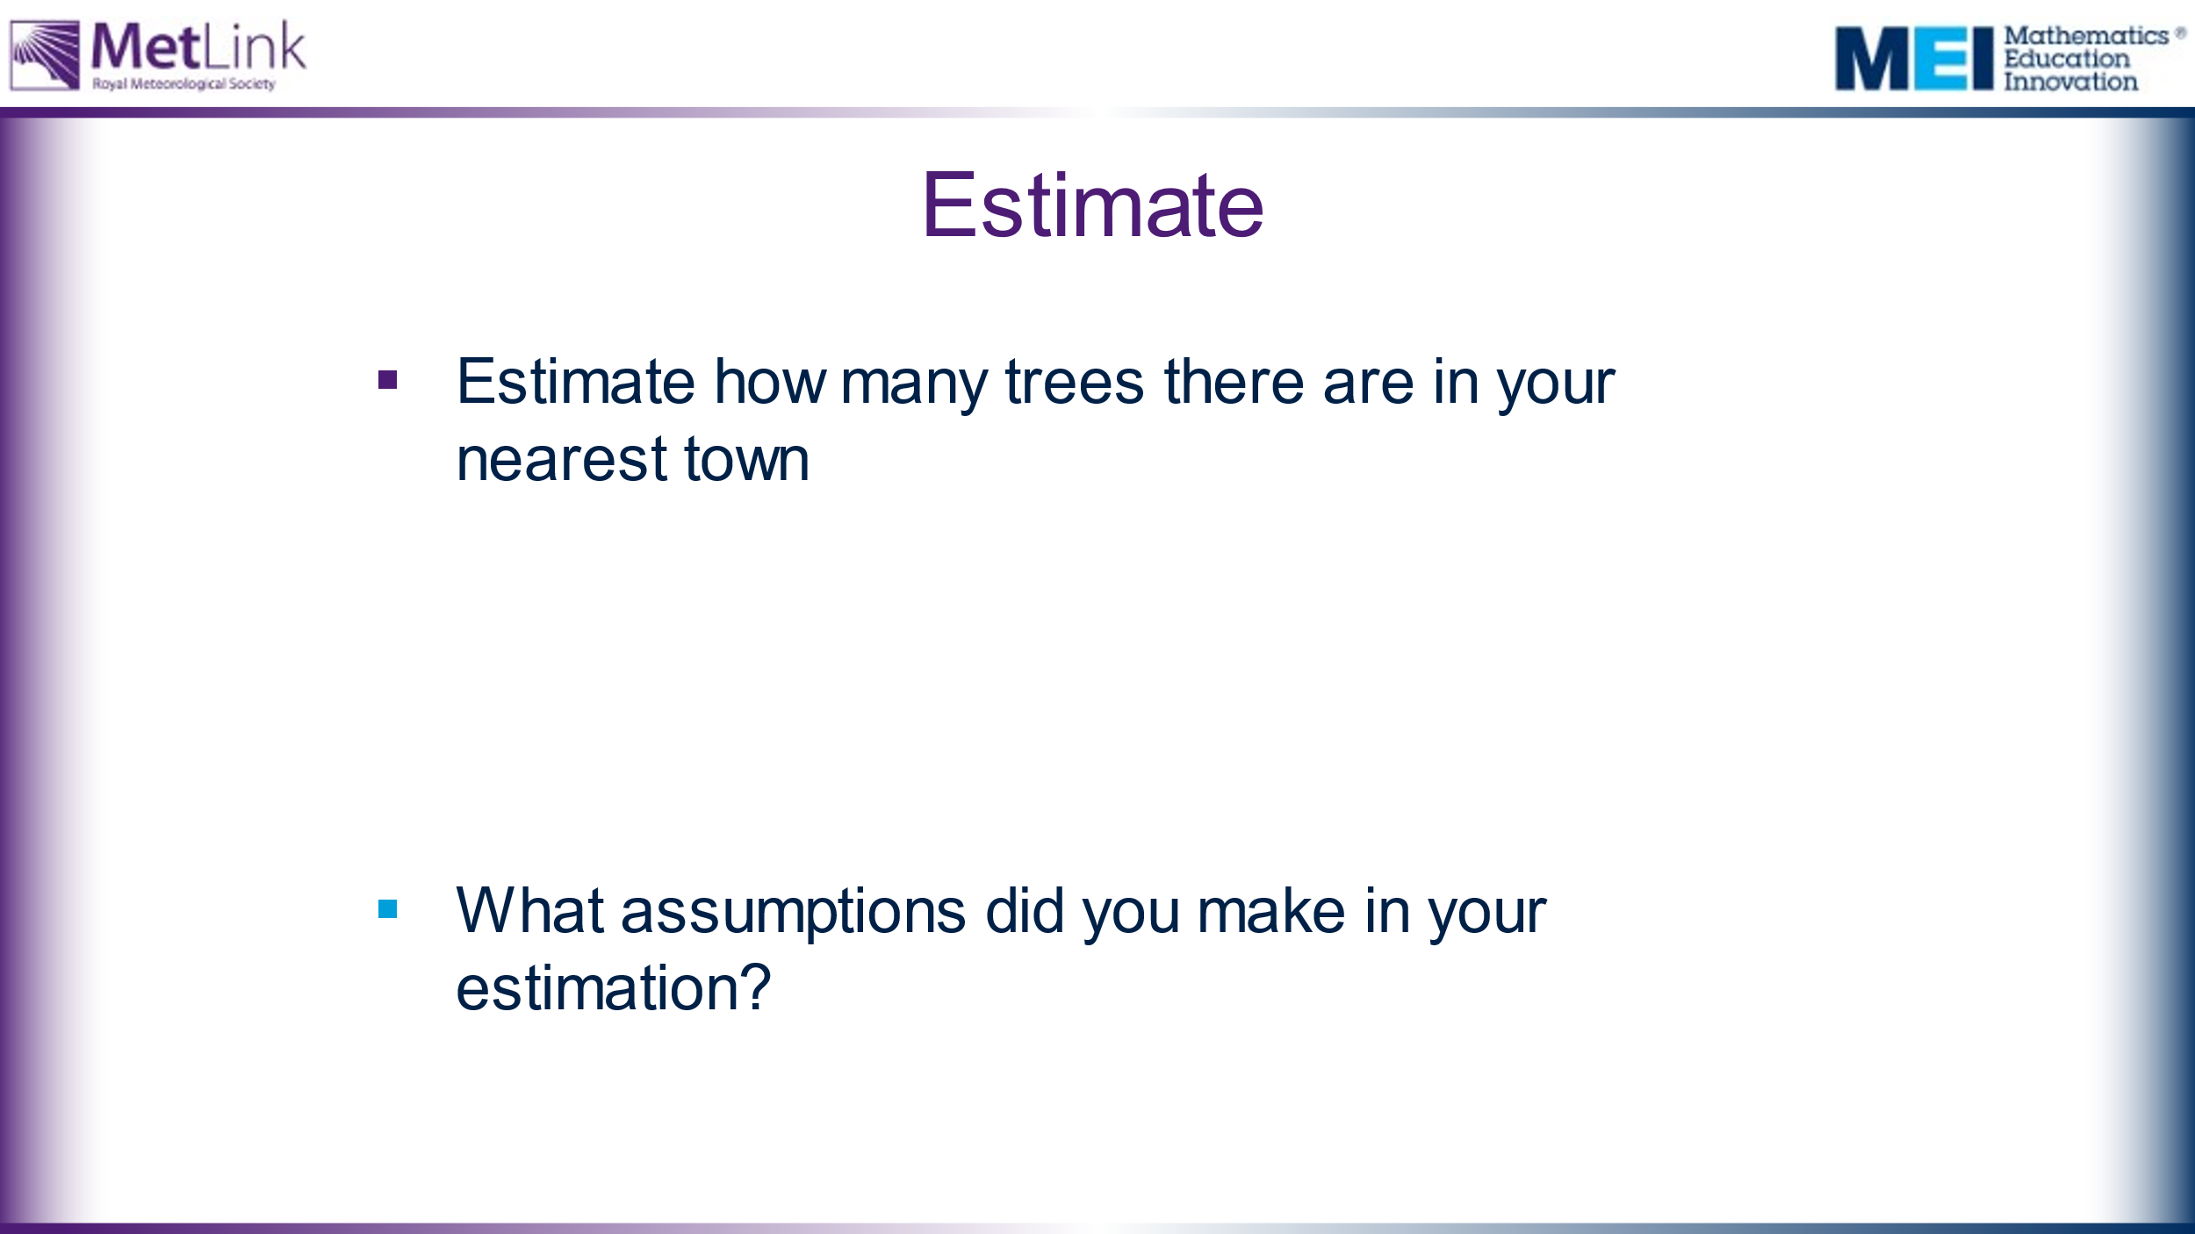 | Students work in groups to estimate how many trees there are in your nearest town.  Students encouraged to write down any assumptions they made along the way. | This gives opportunity for students to relate this session to their own experience and local environment. Teachers can value students’ contributions and stories about local trees they know. It can be worth emphasising that the aim of estimation is not to get the ‘right’ answer – speed and ease of calculation can be as important, when estimating, as accuracy – being aware of assumptions is really important.  Hidden slides 8, 9 and 10 show three possible approaches  Some things to consider or try: Bring up Google Maps or Google Street View. Consider how many trees might be within 100 metres of the classroom. Can this be scaled up? What’s the area of the town? It might be that it helps to look this up. Are there any parts of the town which have lots of trees? How densely are they planted?
20 | 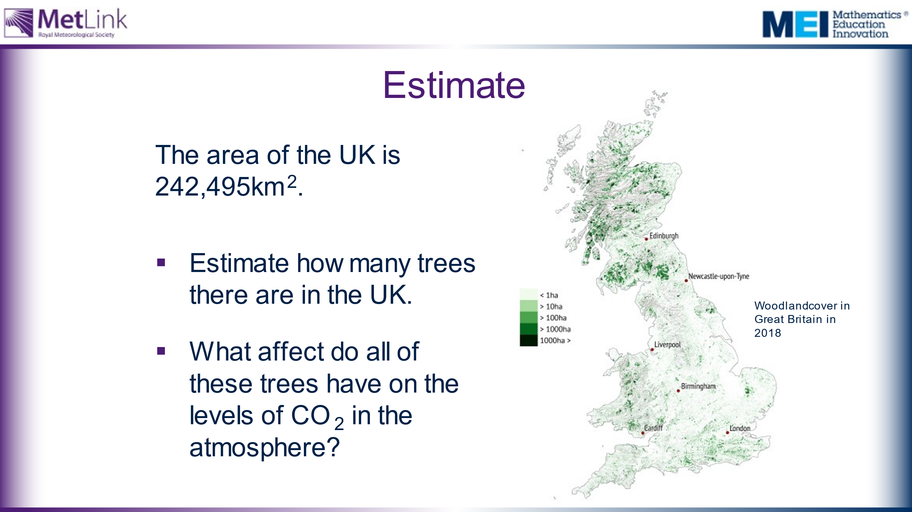 | Estimate how many trees there are in the UK.  One approach might be to estimate the area of the nearest town. Given that the area of the UK is 242,495km², students could scale up their estimate of the number of trees in their nearest town.  What are the limitations of this approach?  What assumptions did students make?  Discuss what affect these trees might have on the CO₂ in the atmosphere. Is their contribution significant? | Emphasis should be on the power of estimation and the importance of being aware of assumptions and limitations.  Students often make mistakes when converting between km² and m². Given that 1km = 1000m, 1km² = 1000000m².  This diagram offers an indication of the density of trees in different regions of the UK, but it is far from obvious how it works. Students could discuss its limitations.  Students are unlikely to have a sense of the affect these trees might have on levels of CO₂ at this stage in the lesson, but it may be worth collecting some intuitive (and possibly naïve) responses at this stage, in order to revisit them later in the lesson.  Image info: Woodland cover in Great Britain in 2018. The definition of woodland used here is a minimum area of 0.5 hectares under stands of trees with, or with the potential to achieve, tree crown cover of more than 20% of the ground. Source: National Forest Inventory. Graphic by Carbon Brief. Available from: https://www.carbonbrief.org/in-depth-qa-how-will-tree-planting-help-the-uk-meet-its-climate-goals
25 | 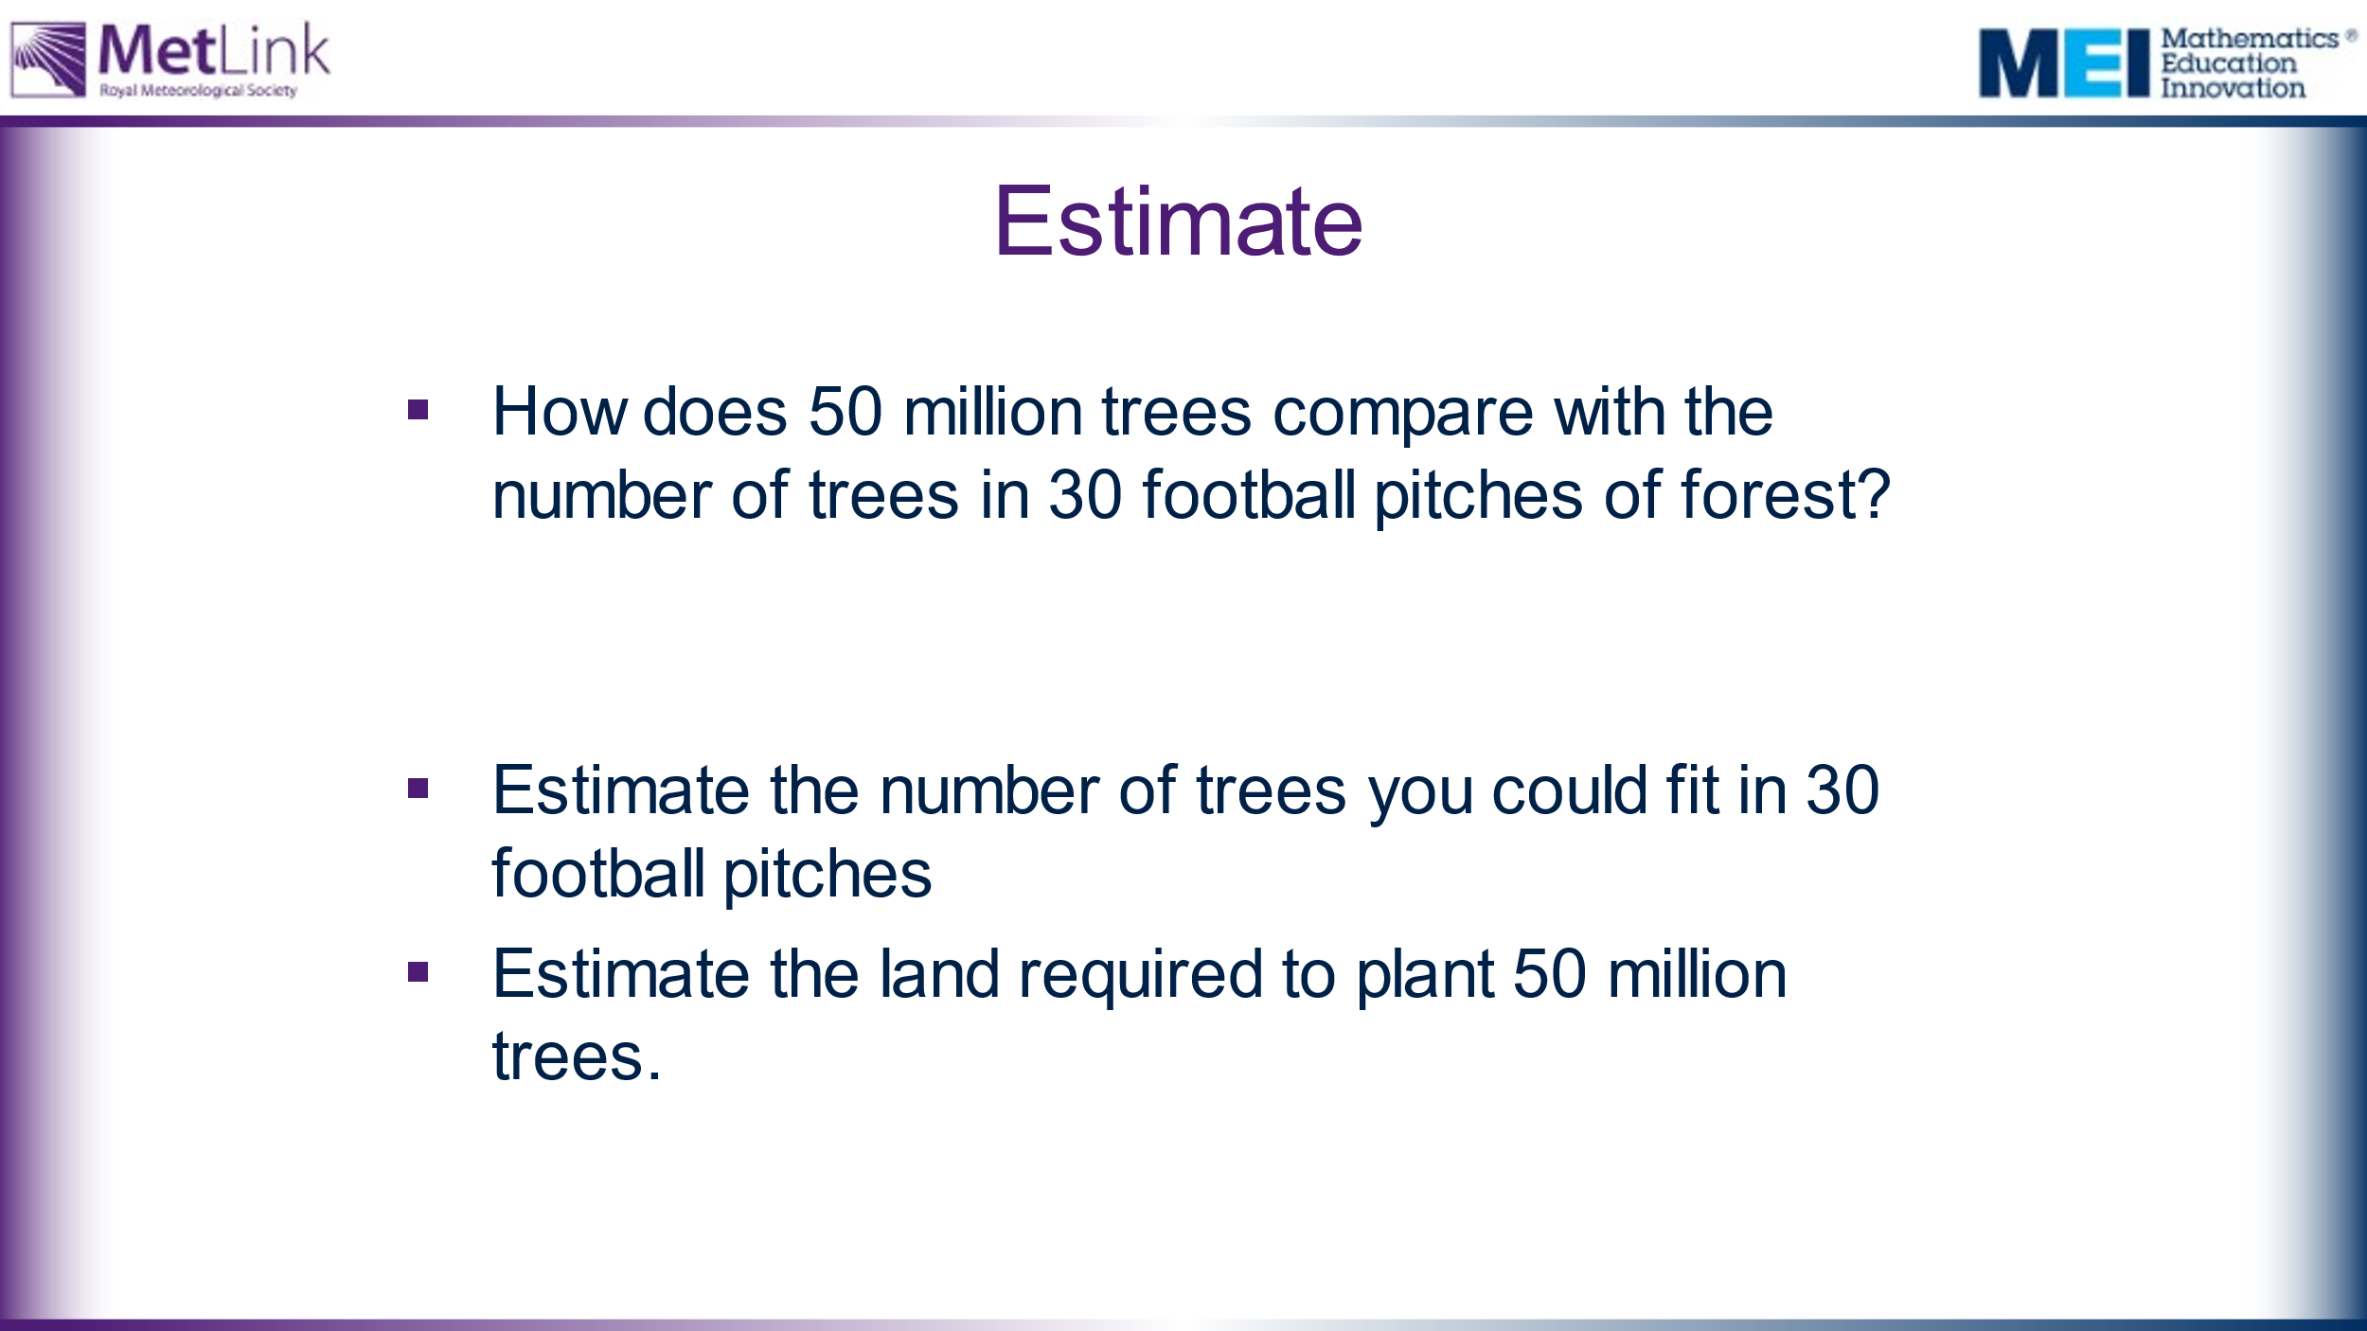 | The Woodland Trust plan to plant 50 million trees by 2025. How does this compare to the number of trees in 30 football pitches of forest?  Students could estimate the area of 30 football pitches and how many trees could be planted in that area. They could use this to estimate how much land would be required to plant 50 million trees. | Note that, according to the initial video, 30 football pitches is how much tropical forest is being cut down every minute.  See: https://www.espn.co.uk/football/austria/story/3936111/soccer-stadium-pitch-becomes-300-tree-forest  This website may give students a starting point for their estimate.  Students need to be aware that the density of trees in tropical forest is likely to be higher than in their nearest town and compensate for this in their estimations.  We should be building motivation for students to explore the CO₂ absorption rates of trees.
30 | 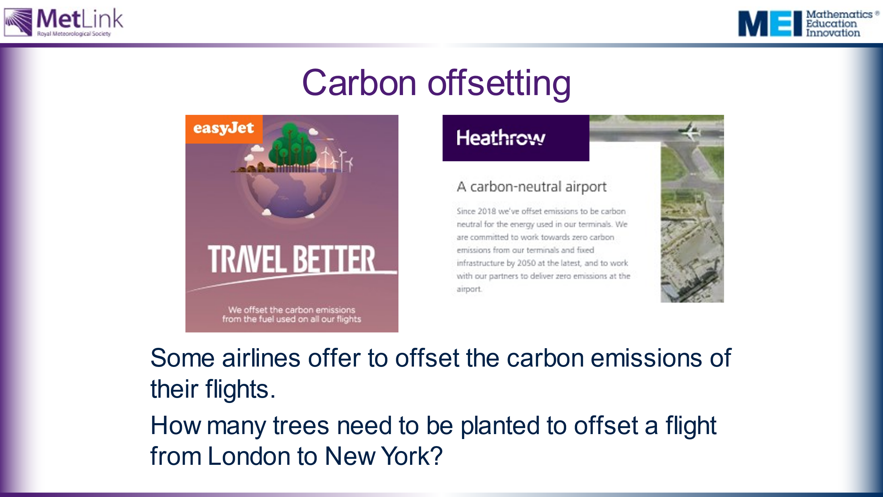 | Easyjet and Heathrow offsetting info.  What are your thoughts about these?  A question to work on during this session:  How many trees would you need to plant to make up for a return flight to New York? | The aim of this slide is to motivate students to explore CO₂ absorption of trees. In order to consider this question we need to investigate how trees absorb CO₂ from the atmosphere and how this changes over the lifespan of a tree.  If appropriate for the class, it might be worth highlighting a social justice issue: Is it okay for people to continue to fly regularly if they can afford to pay for their carbon emissions to be offset? Or, in other words, should people with more money be able to buy themselves a bigger carbon footprint?
 | 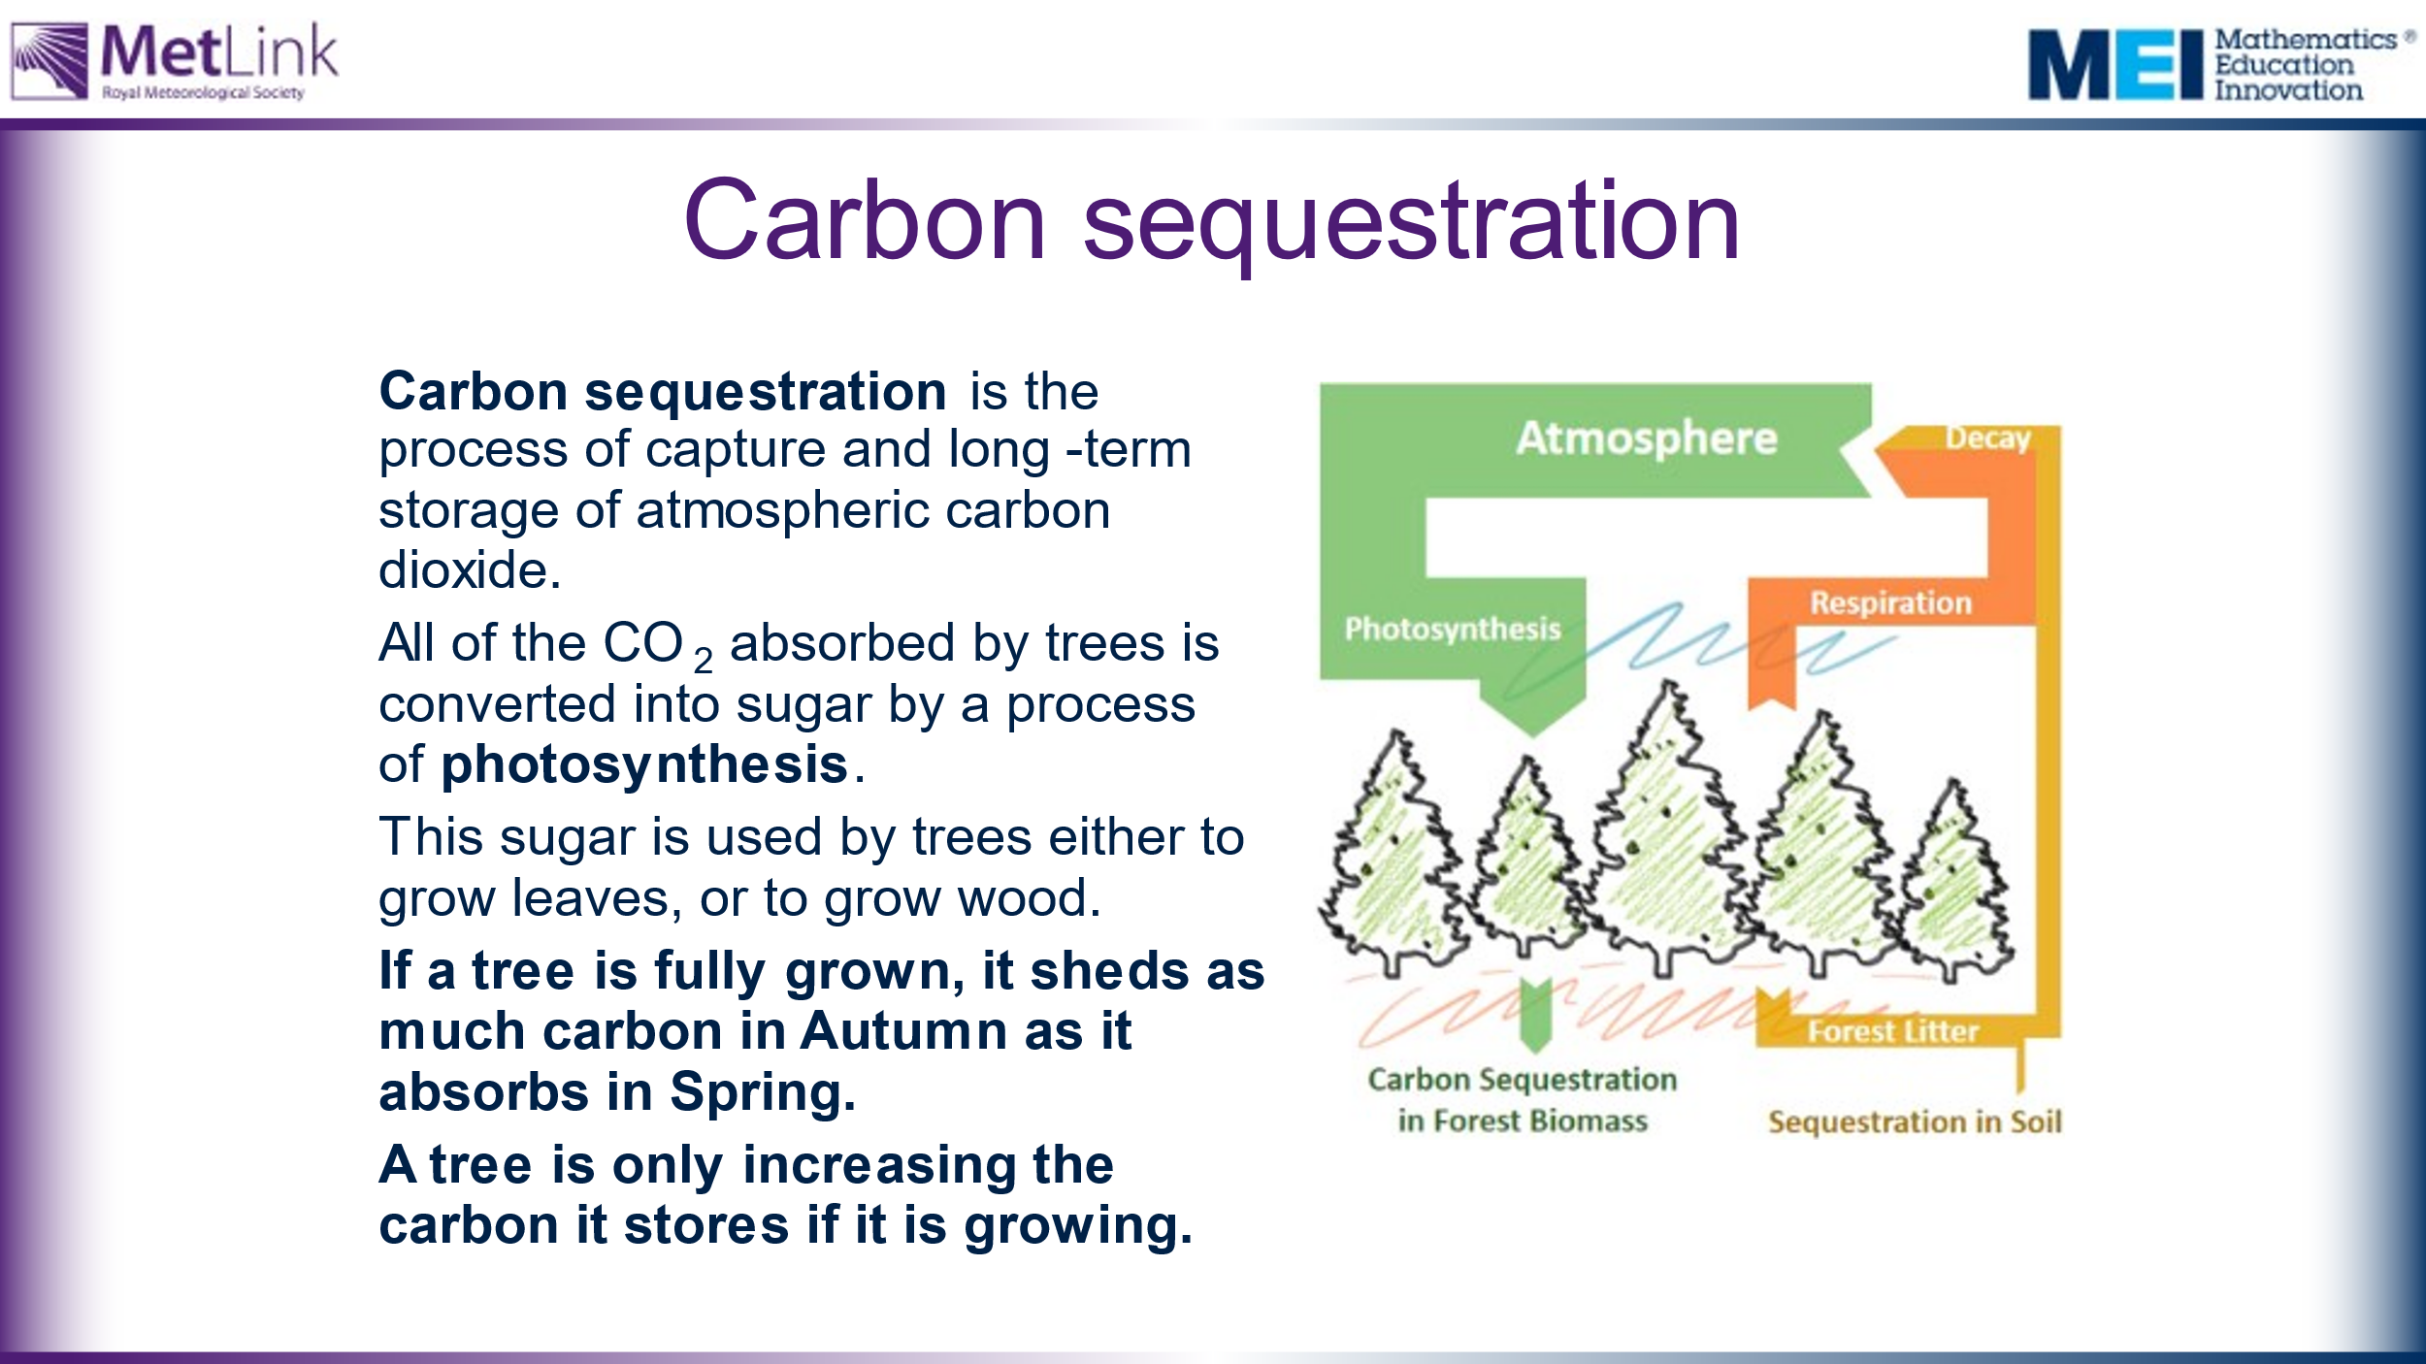 | Emphasise that trees only sequester (capture and store) carbon from the atmosphere when they are actively growing.  Mature trees, which are no longer growing, shed as much carbon as they absorb from the atmosphere.  What are the implications of this? | Image taken from: https://www.sciencedirect.com/science/article/pii/S1364032116306050  Schematic illustration of the carbon cycle within a mature unmanaged forest. The width of the arrows indicate the approximate relative scale of the carbon exchanges.  This image of the carbon cycle may help to explain how the carbon dioxide absorbed by an English Oak tree can reduce, as the tree gets older.
 | 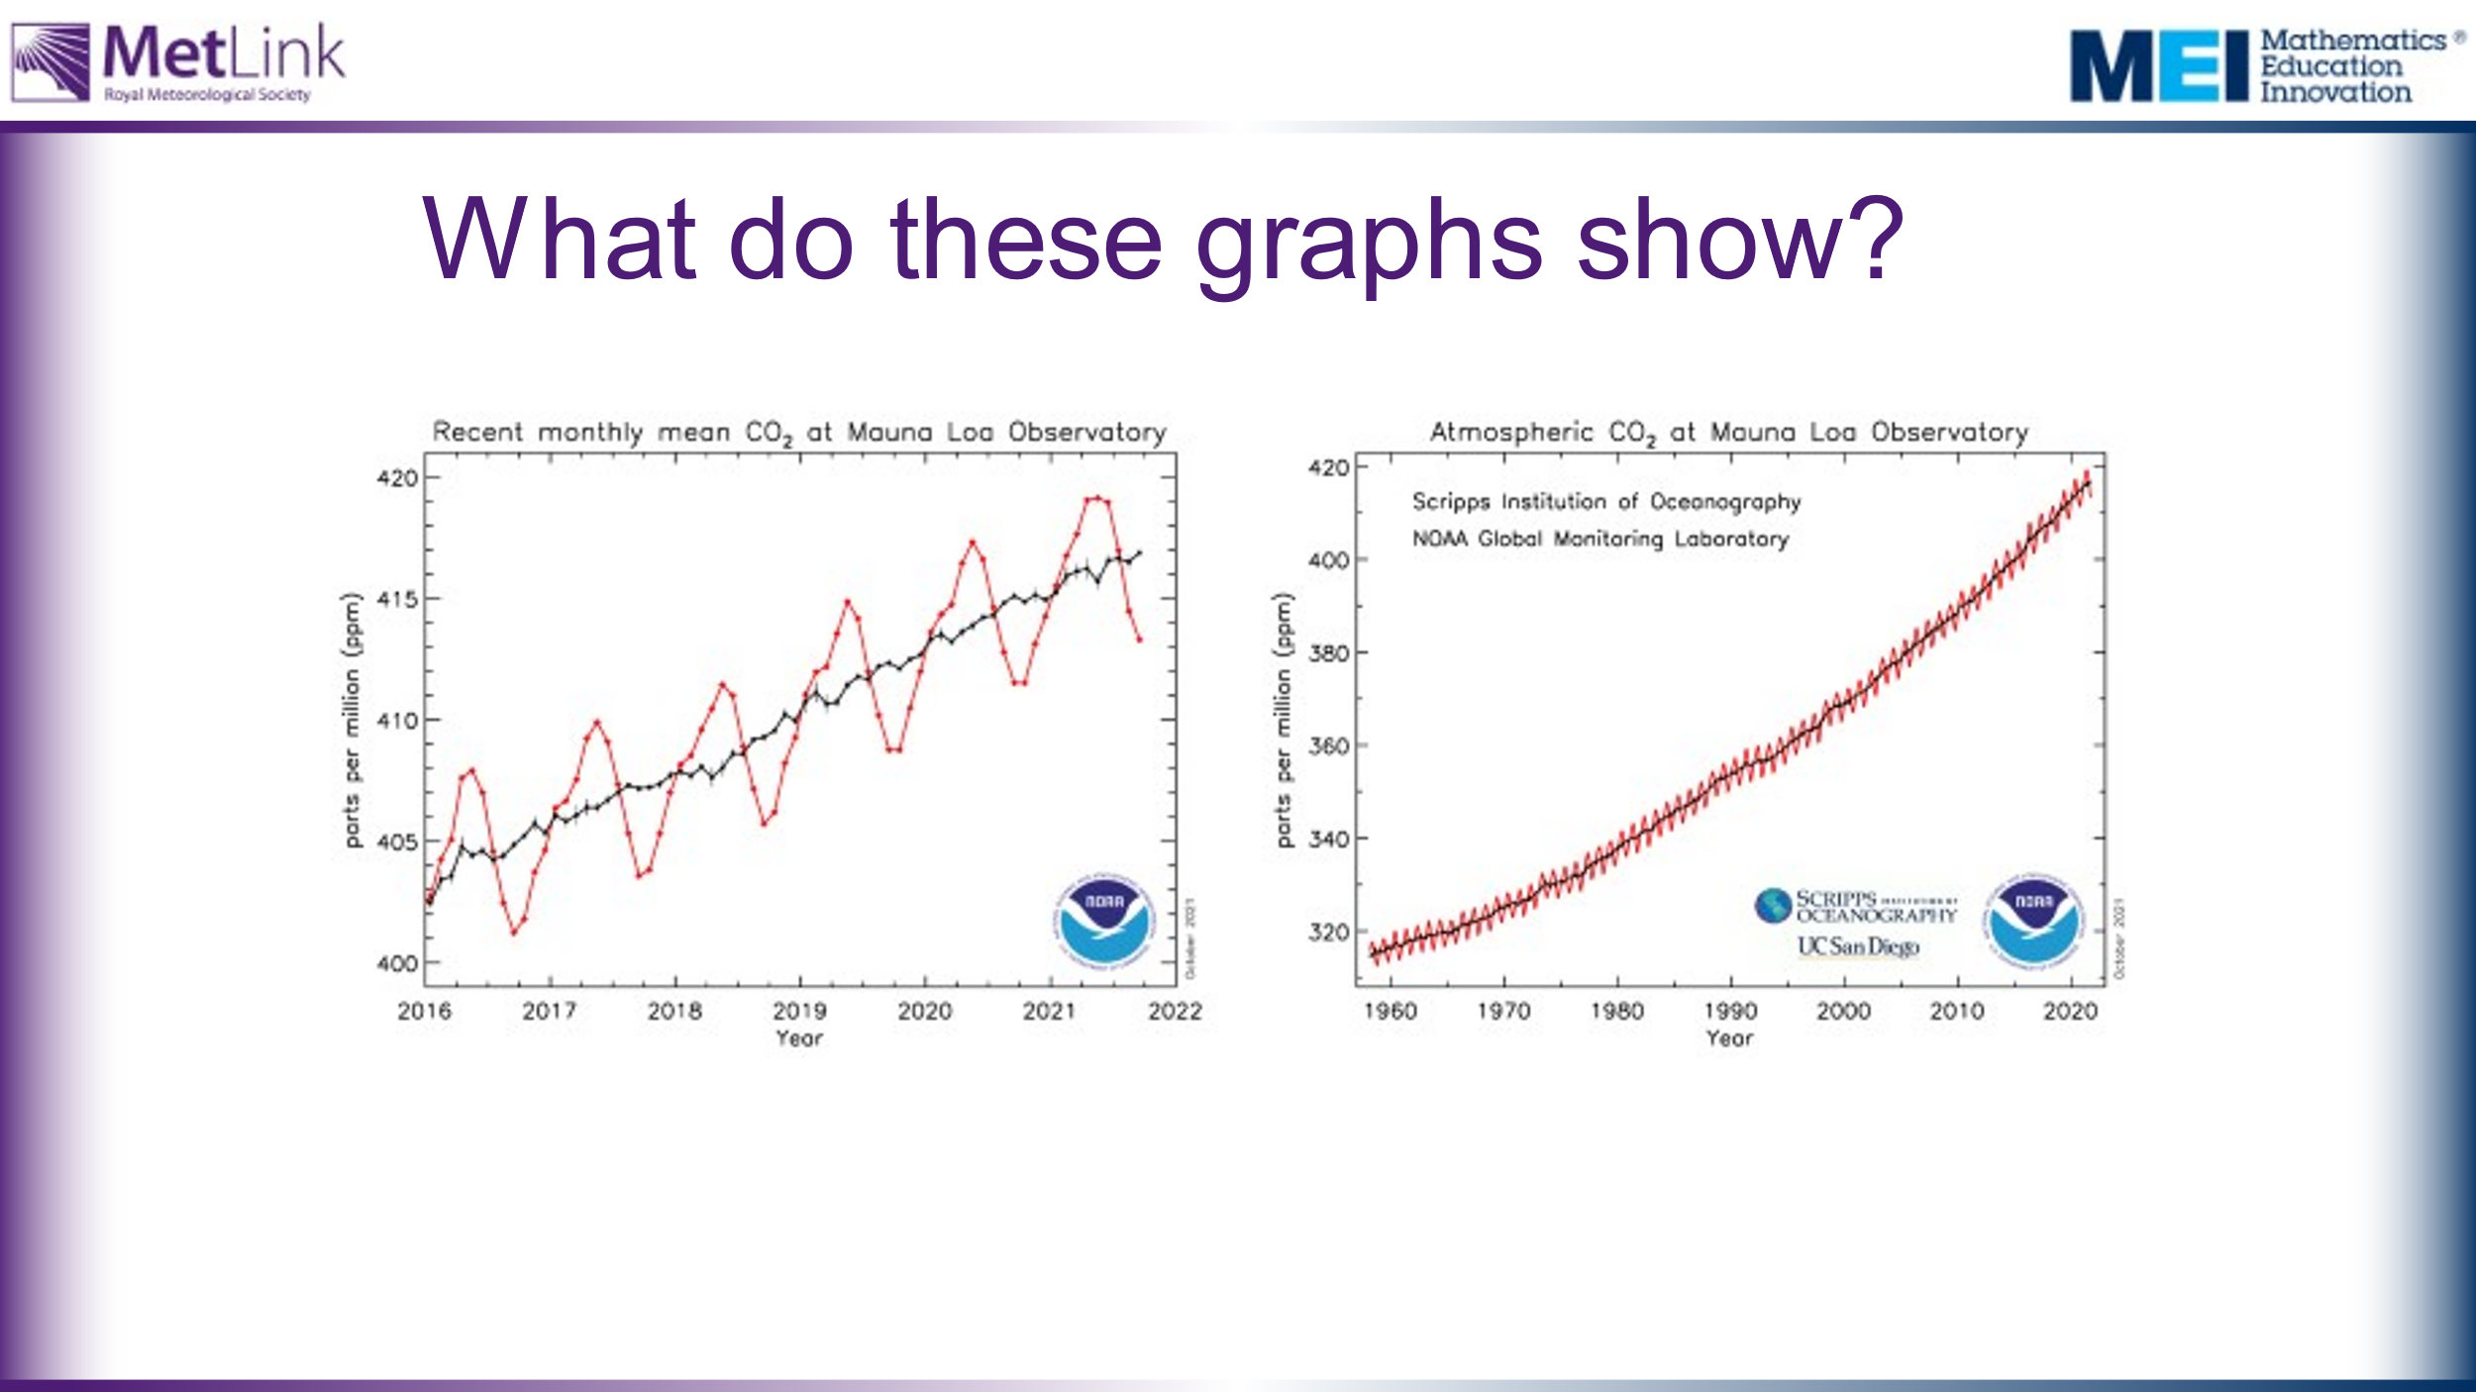 | Emphasise that the red lines demonstrate that trees absorb CO₂ from the atmosphere in Spring and use it to grow leaves, but in the Autumn they shed the leaves, which decay and release CO₂ back into the atmosphere. | Graphs taken from: https://gml.noaa.gov/ccgg/trends/mlo.html  The graphs show monthly mean carbon dioxide measured at Mauna Loa Observatory, Hawaii.  The red lines and symbols represent the monthly mean values, centered on the middle of each month. The black lines and symbols represent the same, after correction for the average seasonal cycle. The black lines offer a useful application of moving averages for demonstrating overall trends within varying data.
35 | 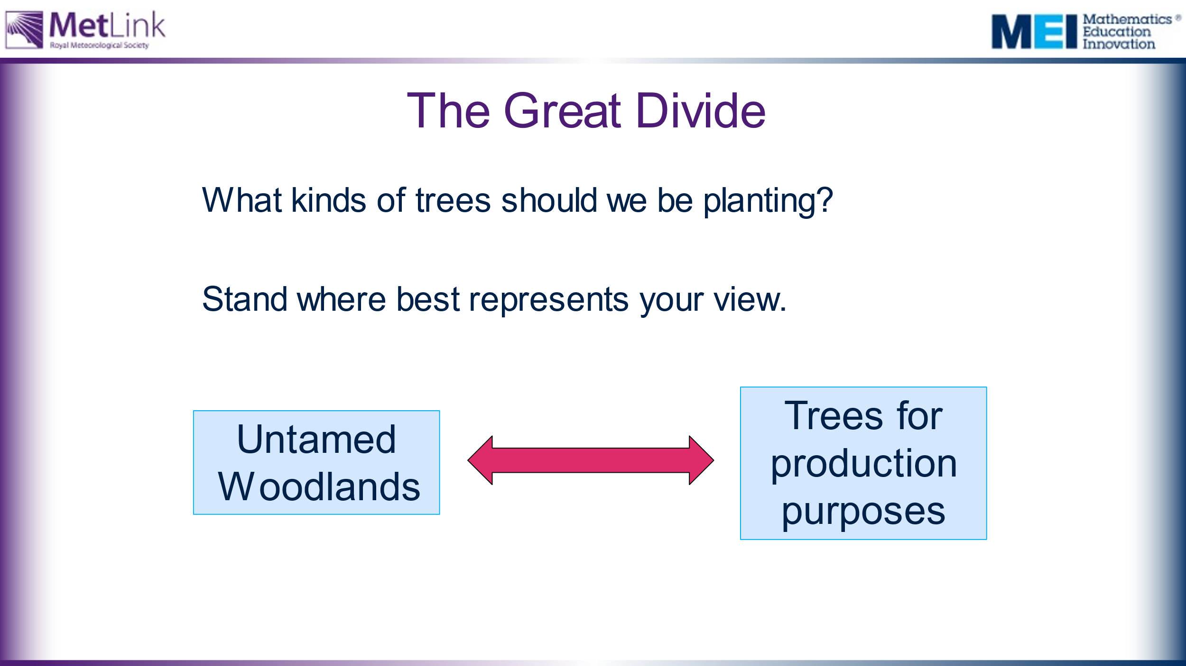 | The Great Divide (see notes column):  Collect initial thoughts and reasons from each side of the room.  This is with a view to then looking at and working on some data about carbon absorption of three different species of tree and then coming back to see if students’ views have changed.  Reasons for untamed woodlands include protecting habitats for animals and encouraging diversity. Trees are more likely to produce saplings naturally.  Reasons for production purposes are that mature woodland sheds as much carbon as it absorbs, but newly growing woodlands absorb more than they shed, because they use it to grow. When trees are used for building then the carbon they contain is then locked out of the atmosphere. These reasons will be explored further throughout this activity. | The Great Divide classroom activity: Set up one side of the classroom as Untamed Woodlands. Set up the opposite side as Trees for Production Purposes. Ask your students to stand and move to where they think represents their view of the kinds of trees that should be planted. When they have all decided, ask individual students to explain why they are stood where they are. Allow students to change their position as they hear different students’ justifications. If you feel that your students will be influenced too much by each others’ views then there are websites and apps available that allow students’ views to be offered anonymously. For example, Plickers (see: https://get.plickers.com/) or Mentimeter (see: https://www.mentimeter.com/).  Untamed woodlands would be planted without any intention of cutting the trees down. There would typically be a variety of species.  Trees for production purposes would typically be one species of fast-growing trees, planted with the intention of cutting them down once they are past their fastest rate of growing. The wood produced might be used as building material, fuel, or to produce paper or cardboard. Note that 83% of UK forests are managed for production purposes.
40 | 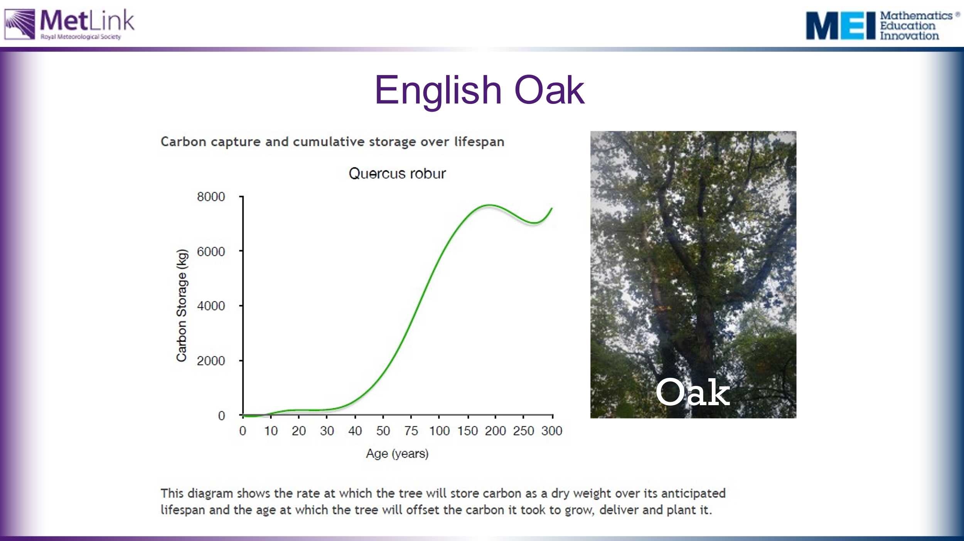 | Main activity:  We are going to look at data showing how much CO2 different species of tree absorb from the atmosphere.  This will allow us to address some of the issues and questions raised in the session so far, including:  - How many trees need to be planted to offset a flight from London to New York  - What kinds of trees and woodlands would it be best for us to plant?  Task 1: Provide students, in groups, with the three graphs and ask them to write down three things that they notice. Collect these points and any questions or issues raised. Show slide with all three graphs together on the board when collecting their views.  Emphasise that it is very difficult to compare the three graphs in their current form. Can your students say why? | The aim of task 1 is to draw attention to some of the issues with the data as presented. Some questions that might emerge include:  - What do the graphs actually show?  - What does it mean for a cumulative frequency graph to go down? (as it does for the English Oak graph)  - Can you work out which trees are best to plant from this data? (It is very difficult to compare these graphs in their current form)  Draw attention to the scales on the graphs – not only are the scales different for the different species, the scales for Age are not linear – the intervals on the x-axes vary. Why do they change? How is this misleading? (or is it not?)  Information about how this data was collected is available here: https://www.treeconomics.co.uk/projects/barchamcarbonperformanceproject/ and here: https://www.barcham.co.uk/store/. Each tree in the Barcham shop has a certificate.  The negative carbon storage in the first few years of each graph are explained by taking into account the carbon emissions in driving to collect the tree before planting it.  The Norway Spruce is a common variety of Christmas Tree.
 | 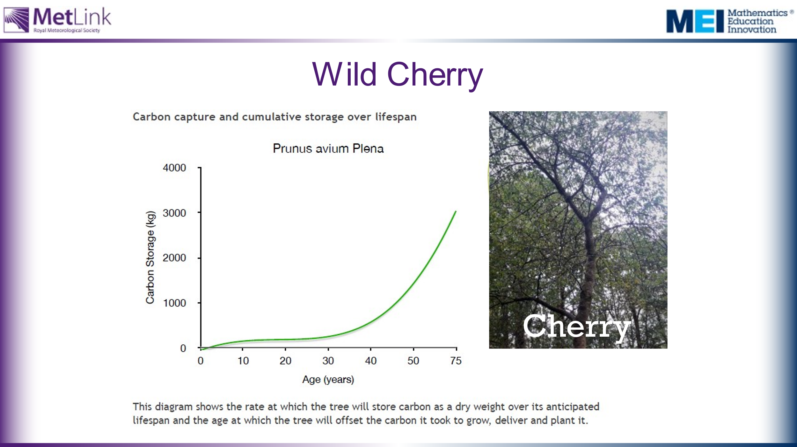
 | 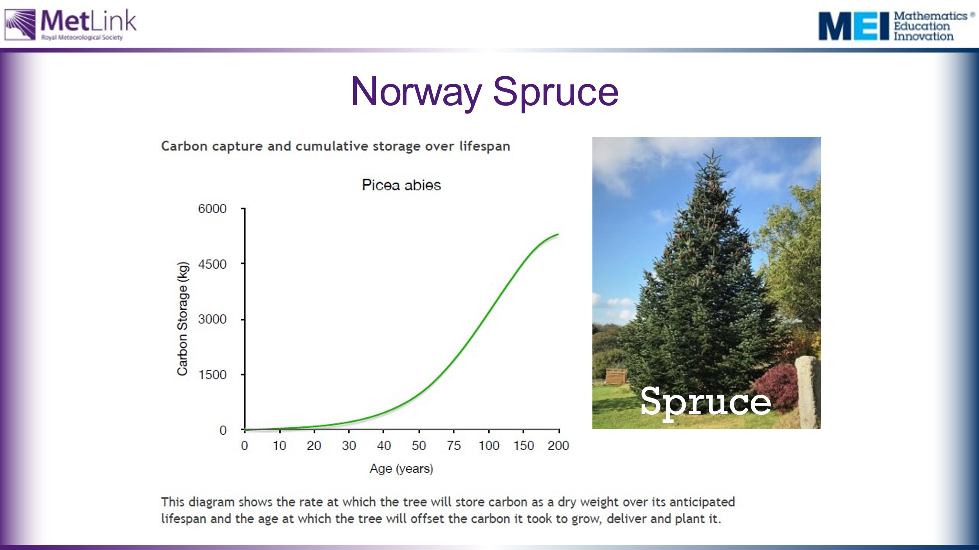
 | 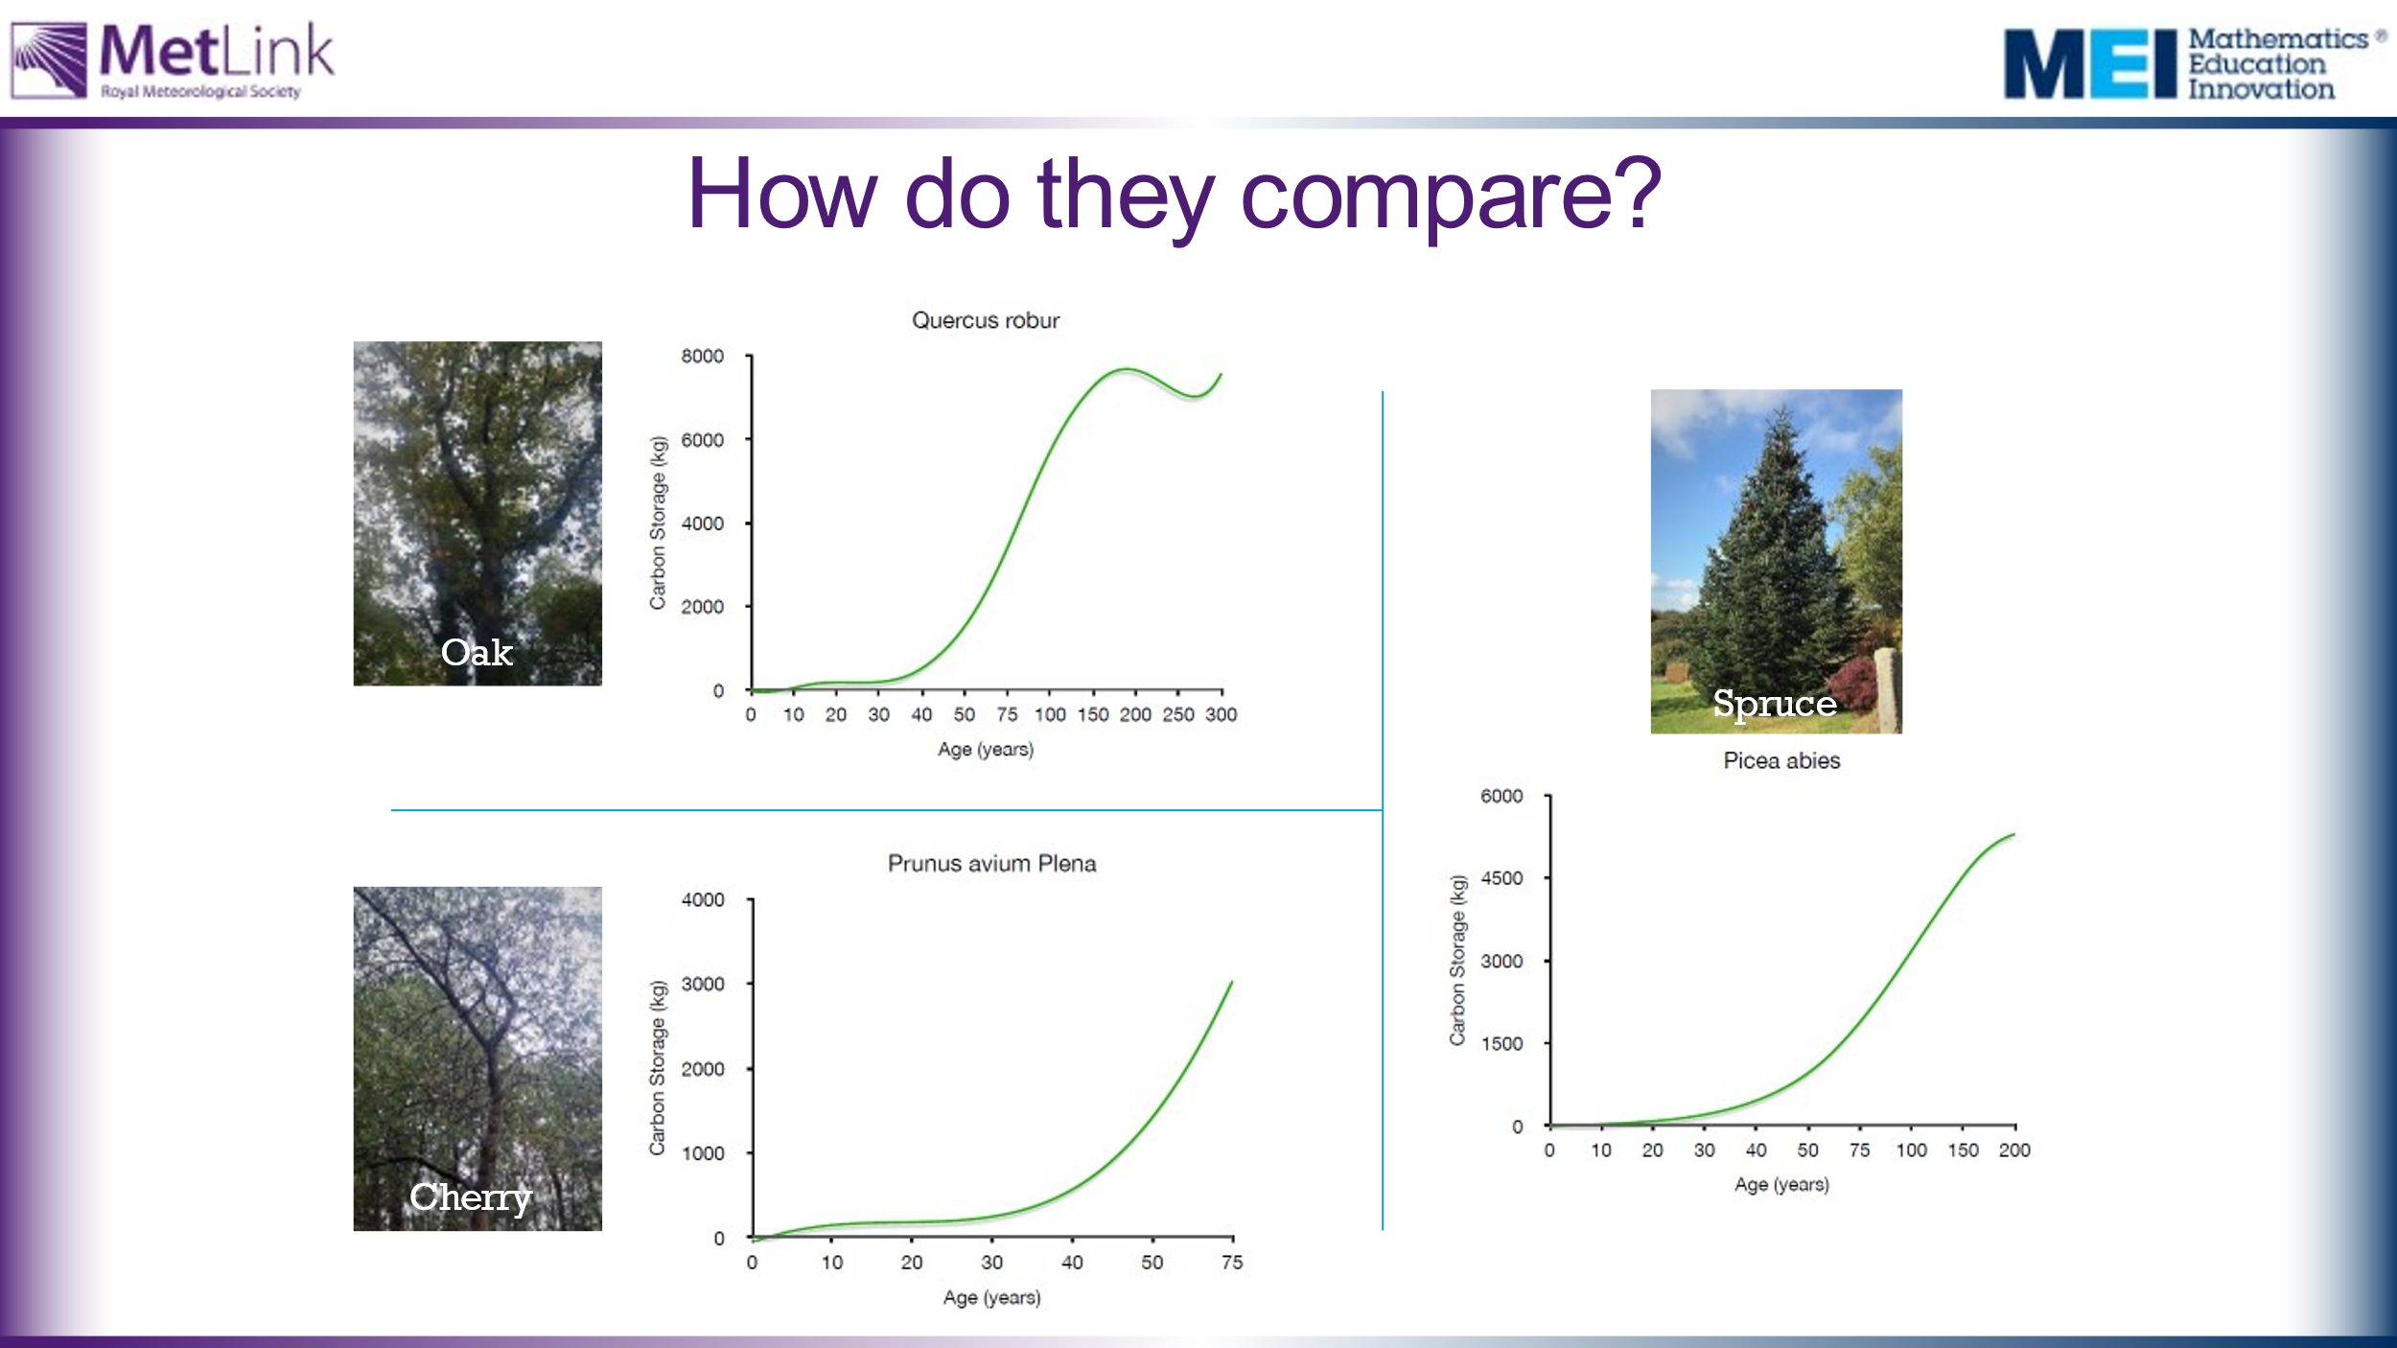
45 | 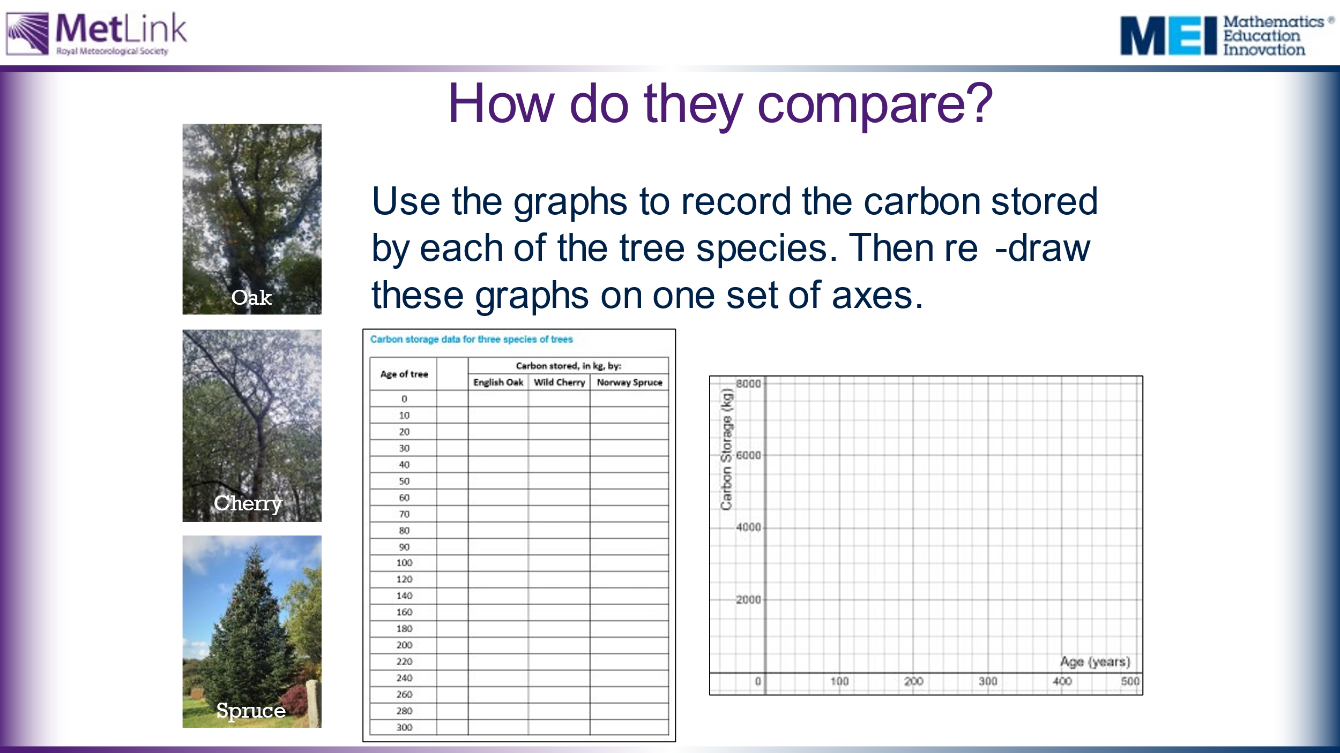 | Task 2: Invite students to explain what they would need to do in order to compare these graphs effectively. Work in groups to present the data in a more useful way.  After 15 minutes they need to present their argument for which trees they would choose to plant and why.  Suggestions might include:  - Reading off the data from the graphs and recording it in a table (provided)  - Using a linear scale  - Plotting all three graphs on one common set of axes (provided) | Warning: It is quite fiddly to read information accurately from the graphs. Students will need a ruler and pencil, and careful attention needs to be paid to the varying scales on the graphs.  It may be worth showing students the following hidden slide to give them an idea of a possible approach.
 | 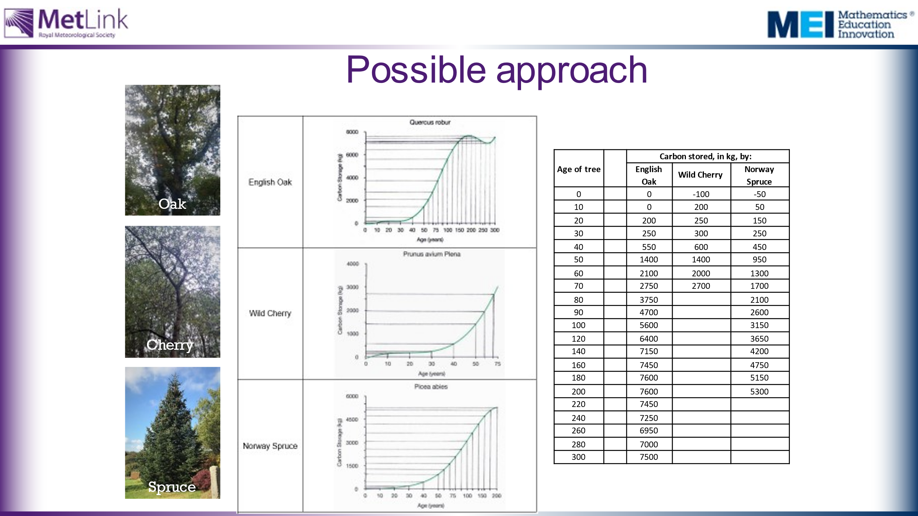 | Hidden slide showing possible approach to reading data from the graphs and tabulating it, ready to replot on one set of axes.
60 | 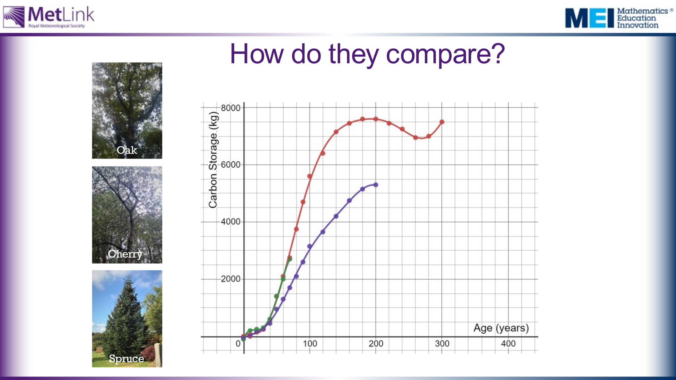 | Task 3: What conclusions can we draw?  Here are the three sets of data plotted on the same set of axes, in Desmos: https://www.desmos.com/calculator/rci87lp05w | It’s worth noting that it takes around 200 years for Oak and Spruce trees to store their maximum amount of carbon.  Some more data students might use is the Yield Class of trees, the volume (in m³) of wood produced per hectare per year. broadleaves generally grow with a YC of between 4-8, meaning they grow 4-8 cubic metres per hectare per year. Oak grows at around 6, Wild Cherry at 8 and Poplar achieving rates of up to 12. How does this relate to the data in the graphs? Note that the graphs consider mass of carbon, not volume, and they don’t take into account the density of planting. However, Yield Class doesn’t take into account the varying growth rates of trees.  For more information on Yield Class, see: https://www.carbonbrief.org/in-depth-qa-how-will-tree-planting-help-the-uk-meet-its-climate-goals
 | 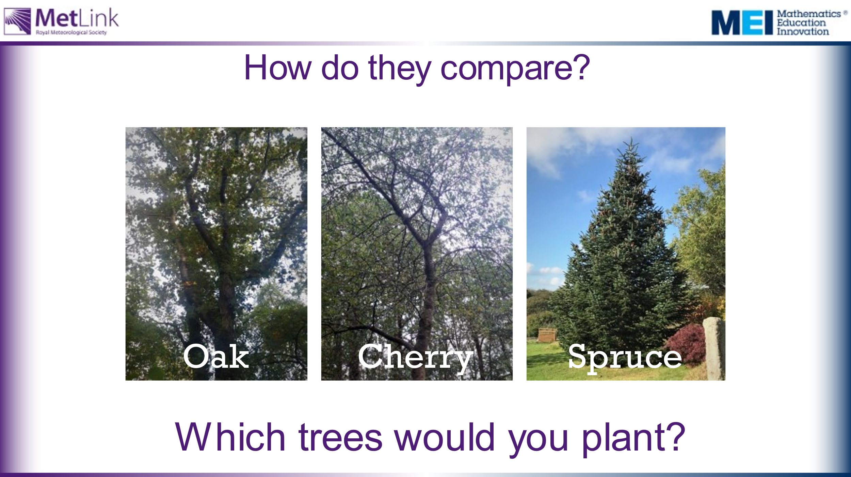
65 | 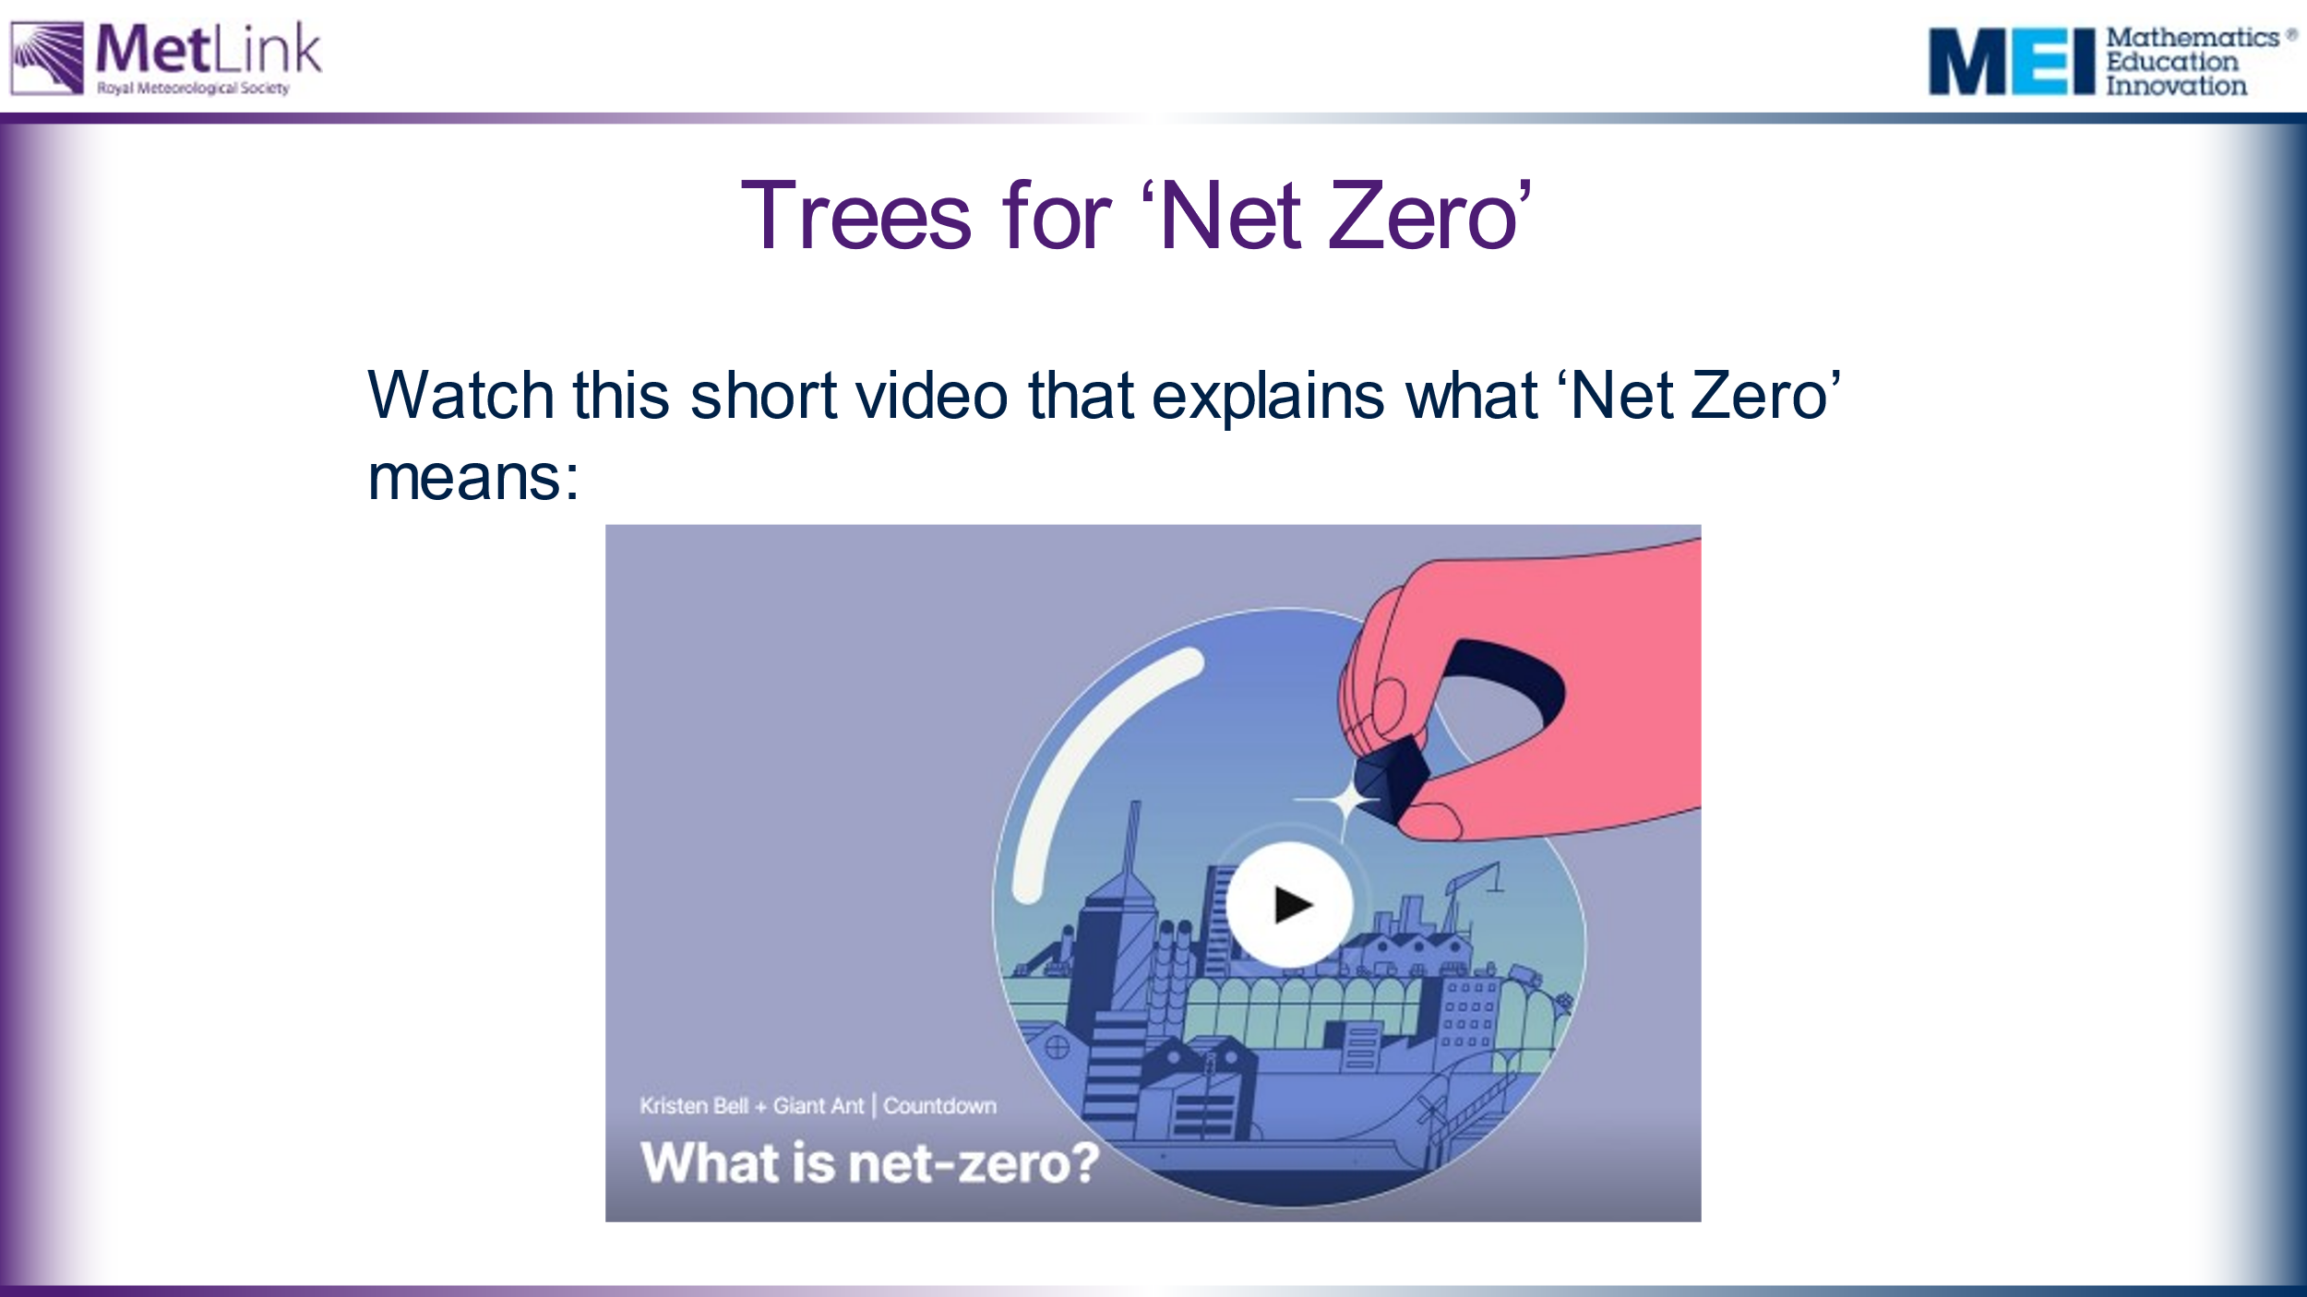 | Watch the video: https://www.ted.com/talks/kristen_bell_giant_ant_what_is_net_zero#t-40608 | ‘Net Zero’ is introduced here in order to allow us to consider the contribution planting trees might make towards achieving Net Zero.
 | 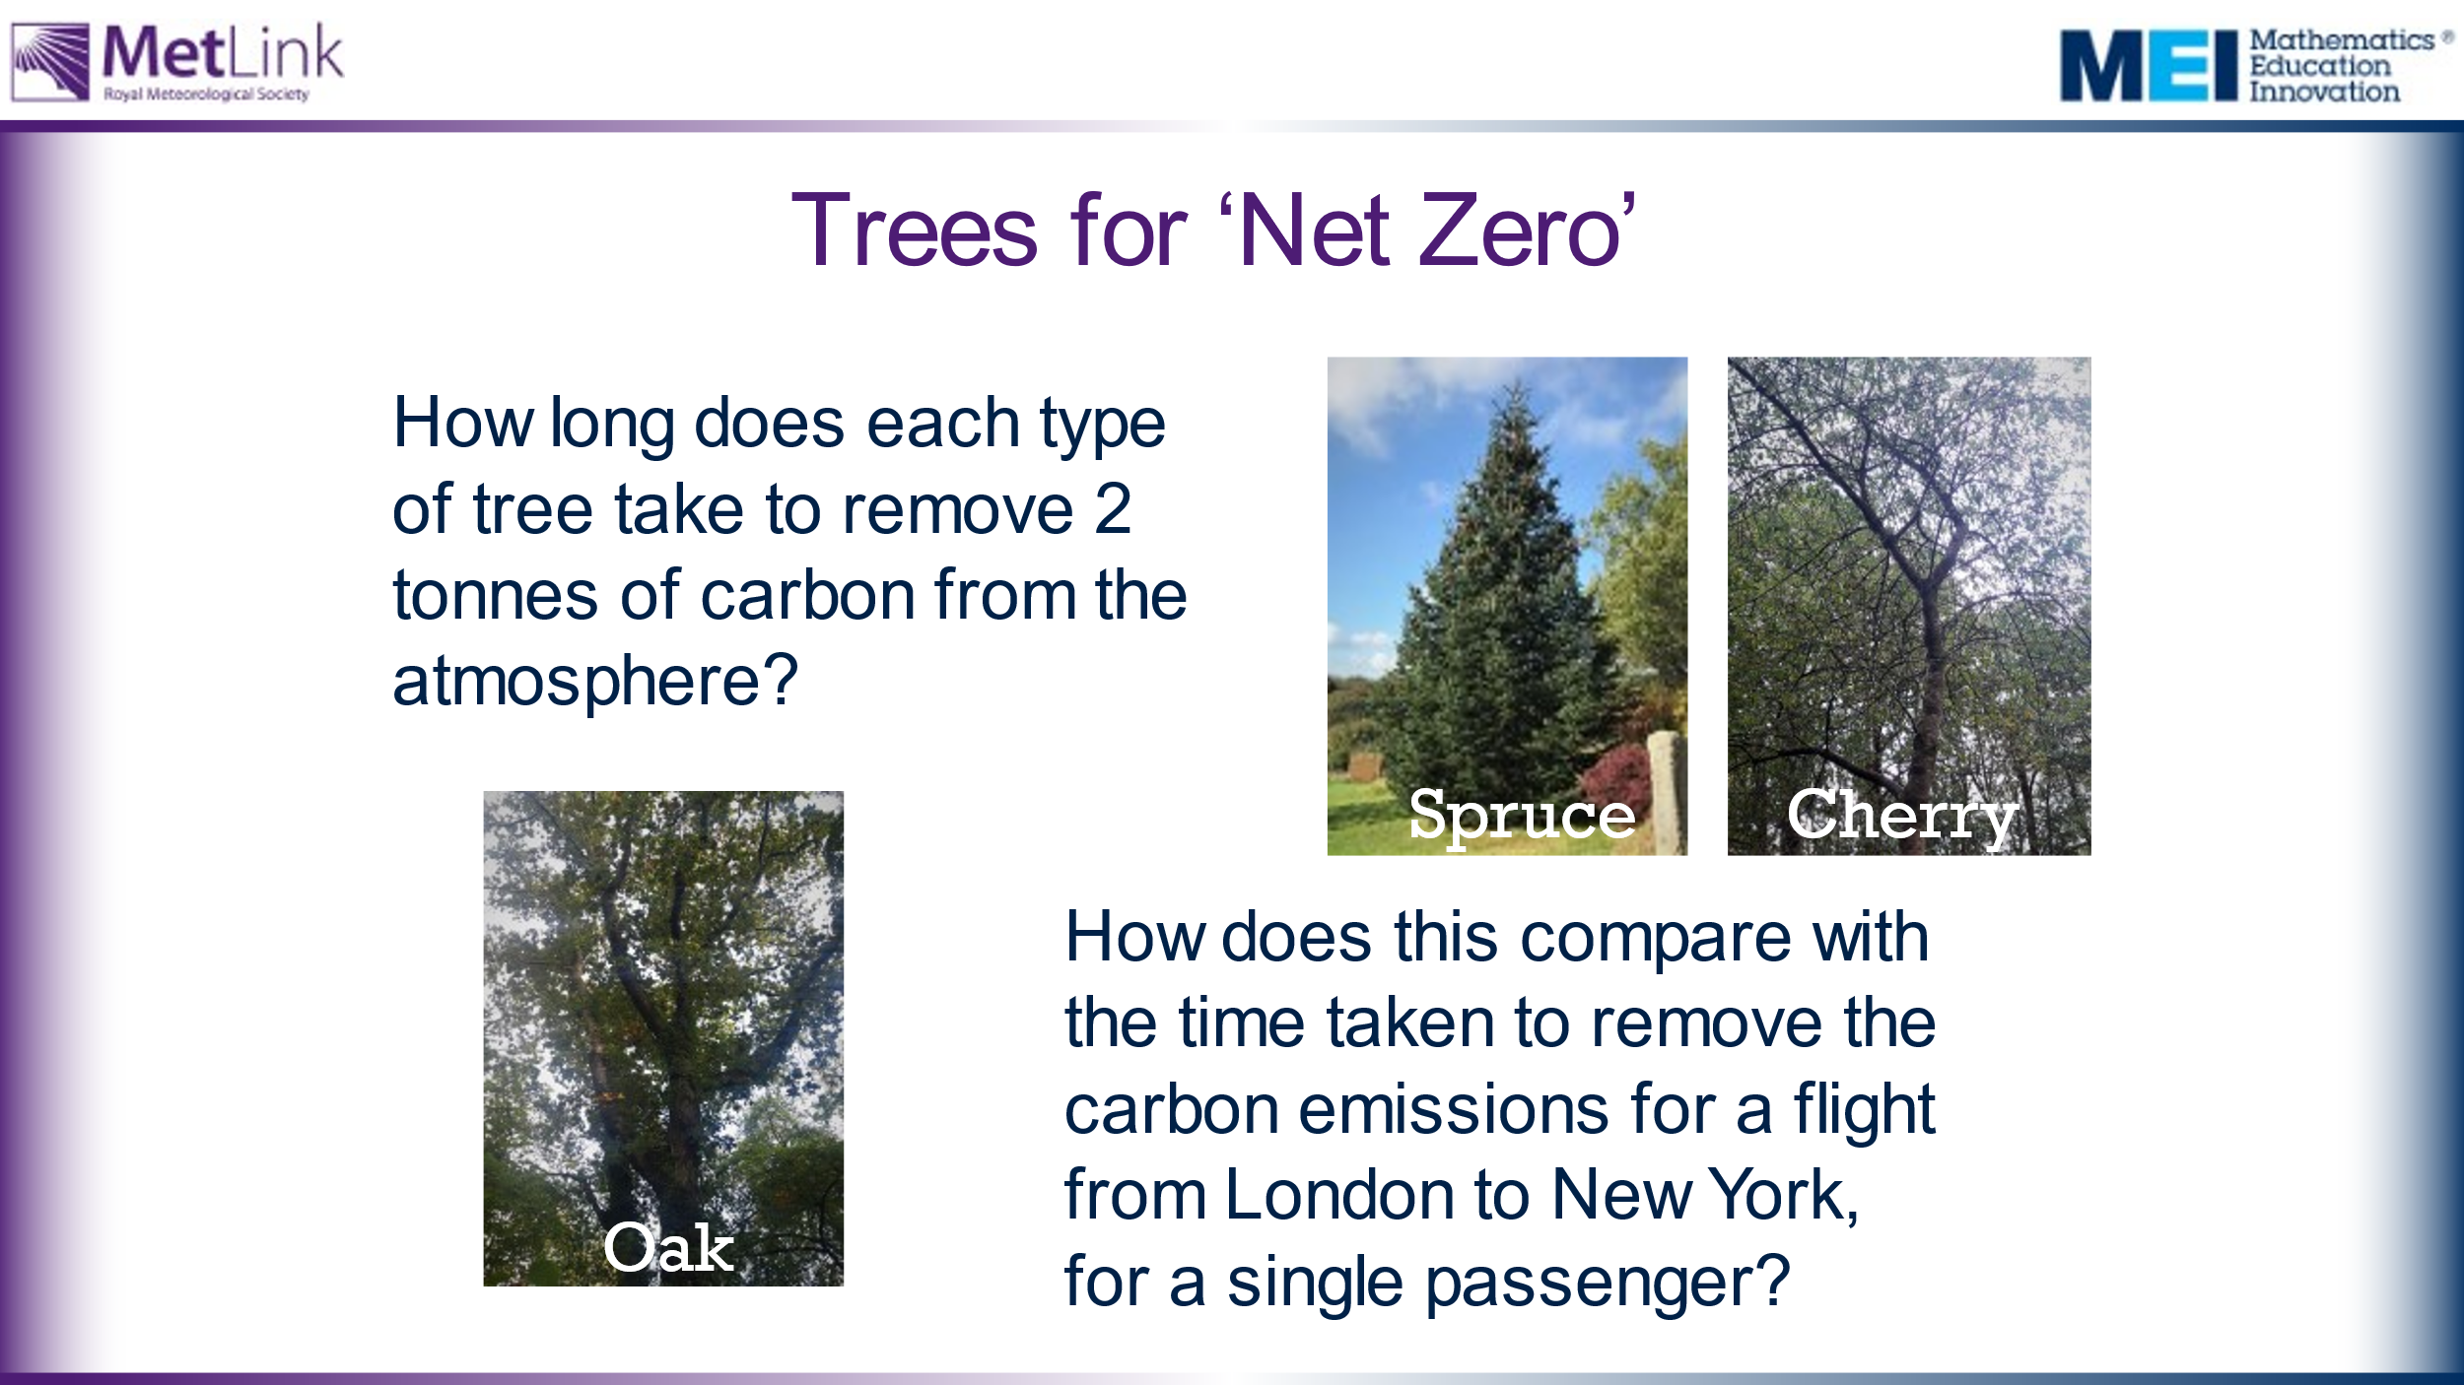 | Work on using the data to address some of the questions raised earlier in the session.  Note that it would take around 40 years for any of these tree species to absorb the 0.6 tonnes of carbon emissions for a single passenger to fly from London to New York.
70 | 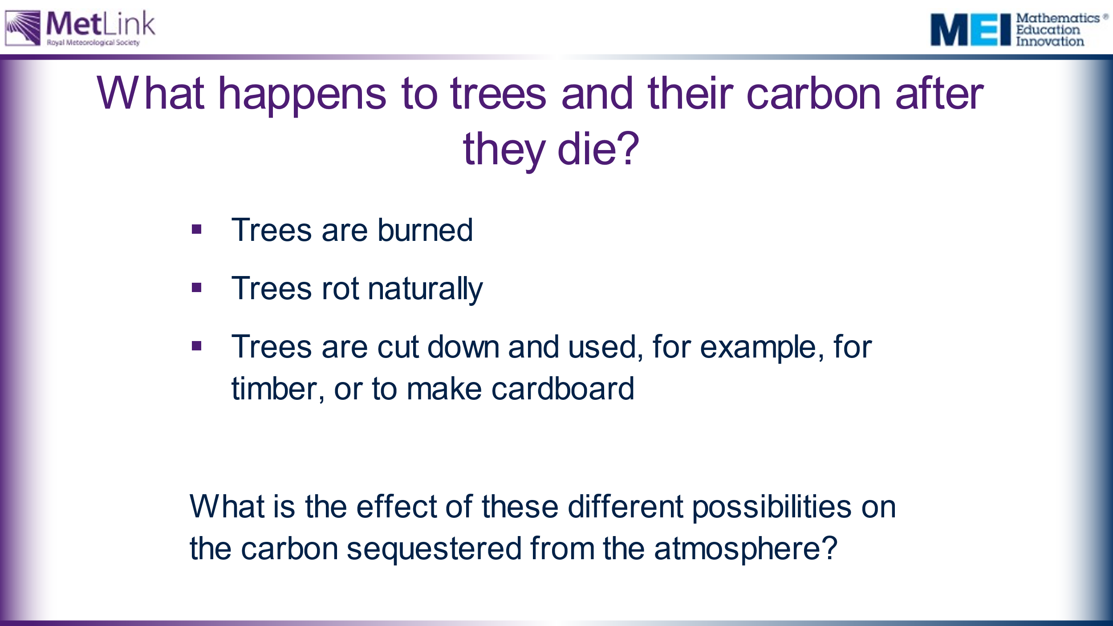 | Collect students’ initial and intuitive responses to the title question before revealing the three suggestions. | The Trees for Life website (https://treesforlife.org.uk/into-the-forest/habitats-and-ecology/ecology/) has much information about decomposition and decay of trees, as well as information about the importance of dead wood. It suggests that it might take around 40 years for a dead tree to completely decompose, whereas the leaves a tree drops will decompose completely within a year.  This article from Science Direct: https://www.sciencedirect.com/science/article/pii/S1364032116306050 has much information about trees being used to produce timber for construction.  Trees being burned quickly released carbon back into the atmosphere. Trees rotting slowly releases some of the carbon into the atmosphere, but some would be absorbed into the ground. Using trees for for building effectively ‘locks’ the carbon out of the atmosphere, provided the products built remain intact.
 | 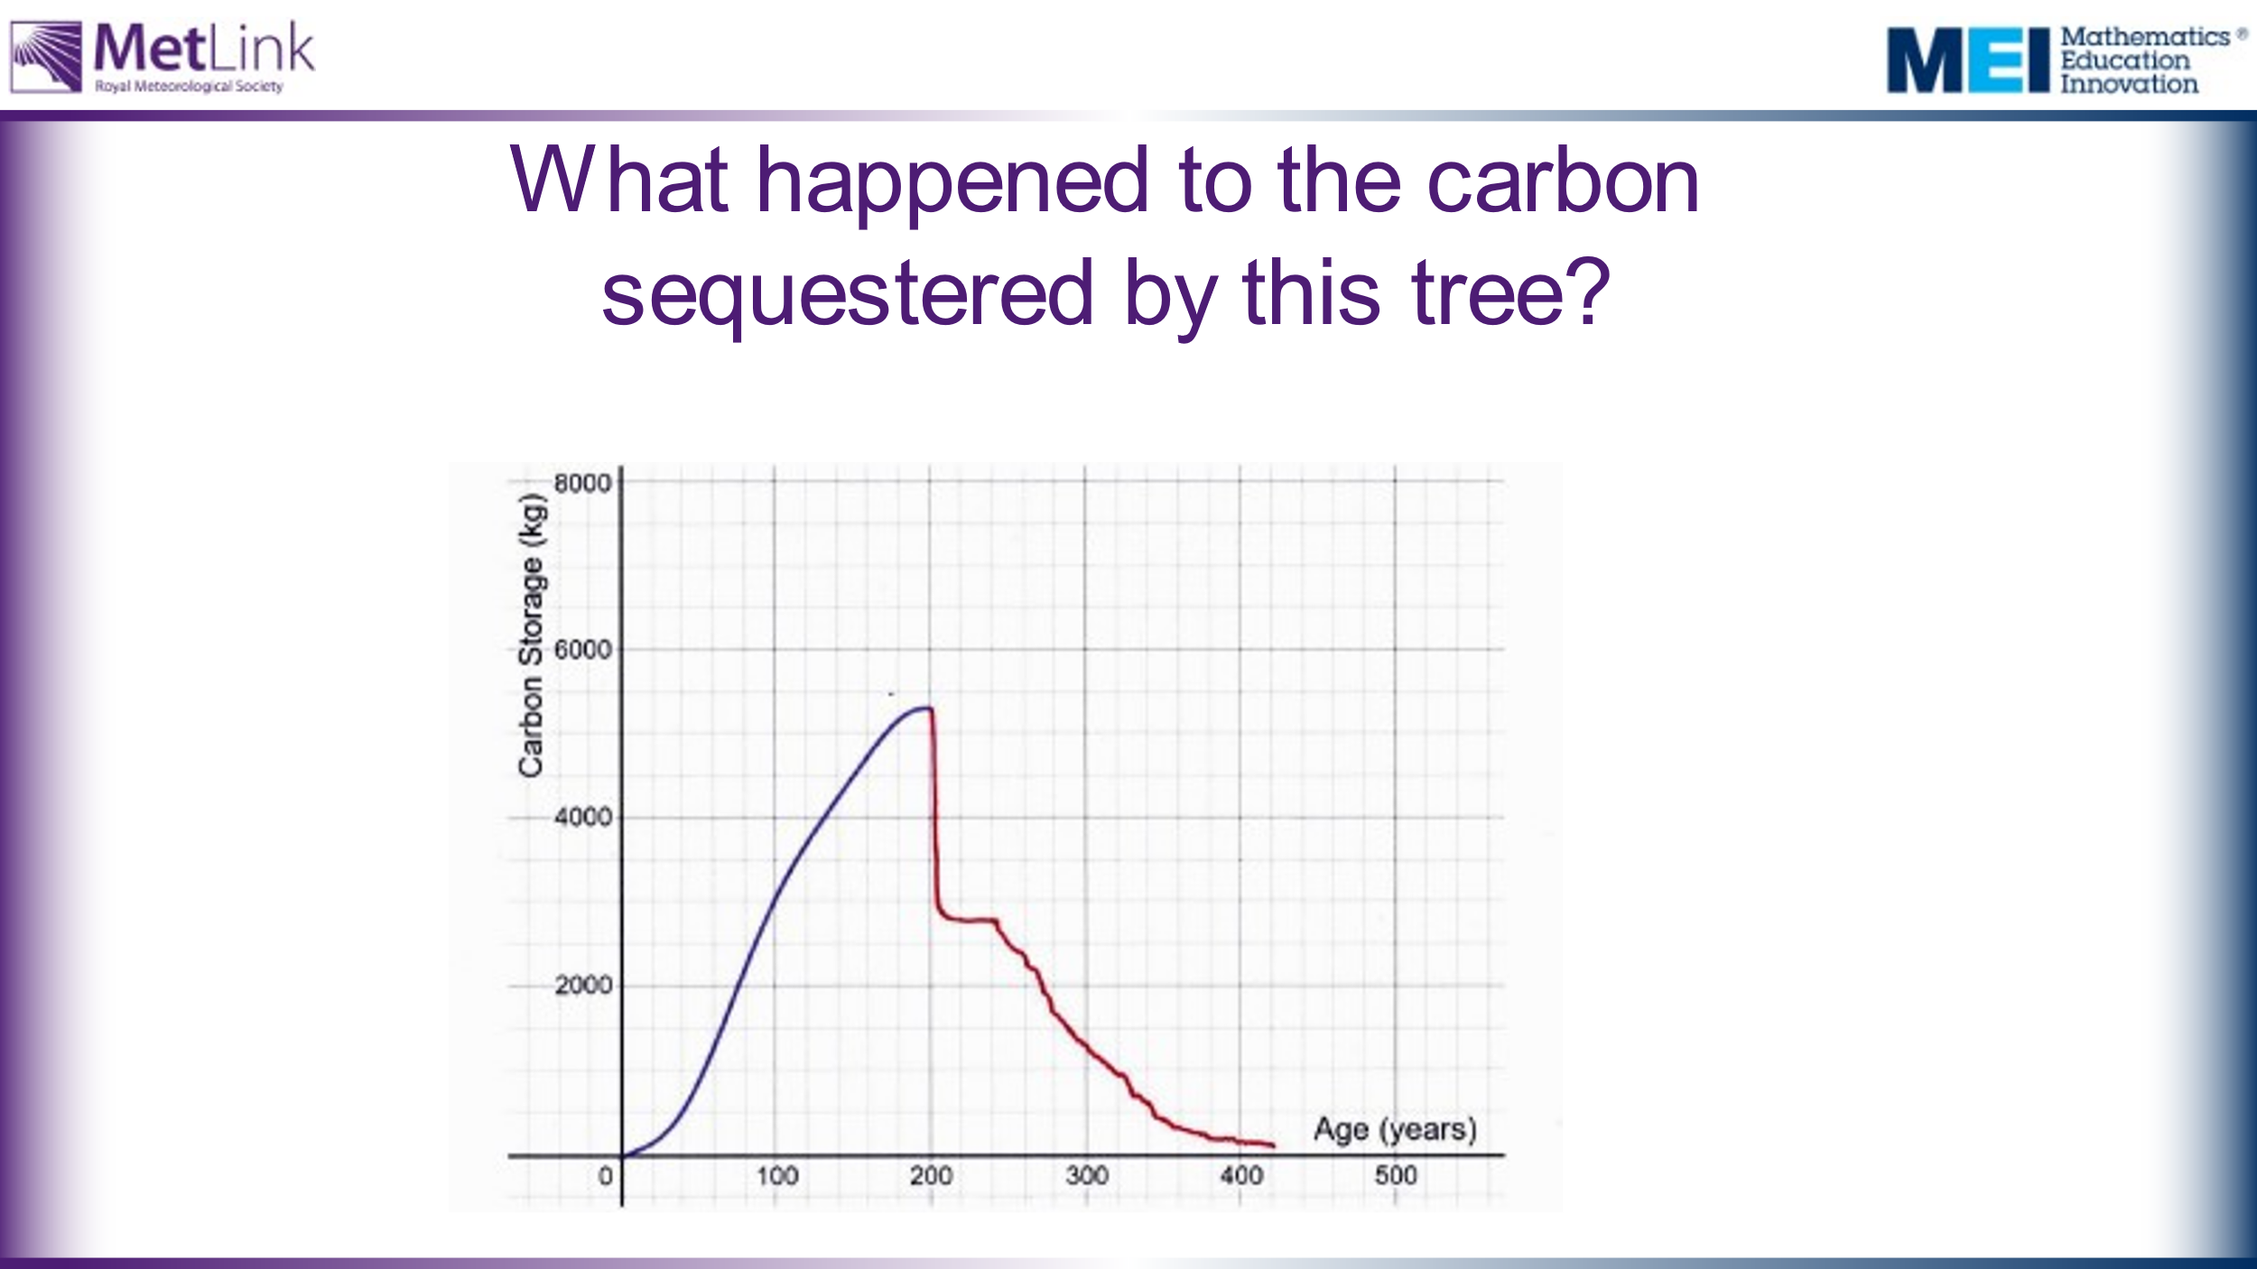 | Ask students to explain the key parts of this graph.  What do they think the tree was used for after it died?
 | 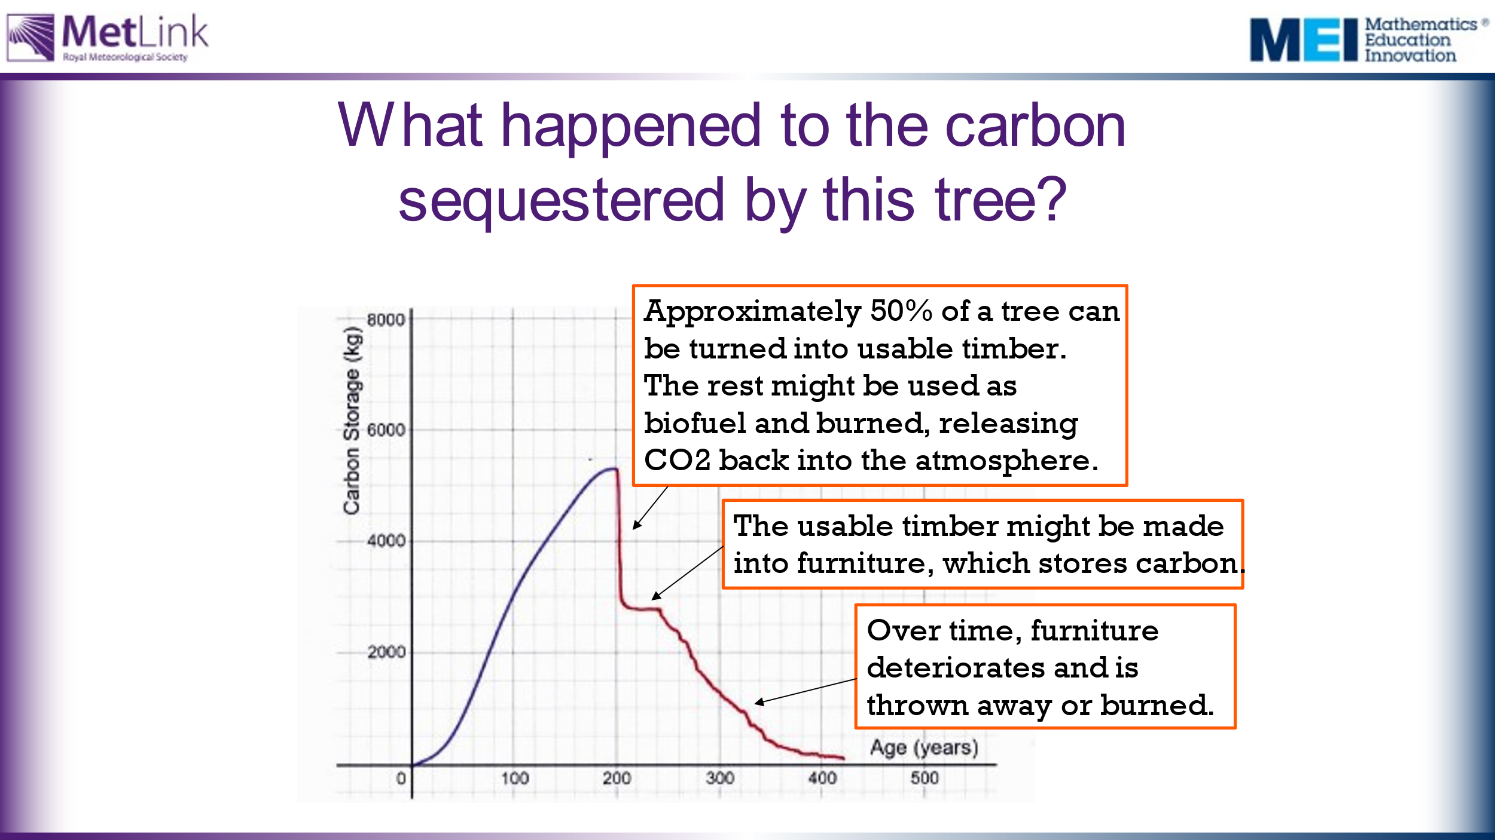 | Emphasise that even a tree that is used for production purposes is likely to only sequester carbon for a limited period. Over time, the products deteriorate and so the wood is burned or rots, returning the CO₂ to the atmosphere. It’s worth considering whether this can be avoided. Some tree litter from dead trees may get covered and preserved, or continue to sequester carbon as soil.
75 | 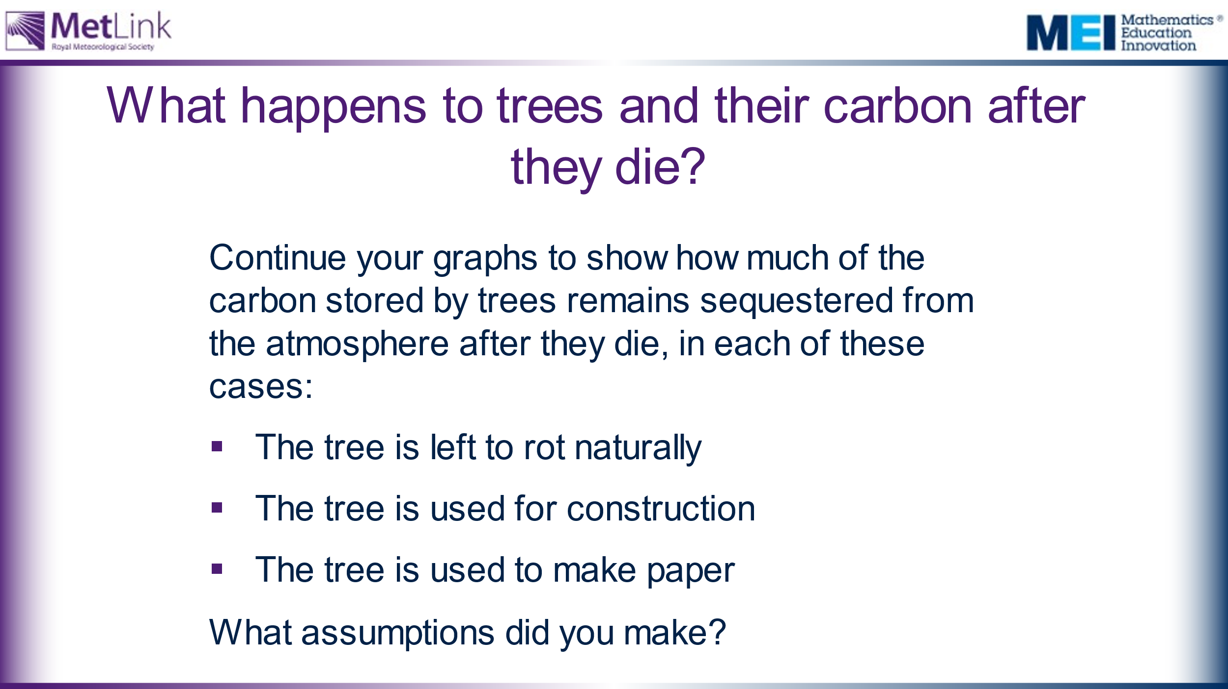 | Ask students to continue their graphs to show how much of the carbon stored by trees remains sequestered from the atmosphere after it dies, in each of the following cases:  - The tree rots naturally  - The tree is used for construction  - The tree is used to make paper  Emphasise the importance of being clear about the assumptions made. | The Trees for Life website (https://treesforlife.org.uk/into-the-forest/habitats-and-ecology/ecology/) has much information about decomposition and decay of trees, as well as information about the importance of dead wood. It suggests that it might take around 40 years for a dead tree to completely decompose, whereas the leaves a tree drops will decompose completely within a year.  This article from Science Direct: https://www.sciencedirect.com/science/article/pii/S1364032116306050 has much information about trees being used to produce timber for construction.  Trees being burned quickly released carbon back into the atmosphere. Trees rotting slowly releases some of the carbon into the atmosphere, but some would be absorbed into the ground. Using trees for for building effectively ‘locks’ the carbon out of the atmosphere, provided the product built remains intact.
80 | 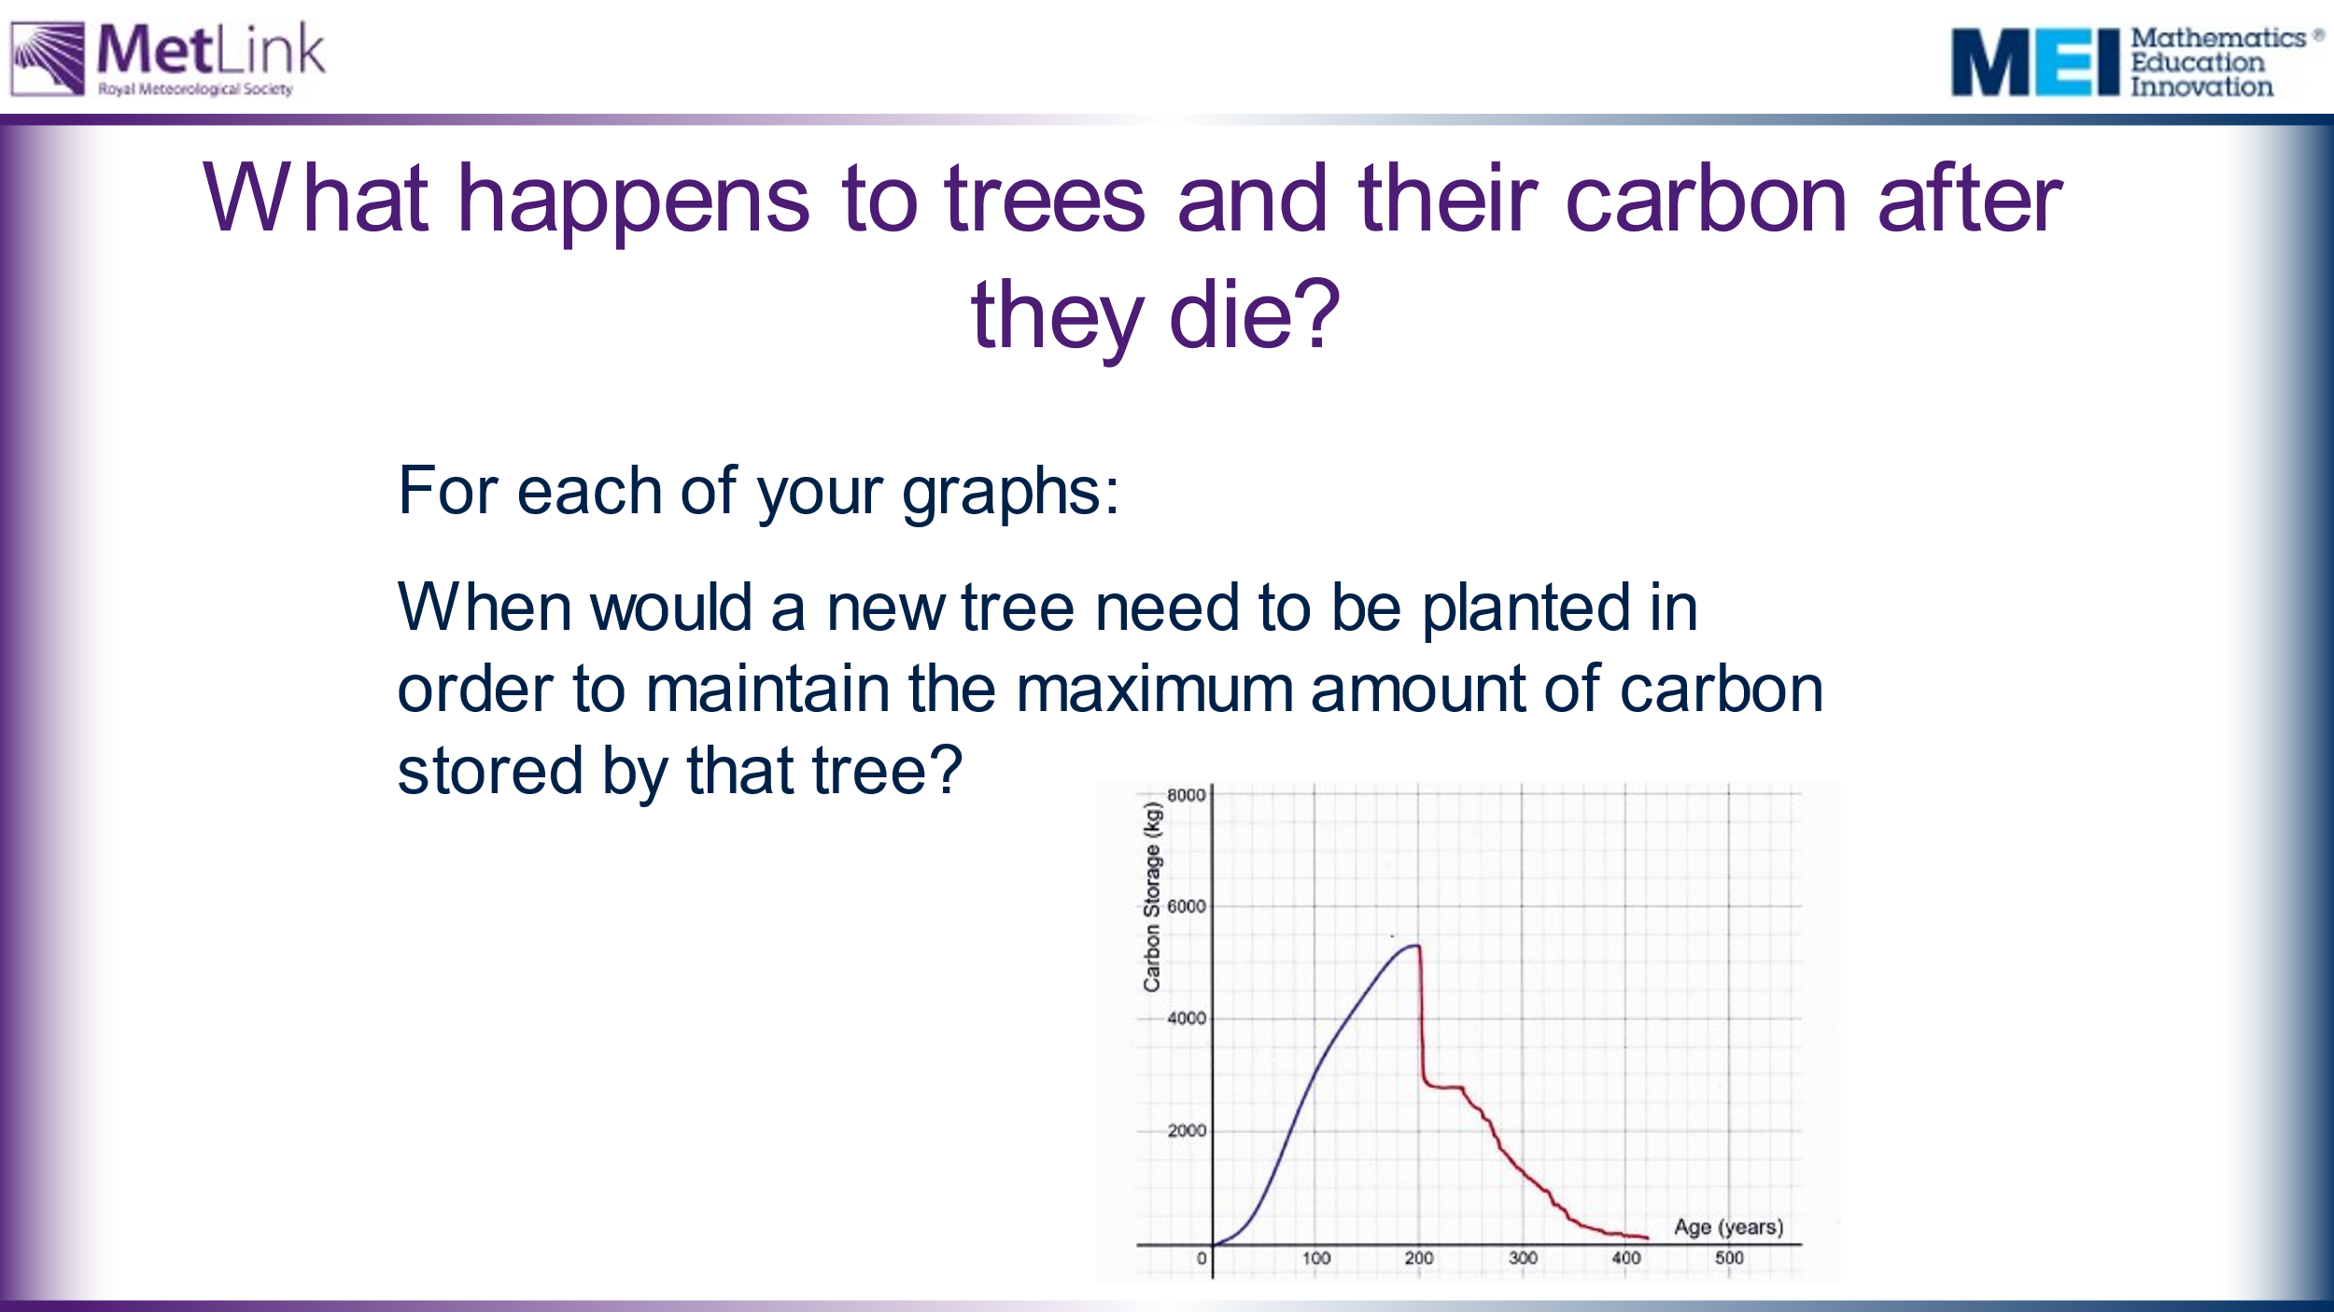 | Ask students when they would need to plant another tree, in the case of each of their graphs, in order to maintain the maximum amount of carbon sequestered by the tree.  Emphasise that to maintain the carbon sequestration more trees need to keep being planted. | For the graph shown on this slide, a new tree would need to be planted when the first is around 100 years old. This would allow the second tree to have stored around 50% of its carbon when the first tree loses 50%. This process would need to keep being repeated.
 | 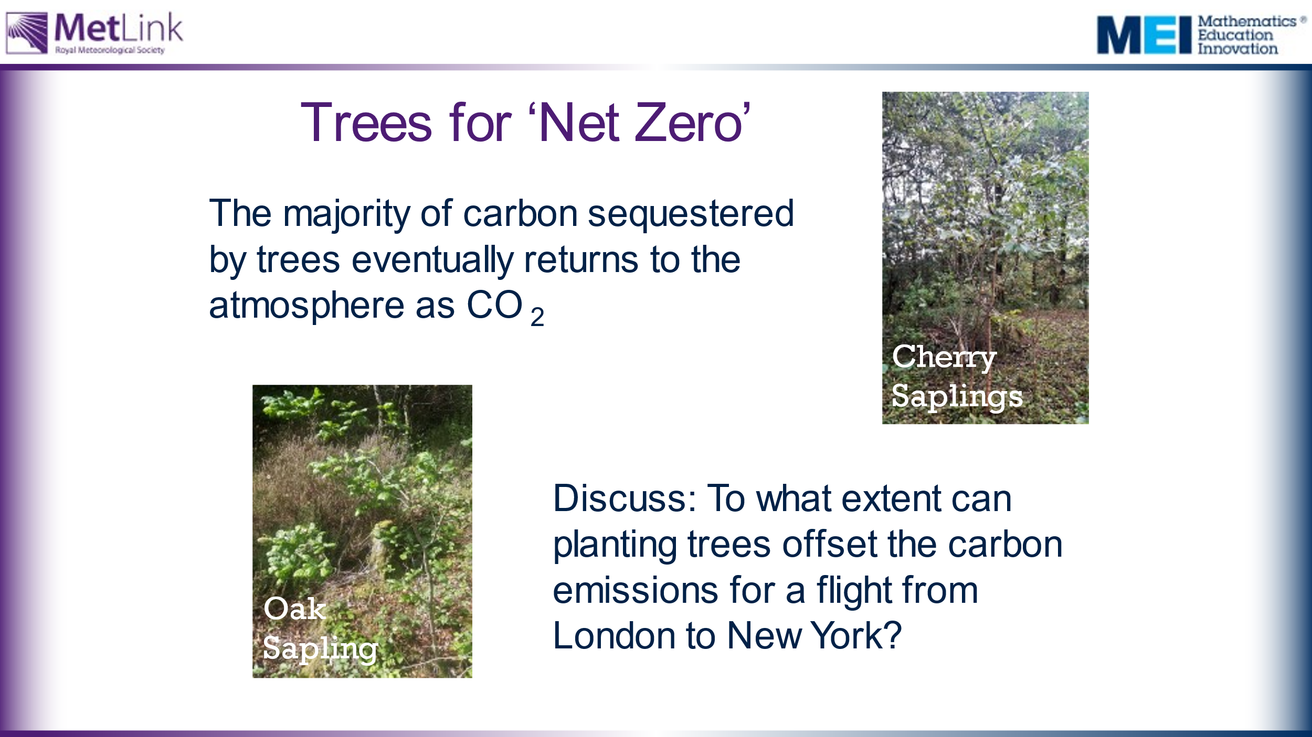 | Discuss the extent to which planting trees can offset the carbon emissions from flights. | The conclusion that should be reached is that, to offset one flight, you need to keep replacing the tree that you planted. It may be worth also considering the implications for land use if planting trees is going to be used to offset ongoing carbon emissions.
85 | 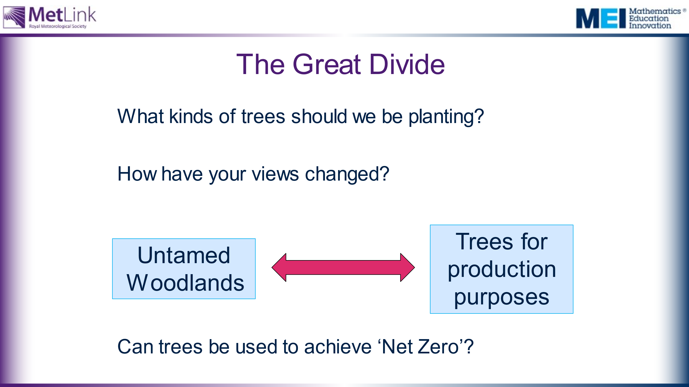 | The Great Divide:  How have students positions and views changed?  Ask students to justify their positions and explain why their views have changed.  It is worth considering how trees that die can be replaced with new trees, so that the carbon sequestered by the planting of trees doesn’t reduce when they die. In forests managed for production purposes, more trees are typically planted when trees are cut down. In untamed woodlands, tree saplings may grow naturally.  It may be worth considering the implications for land use if planting trees is going to be used to offset ongoing carbon emissions and achieve Net Zero. | Untamed woodlands tend to be better for biodiversity as they provide safer habitats for more animals and other plants, providing a larger variety of food sources for less dominant species. They also provide an environment where trees can produce saplings naturally. However, mature woodland actually sheds as much carbon as it absorbs, through dropping leaves and branches, whereas actively growing woodlands absorb more carbon than they shed.  Trees for production purposes don’t provide good habitats for other wildlife but young and growing trees absorb more CO₂ from the atmosphere. When trees are cut down and used for timber the carbon stored in them is effectively ‘locked’ out of the atmosphere, provided the timber product remains intact.  Note that 83% of UK forests are managed for production purposes.
 | 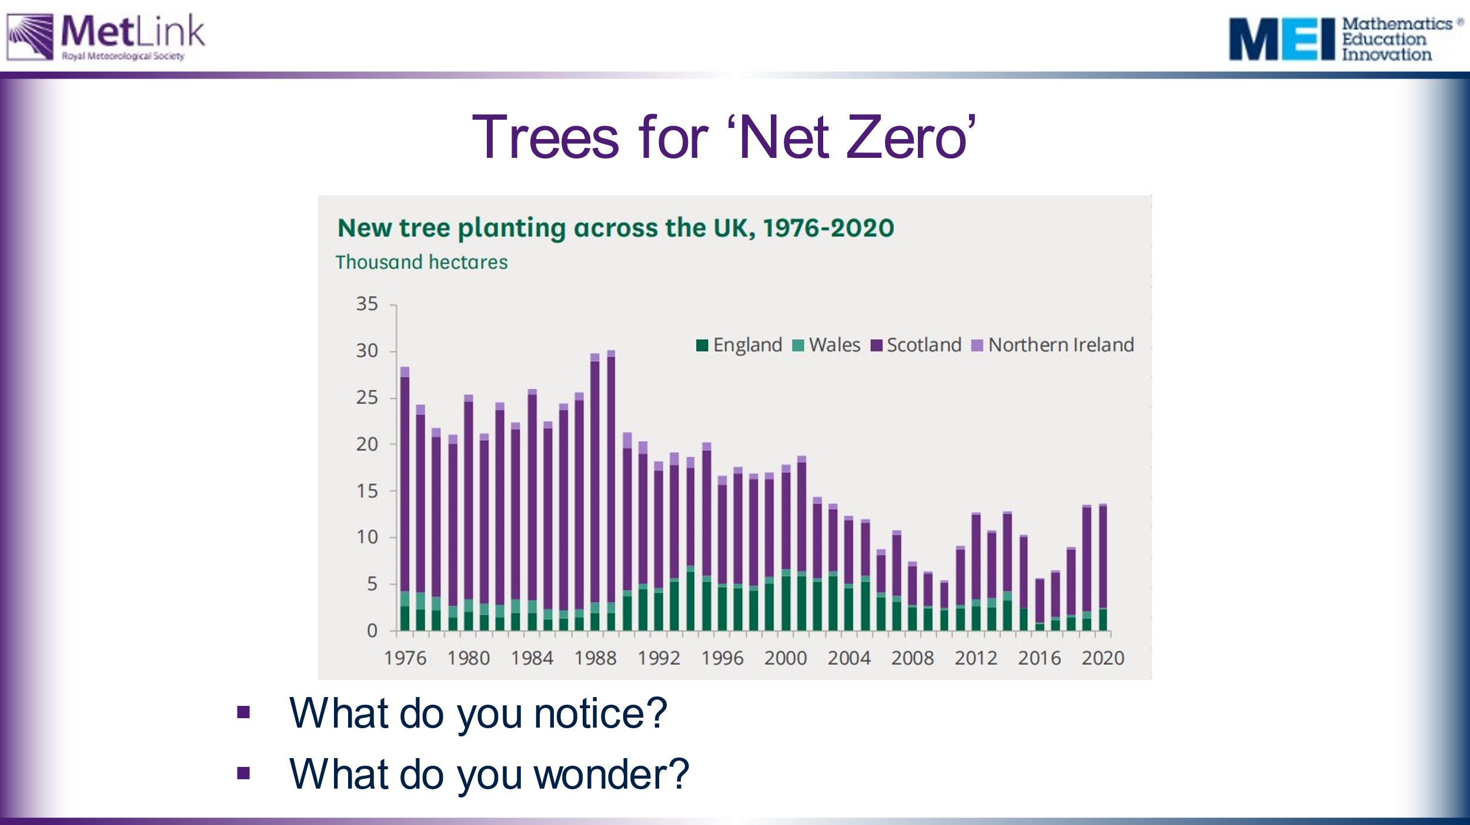 | For Core Maths only:  Where is the UK with tree planting now? | Image from: https://researchbriefings.files.parliament.uk/documents/CBP-9084/CBP-9084.pdf  Note that England planted many more trees in the 90’s and 00’s than they are doing now.
90 | 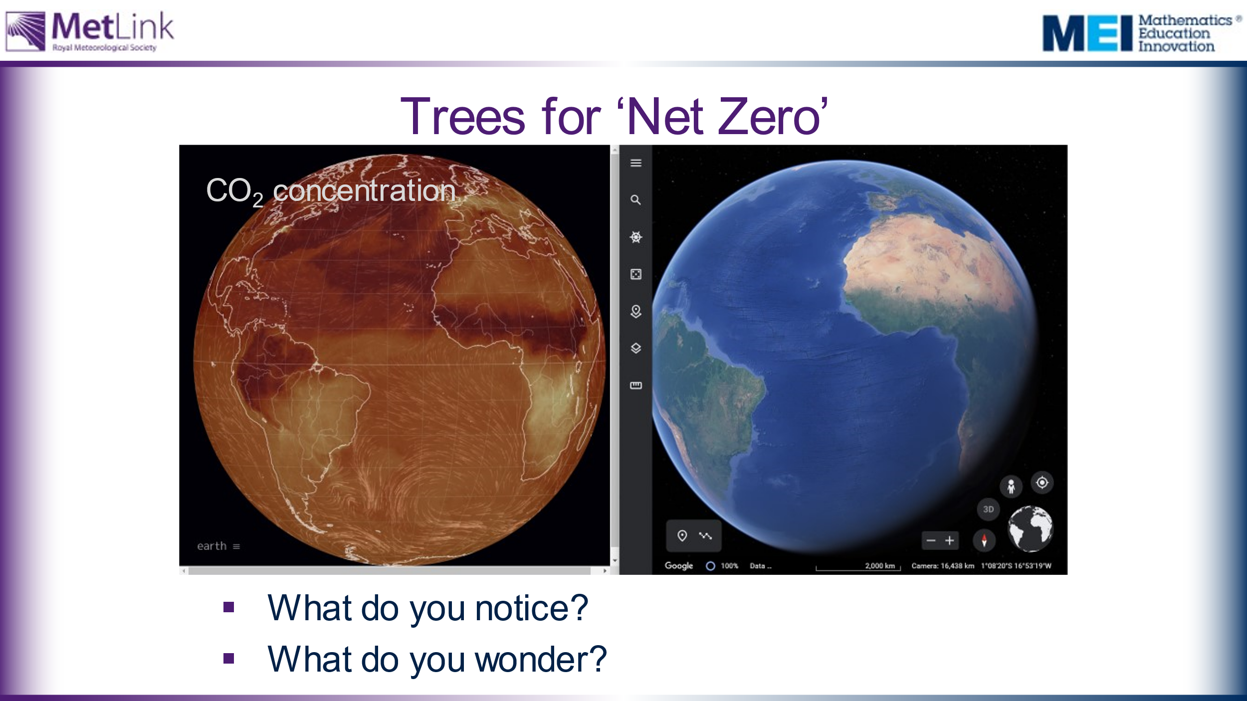 | Extension task? Students may want to explore the links between CO2 concentration on Earth and the location of rainforests by playing with the following websites:  https://earth.nullschool.net/  https://earth.google.com/web/
 | 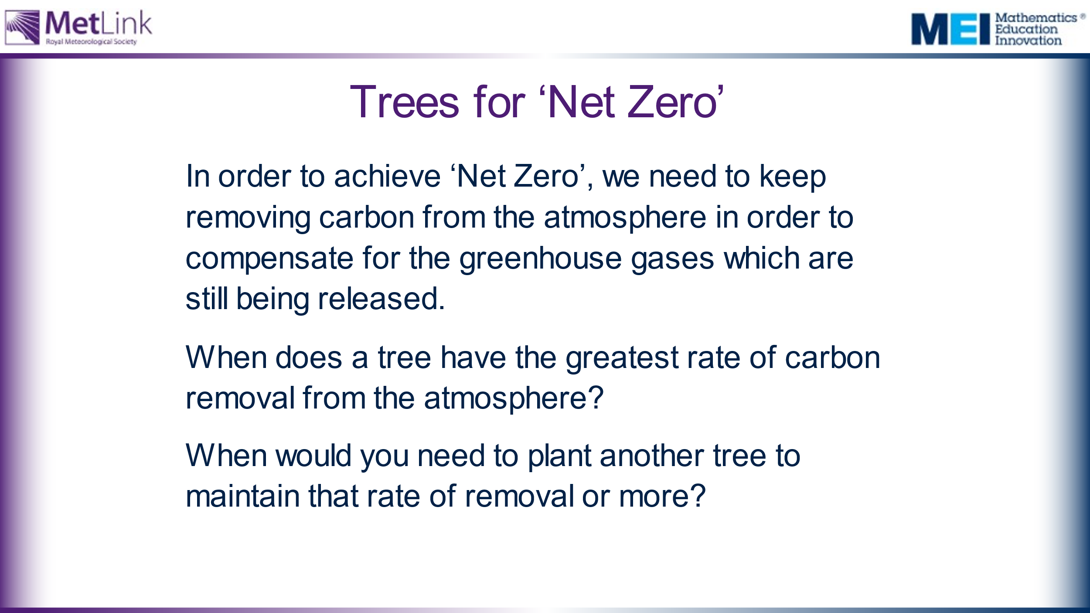 | Extension task? Some groups could use their data to inform their response to this question.

