Trees for Net Zero session plan
Brief overview of session ‘logic’ | Mathematical opportunities offered
- Why trees are good  - People are planting trees – estimates around what the numbers look like in terms of land use  - Some companies encourage you to offset flights by planting trees - how many trees for one flight?  - How much carbon do trees capture and store?  - How does the amount of carbon captured and stored by a tree change during its lifecycle?  - What happens to that carbon when a tree dies?  - Can you plant a tree to offset a flight?  - What is Net Zero?  - Can trees be used to achieve Net Zero? | - Estimation and proportional reasoning  - Developing a sense of scale of large numbers  - Interpretation of data, statistics, graphs, infographics in context  - Critiquing graphs  - Analysing and comparing data in order to develop and present a conclusion  - Making assumptions  - Making predictions  - Reading scales  - Plotting graphs

Time for session: 120 minutes, or two 60 minute sessions
Time | Slide | What to do… | Aims, additional info and comments
00 | 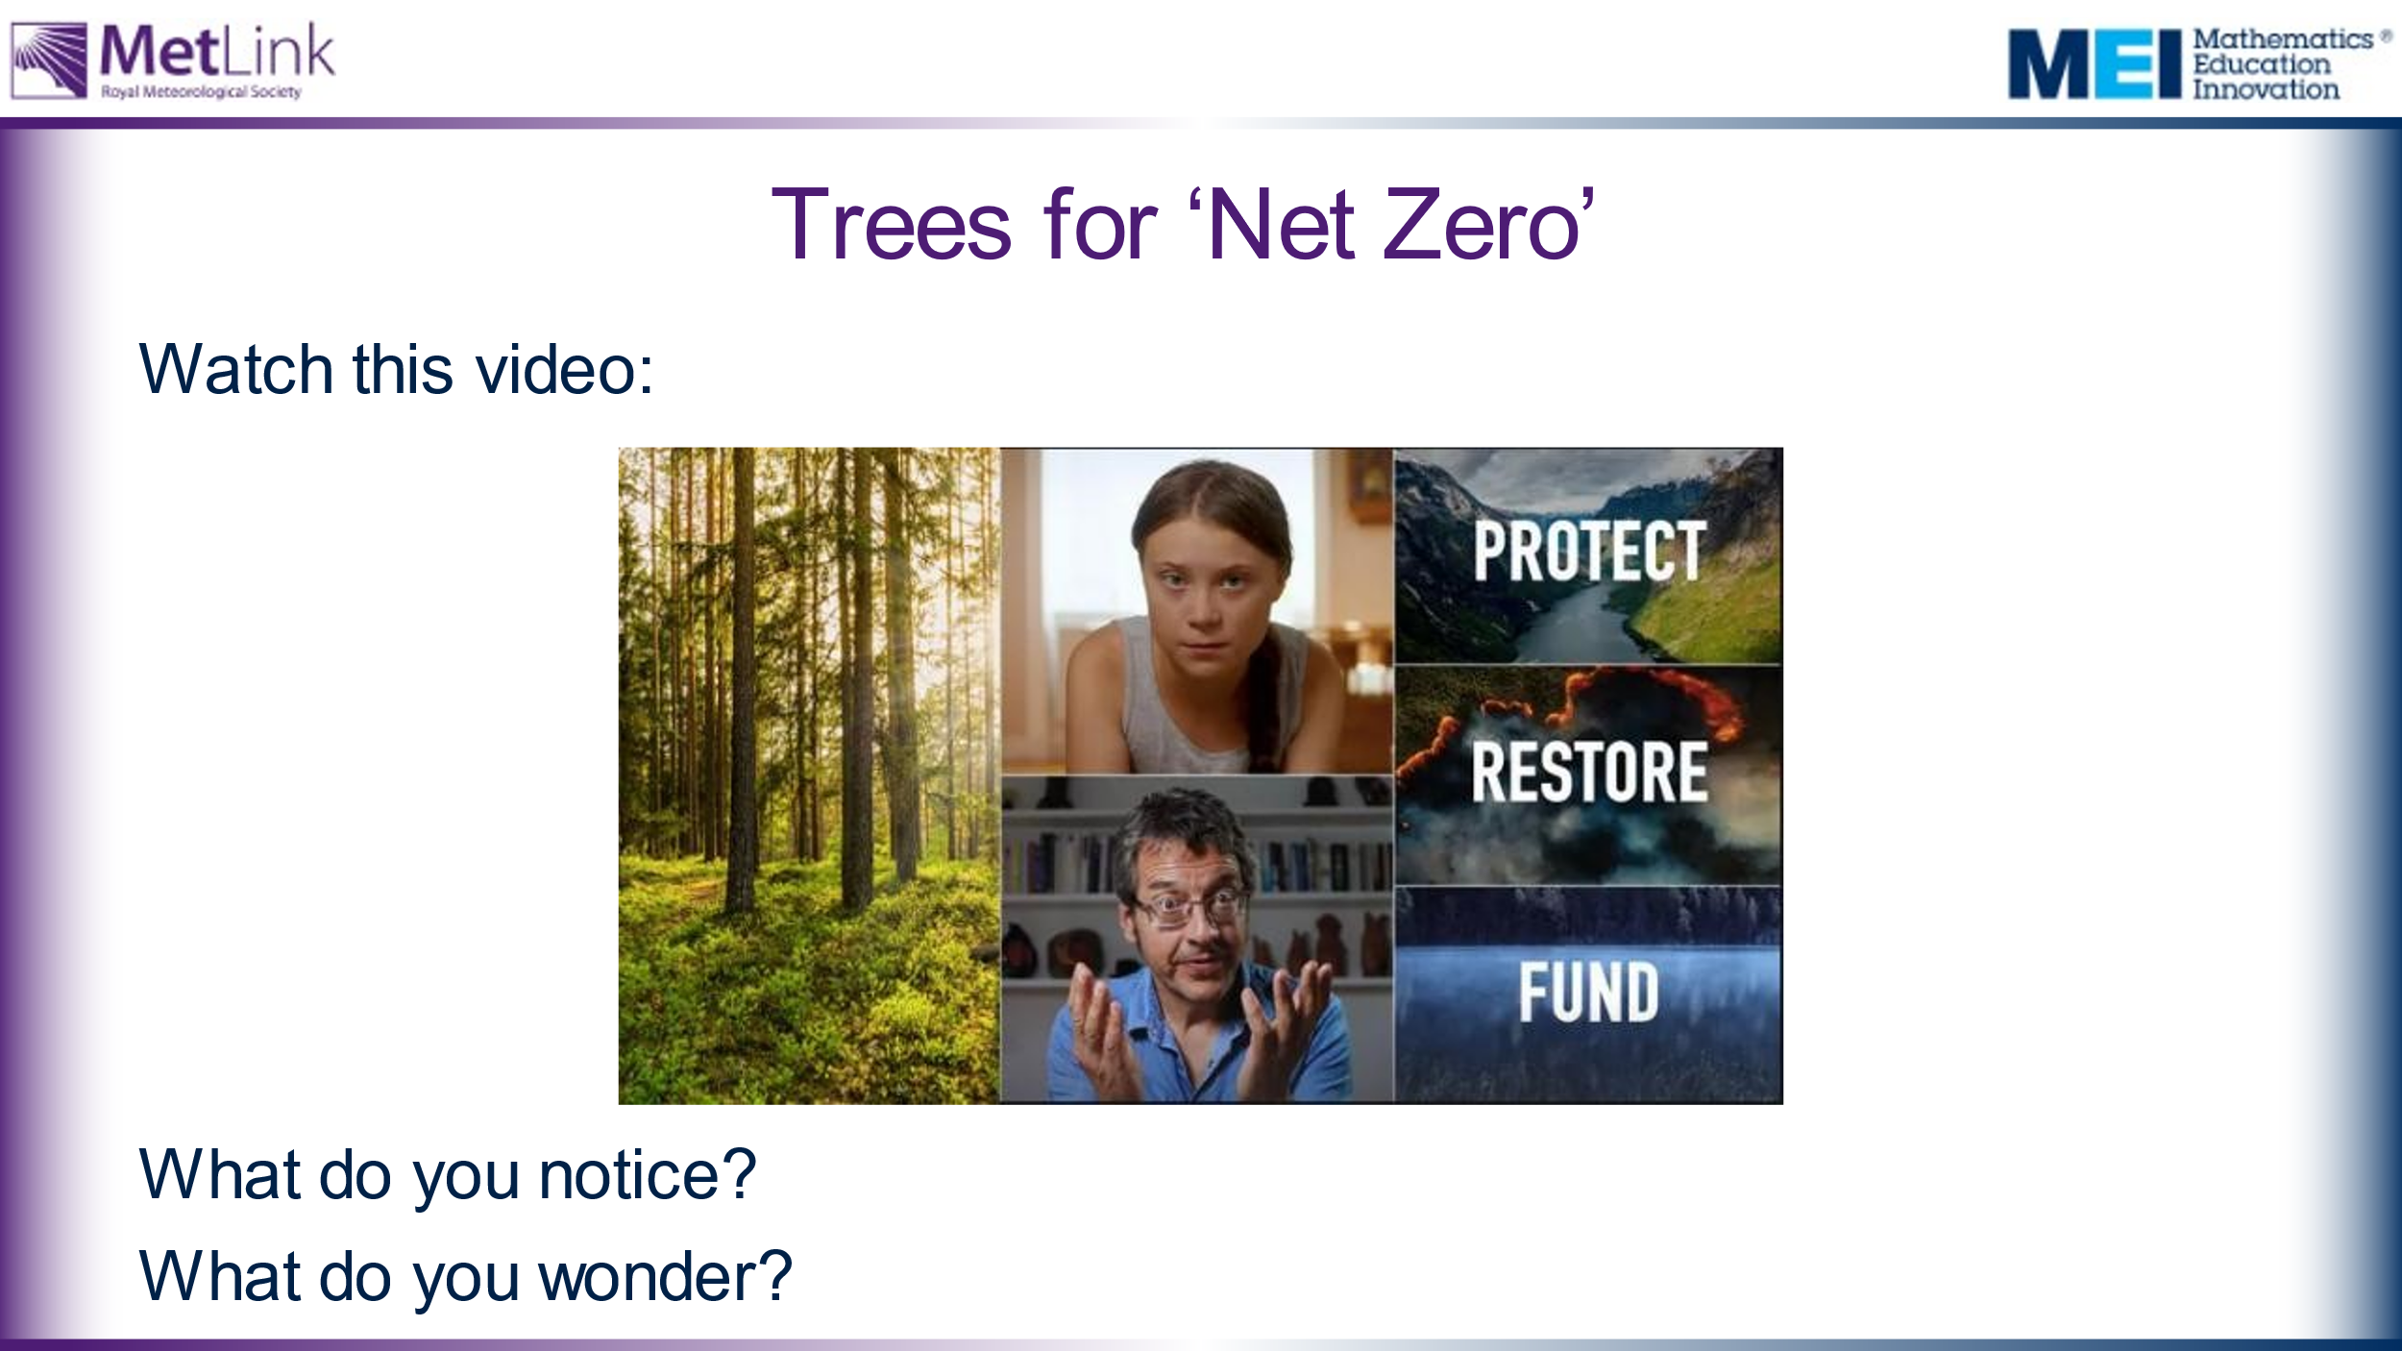 | Watch the video twice:  - On first viewing, ask students how it makes them feel. Do students agree or disagree with the statement: “What you do counts”?  - On second viewing, ask students to make a note of any facts or statistics they find interesting or surprising.  This session is about trees – what affect will this tree cutting have on the CO₂ in our atmosphere and to what extent can planting trees solve this problem? | This video introduces the idea that planting trees can help to absorb CO₂ from the atmosphere and potentially sets up a question to explore throughout the session:  To what extent can planting trees solve our climate crisis?  Tropical forests are being cut down at a rate of 30 football pitches per minute – what does this mean? How many trees is this? How significant is the carbon stored by a tree? What does this mean for CO₂ in the atmosphere? How does this compare to the numbers of trees being planted around the World? We will explore these questions in this session.
 | 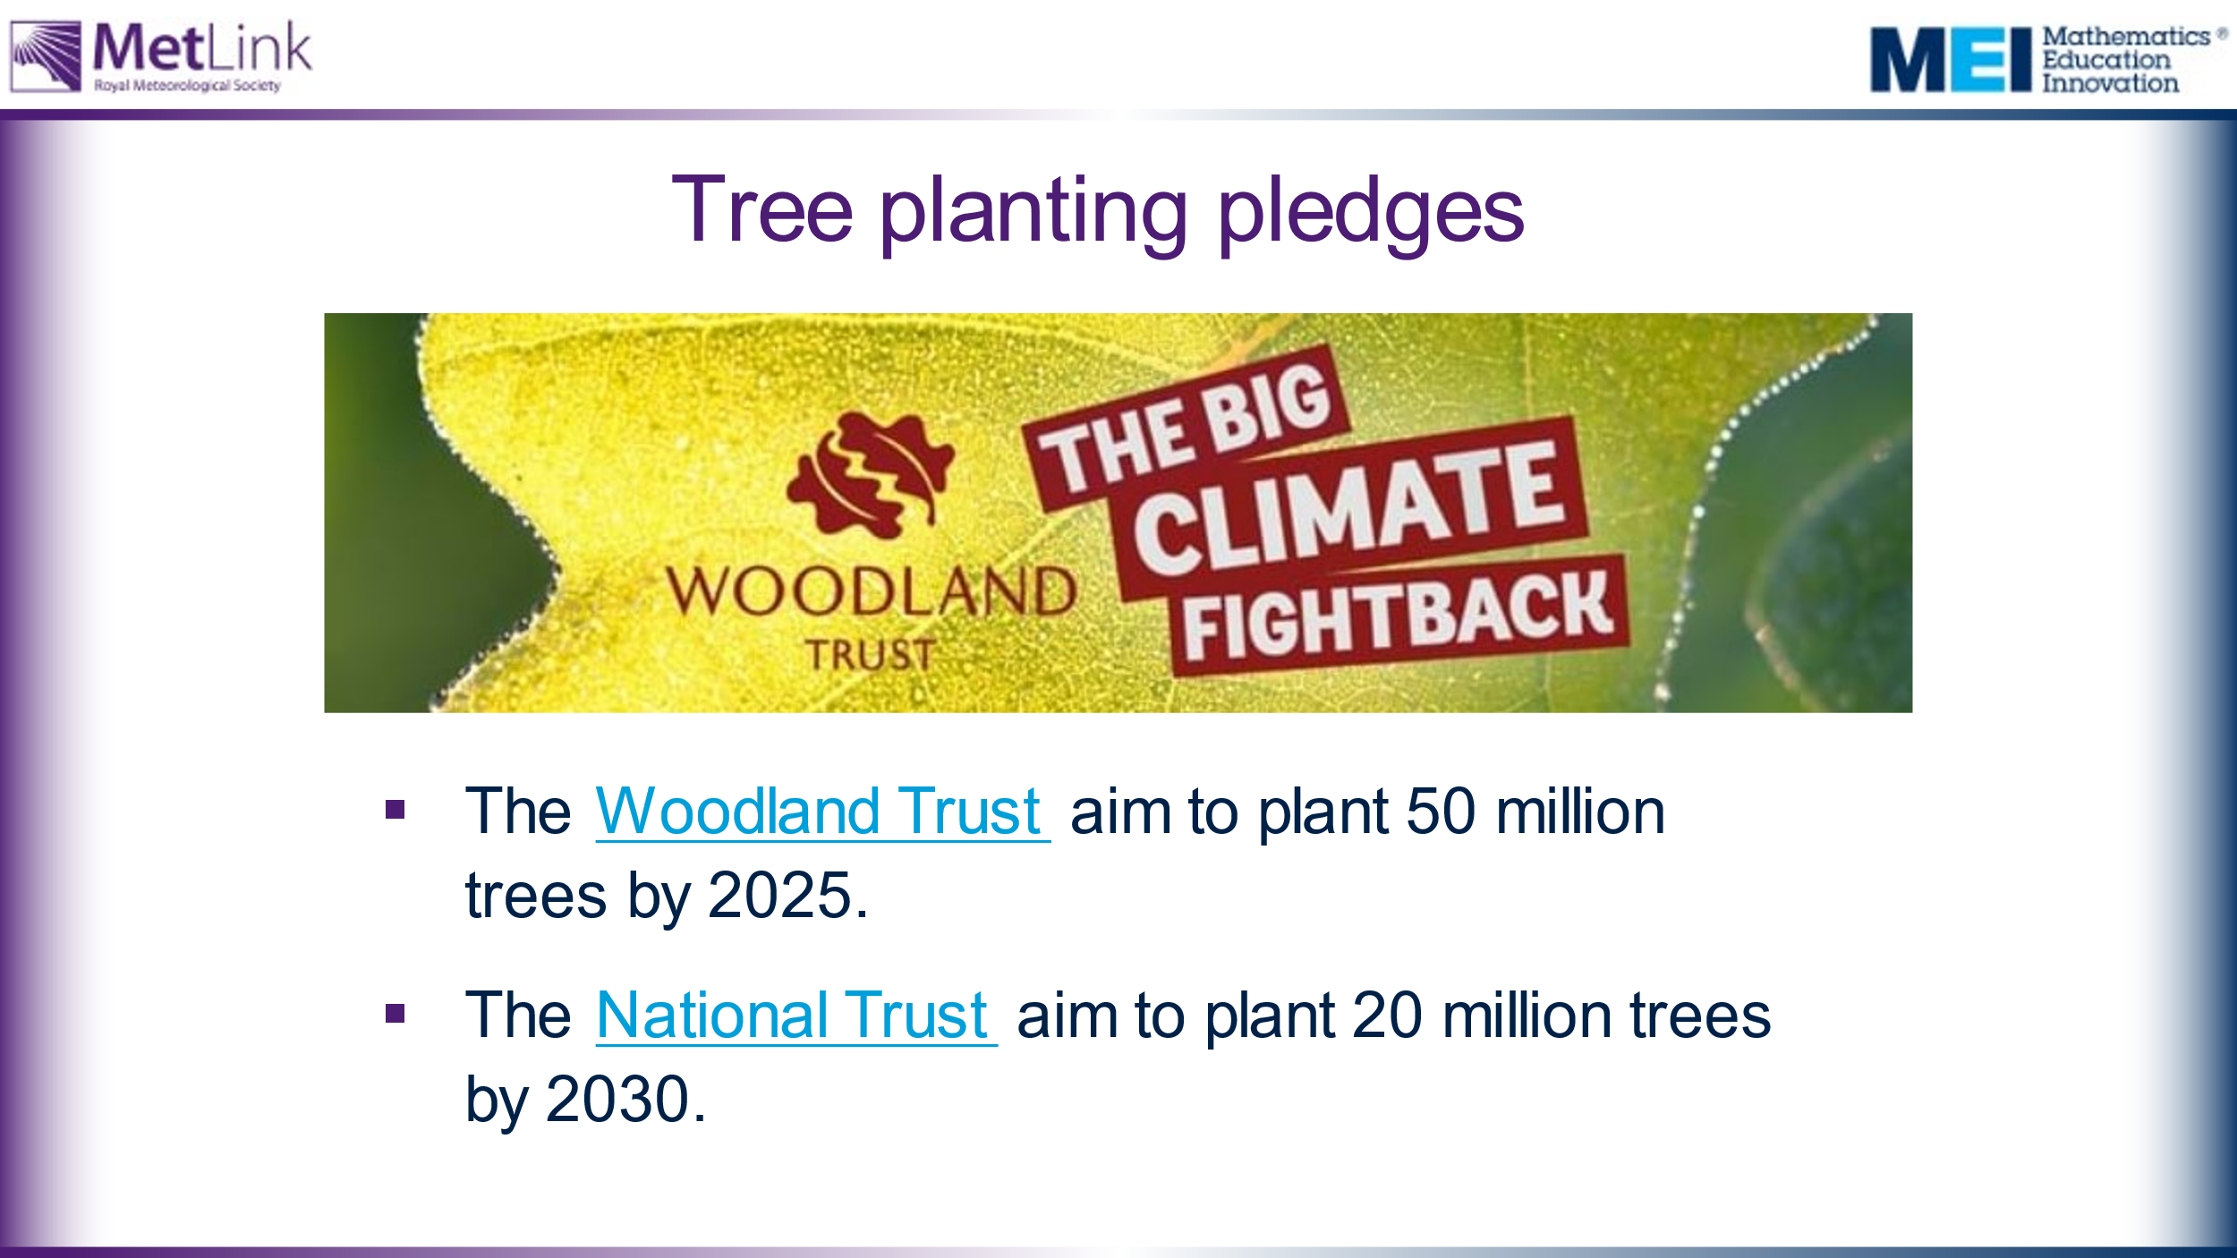 | Offer students some examples of positive ways forward and potential ways for students to contribute. | It might be worth exploring with students how 50 million trees compares with 30 football pitches of forest. This is explicitly mentioned on slide 9.
10 | 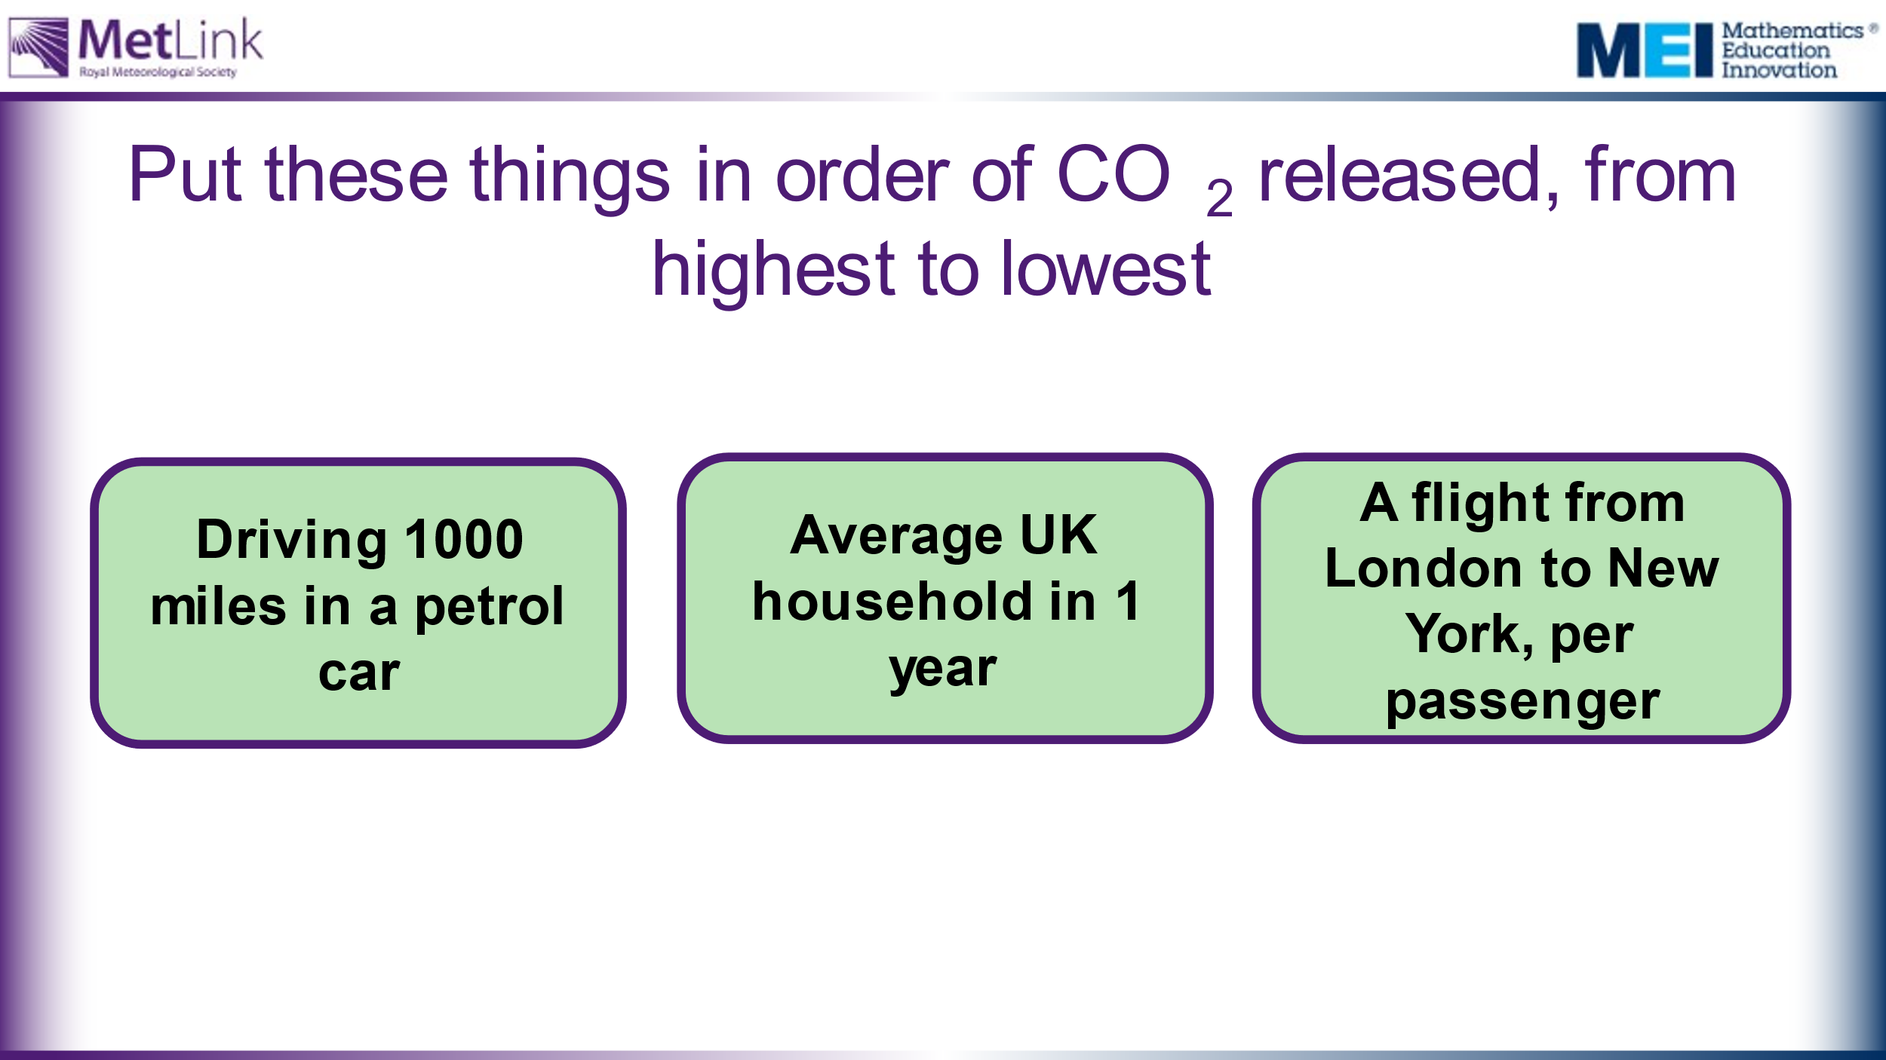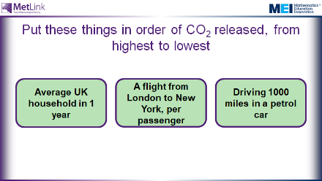 | Order the actions according to amount of CO2 released.  Are there any surprises?  One implication of this is that what we do as individuals, and within our households, can have a big impact on our environment. | Initial engagement – making predictions and motivating a need for finding out about CO₂ absorption from trees. This also gives opportunity to put some of the large numbers in context, giving a sense of relative scale.  This session is on trees, so this allows students to compare the CO₂ stored by a tree with some other more meaningful and imaginable scenarios. One implication is that trees can potentially have a significant impact on the CO₂ in our atmosphere, but we will find out more about this throughout this lesson.  This potentially sets up a question later in the session about whether the CO₂ produced by a flight from London to New York could be offset by planting trees.  Answers: UK Household 17.1 tonnes, Driving 1000 miles 0.22 tonnes, Oak tree 7.5 tonnes, Flight London to New York (per passenger) 0.6 tonnes, 1 cow 0.6 tonnes.
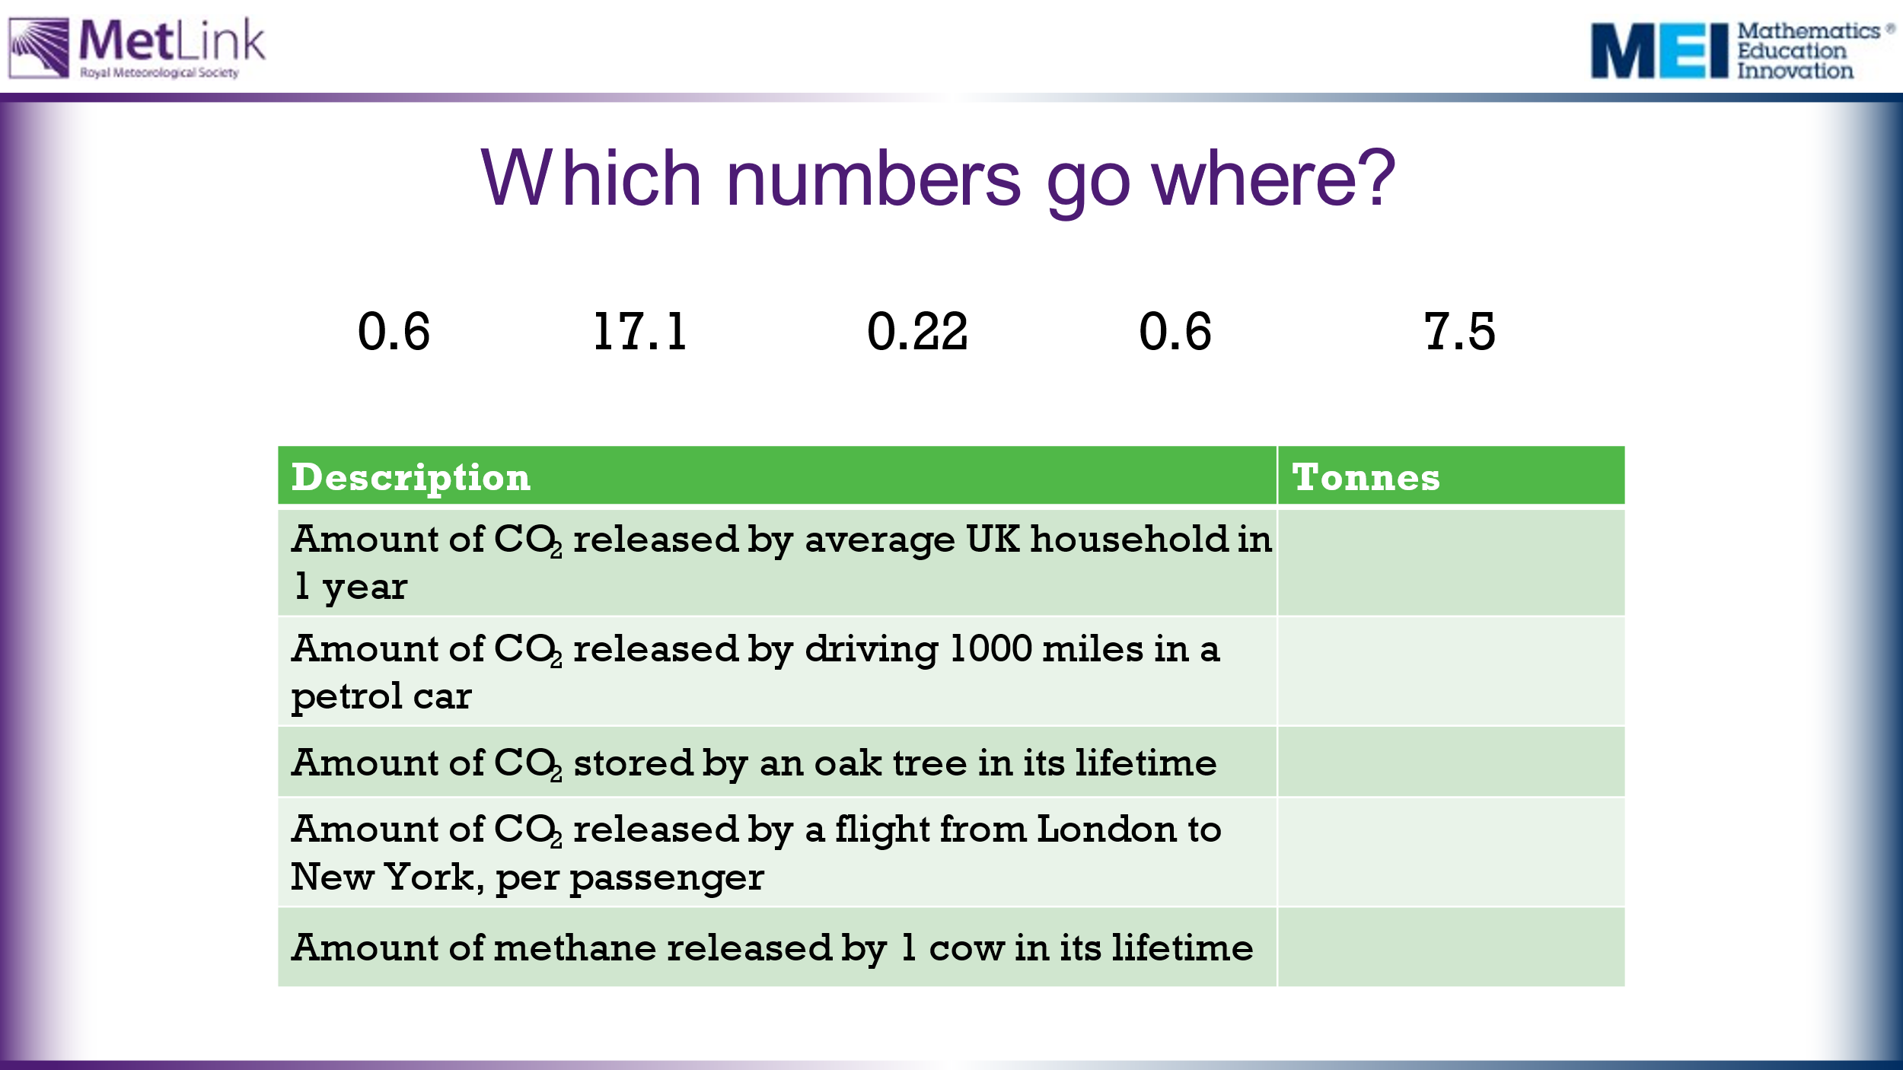

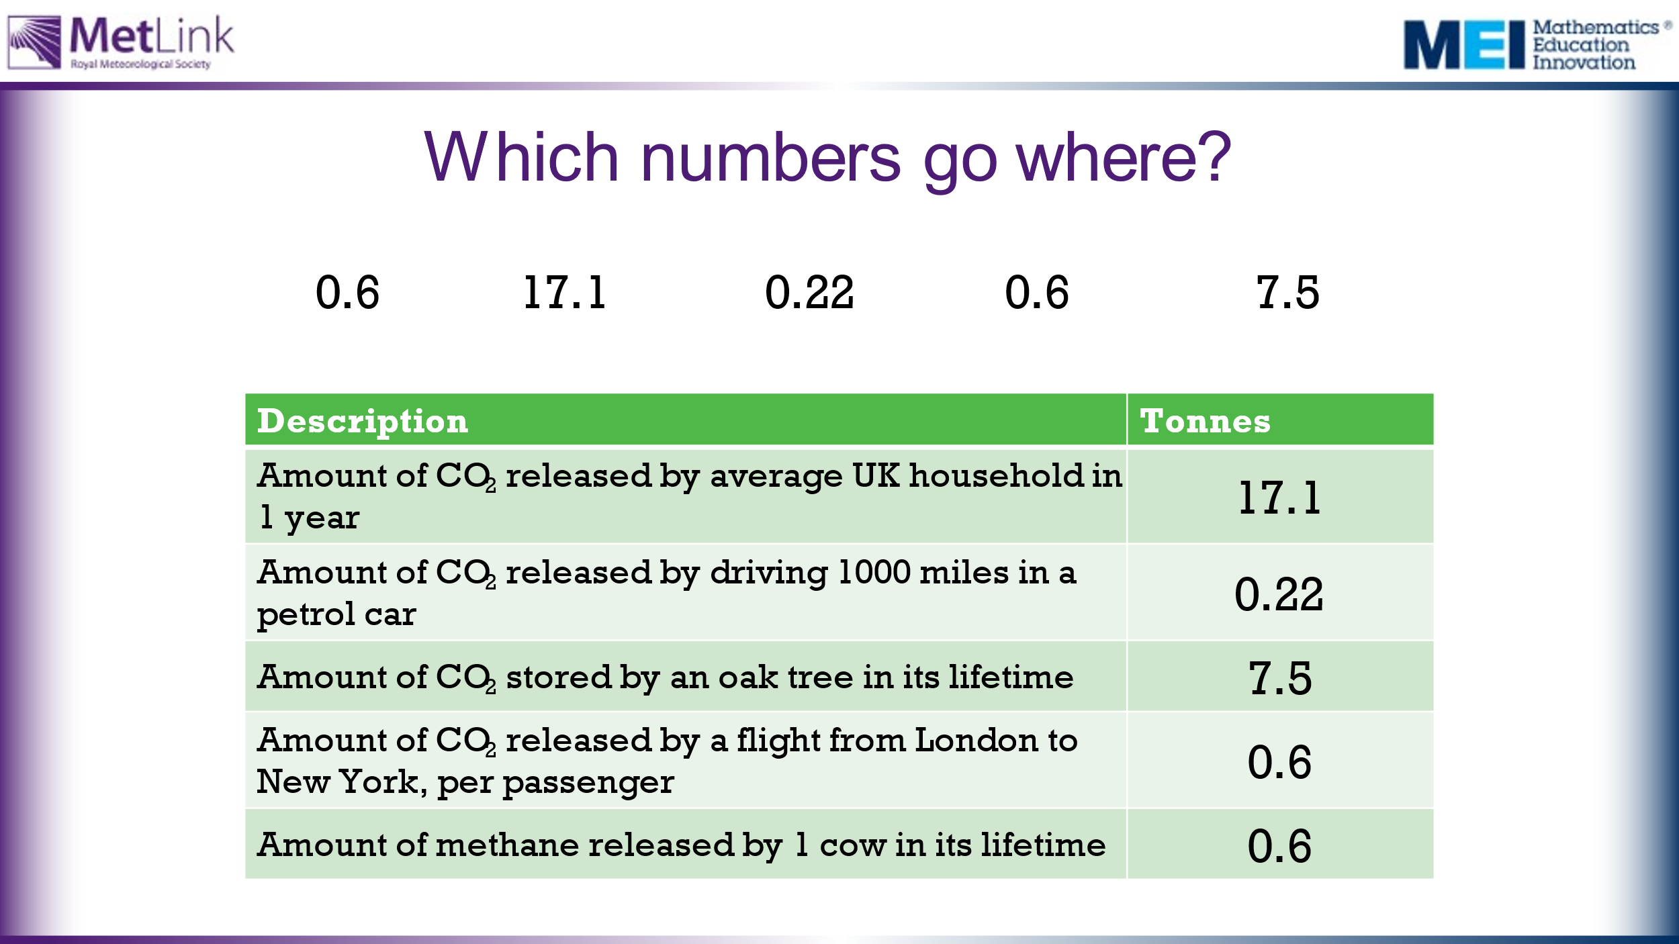
15 | 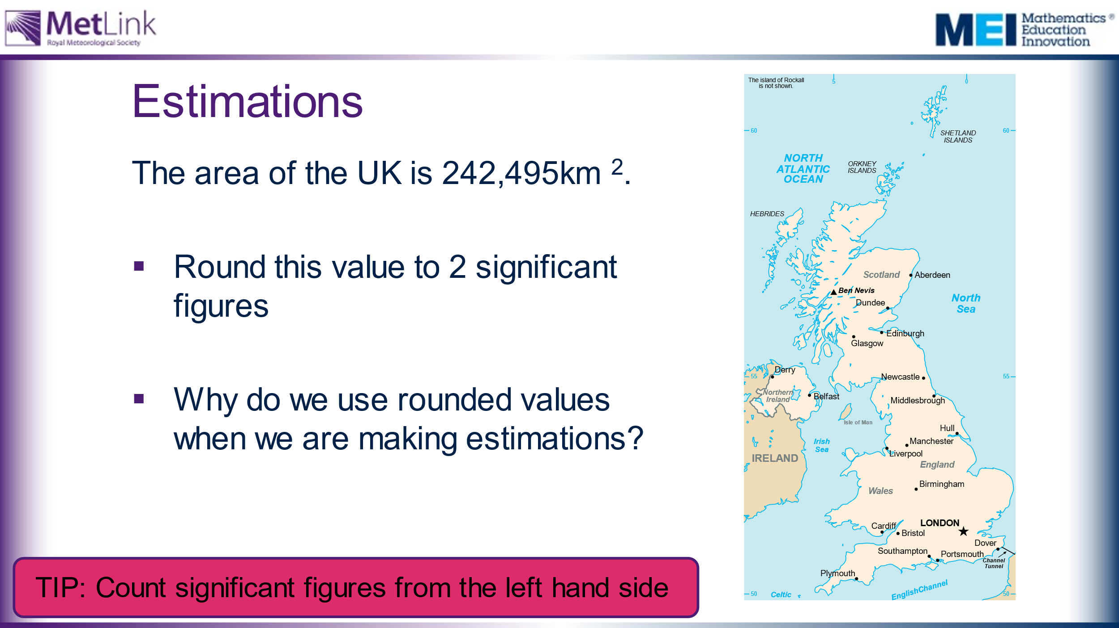 | Opportunity for a reminder of the process of rounding to significant figures. | The TIP box can be edited to take into account methods used by individual classes/teachers.
 | 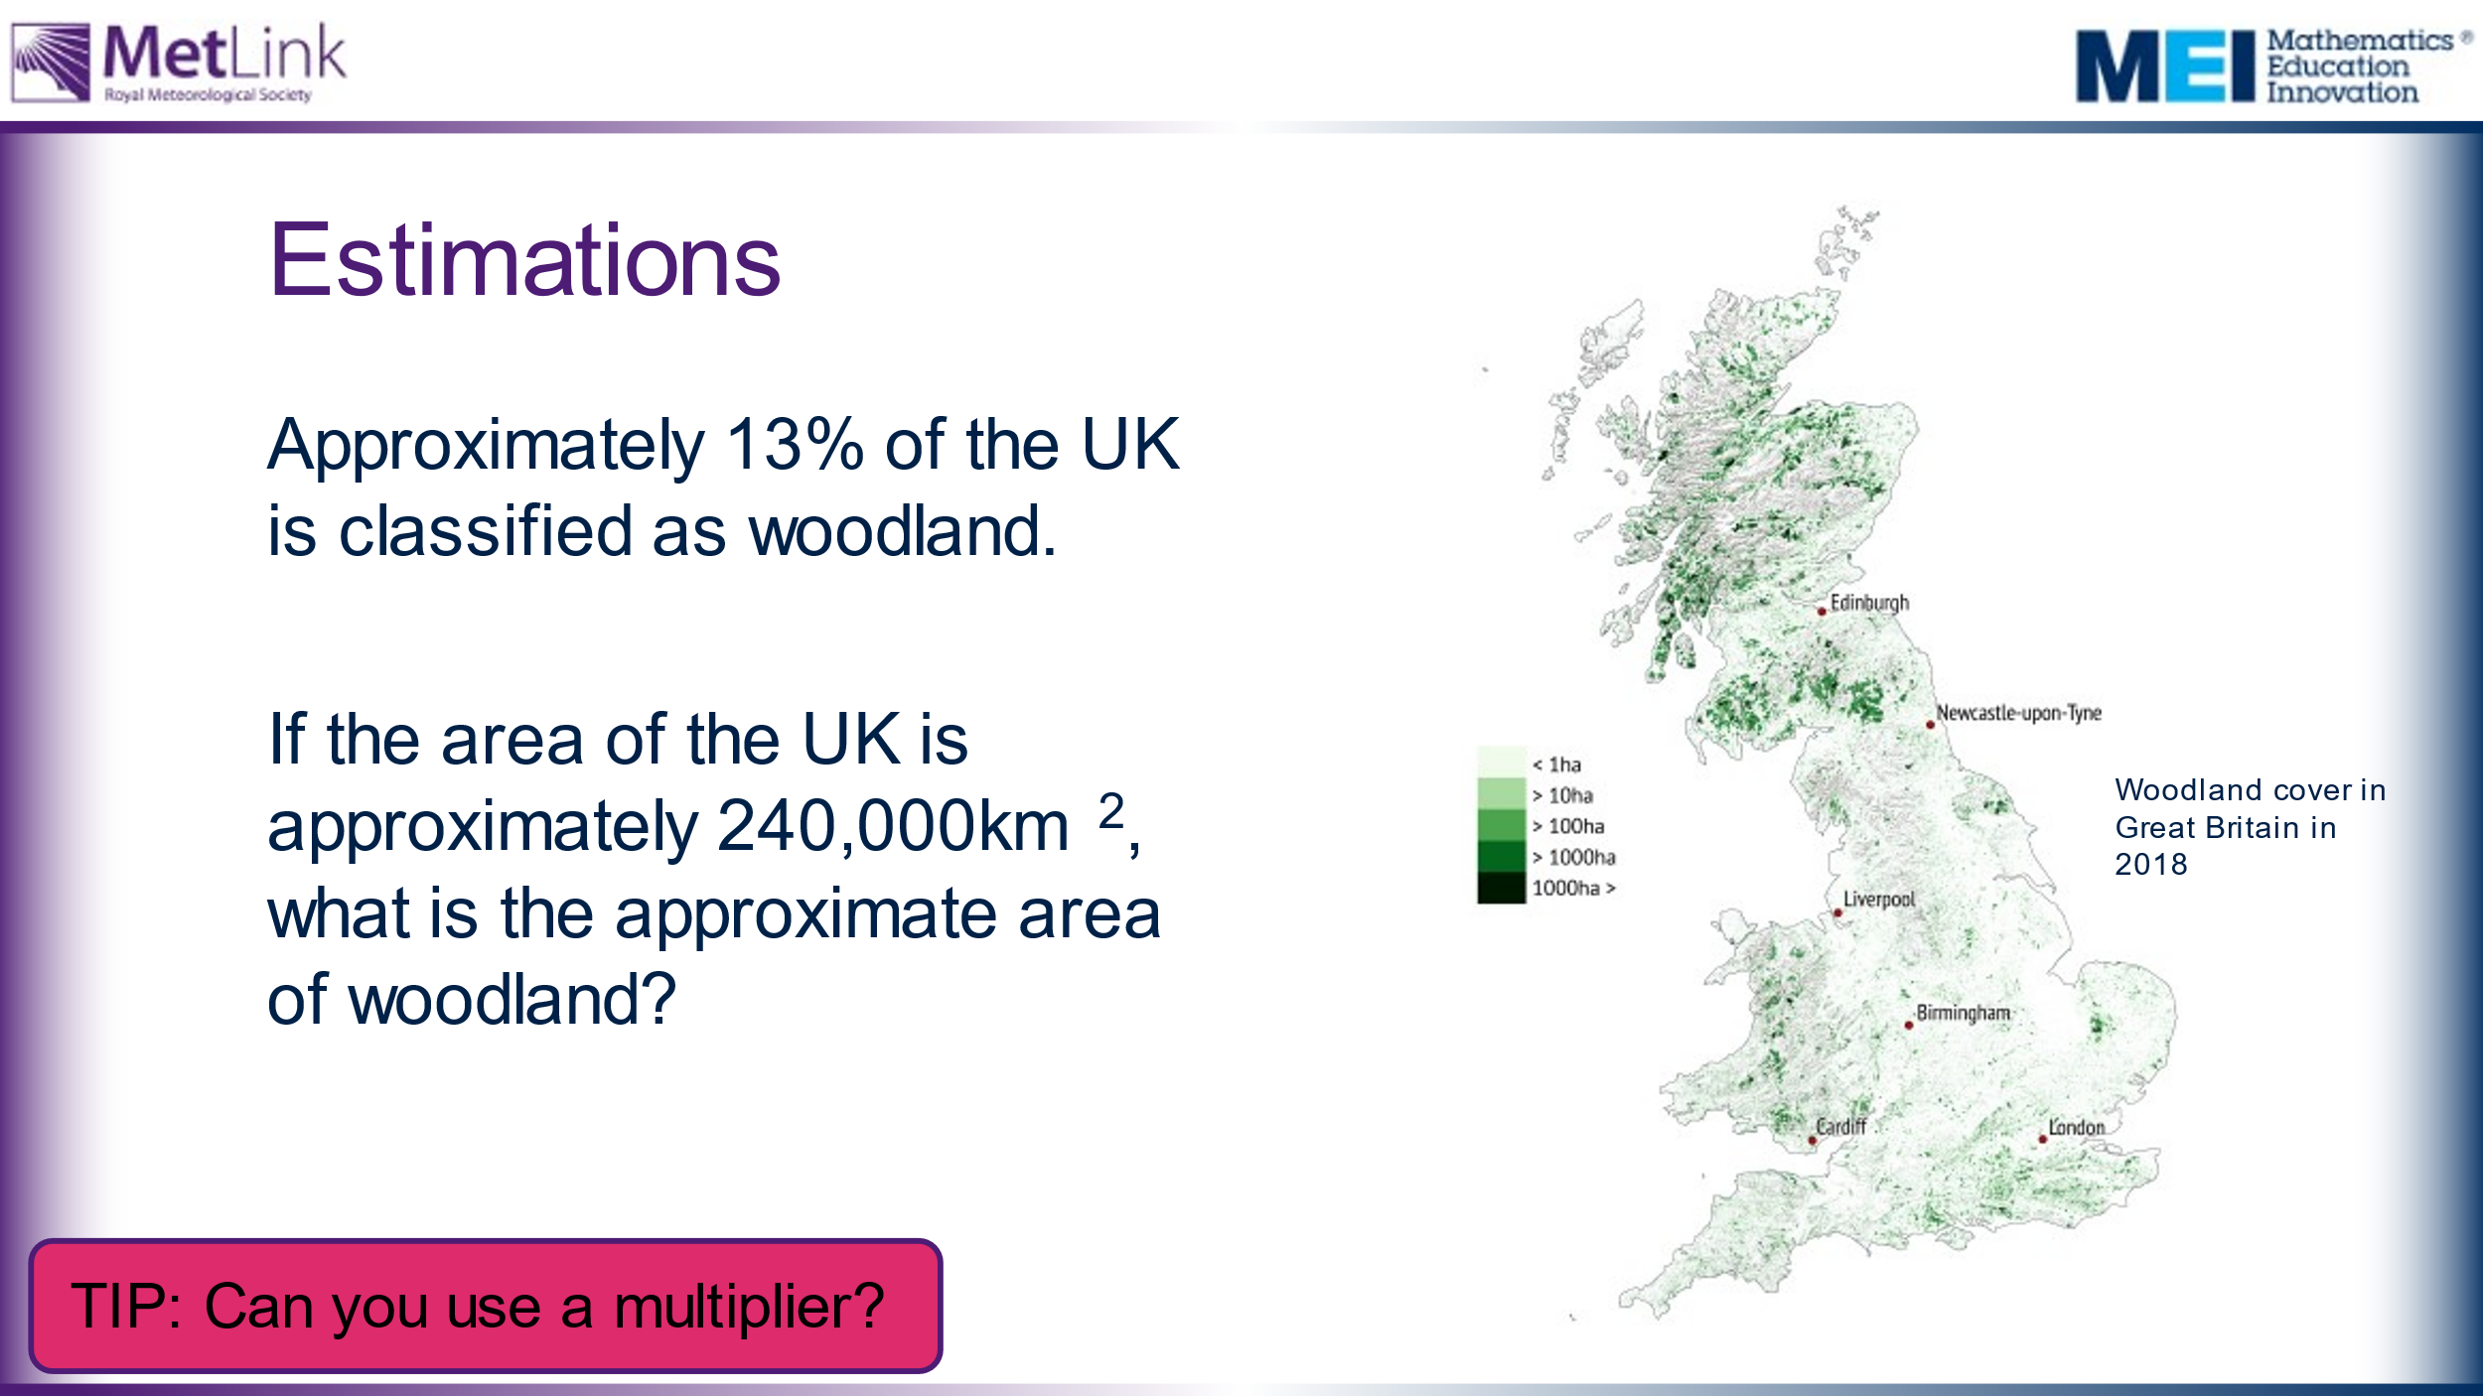 | Estimate how much of the UK is classed as woodland.  Opportunity for a reminder of the process of calculating a percentage. | The TIP box can be edited to take into account methods used by individual classes/teachers.
20 | 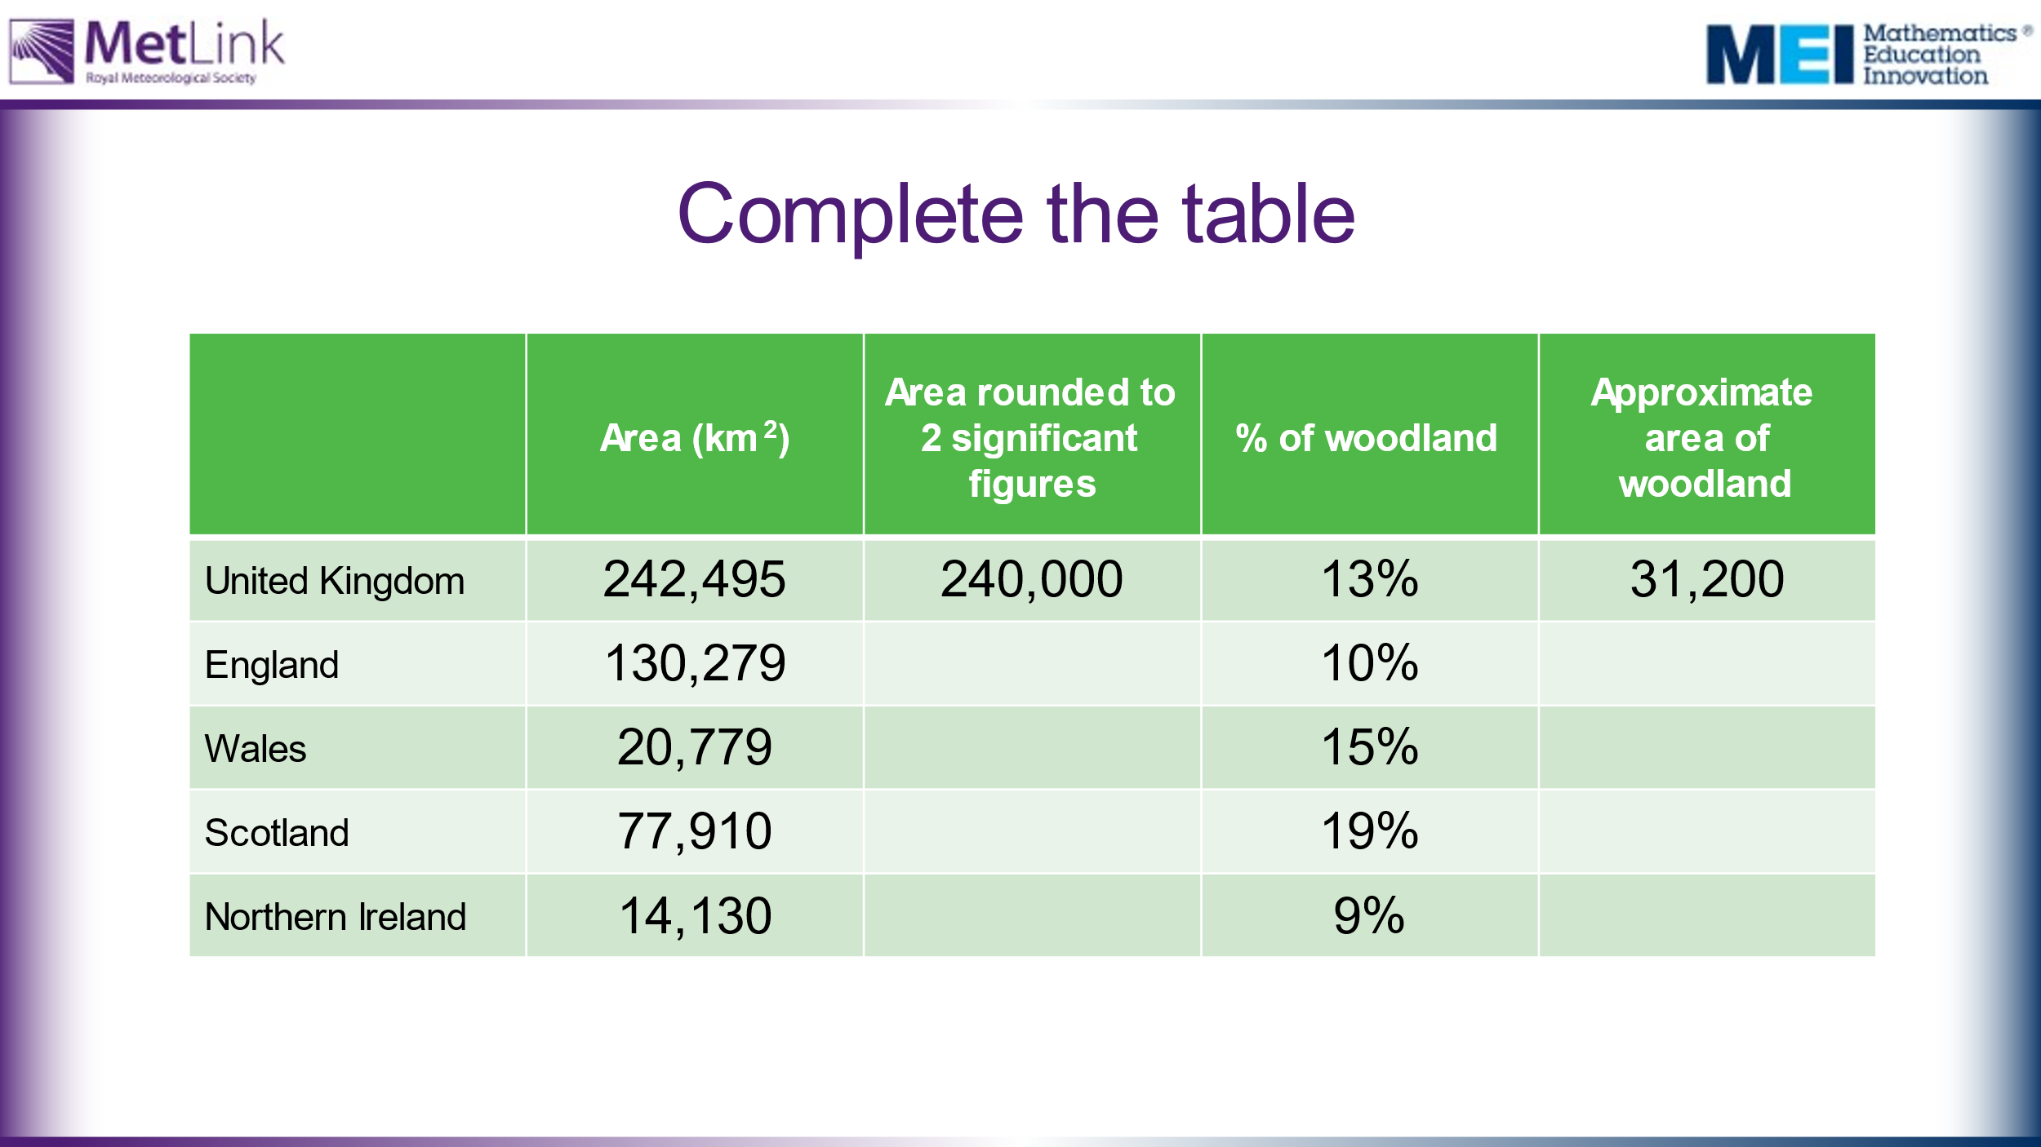 | Students use skills reviewed in previous slides to complete full table for the constituent parts of the UK.  Slide 11 reveals answers one by one. | Answers  England – 130,000 and 13,000  Wales – 21,000 and 3,150  Scotland – 78,000 and 14,820  Northern Ireland – 14,000 and 1,260
30 | 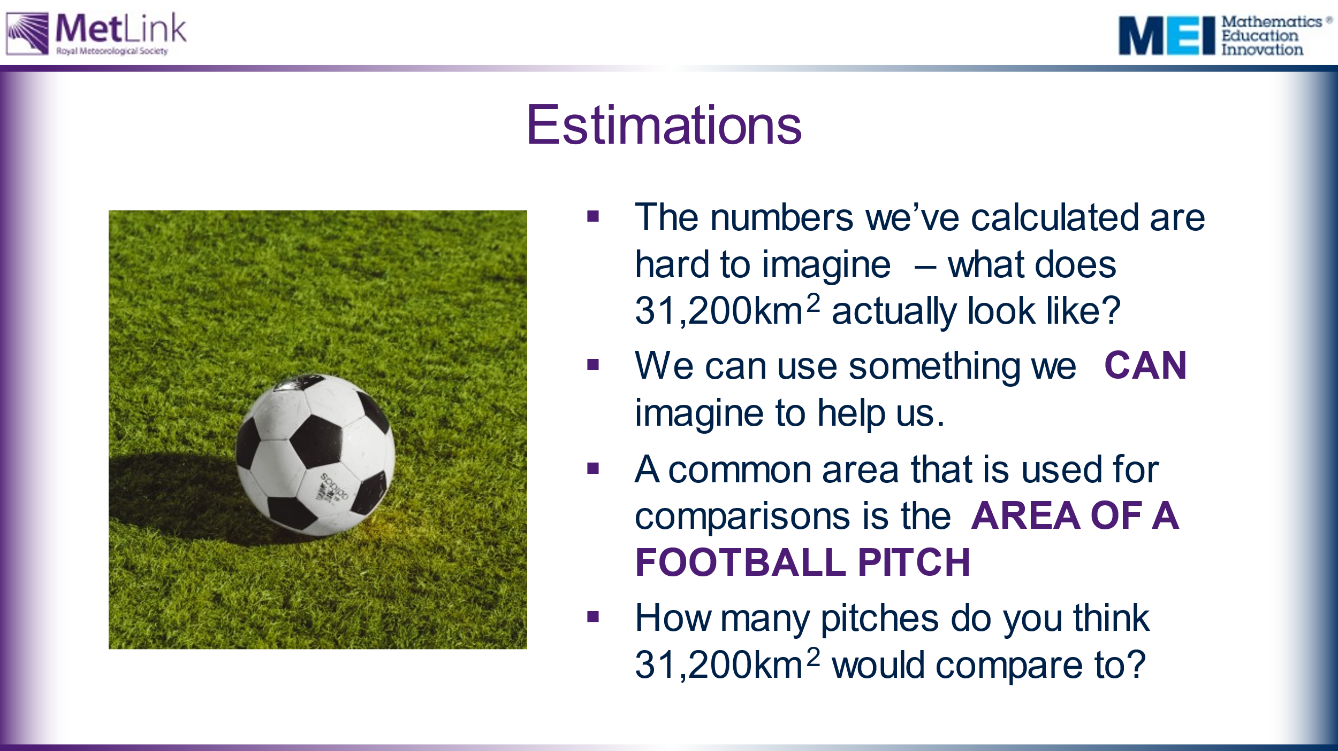  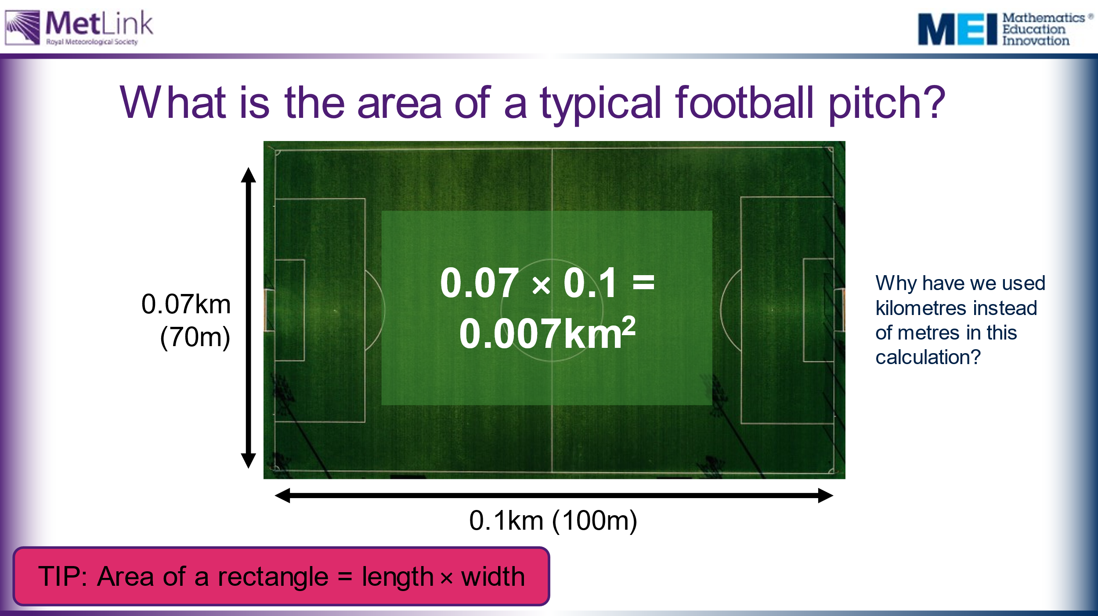  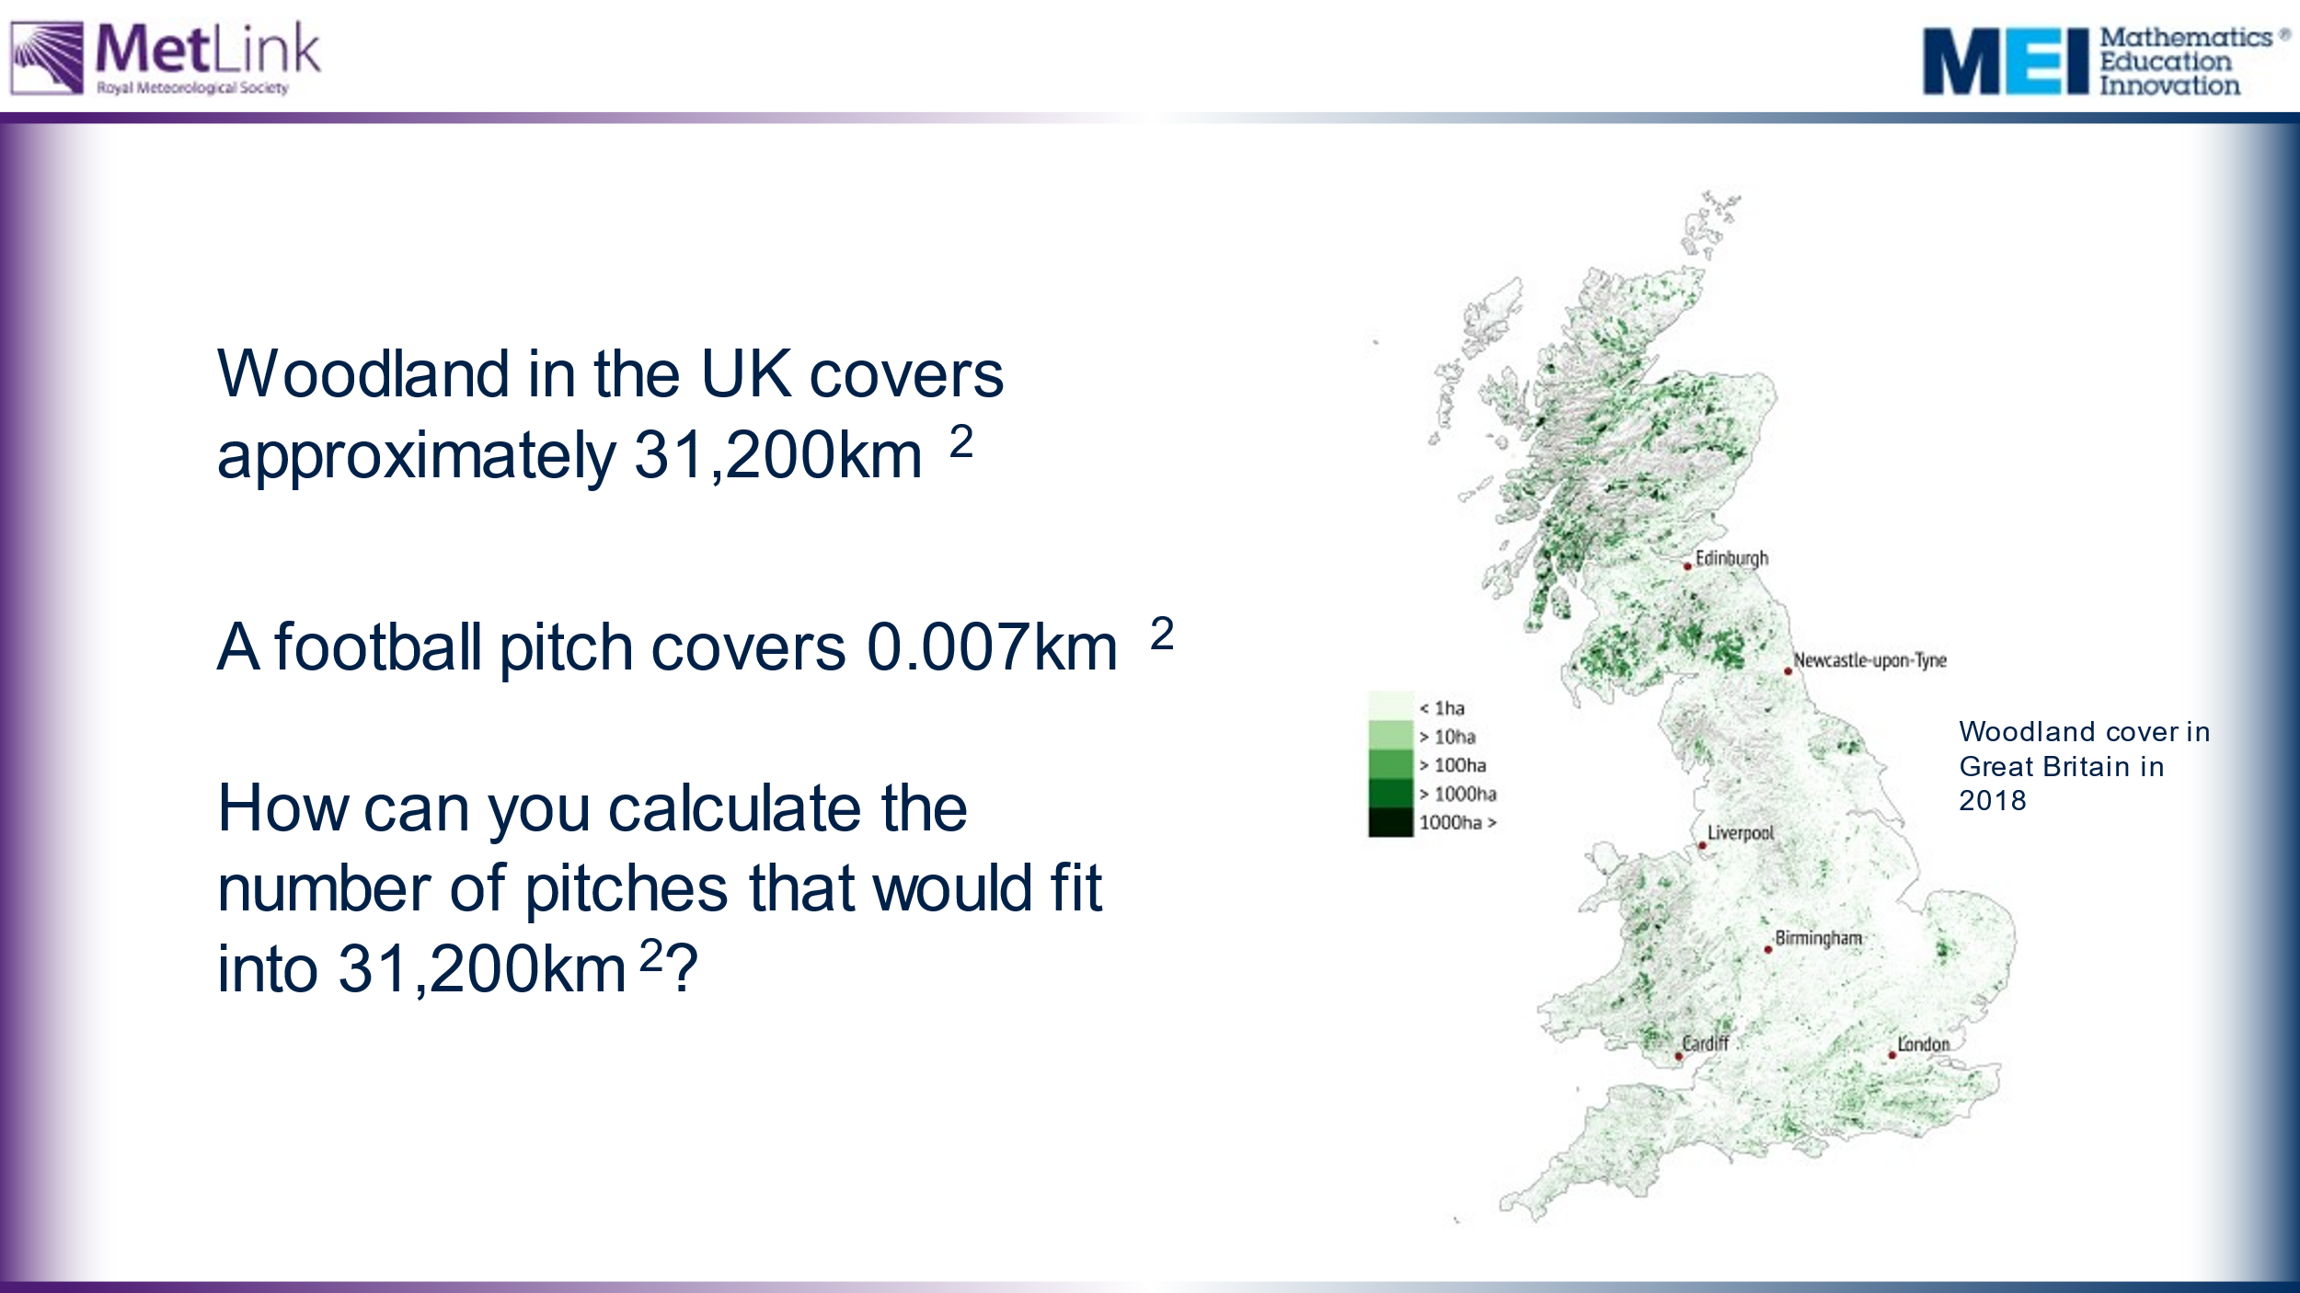 | Slides explain the that we can use comparisons to make sense of large number – a common one being comparing areas to the area of a football pitch (like in the intro video).  Students to be asked about units and why they are calculating the size of a football pitch in km2. | Slides lead students through the calculation of the number of pitches that would fit in the woodland coverage of the UK.  Opportunity to extend here to conversions between square units.  The TIP box can be edited to take into account methods used by individual classes/teachers.
35 | 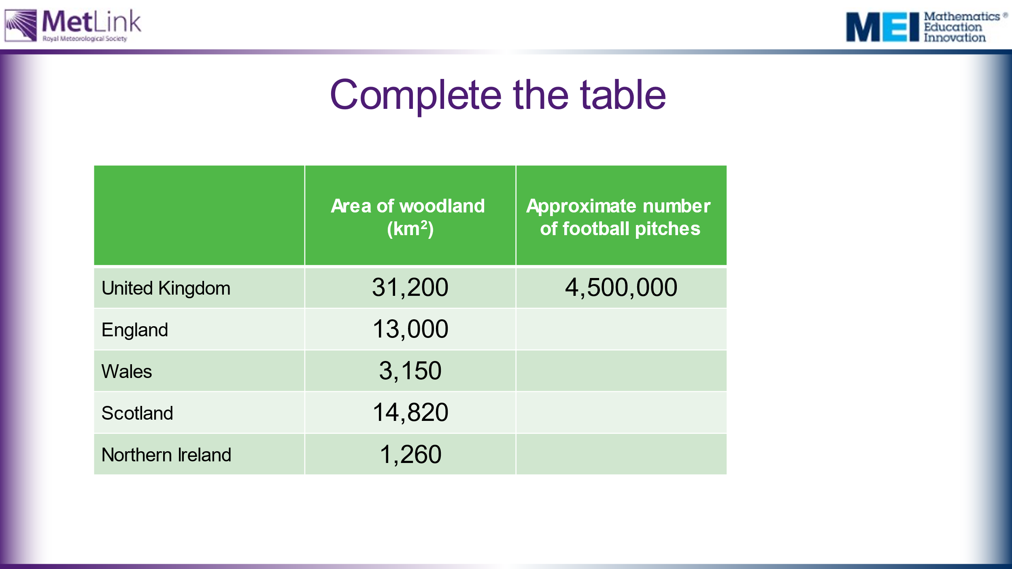  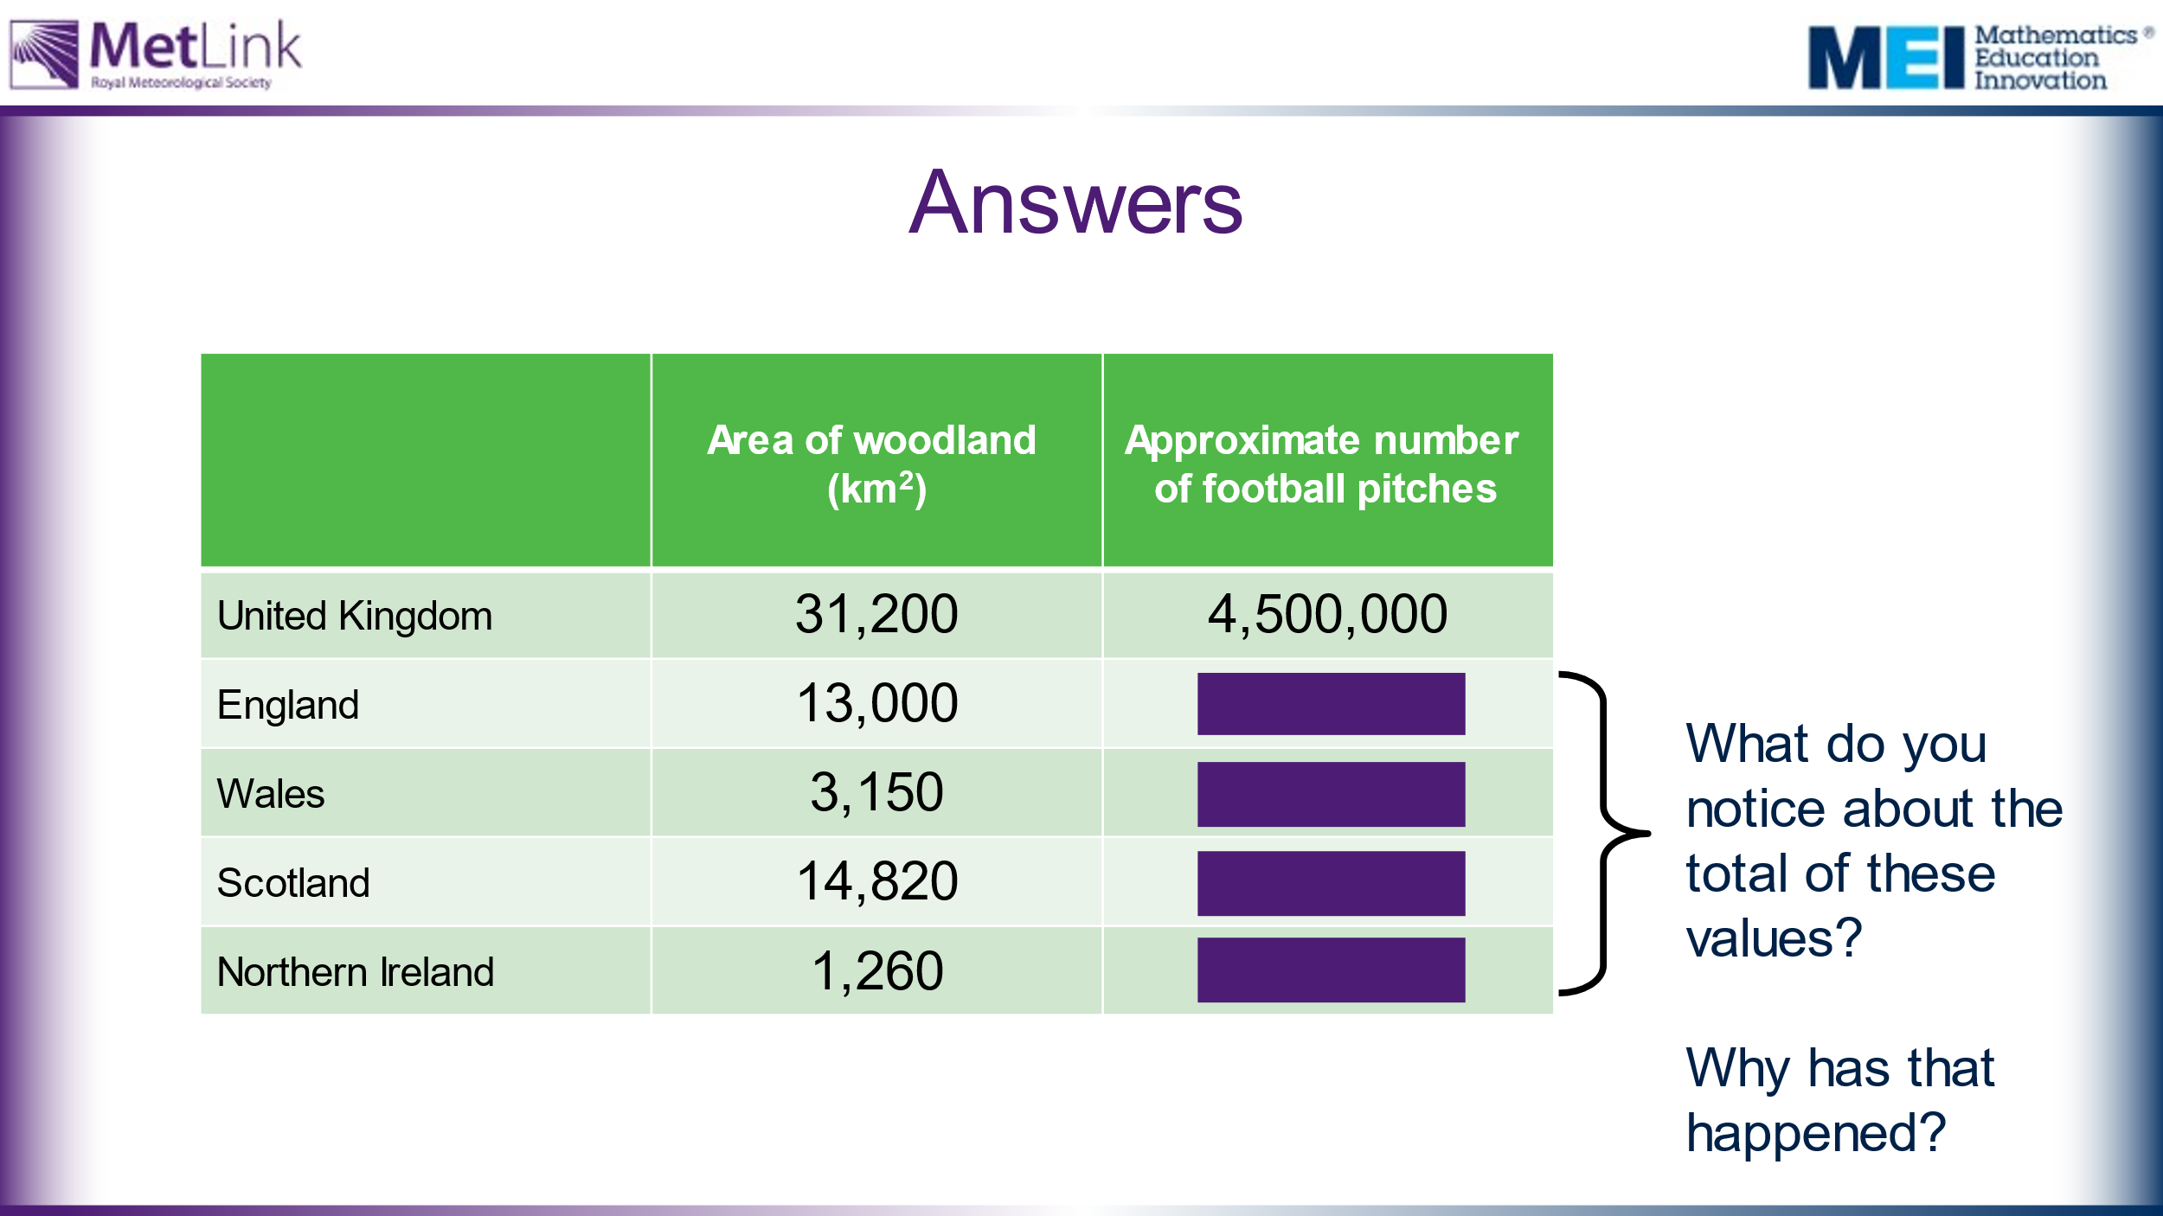 | Students repeat calculations for the constituent parts of the UK.  Slide 16 reveals answers one by one.  Possible probing question about the nuances of estimation – why do the values not total 4,500,000? | Answers  England – 1,900,000  Wales – 450,000  Scotland – 2,100,000  Northern Ireland – 180,000
45 | 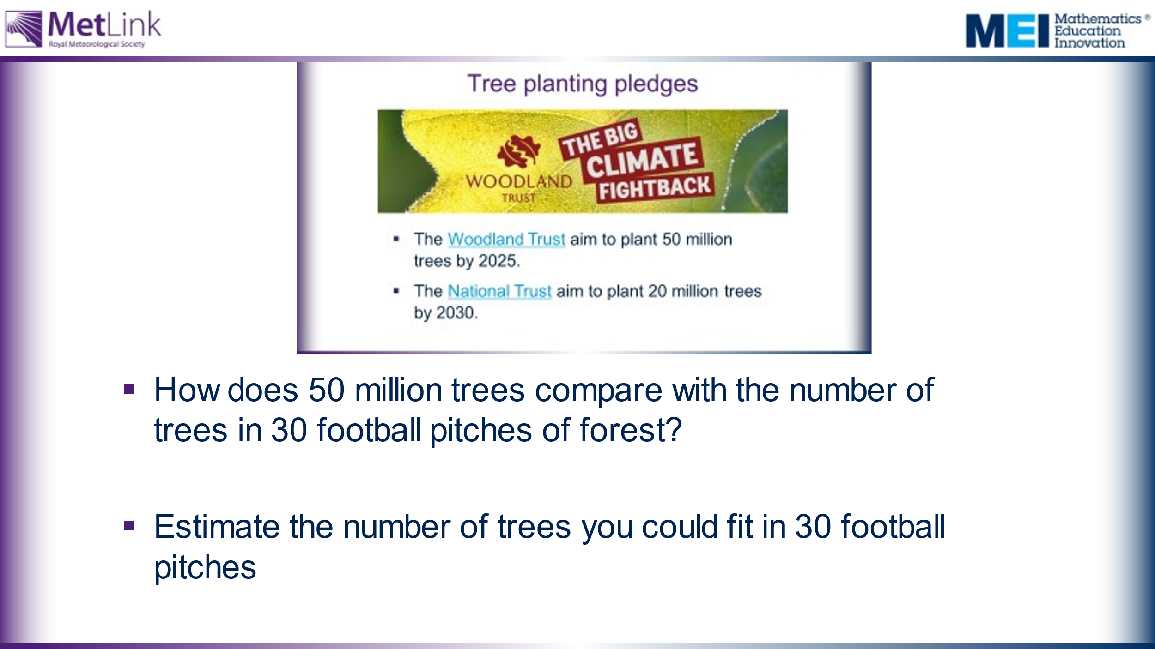 | Back to Tree pledge slide, and reference the introductory video.  Can students used the maths they have developed to answer the questions? | Note that, according to the initial video, 30 football pitches is how much tropical forest is being cut down every minute.  See: https://www.espn.co.uk/football/austria/story/3936111/soccer-stadium-pitch-becomes-300-tree-forest  This website may give students a starting point for their estimate.  We should be building motivation for students to explore the CO₂ absorption rates of trees. Open questions could be used to provoke discussion before moving onto next set of activities based on carbon storage in a tree.
60 | 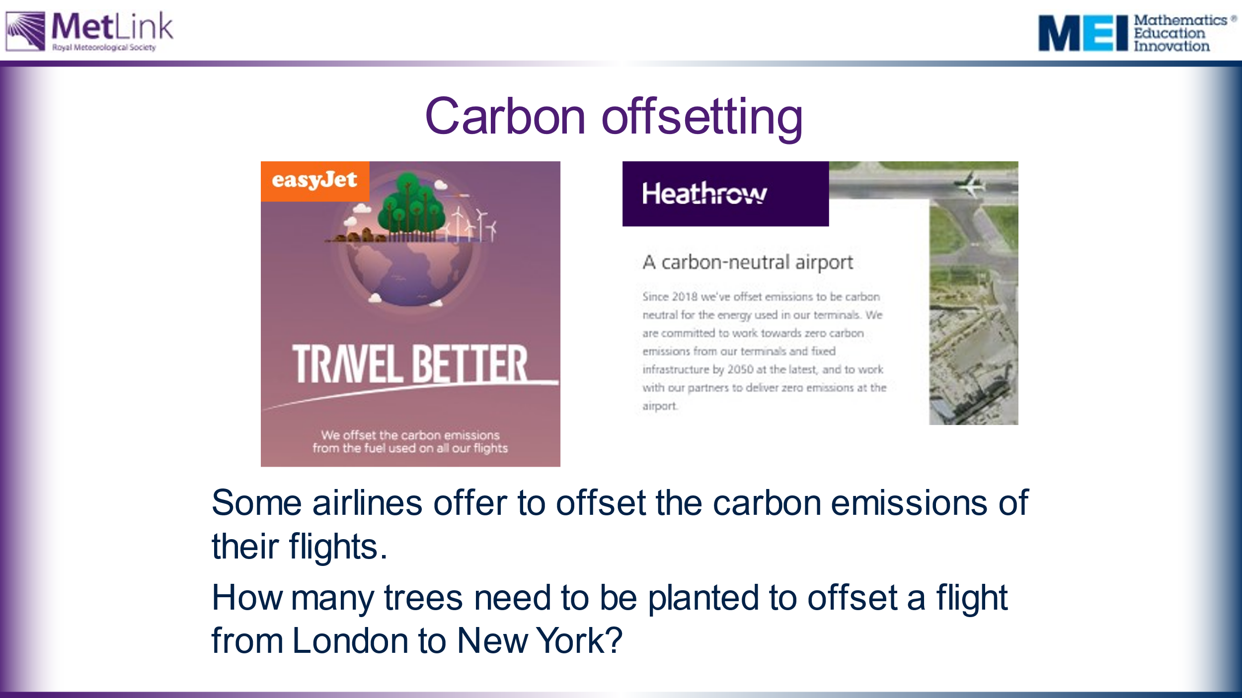 | Easyjet and Heathrow offsetting info.  What are your thoughts about these?  A question to work on during this session:  How many trees would you need to plant to make up for a return flight to New York? | The aim of this slide is to motivate students to explore CO₂ absorption of trees. In order to consider this question we need to investigate how trees absorb CO₂ from the atmosphere and how this changes over the lifespan of a tree.  If appropriate for the class, it might be worth highlighting a social justice issue: Is it okay for people to continue to fly regularly if they can afford to pay for their carbon emissions to be offset?
 | 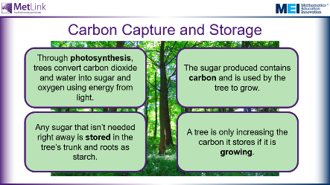 | Emphasise that trees only capture and store carbon from the atmosphere when they are actively growing.  Mature trees, which are no longer growing, shed as much carbon as they absorb from the atmosphere.  What are the implications of this?
65 | 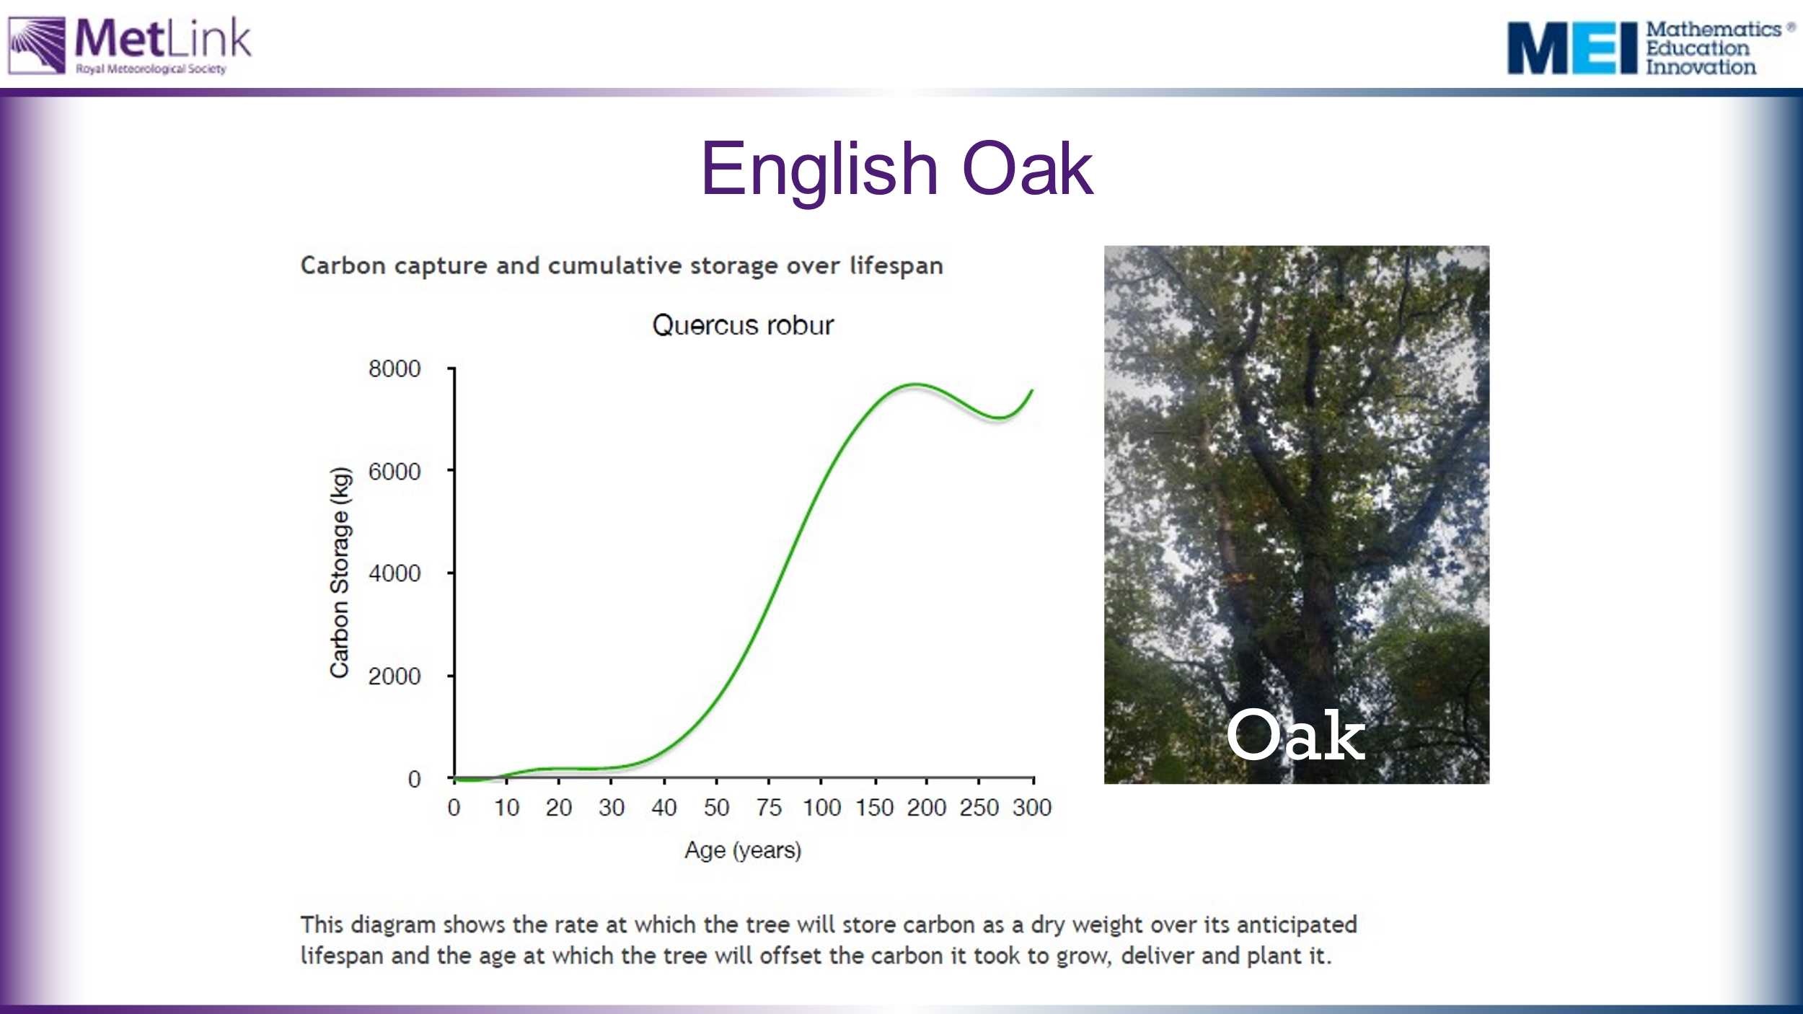 | Main activity:  We are going to look at data showing how much CO₂ different species of tree absorb from the atmosphere.  This will allow us to address some of the issues and questions raised in the session so far, including:  - How many trees need to be planted to offset a flight from London to New York  - What kinds of trees and woodlands would it be best for us to plant?  Task 1: Provide students, in groups, with the three graphs and ask them to write down three things that they notice. Collect these points and any questions or issues raised. Show slide with all three graphs together on the board when collecting their views.  Emphasise that it is very difficult to compare the three graphs in their current form. Can your students say why? | The aim of task 1 is to draw attention to some of the issues with the data as presented. Some questions that might emerge include:  - What do the graphs actually show?  - What does it mean for a cumulative frequency graph to go down? (as it does for the English Oak graph)  - Can you work out which trees are best to plant from this data? (It is very difficult to compare these graphs in their current form)  Draw attention to the scales on the graphs – not only are the scales different for the different species, the scales for Age are not linear – the intervals on the x-axes vary. Why do they change? How is this misleading? (or is it not?)  Information about how this data was collected is available here: https://www.treeconomics.co.uk/projects/barchamcarbonperformanceproject/ and here: https://www.barcham.co.uk/store/. Each tree in the Barcham shop has a certificate.  The negative carbon storage in the first few years of each graph are explained by taking into account the carbon emissions in driving to collect the tree before planting it.  The Norway Spruce is a common variety of Christmas Tree.
 | 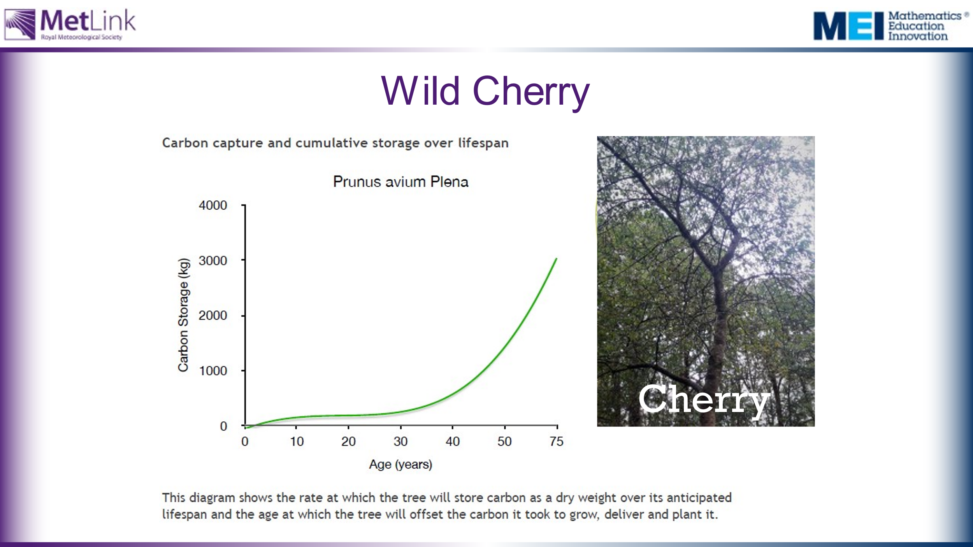
 | 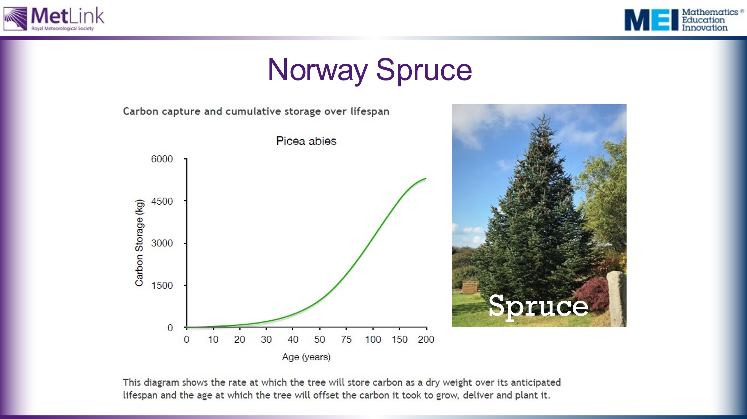
 | 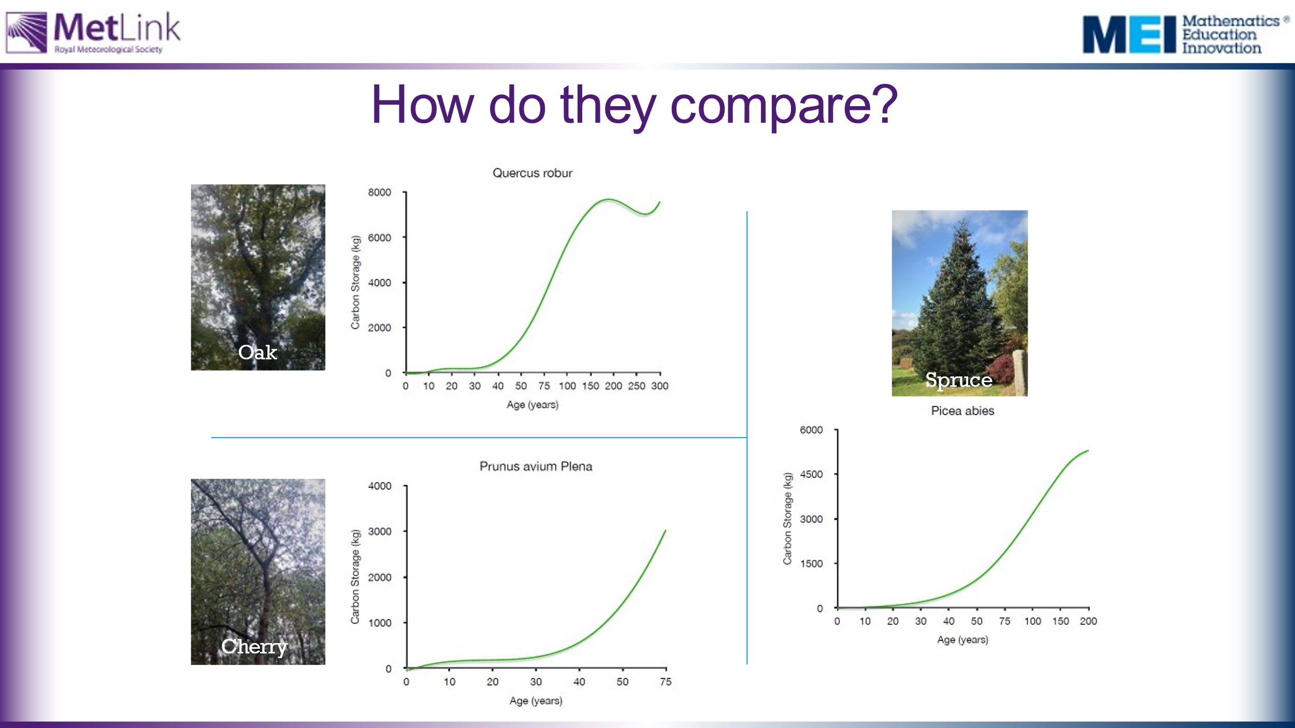
75 | 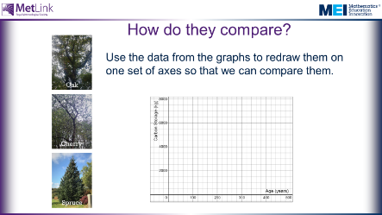 | Task 2: Provide students with blank axes and data take from the graphs. Students should plot the data from each tree on the same axes to allow for effective comparisons to be made between the trees. | Warning: It is quite fiddly to read information accurately from the graphs. Students will need a ruler and pencil, and careful attention needs to be paid to the varying scales on the graphs.  It may be worth showing students the following hidden slide to give them an idea of a possible approach.
 | 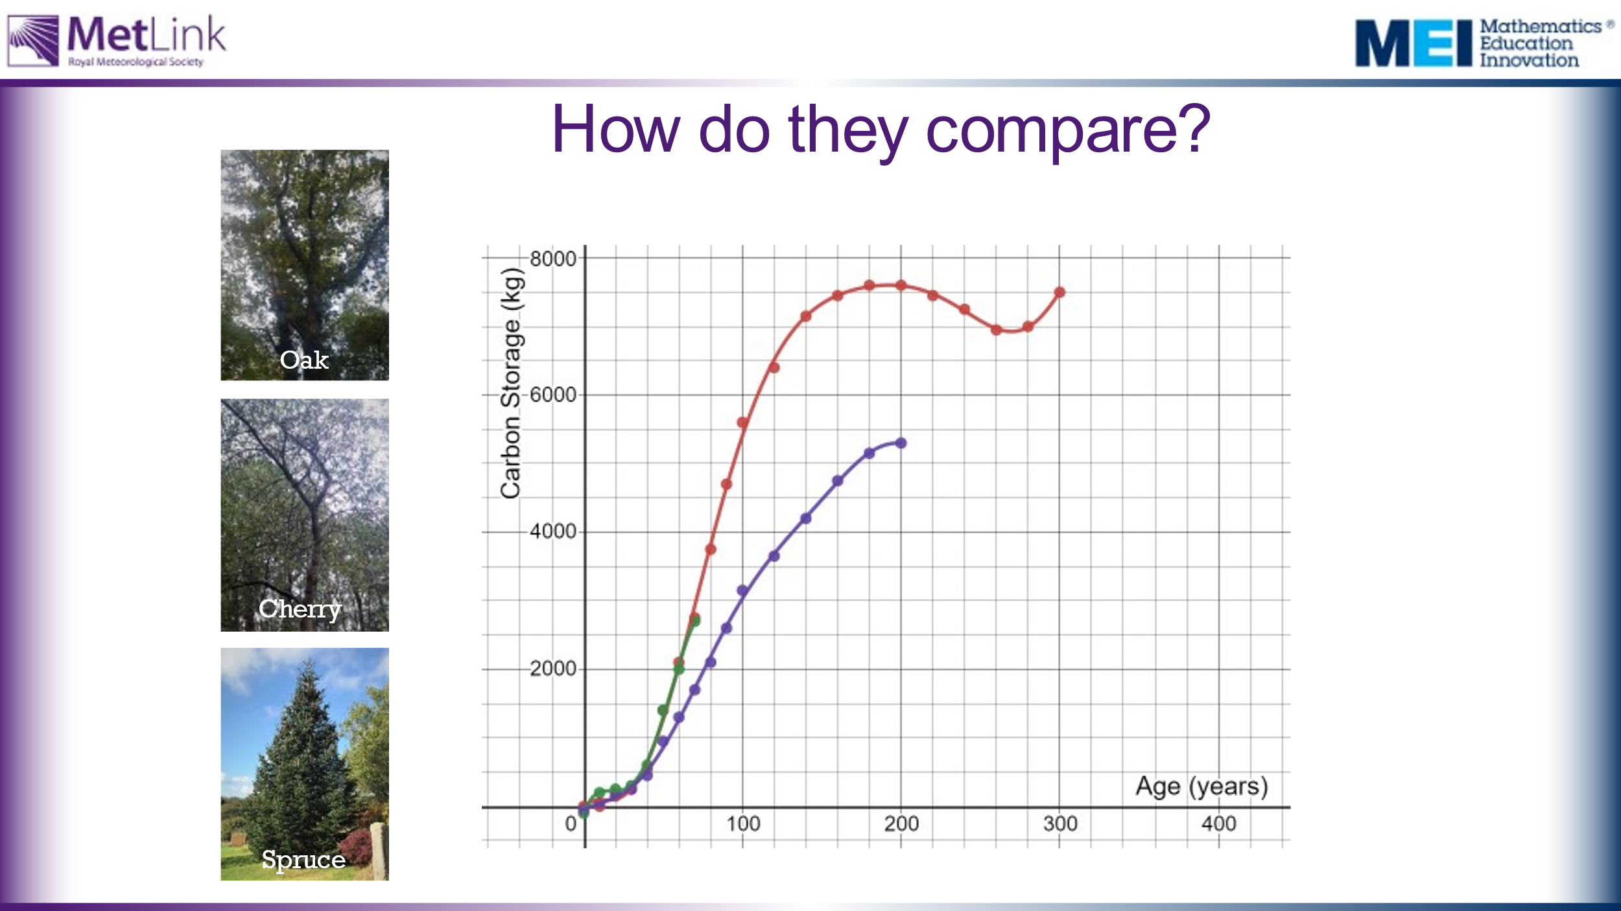 | What conclusions can we draw?  Here are the three sets of data plotted on the same set of axes, in Desmos: https://www.desmos.com/calculator/rci87lp05w  After 15 minutes they need to present their argument for which trees they would choose to plant and why. | It’s worth noting that it takes around 200 years for Oak and Spruce trees to store their maximum amount of carbon.
 | 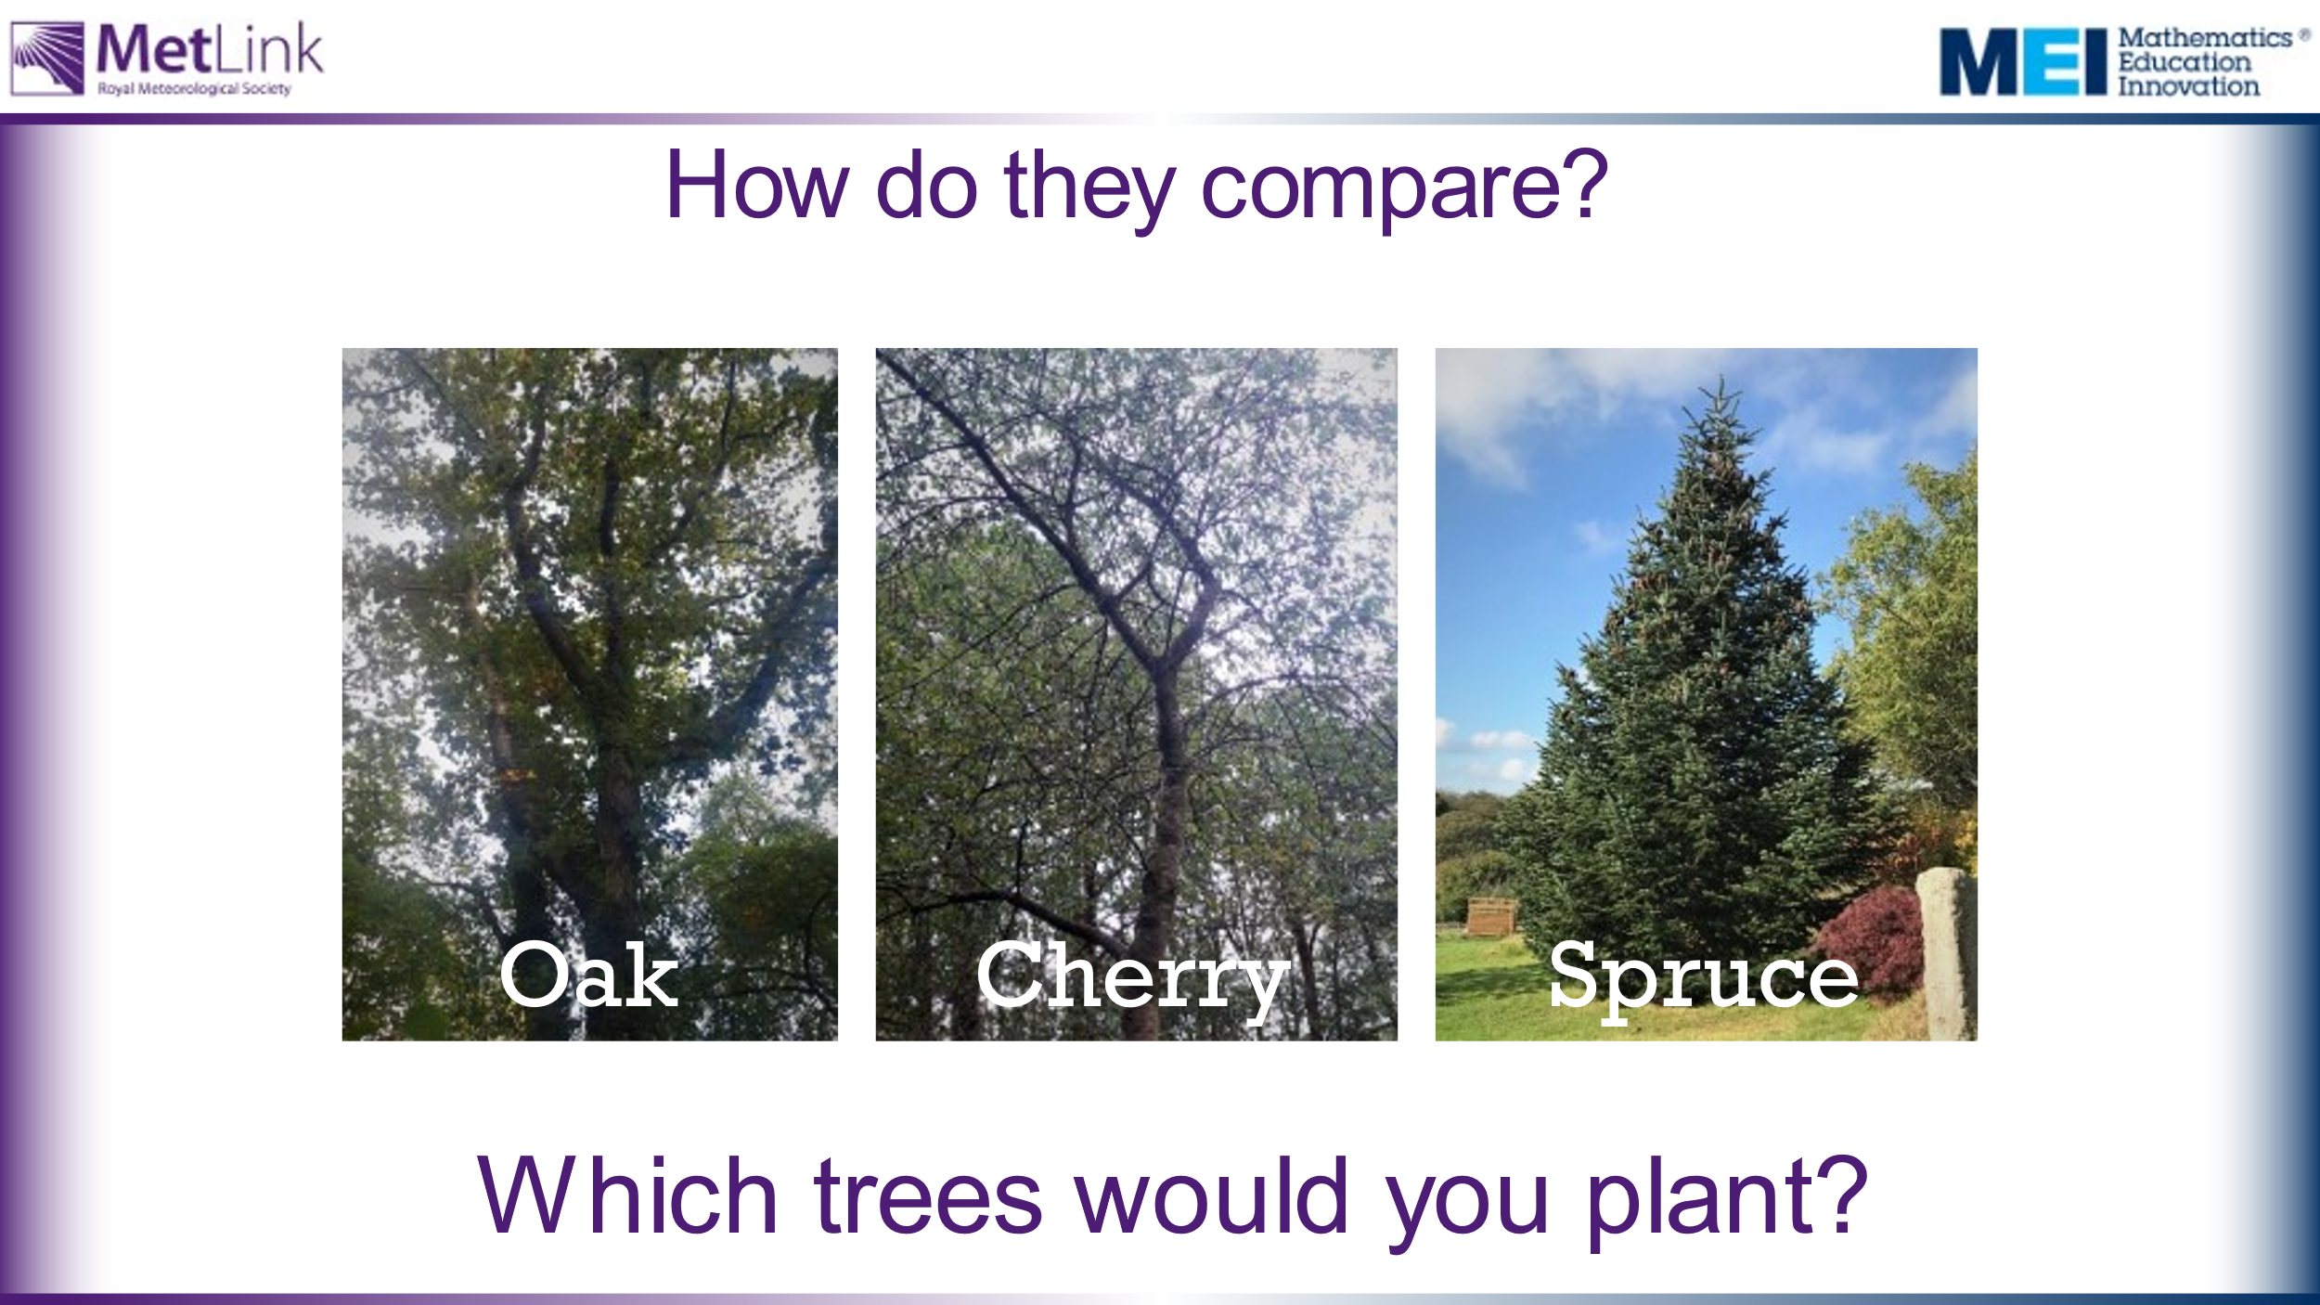
100 | 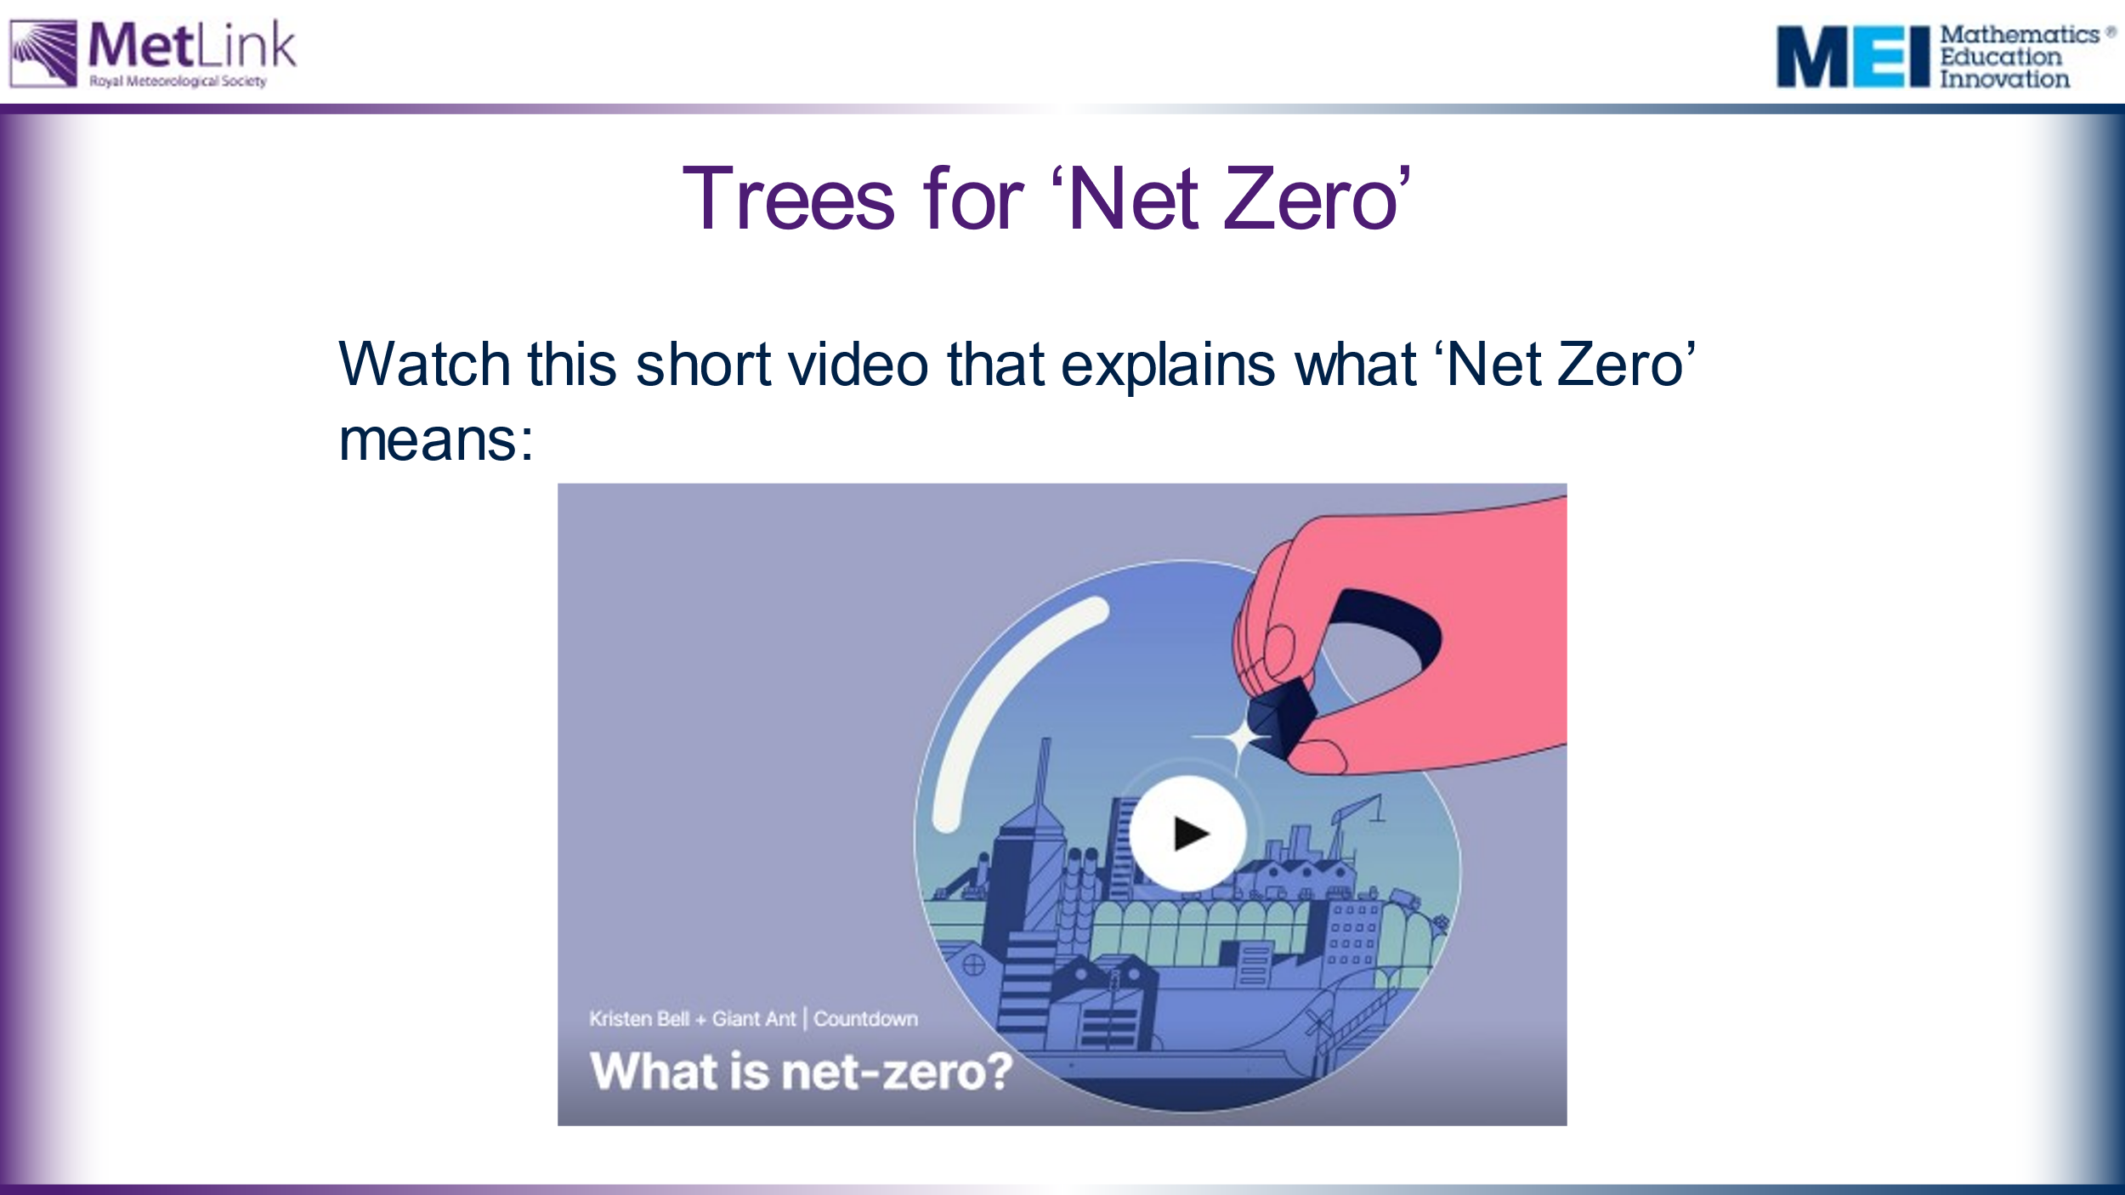 | Watch the video: https://www.ted.com/talks/kristen_bell_giant_ant_what_is_net_zero#t-40608 | ‘Net Zero’ is introduced here in order to allow us to consider the contribution planting trees might make towards achieving Net Zero.
105 | 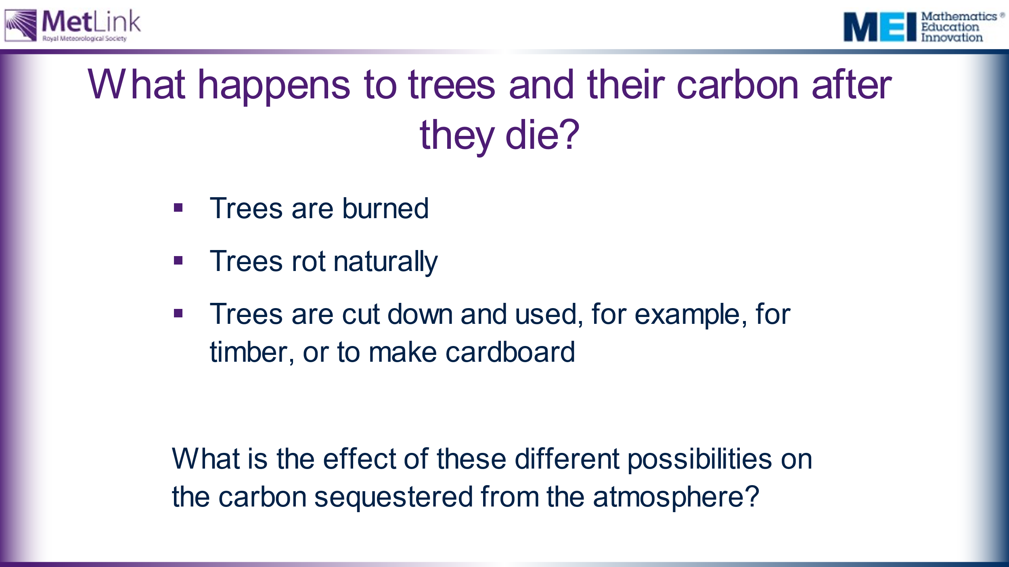 | Collect students’ initial and intuitive responses to the title question before revealing the three suggestions. | The Trees for Life website (https://treesforlife.org.uk/into-the-forest/habitats-and-ecology/ecology/) has much information about decomposition and decay of trees, as well as information about the importance of dead wood. It suggests that it might take around 40 years for a dead tree to completely decompose, whereas the leaves a tree drops will decompose completely within a year.  This article from Science Direct: https://www.sciencedirect.com/science/article/pii/S1364032116306050 has much information about trees being used to produce timber for construction.  Trees being burned quickly released carbon back into the atmosphere. Trees rotting slowly releases some of the carbon into the atmosphere, but some would be absorbed into the ground. Using trees for building effectively ‘locks’ the carbon out of the atmosphere, provided the products built remain intact.
 | 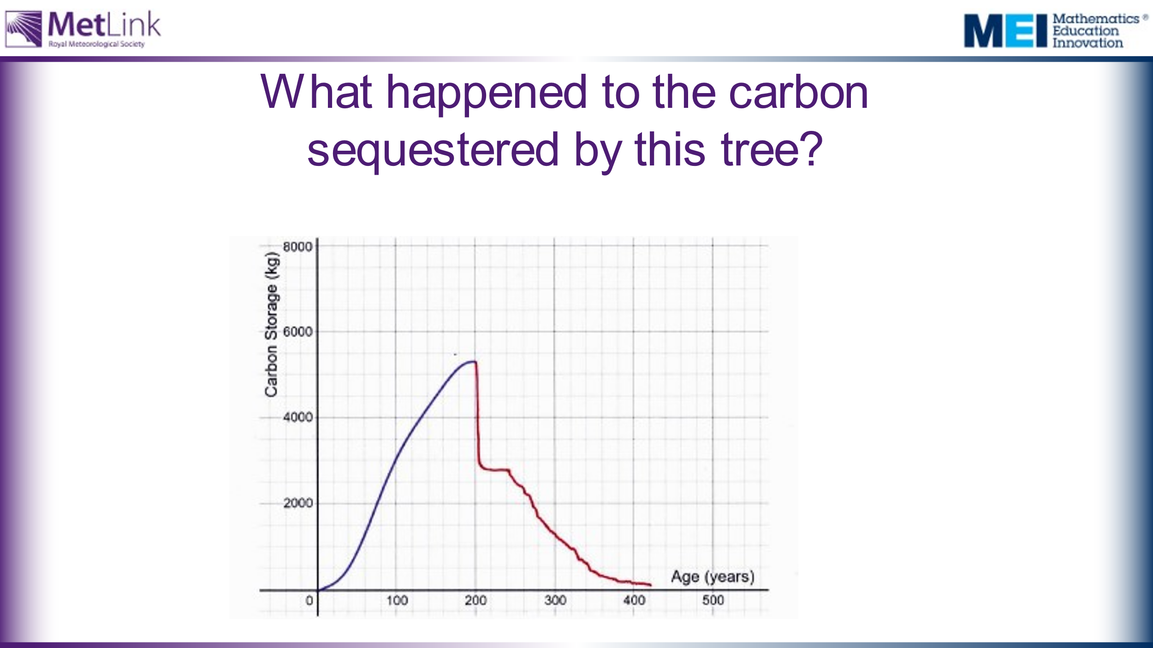 | Ask students to explain the key parts of this graph.  What do they think the tree was used for after it died?
 | 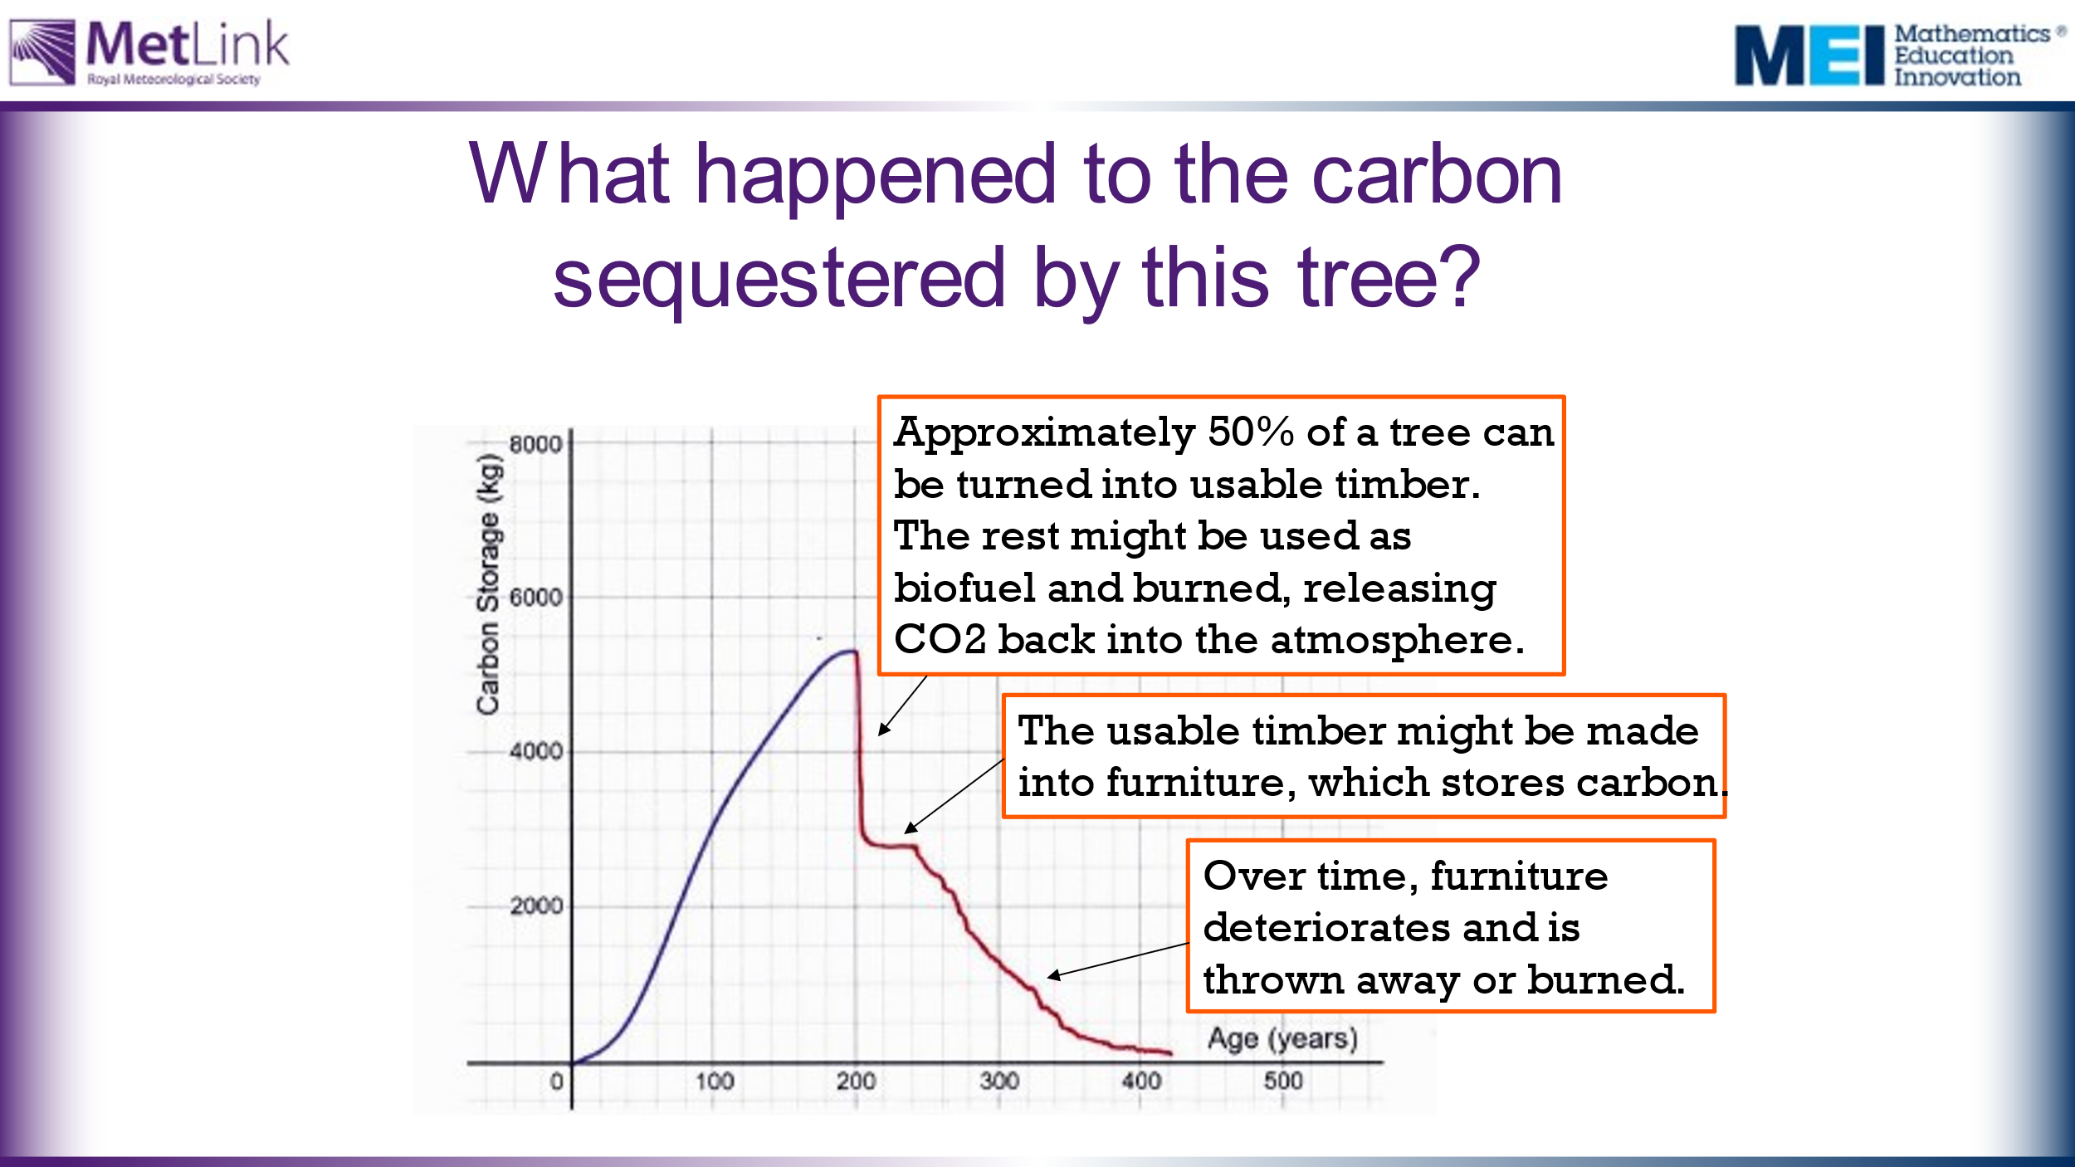 | Emphasise that even a tree that is used for production purposes is likely to only capture and store carbon for a limited period. Over time, the products deteriorate and so the wood is burned or rots, returning the CO₂ to the atmosphere. It’s worth considering whether this can be avoided. Some tree litter from dead trees may get covered and preserved, or continue to store carbon as soil.
 | 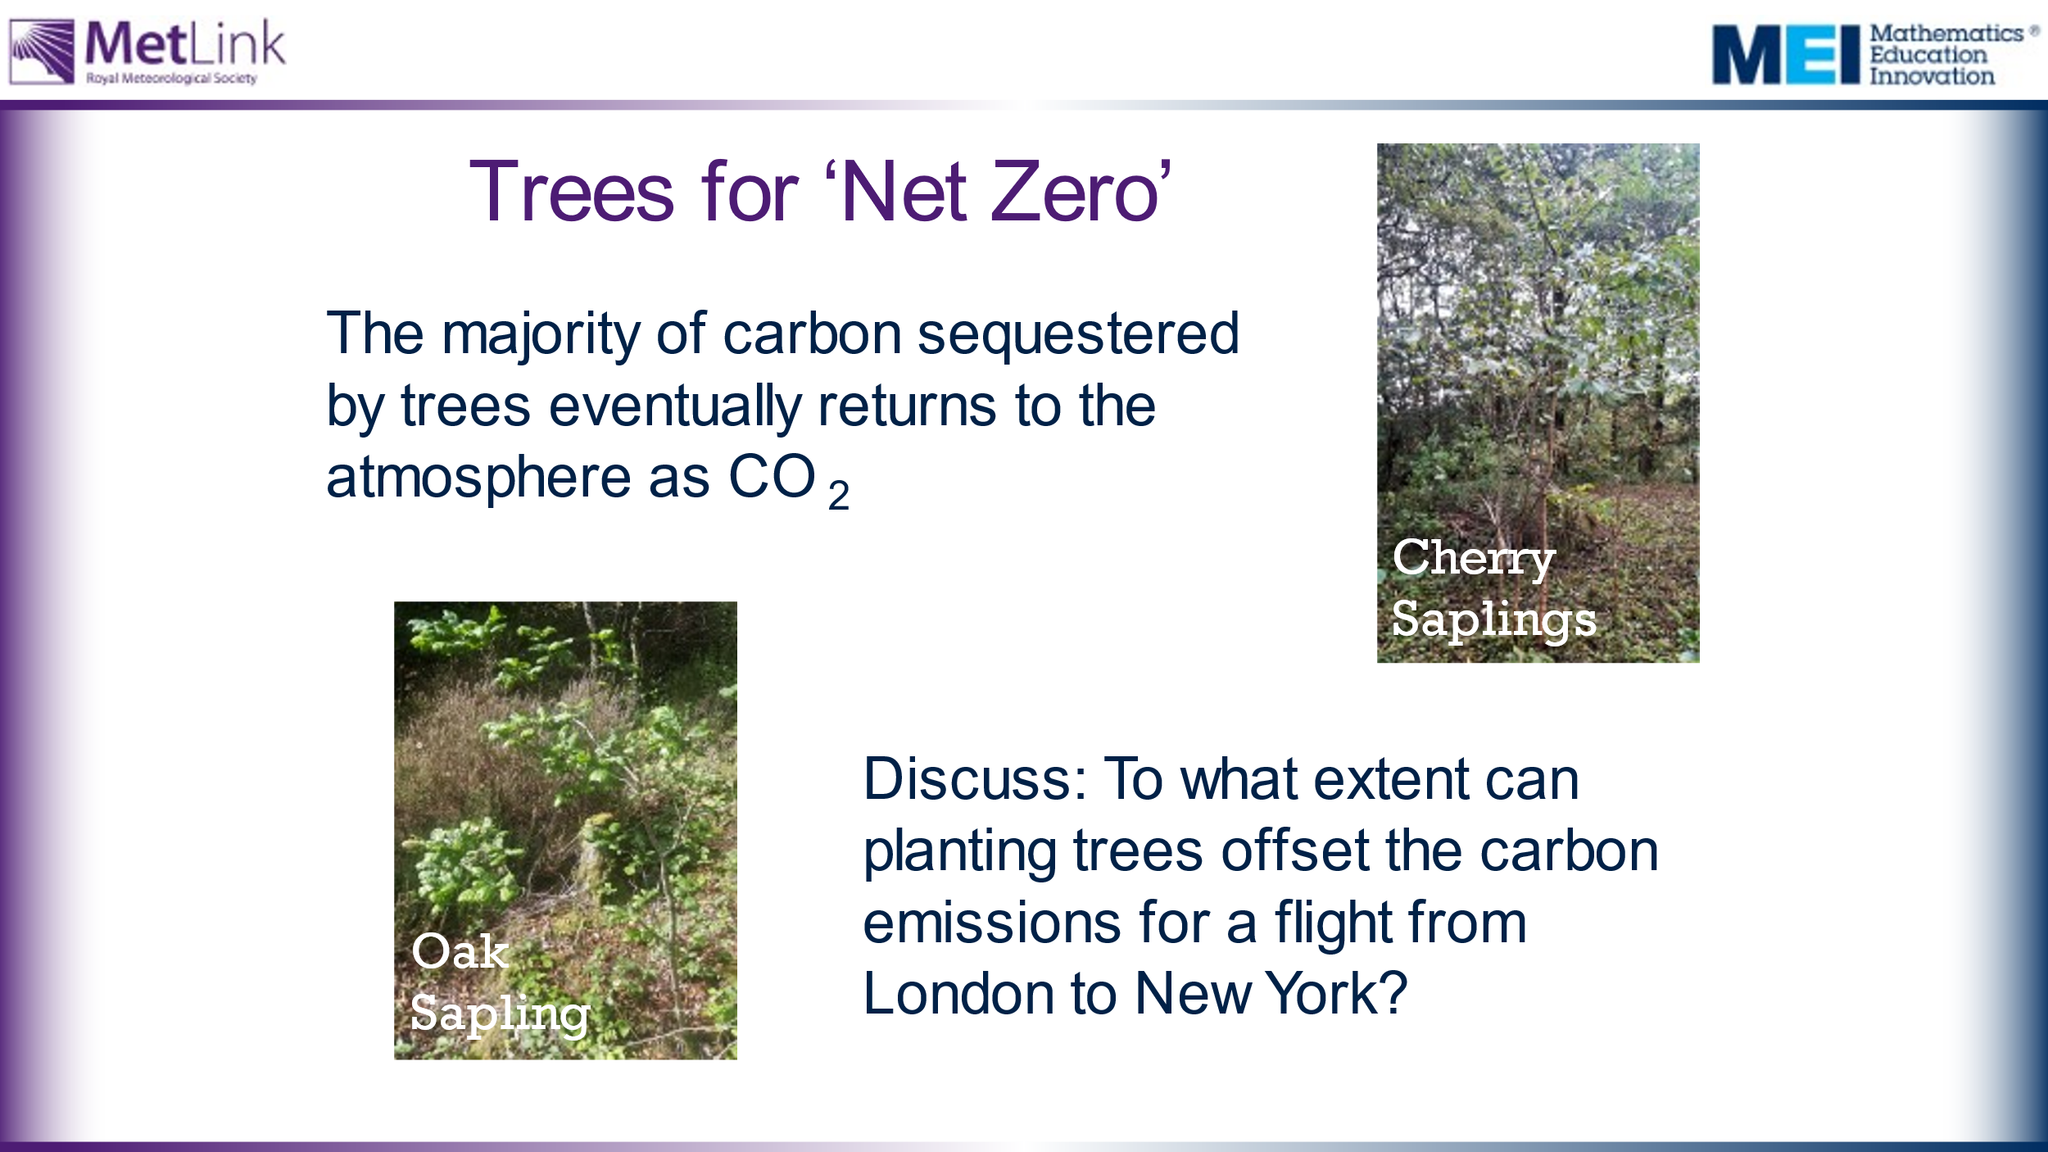 | Discuss the extent to which planting trees can offset the carbon emissions from flights. | The conclusion that should be reached is that, to offset one flight, you need to keep replacing the tree that you planted. It may be worth also considering the implications for land use if planting trees is going to be used to offset ongoing carbon emissions.
120 | 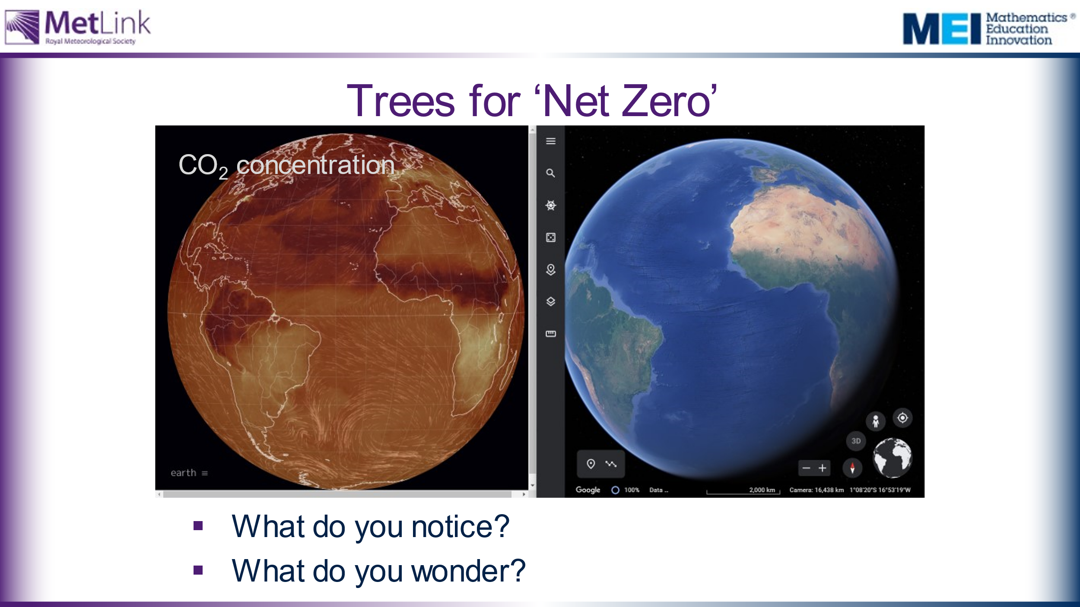 | Extension task possibility.  Students may want to explore the links between CO₂ concentration on Earth and the location of rainforests by playing with the following websites:  https://earth.nullschool.net/  https://earth.google.com/web/

