UK Climate Change and the Sustainable Development Goals

As the UK climate continues to change, it has an impact on our ability to meet the UN’s Sustainable Development Goals.

Read the 2021 UK Climate Change Risk Assessment

Task: Annotate this graphic showing the UN’s Sustainable Development Goals with ways that they might be affected by climate change. One is already done as an example.

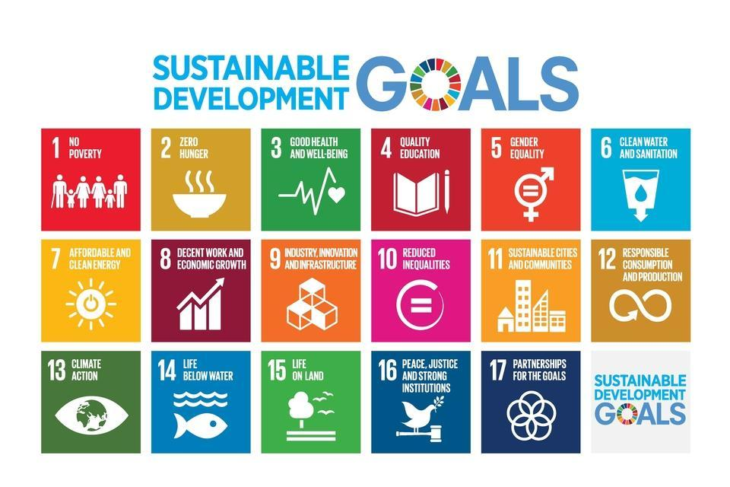
Water supplies can become scarce in warm summers

Which Sustainable Development Goal do you think is the most negatively impacted by climate change? Why?
__________________________________________________________________________
__________________________________________________________________________
__________________________________________________________________________

List five ways that we can adapt to climate change, and make progress to meeting one of the Sustainable Development Goals:

Adaptation to Climate Change Sustainable Development Goal

1 ) _________________________________ ________________________________
_________________________________ ________________________________
_________________________________ ________________________________
_________________________________ ________________________________

2 ) _________________________________ ________________________________
_________________________________ ________________________________
_________________________________ ________________________________
_________________________________ ________________________________

3 ) _________________________________ ________________________________
_________________________________ ________________________________
_________________________________ ________________________________
_________________________________ ________________________________

4 ) _________________________________ ________________________________
_________________________________ ________________________________
_________________________________ ________________________________
_________________________________ ________________________________

5 ) _________________________________ ________________________________
_________________________________ ________________________________
_________________________________ ________________________________
_________________________________ ________________________________

