Track a Tropical Storm!

This exercise uses the https://earth.nullschool.net/ website to track a North Atlantic tropical storm.
Firstly, use the Wikipedia overview documents e.g. https://en.wikipedia.org/wiki/2021_Atlantic_hurricane_season (edit the year in the link to see other years) to pick a tropical storm to study.

Storm Name ___________________________________
Storm start date ________________________________
Storm category _________________________________

Now, go to https://earth.nullschool.net/ and click on the ‘earth’ text at the bottom left of the screen. Click on the little calendar icon to select the date when your Tropical storm started.
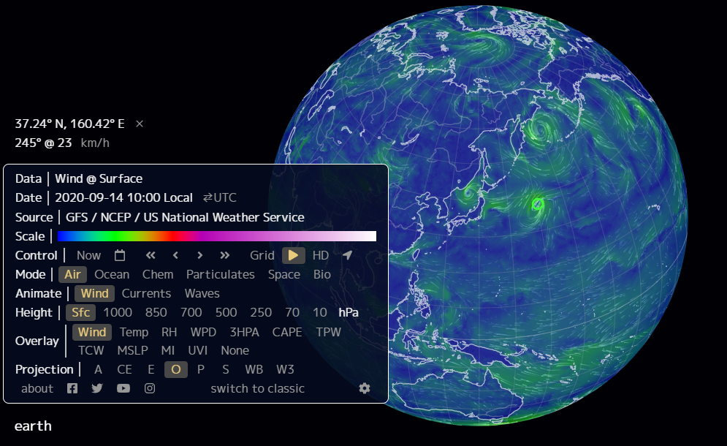

Identify your tropical storm on the map. Click in the centre of it to reveal its latitude and longitude:
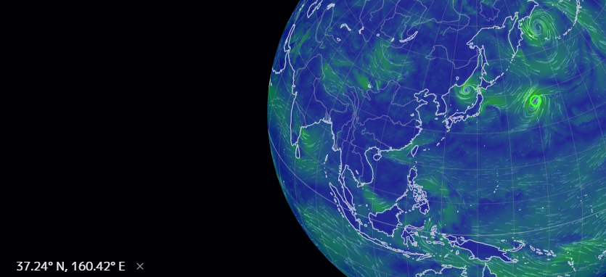

Record the data and coordinates in a table, then use the calendar to advance the date. For each day, record the location of the tropical storm:

Date | Latitude | Longitude

Now plot the course your tropical cyclone took on one of the maps below:

