Steart Marshes – A Salt Marsh Designed to Adapt to Climate Change

Task: Design a poster explaining the benefits of Steart Marshes for protecting the local community against the effects of climate change.

Critics of the project claimed that it was a waste of money that should have been spent on other flood prevention schemes.

Your poster should include information about
- Why sea levels are rising
- Why the area is prone to flooding
- How marshes can protect the surrounding area
- How the marsh is created
- Other benefits, for example to wildlife and for tourism

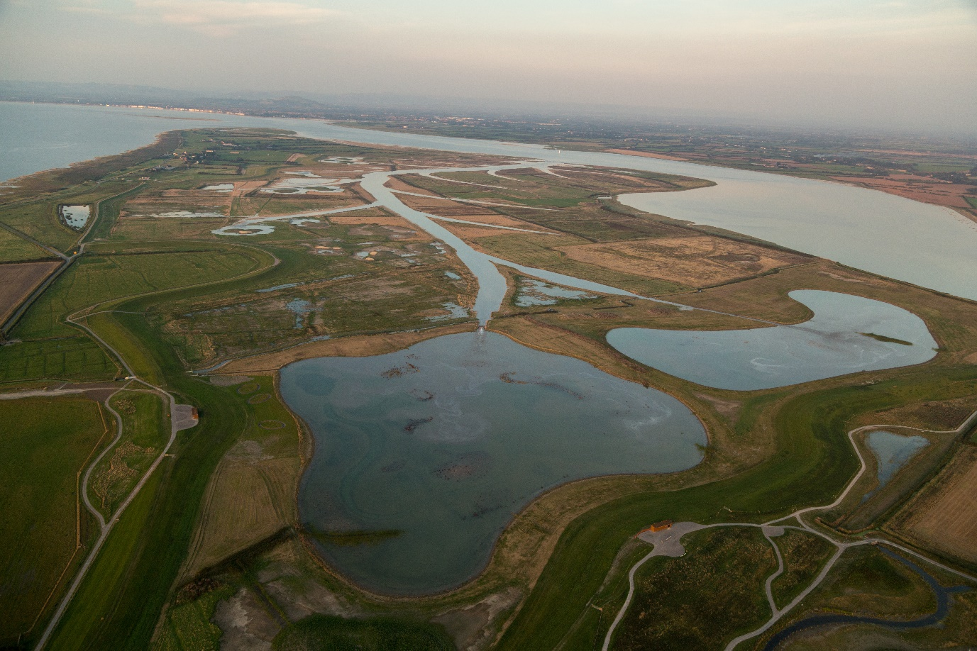
Steart Marshes Image Source: Wildfowl and Wetlands Trust/ Sacha Dench

Recommended Sources of Information

Watch the film at https://www.wwt.org.uk/wetland-centres/steart-marshes/

Steart Marshes

Steart Marsh provides flood defences for local homes and businesses and is home to a thriving nature reserve. The project proves we can fight climate change by working with nature.
Rising sea levels are putting the squeeze on our coast, so the Wildlife and Wetlands Trust and the Environment Agency have created Steart Marshes – one of the UK’s largest new wetland reserves. Hundreds of hectares of saltmarsh and freshwater wetlands protect homes and businesses from rising sea levels.
The marshes also provide habitat for a rich mix of wetland wildlife including otters, owls and waders.
Salt marshses are also a place that people love to visit.
Steart Marshes was once arable farmland and it continues to be farmed, producing saltmarsh lamb and beef for a premium because its flavour is valued by food lovers.
https://www.wwt.org.uk/wetland-centres/steart-marshes/

Local Opposition
Ian Liddell-Grainger, the MP for Bridgwater and West Somerset, has led the opposition, calling the marsh an "extravagant, ridiculous scheme" that puts birds ahead of humans.
But the Environment Agency and the Wildfowl and Wetlands Trust argue that the Steart peninsula scheme is an example of working with nature to combat the challenges of rising sea levels and more frequent, violent winter storms.
https://www.theguardian.com/environment/2014/sep/08/20m-pound-salt-marsh-somerset-wildlife-habitat-fights-sea-erosion

Coastal Management

Managed retreat is the controlled flooding of low-lying coastal areas.
Advantages include that this is a cheap option compared to paying for sea defences and it creates a salt marsh which can provide habitats for wildlife and a natural defence against erosion and flooding.
Disadvantages include that fand is lost as it is reclaimed by the sea and the landowners need to be compensated.
https://www.bbc.co.uk/bitesize/guides/z2234j6/revision/1

Rising Sea Levels
Watch the video at
https://climate.nasa.gov/climate_resources/199/rising-tides-understanding-sea-level-rise/

The major impacts of sea level rise occur during high tides and storms, causing flooding along coastlines. By the 2080s in England, up to 1.5 million properties, including 1.2 million homes, may be in areas at significant level of coastal flood risk.
Flooding places property, farmland, ports, roads and railways, and also natural habitats at risk.
https://www.lse.ac.uk/granthaminstitute/explainers/how-is-climate-change-affecting-coastal-flooding-in-the-uk/
Why Somerset is Prone to Flooding

The Somerset Levels and Moors is a unique flat landscape that extends for about 170,000 acres (70,000 ha) across parts of the north and centre of the county of Somerset in the West of England.
Thousands of years ago the area was covered by the sea, but today it's a landscape of rivers and wetlands – drained by people to allow productive farming.
It's one of lowest and flattest areas in the country with much of it below high water level when the tide is highest, and a maximum altitude of only 8m above sea level.
https://www.bbc.co.uk/news/uk-england-somerset-26080597

Massive areas of Somerset could be underwater by 2050.
The areas near the coast are naturally the most likely to be affected, but problems could be felt much further inland across the county as well.
New statistics have claimed more than 18,000 properties in Somerset are currently at medium to high risk of flooding.
https://www.somersetlive.co.uk/news/somerset-news/map-shows-how-massive-areas-3529511

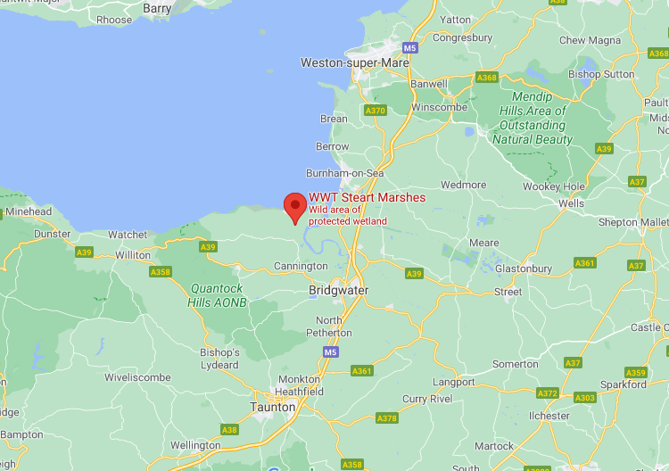
Google Maps

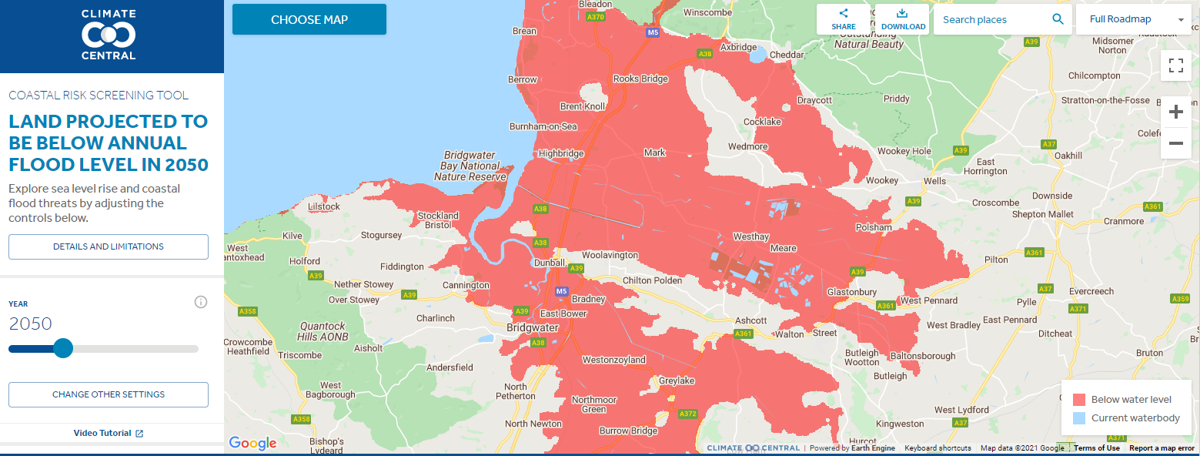
Areas at risk from flooding by 2050 – from https://coastal.climatecentral.org

