Steart Marshes – A Salt Marsh Designed to Adapt to Climate Change

Task: Design a poster explaining the benefits of Steart Marshes for protecting the local community against the effects of climate change.

Critics of the project claimed that it was a waste of money that should have been spent on other flood prevention schemes.

Your poster should include information about
- Why sea levels are rising
- Why the area is prone to flooding
- How marshes can protect the surrounding area
- How the marsh is created
- Other benefits, for example to wildlife and for tourism

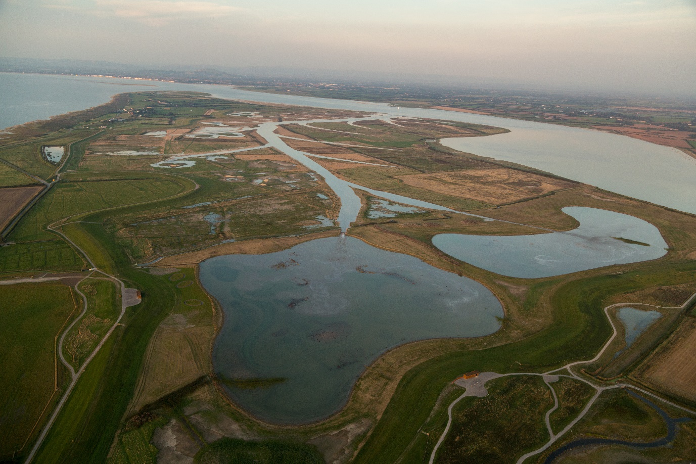
Steart Marshes Image Source: Wildfowl and Wetlands Trust/ Sacha Dench

Recommended Sources of Information

Watch the film at https://www.wwt.org.uk/wetland-centres/steart-marshes/

Steart Marshes

Steart Marsh provides flood defences for local homes and businesses, showcases productive farmland and is home to a thriving nature reserve. The project proves we can fight climate change by working with nature.
Rising sea levels are putting the squeeze on our coast, so WWT and the Environment Agency have created Steart Marshes – one of the UK’s largest new wetland reserves. Hundreds of hectares of saltmarsh and freshwater wetlands buffer homes and businesses from rising sea levels, and provide habitat for a rich mix of wetland wildlife including otters, egrets, owls, waders and wildfowl.
Rising sea levels are predicted to completely flood thousands of hectares of saltmarsh and mudflats over the next 50 years. These habitats are important feeding places for many birds and fish. They are also a natural buffer against the sea, which protects us against the worst storms and tides. At many places along the coast there is no choice but to build higher defences to protect homes and businesses. But at some places, such as Steart Marshes, it is possible to realign the coastline allowing new saltmarsh to form. These newly created saltmarshes go some way to replacing those lost to the sea. They're a cheaper and more sustainable way to protect against flooding into the future and they create much needed space for wildlife.
The marshes are home to a vast array of wildlife and it's a place that people love to visit. But as well as that, it's locking away carbon from the atmosphere that would otherwise contribute to climate change.
Steart Marshes was once arable farmland and it continues to be farmed with livestock by local graziers who are able to market saltmarsh lamb and beef for a premium because its flavour is valued by food lovers.
The tidal creeks that run across Steart Marshes shelter fish fry. The fish attract herons and egrets but they are also from commercially important species such as sea bass.
https://www.wwt.org.uk/wetland-centres/steart-marshes/

Local Opposition
Ian Liddell-Grainger, the MP for Bridgwater and West Somerset, has led the opposition, calling the marsh an "extravagant, ridiculous scheme" that puts birds ahead of humans.
But the Environment Agency and the Wildfowl and Wetlands Trust argue that the Steart peninsula scheme is an example of working with nature to combat the challenges of rising sea levels and more frequent, violent winter storms.
The idea is that the shallow gradient and coarse vegetation of the salt marsh will naturally absorb wave energy. The EA and the WWT concedes the scheme will directly protect only a handful of homes. But it will also protect National Grid connections to the power station at Hinkley Point and ease pressure on other "hard" sea defences such as walls in the area, which help secure many more homes.
Half a million cubic metres of soil were dug and moved to create new and improved flood banks. At high tide, sea water was allowed to enter the low-lying land of the peninsula through a newly excavated 200m gap in the River Parrett coastal embankment.
The area is being managed as farmland and a nature reserve and in time its creek system could become a nursery for commercial fish stocks such as sea bass.
https://www.theguardian.com/environment/2014/sep/08/20m-pound-salt-marsh-somerset-wildlife-habitat-fights-sea-erosion

However, the project has sparked controversy, with some farmers whose land was bought to create the habitat, branding the area ‘Disney for ducks’.
And speaking to the Mercury yesterday, longstanding opponent of the project Mr Liddell- Grainger said: “It is a complete and utter waste of money and a complete white elephant. “It’s £30 million which could’ve been spent on the barrage or new flooding pumps for the Levels.”
https://www.bridgwatermercury.co.uk/news/11463948.completed-steart-marshes-project-slammed-by-bridgwater-mp/

Coastal Management

Managed retreat is the controlled flooding of low-lying coastal areas. If an area is at high risk of erosion, managed retreat could be an option. It usually occurs where the land is of low value, for example farm land.
Advantages include that this is a cheap option compared to paying for sea defences and it creates a salt marsh which can provide habitats for wildlife and a natural defence against erosion and flooding.
Disadvantages include that fand is lost as it is reclaimed by the sea and the landowners need to be compensated
https://www.bbc.co.uk/bitesize/guides/z2234j6/revision/1

Rising Sea Levels
Watch the video at
https://climate.nasa.gov/climate_resources/199/rising-tides-understanding-sea-level-rise/

The major impacts of sea level rise occur during high tides and storms, causing flooding along coastlines and estuaries. In 2018 the Climate Change Committee, the Government’s independent advisers on climate change, said that﻿ by the 2080s in England, “up to 1.5 million properties, including 1.2 million homes, may be in areas at significant level of coastal flood risk”.
Sea level rise can also increase coastal erosion because waves can extend further up and along beaches and cliffs. The CCC estimates﻿ that more than 100,000 properties in England may be at risk from coastal erosion by the 2080s.
Both flooding and erosion place property, farmland, infrastructure including ports, roads and railways, and also natural habitats at risk.
https://www.lse.ac.uk/granthaminstitute/explainers/how-is-climate-change-affecting-coastal-flooding-in-the-uk/
Why Somerset is Prone to Flooding

The Somerset Levels and Moors is a unique flat landscape that extends for about 170,000 acres across parts of the north and centre of the county of Somerset in the West of England.
Thousands of years ago the area was covered by the sea, but today it's a landscape of rivers and wetlands - artificially drained, irrigated and modified to allow productive farming.
It's one of lowest and flattest areas in the country with much of it below high water level on spring tides, and a maximum altitude of only 8m above sea level.
https://www.bbc.co.uk/news/uk-england-somerset-26080597

Massive areas of Somerset could be underwater by 2050. Large areas of the Somerset coastline, including the areas around Burnham-on-Sea, Weston-super-Mare, Clevedon, Minehead and Bridgwater, are all at risk of disappearing due to rising sea levels.
The areas near the coast are naturally the most likely to be affected, but the geographical layout of Somerset means the problems could be felt much further inland across the county as well.
This information comes as new statistics have claimed more than 18,000 properties in Somerset are currently at medium to high risk of flooding.
https://www.somersetlive.co.uk/news/somerset-news/map-shows-how-massive-areas-3529511

How Salt Marshes Protect the Surrounding Land from Flooding

There are many ways in which the UK can adapt. These include using ‘hard engineering’ to maintain and strengthen existing structures such as sea walls in a policy approach called ‘hold the line’, and building new defences further out from the coastline to ‘advance the line’.
Alternatively, a policy of ‘managed realignment’ may be taken, where the shoreline is allowed to move backwards (or forwards) naturally to an agreed position, with management to control the extent. This may be appropriate in locations that are considered too difficult to protect with hard engineering or where the economic cost of protection would outweigh the benefit – for example, where the population density is low or where there are few businesses to protect.
Restoring coastal environments such as saltmarshes can also protect the coast as the natural feature acts as a barrier to the sea, dissipating waves’ energy and reducing the risk of erosion and of flooding further inland. This approach also has the advantage of creating or improving wildlife habitats. Saltmarshes may form as a result of managed realignment.
https://www.lse.ac.uk/granthaminstitute/explainers/how-is-climate-change-affecting-coastal-flooding-in-the-uk/

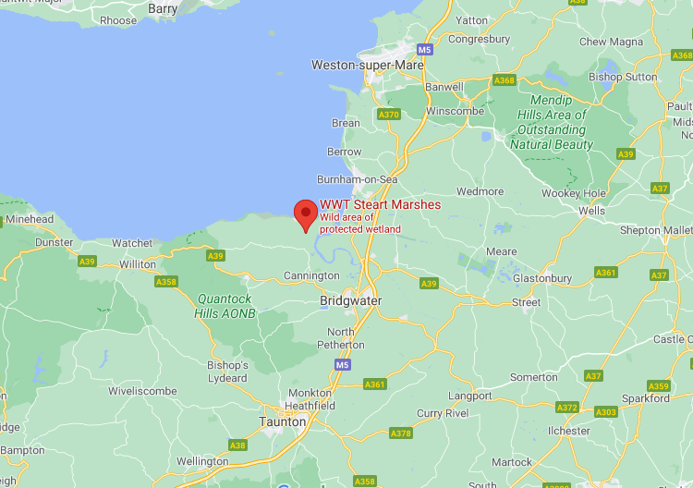
Google Maps

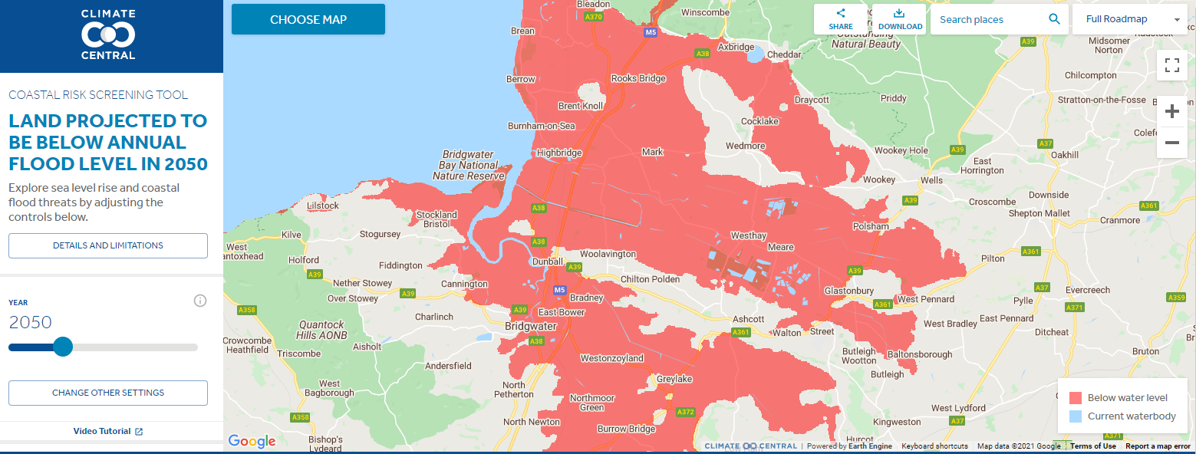
Areas at risk from flooding by 2050 – from https://coastal.climatecentral.org

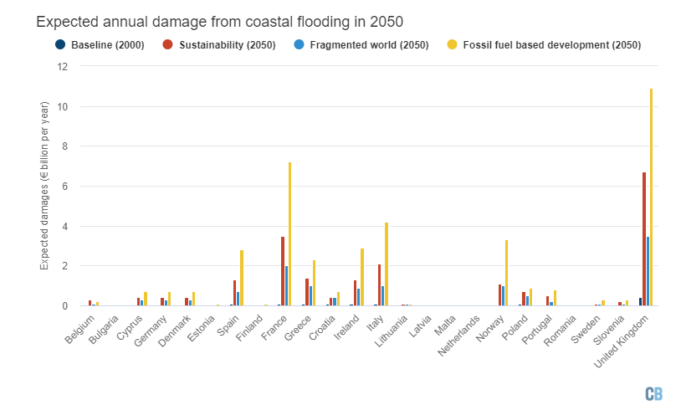
The expected annual costs of flooding in the UK and other European countries by 2050. The dark blue bar shows the costs in 2000. The red, light blue and yellow bars show the range of possible costs, depending on how much greenhouse gas continues to be emitted into the atmosphere over the next 30 years. https://www.carbonbrief.org/coastal-flooding-in-europe-could-cost-up-to-one-trillion-euros-per-year-by-2100

