Weather Taboo
You can find some ideas for a game of weather taboo below.
You could ask your class to play it in small groups or with two teams, possibly involving the labelling of a map or chart once the correct term has been guessed.
You could always set a homework exercise to write a good definition of each feature without using the banned words.
General guidelines for using taboo in a class can be found at http://www.geoworld.co.uk/tab.htm.

Depressions Taboo

Warm front

You may not say:
Warm
Front
Red
Semi-circle
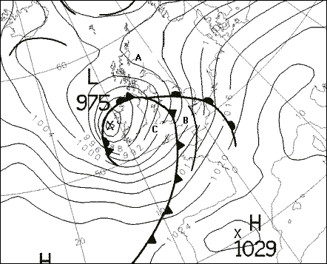
Meet(s)
Line

Depressions Taboo

Cold front

You may not say:
Cold
Front
Blue
triangle
Meet(s)
Line

Depressions Taboo

Warm sector

You may not say:
Warm
Sector
Tropical
Front(s)
Air

Depressions Taboo

Polar front

You may not say:
Polar
Front
Tropical
Wave
Meet(s)
Line

Depressions Taboo

Cirrus Cloud

You may not say:
Cirrus
Cloud
Warm
Front
Depression

Depressions Taboo

Depression

You may not say:
Depression
Cyclone
Low
Fronts
Weather
Unhappy

Depressions Taboo

Air Pressure

You may not say:
Air
Pressure
Low
High
Weight
Atmosphere

Depressions Taboo

Occluded Front

You may not say:
Occluded
Front
Purple
Semi-circle
Depression
Line

