European Union 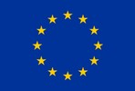 |  | European Union
European Union |  | European Union
USA 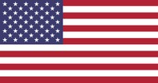 |  | USA
USA |  | USA
China 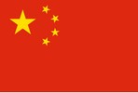 |  | China
China |  | China
Russian Federation 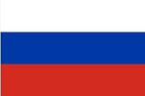 |  | Russian Federation
Russian Federation |  | Russian Federation
Nigeria |  | Nigeria
Nigeria |  | Nigeria
Maldives 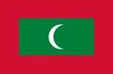 |  | Maldives
Maldives |  | Maldives
India 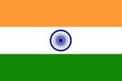 |  | India
India |  | India
Australia 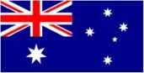 |  | Australia
Australia |  | Australia
Venezuela 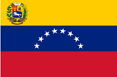 |  | Venezuela
Venezuela |  | Venezuela
Bangladesh 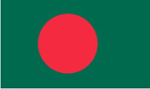 |  | Bangladesh
Bangladesh |  | Bangladesh
Star Rapporteur |  | Star Rapporteur
Nelson Mandela Award for Best Negotiator |  | Nelson Mandela Award for Best Negotiator
Donald Trump Award for international negotiations |  | Donald Trump Award for international negotiations
Nelson Mandela Award for Best Negotiator |  | Donald Trump Award for international negotiations

