Basin names | Australian/Southwest Pacific | Northwest Pacific | North Indian
Southwest Indian | Australian/Southeast Indian | North Atlantic | Eastern/Central Pacific
What do you call a Tropical Cyclone?
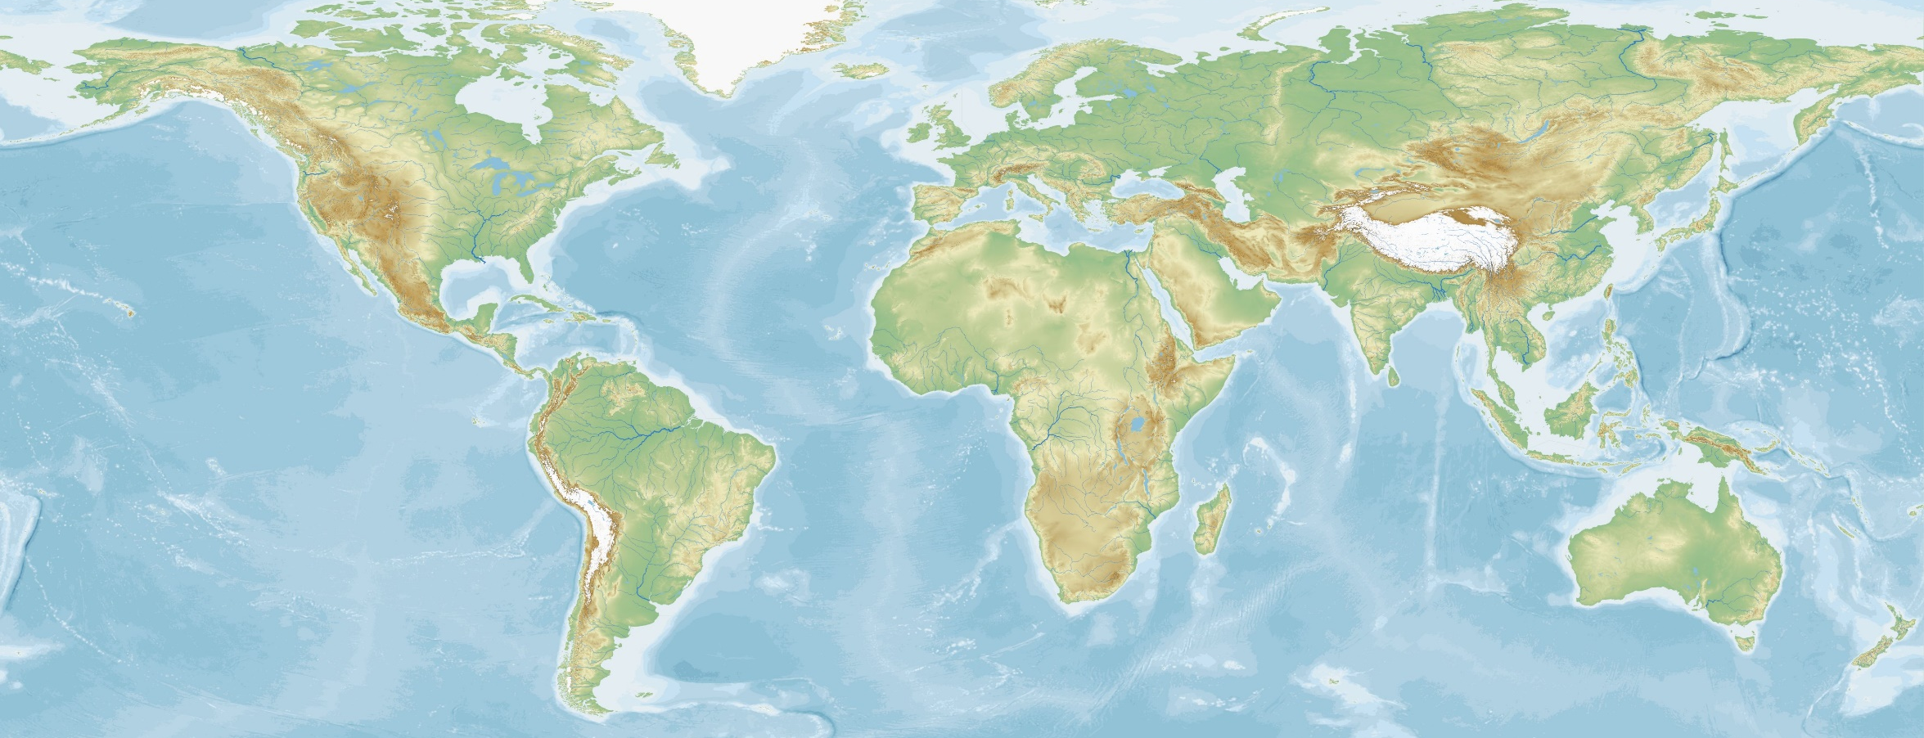
7

1

5
6
2
No. | Basin name | What do they call a tropical cyclone? | Recent storms (2018) | Storms in 2019
1 | Northwest Pacific | Typhoon | Man-yi, Usagi, Yutu
2 | North Atlantic | Hurricane | Florence, Leslie, Nadine
3 | North Indian | Cyclone | Phetha, Gaja, Luban
4 | Australian/Southwest Pacific | Cyclone | Gita, Hola, Lexi
5 | Southwest Indian | Cyclone | Cilida, Kenanga, Bouchra
6 | Eastern/Central Pacific | Hurricane | Sergio, Norman, Olivia
7 | Australian/Southeast Indian | Cyclone | Owen, Usagi, Kelvin
Basin names | Australian/Southwest Pacific | Northwest Pacific | North Indian
Southwest Indian | Australian/Southeast Indian | North Atlantic | Eastern/Central Pacific
What do you call a Tropical Cyclone?

4
1
3
5
6

No. | Basin name | What do they call a tropical cyclone? | Recent storms (2018) | Storms in 2019
1 | Northwest Pacific | Typhoon | Man-yi, Usagi, Yutu
2 | North Atlantic | Hurricane | Florence, Leslie, Nadine
3 | North Indian | Cyclone | Phetha, Gaja, Luban
4 | Australian/Southwest Pacific | Cyclone | Gita, Hola, Lexi
5 | Southwest Indian | Cyclone | Cilida, Kenanga, Bouchra
6 | Eastern/Central Pacific | Hurricane | Sergio, Norman, Olivia
7 | Australian/Southeast Indian | Cyclone | Owen, Usagi, Kelvin

Basin names | Australian/Southwest Pacific | Northwest Pacific | North Indian
Southwest Indian | Australian/Southeast Indian | North Atlantic | Eastern/Central Pacific
What do you call a Tropical Cyclone?
7
4
1
3

2
No. | Basin name | What do they call a tropical cyclone? | Recent storms (2018) | Storms in 2019
1 | Northwest Pacific | Typhoon | Man-yi, Usagi, Yutu
2 | North Atlantic | Hurricane | Florence, Leslie, Nadine
3 | North Indian | Cyclone | Phetha, Gaja, Luban
4 | Australian/Southwest Pacific | Cyclone | Gita, Hola, Lexi
5 | Southwest Indian | Cyclone | Cilida, Kenanga, Bouchra
6 | Eastern/Central Pacific | Hurricane | Sergio, Norman, Olivia
7 | Australian/Southeast Indian | Cyclone | Owen, Usagi, Kelvin

Basin names | Australian/Southwest Pacific | Northwest Pacific | North Indian
Southwest Indian | Australian/Southeast Indian | North Atlantic | Eastern/Central Pacific
What do you call a Tropical Cyclone?
7
4

5
6
2
No. | Basin name | What do they call a tropical cyclone? | Recent storms (2018) | Storms in 2019
1 | Northwest Pacific | Typhoon | Man-yi, Usagi, Yutu
2 | North Atlantic | Hurricane | Florence, Leslie, Nadine
3 | North Indian | Cyclone | Phetha, Gaja, Luban
4 | Australian/Southwest Pacific | Cyclone | Gita, Hola, Lexi
5 | Southwest Indian | Cyclone | Cilida, Kenanga, Bouchra
6 | Eastern/Central Pacific | Hurricane | Sergio, Norman, Olivia
7 | Australian/Southeast Indian | Cyclone | Owen, Usagi, Kelvin

Basin names | Australian/Southwest Pacific | Northwest Pacific | North Indian
Southwest Indian | Australian/Southeast Indian | North Atlantic | Eastern/Central Pacific
What do you call a Tropical Cyclone?
7

1
3

6
2
No. | Basin name | What do they call a tropical cyclone? | Recent storms (2018) | Storms in 2019
1 | Northwest Pacific | Typhoon | Man-yi, Usagi, Yutu
2 | North Atlantic | Hurricane | Florence, Leslie, Nadine
3 | North Indian | Cyclone | Phetha, Gaja, Luban
4 | Australian/Southwest Pacific | Cyclone | Gita, Hola, Lexi
5 | Southwest Indian | Cyclone | Cilida, Kenanga, Bouchra
6 | Eastern/Central Pacific | Hurricane | Sergio, Norman, Olivia
7 | Australian/Southeast Indian | Cyclone | Owen, Usagi, Kelvin

