Basin names | Australian/Southwest Pacific | Northwest Pacific | North Indian
Southwest Indian | Australian/Southeast Indian | North Atlantic | Eastern/Central Pacific
What do you call a Tropical Cyclone?
Every line is the path of a tropical cyclone
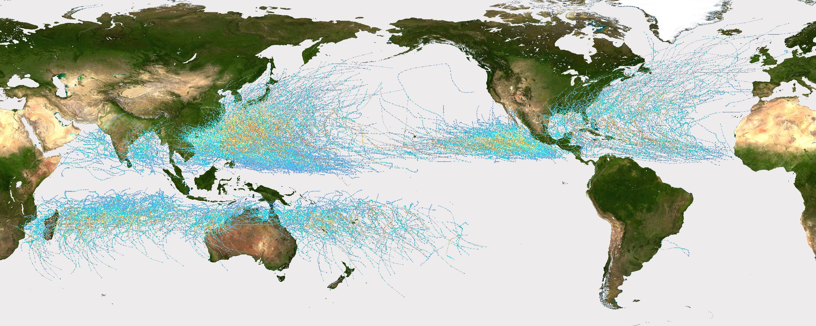
Only 2 storms ever! Not enough to be called a basin!

5

7
1

6
2
No. | Basin name | What do they call a tropical cyclone? | Recent storms (2018) | Storms in 2019
1 | Northwest Pacific | Typhoon | Man-yi, Usagi, Yutu
2 | North Atlantic | Hurricane | Florence, Leslie, Nadine
3 | North Indian | Cyclone | Phetha, Gaja, Luban
4 | Australian/Southwest Pacific | Cyclone | Gita, Hola, Lexi
5 | Southwest Indian | Cyclone | Cilida, Kenanga, Bouchra
6 | Eastern/Central Pacific | Hurricane | Sergio, Norman, Olivia
7 | Australian/Southeast Indian | Cyclone | Owen, Usagi, Kelvin

Basin names | Australian/Southwest Pacific | Northwest Pacific | North Indian
Southwest Indian | Australian/Southeast Indian | North Atlantic | Eastern/Central Pacific
What do you call a Tropical Cyclone?
Every line is the path of a tropical cyclone
Only 2 storms ever! Not enough to be called a basin!

5
3

1
4
6

No. | Basin name | What do they call a tropical cyclone? | Recent storms (2018) | Storms in 2019
1 | Northwest Pacific | Typhoon | Man-yi, Usagi, Yutu
2 | North Atlantic | Hurricane | Florence, Leslie, Nadine
3 | North Indian | Cyclone | Phetha, Gaja, Luban
4 | Australian/Southwest Pacific | Cyclone | Gita, Hola, Lexi
5 | Southwest Indian | Cyclone | Cilida, Kenanga, Bouchra
6 | Eastern/Central Pacific | Hurricane | Sergio, Norman, Olivia
7 | Australian/Southeast Indian | Cyclone | Owen, Usagi, Kelvin

Basin names | Australian/Southwest Pacific | Northwest Pacific | North Indian
Southwest Indian | Australian/Southeast Indian | North Atlantic | Eastern/Central Pacific
What do you call a Tropical Cyclone?
Every line is the path of a tropical cyclone
Only 2 storms ever! Not enough to be called a basin!

3

7
1
4

2
No. | Basin name | What do they call a tropical cyclone? | Recent storms (2018) | Storms in 2019
1 | Northwest Pacific | Typhoon | Man-yi, Usagi, Yutu
2 | North Atlantic | Hurricane | Florence, Leslie, Nadine
3 | North Indian | Cyclone | Phetha, Gaja, Luban
4 | Australian/Southwest Pacific | Cyclone | Gita, Hola, Lexi
5 | Southwest Indian | Cyclone | Cilida, Kenanga, Bouchra
6 | Eastern/Central Pacific | Hurricane | Sergio, Norman, Olivia
7 | Australian/Southeast Indian | Cyclone | Owen, Usagi, Kelvin

Basin names | Australian/Southwest Pacific | Northwest Pacific | North Indian
Southwest Indian | Australian/Southeast Indian | North Atlantic | Eastern/Central Pacific
What do you call a Tropical Cyclone?
Every line is the path of a tropical cyclone
Only 2 storms ever! Not enough to be called a basin!

5

7

4
6
2
No. | Basin name | What do they call a tropical cyclone? | Recent storms (2018) | Storms in 2019
1 | Northwest Pacific | Typhoon | Man-yi, Usagi, Yutu
2 | North Atlantic | Hurricane | Florence, Leslie, Nadine
3 | North Indian | Cyclone | Phetha, Gaja, Luban
4 | Australian/Southwest Pacific | Cyclone | Gita, Hola, Lexi
5 | Southwest Indian | Cyclone | Cilida, Kenanga, Bouchra
6 | Eastern/Central Pacific | Hurricane | Sergio, Norman, Olivia
7 | Australian/Southeast Indian | Cyclone | Owen, Usagi, Kelvin

Basin names | Australian/Southwest Pacific | Northwest Pacific | North Indian
Southwest Indian | Australian/Southeast Indian | North Atlantic | Eastern/Central Pacific
What do you call a Tropical Cyclone?
Every line is the path of a tropical cyclone
Only 2 storms ever! Not enough to be called a basin!

3

7
1

6
2
No. | Basin name | What do they call a tropical cyclone? | Recent storms (2018) | Storms in 2019
1 | Northwest Pacific | Typhoon | Man-yi, Usagi, Yutu
2 | North Atlantic | Hurricane | Florence, Leslie, Nadine
3 | North Indian | Cyclone | Phetha, Gaja, Luban
4 | Australian/Southwest Pacific | Cyclone | Gita, Hola, Lexi
5 | Southwest Indian | Cyclone | Cilida, Kenanga, Bouchra
6 | Eastern/Central Pacific | Hurricane | Sergio, Norman, Olivia
7 | Australian/Southeast Indian | Cyclone | Owen, Usagi, Kelvin

