About Tropical Cyclones (Hurricanes)
Do you know where tropical cyclones happen? Do you know how they might be changing because of climate change? This investigation will help you explore these questions. The first step is to collect and organise the facts about tropical cyclones. Use this page to list what you know and the questions you have about tropical cyclones. Then explore more by reading the web article.

What I know about tropical cyclones: | What I learned about tropical cyclones  Go to http://scied.ucar.edu/shortcontent/hurricanes  As you explore online, fill in what you learn here.
Questions I have about tropical cyclones:

Where do Tropical Cyclones Happen?
There are six regions of the world where tropical cyclones are likely to occur. In different regions, the storms are given different names. Use the information below to complete the boxes on the map.
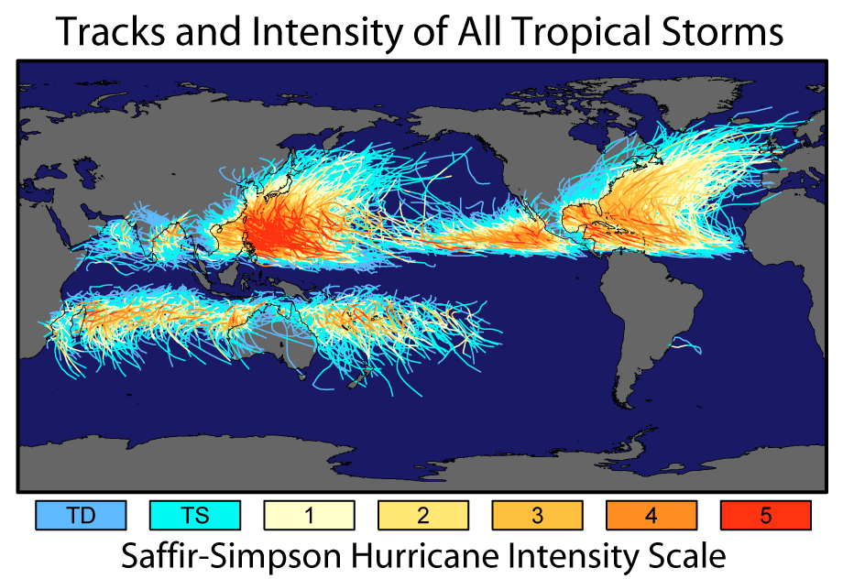
- In the North Atlantic, eastern North Pacific, Caribbean Sea and Gulf of Mexico, tropical cyclones are called "hurricanes".
- In the western North Pacific, tropical cyclones are called "typhoons"
- In the Bay of Bengal and Arabian Sea, western South Pacific and Indian Ocean Tropical Cyclones are called "tropical cyclones"
What do you think?
Do the same number of tropical cyclones happen in each of the 6 regions?
Yes
No

How many Tropical Cyclones happen?
The number of tropical cyclones that happen varies a bit from year to year. However, the average number can tell you how many are likely. Take a look at the data table below.
For each tropical cyclone region, calculate the average (mean) number of tropical cyclones, rounded to the nearest whole number.
Region | 2008 | 2009 | 2010 | 2011 | 2012 | 2013 | 2014 | 2015 | 2016 | 2017 | Mean
North Atlantic | 8 | 3 | 12 | 7 | 10 | 2 | 6 | 4 | 7 | 10
East North Pacific | 7 | 8 | 3 | 10 | 10 | 9 | 16 | 16 | 13 | 9
West North Pacific | 12 | 13 | 7 | 8 | 14 | 13 | 11 | 18 | 13 | 11
South Pacific | 6 | 8 | 7 | 3 | 5 | 6 | 6 | 8 | 4 | 6
North Indian Ocean | 4 | 4 | 5 | 2 | 2 | 5 | 3 | 4 | 4 | 3
Southwest Indian Ocean | 2 | 5 | 2 | 3 | 7 | 5 | 4 | 3 | 3 | 6

Now display this information as a bar graph:

Which 2 regions get the most tropical cyclones, on average, each year?
Which 2 regions get the fewest tropical cyclones, on average, each year?

When do tropical cyclones happen?
Tropical cyclone season is the time of year when tropical cyclones are most likely to happen. However, tropical cyclone season is not at the same time in all places. Colour in the months with the most cyclones, on average, for each region in the table below – we’ve done the North Atlantic already.
Region | Jan | Feb | Mar | Apr | May | Jun | Jul | Aug | Sept | Oct | Nov | Dec
North Atlantic | 0 | 0 | 0 | 1 | 2 | 5 | 12 | 27 | 32 | 18 | 6 | 1
East North Pacific | 0 | 0 | 0 | 0 | 5 | 12 | 22 | 25 | 21 | 14 | 2 | 0
West North Pacific | 2 | 1 | 1 | 3 | 5 | 8 | 15 | 22 | 21 | 14 | 8 | 4
South Pacific | 27 | 25 | 19 | 9 | 2 | 1 | 0 | 0 | 0 | 2 | 4 | 12
Southwest Indian Ocean | 24 | 26 | 17 | 8 | 4 | 1 | 0 | 0 | 1 | 2 | 7 | 12
Source http://naturalhazardscience.oxfordre.com/view/10.1093/acrefore/9780199389407.001.0001/acrefore-9780199389407-e-79 Percentage of tropical cyclones by month for the period 1985-2014
Can you group the regions into two groups, based on the time of year in which the tropical cyclone happens?
Group 1 Group 2

Look at where these regions are located. What do the regions in each group have in common?

In which seasons are tropical cyclones most common? (remember that the seasons are opposite in the Northern and Southern hemispheres)

Where is the warm water?
The temperature of the ocean surface is not the same everywhere and this has an impact on tropical cyclone formation.
Using a red or orange pencil, shade the parts of the ocean where the water is warmest based on what you see in the ‘sea surface temperature’ map.
Now, using an atlas, draw thick black lines on the map to mark the position of the Equator and the Tropics of Cancer and Capricorn.
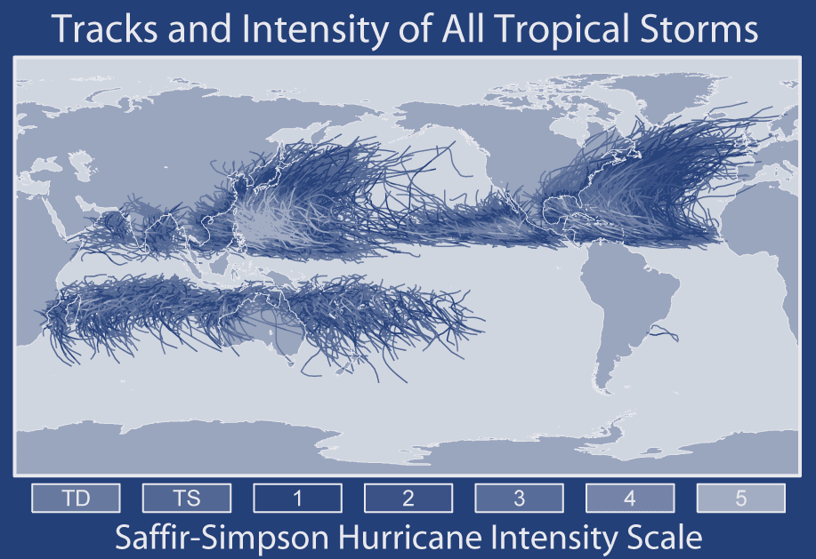
Tick the correct boxes:
Tropical cyclones occur where the ocean surface temperature is
Warm or Cold
Tropical Cyclones are mostly found
Over land or Over Water
Tropical Cyclones are found
In the Tropics
In the Tropics but not near the Equator

Are North Atlantic Hurricanes Getting Stronger?
We know that hurricanes form above warm ocean water, and that climate change is causing sea surface temperatures in the Tropics to rise. The temperature of the tropical north Atlantic has risen by over 1°C over the last 30 years (https://www.epa.gov/climate-indicators/climate-change-indicators-tropical-cyclone-activity) and is expected to carry on rising in the future.
The strength of a hurricane is measured on the Saffir-Simpson scale, with a category 5 hurricane having the most damaging wind speeds – over 252km/hr.
Year | 2008 | 2009 | 2010 | 2011 | 2012 | 2013 | 2014 | 2015 | 2016 | 2017
All hurricanes | 8 | 3 | 12 | 7 | 10 | 2 | 6 | 4 | 7 | 10
Category 4-5 hurricanes | 4 | 1 | 4 | 2 | 0 | 0 | 1 | 1 | 2 | 4
Number of North Atlantic Hurricanes by year
Complete the graph below using the table above

Has the total number of hurricanes:
Increased Decreased Stayed about the same
Justify your answer:

Has the total number of category 4 and 5 hurricanes:
Increased Decreased Stayed about the same
Justify your answer:

