Recipe for a Hurricane

Tropical cyclones (called hurricanes in some places) can only form when the conditions are right. You could think of it as a recipe – a tropical cyclone will only form if you have all the ingredients.
Use the online interactive challenge to work out where tropical cyclones can form.
- If you reveal a card with all 5 hurricane symbols, then you know that that location has all 5 ingredients for a tropical cyclone. You can write those in the ‘tropical cyclones found at’ boxes below.
- Use those values to make a first guess about the ingredients for a tropical cyclone to form.
Latitude
Tropical cyclones found at
As you play the game, note down the latitude of the places where tropical cyclones are found here

- First guess: For a tropical cyclone to form, the latitude must be
______________________________________________________________________________________________
Surface Temperature
Tropical cyclones found at
As you play the game, note down the surface temperature of the places where tropical cyclones are found here

- First Guess: For a tropical cyclone to form, the surface temperature must be
_____________________________________________________________________________________________
Water Vapour – Available Water
Tropical cyclones found at
As you play the game, note down the available water of the places where tropical cyclones are found here

- First Guess: For a tropical cyclone to form, the available water must be high/ low
Upper Level Wind Speed
If upper level wind speeds are high, then the difference in wind speed between the surface and the top of the tropical cyclone is high. If upper level wind speeds are low, then the wind speed near the surface and near the top of the tropical cyclone will be similar.
Tropical cyclones found at
As you play the game, note down the upper level wind of the places where tropical cyclones are found here

- First Guess: For a tropical cyclone to form, the upper level wind speeds must be high/ low.
One last thing:
- The game gives you two more pieces of information about where Tropical Cyclones form – Longitude and Land/ Sea. Only one is an ingredient in the recipe for a Tropical Cyclone, the other is a red herring – it has got nothing to do with Tropical Cyclone formation. What is the last ingredient for a Tropical Cyclone?
Conclusion:_________________________________________________________________________________________________________________________________________________________________________________

- Now, look at some of the places with 4, 3, 2, and 1 hurricane symbols. Can you use the information on the cards to improve your recipe for a tropical cyclone?
For example, by comparing North Atlantic 3 and Arabian Sea, what can you find out?
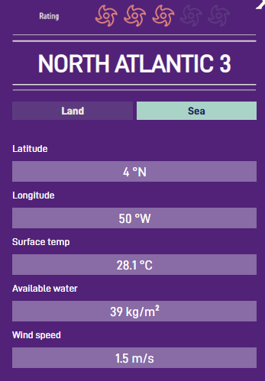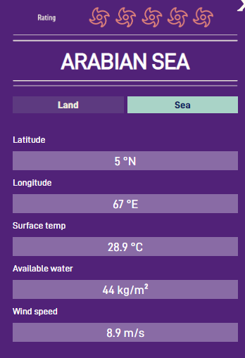
North Atlantic 3 has 3 hurricane symbols and Arabian Sea has 5, so we know that North Atlantic fails to meet 2 criteria that Arabian Sea does meet.
- We think that upper level wind speed should be low for tropical cyclones to form, but the upper level wind speed is even lower at North Atlantic 3 than Arabian Sea – these places both have low enough upper level wind speed.
- Both develop over the sea.
- The surface temperature is very similar for both and you’ve hopefully already seen other places with all 5 criteria met that have lower surface temperatures. These places are both warm enough.
- So, the two criteria that are not met are available water and latitude.
- The threshold for latitude must be between 4° and 5° and the threshold for available water must be between 39kg/m³ and 44kg/m³.
Use this table to improve your guess for what the ingredients for a tropical cyclone must be:
Latitude | Note down the latitude of the places where the latitude criteria has been met here | Note down the latitude of the places where the latitude criteria has not been met here
Surface Temperature | Note down the surface temperature of the places where the surface temperature criteria has been met here | Note down the surface temperature of the places where the surface temperature criteria has not been met here
Available Water | Note down the available water of the places where the moisture criteria has been met here | Note down the available water of the places where the moisture criteria has not been met here
Upper Level Wind Speed | Note down the upper level wind of the places where the wind speed criteria has been met here | Note down the upper level wind of the places where the wind speed criteria has not been met here

Conclusion: For a tropical cyclone to form, the latitude must be
____________________________________________________________________________________________________________________________________________________________________________________________
Conclusion: For a tropical cyclone to form, the surface temperature must be
____________________________________________________________________________________________________________________________________________________________________________________________
Conclusion: For a tropical cyclone to form, the humidity must be high/ low
Conclusion: For a tropical cyclone to form, the upper level wind speeds must be high/ low.

- On the map below, shade the areas where tropical cyclones can form:
