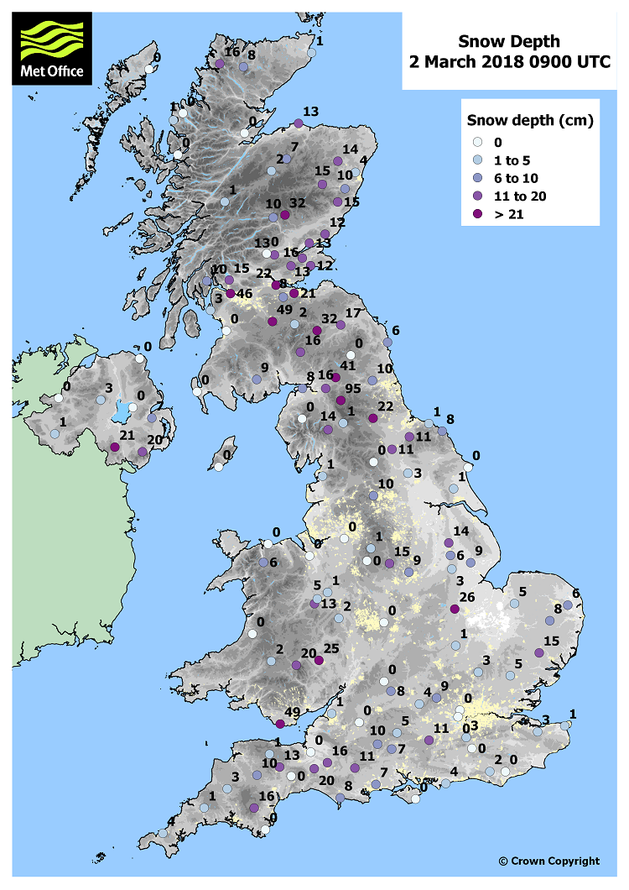
Workstation 1 – Snow Depths

Workstation 1 – Snow Depths
Answer the following questions in sentences, use the atlas to help you.
- Where was the deepest snow? How deep was it?
- How deep was the snow in Dunblane?
- How deep was the snow in Glasgow?
- Where was the deepest snow in Scotland? How deep was it?
- Look at the dark purple dots showing the deepest snow depths and compare this to the map in the atlas. Why did these areas receive the most snow?
- Look at the areas that had no snow on the ground. Why did these areas have no snow on the ground?
- Is there more snow in the north or south of the UK? Why do you think this is?
- Is there more snow in the east or west of the UK? Why do you think this is?

Workstation 1 – Snow Depths
Answer the following questions in sentences, use the atlas to help you.
- Where was the deepest snow? How deep was it?
- How deep was the snow in Dunblane?
- How deep was the snow in Glasgow?
- Where was the deepest snow in Scotland? How deep was it?
- Look at the dark purple dots showing the deepest snow depths and compare this to the map in the atlas. Why did these areas receive the most snow?
- Look at the areas that had no snow on the ground. Why did these areas have no snow on the ground?
- Is there more snow in the north or south of the UK? Why do you think this is?
- Is there more snow in the east or west of the UK? Why do you think this is?

Workstation 2 – Maximum Temperatures
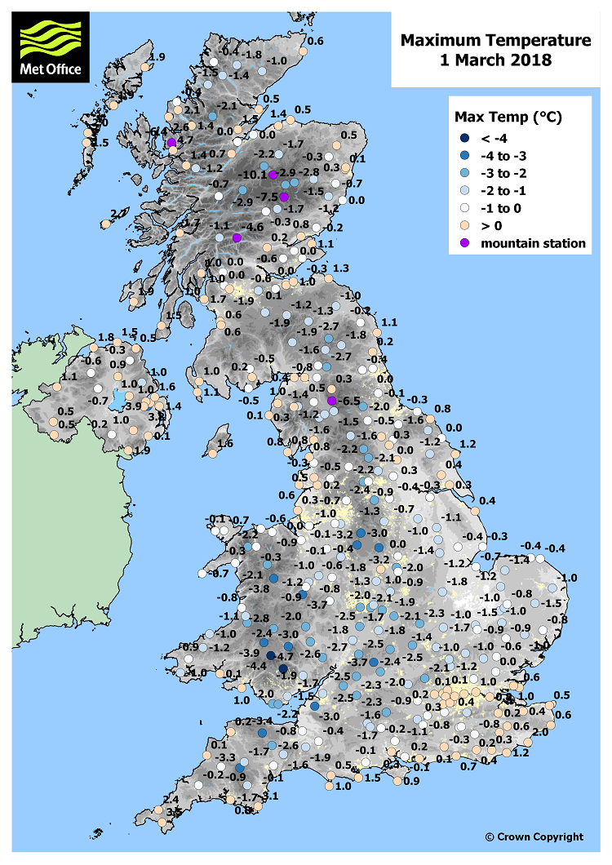

Workstation 2 – Maximum Temperatures
Answer the following questions in sentences, use the atlas to help you.
- Where was the coldest place? How cold was it?
- Where was the warmest place? What was the temperature?
- What was the temperature in Dunblane?
- Look at the coldest temperatures, where do they occur? Compare the map to your atlas to help you.
- Look at the areas that have higher temperatures, where do they occur? Why?
- Are the temperatures lower in the north or the south of the UK? Why do you think this is?
- Are the temperatures lower in the east or west of the UK? Why do you think this is?

Workstation 2 – Maximum Temperatures
Answer the following questions in sentences, use the atlas to help you.
- Where was the coldest place? How cold was it?
- Where was the warmest place? What was the temperature?
- What was the temperature in Dunblane?
- Look at the coldest temperatures, where do they occur? Compare the map to your atlas to help you.
- Look at the areas that have higher temperatures, where do they occur? Why?
- Are the temperatures lower in the north or the south of the UK? Why do you think this is?
- Are the temperatures lower in the east or west of the UK? Why do you think this is?

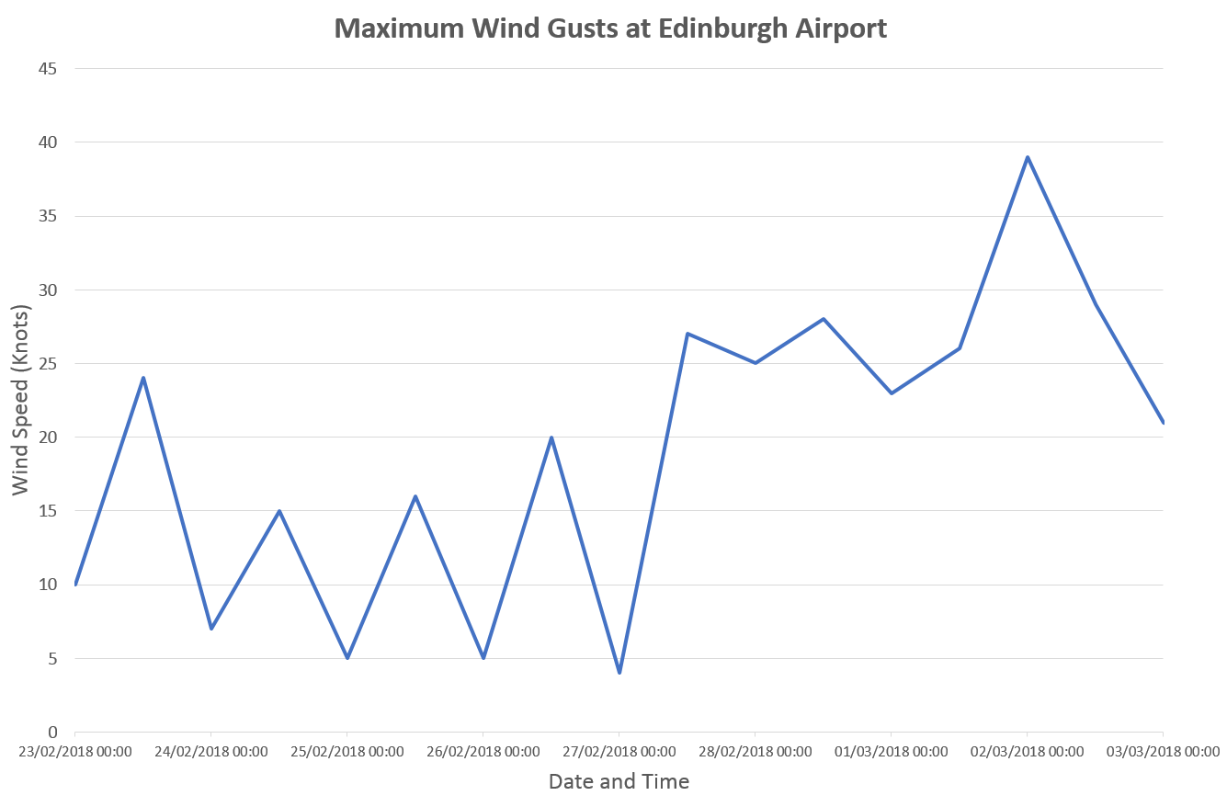
Workstation 3 – Maximum Wind Gusts

Workstation 3 – Maximum Wind Gusts
- When was the highest recorded wind gust? What was the wind gust speed?
- Which three days had the strongest wind gusts during that week?
- What was the strength of the wind gust on 23/02/2018 at 00:00?
- What was the strength of the wind gust on 27/02/2018 at 12:00?
- Where do you think the strongest wind gusts in Scotland would be recorded? Why?
- Do you think the winds would be stronger in the east or the west of Scotland?

Workstation 3 – Maximum Wind Gusts
- When was the highest recorded wind gust? What was the wind gust speed?
- Which three days had the strongest wind gusts during that week?
- What was the strength of the wind gust on 23/02/2018 at 00:00?
- What was the strength of the wind gust on 27/02/2018 at 12:00?
- Where do you think the strongest wind gusts in Scotland would be recorded? Why?
- Do you think the winds would be stronger in the east or the west of Scotland?

Workstation 4 – Weather Warnings
The UK had a period of severe winter weather with very low temperatures and lots of snow from late February to early March 2018. This was known as ‘The Beast from the East’.
Temperatures during the day were below freezing on 28th February and 1st March with a strong easterly wind and significant amounts of snow. This was the most significant periods of snow and low temperatures in the UK since December 2010.
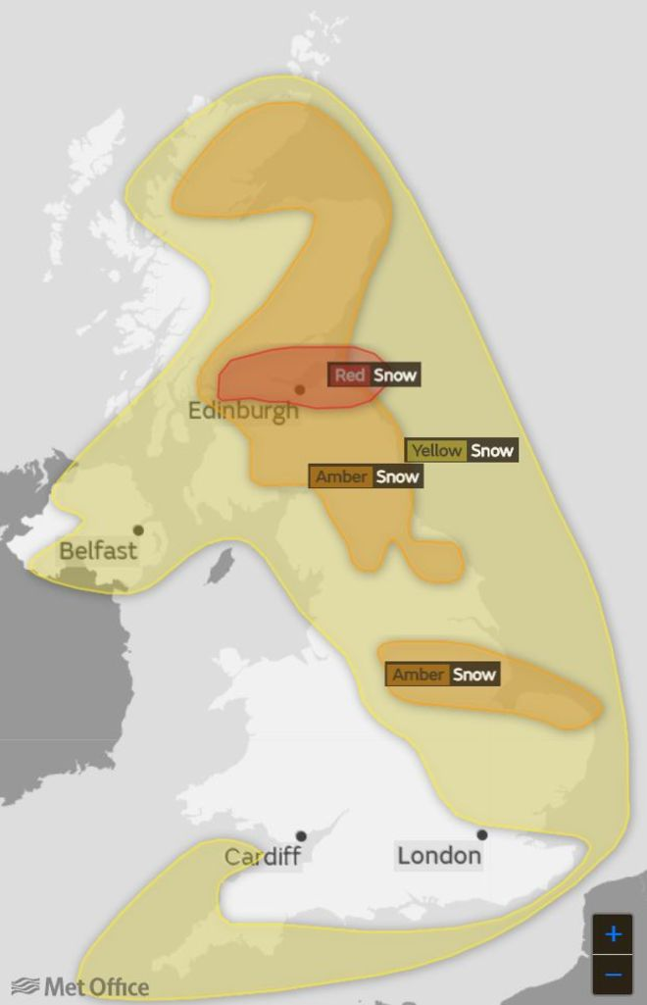
The Met Office – which forecasts the UK’s weather - issued two red warnings for snow. A weather warning is used to alert people to stay safe when severe weather, such as heavy rain, snow, wind, fog and ice, hits the UK. The warnings have different colours depending on how severe and potentially dangerous the weather is. These are yellow, amber and red. A red weather warning is the most serious warning that the Met Office can issue. It means that it is likely the weather will cause damage, for example to buildings and roads. It also means that there will be problems with travelling so buses, trains and flights may be delayed or cancelled. It could also affect power cuts which may mean homes in the area could have power cuts. A red warning means that there could be a risk to people’s lives if they are not careful. The Met Office says that when it issues a red weathering warning, people must stay away from areas which could be potentially dangerous and they should follow the advice of the emergency services and local authorities. During the amber and red weather warnings in February, Police Scotland advice was not to travel unless it was essential.

Workstation 4 – Weather Warnings
- What was the weather like during the Beast from the East?
- Which days were the temperatures below 0°C all day?
- What is the Met Office?
- What is a weather warning?
- What does a red weather warning mean?
- What advice did Police Scotland give to people?
- How many red warnings were issued?
- Look at the map, where was the red warning?
- Look at the map, where were the amber warnings?

Workstation 4 – Weather Warnings
- What was the weather like during the Beast from the East?
- Which days were the temperatures below 0°C all day?
- What is the Met Office?
- What is a weather warning?
- What does a red weather warning mean?
- What advice did Police Scotland give to people?
- How many red warnings were issued?
- Look at the map, where was the red warning?
- Look at the map, where were the amber warnings?

