Isotherm mapping activity
Notes for Teachers
This activity relates to section 1.1 How can weather be hazardous and 9.1 Geographical skills (…construct maps to present information (isoline)) of the Geography B specification content.
- Demonstrating isolines is the best way to show pupils how to draw them. You could complete one isotherm as an example with the pupils, before letting them complete the others independently.
- The activity is derived from a Met Office map (below left) and is presented at three levels of difficulty.
- The completed pupil map (below right) is simplified from the original (intermediate isolines have been removed) and is included for pupil-marking of the activity.
- It is suggested that you do not show pupils the completed map until they have attempted it themselves.
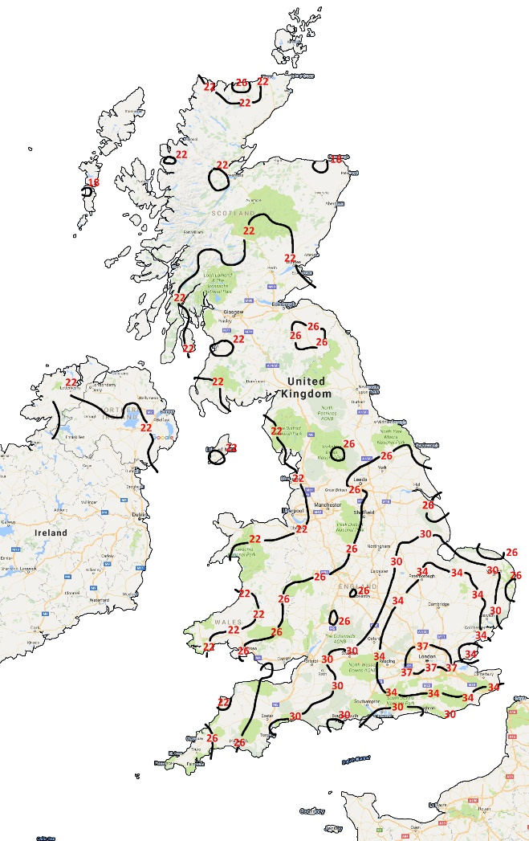
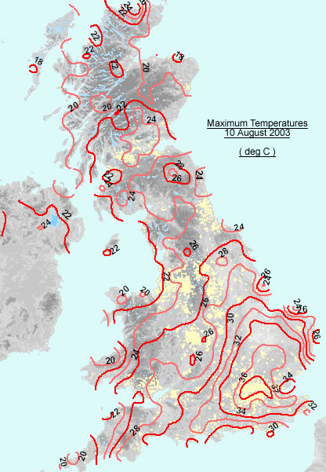
- Discussion of the isotherms, appropriate to GCSE level study, could explore apparent patterns such as the effect of latitude, the urban heat island of London, temperature differences inland/on the coast, and topographical reasons for patterns (e.g. Yorkshire dales, Cairngorms, Cullin).

Drawing isotherms
- Isotherms are a type of isoline map.
- Isotherms connect equal temperatures, in the same way that isobars connect equal pressures on a weather map.
- The isotherms in this exercise are at intervals of 4C.
- If they are closely spaced, the temperature is changing quickly; if they are far apart the change is slower.
- Drawing isotherms is as simple as connecting the numbers with a line, but there are some basic rules:
- An isotherm can’t stop in the middle of the land. It must either form a circle or continue to the edge of the land.
- Isotherms can’t divide or combine
- Isotherms can never touch or cross (you’d have two temperatures in the same place)
Tips
- Draw in pencil so you can erase mistakes.
- Look and think, then draw. Isotherms often follow their neighbours but they are also affected by many other things including relief, land and water.

Instructions
There are three levels of difficulty – basic, moderate and challenging. The harder the difficulty the fewer isotherms have already been completed.
Basic
- Complete the 26°C, 30°C and 34°C Isotherms in the South of the UK
- Complete the 22°C isotherm that crosses Wales and ends on the East coast of Scotland.
- Complete the 22°C isotherm in northern Scotland and Northern Ireland.
Moderate
- Nearly all isotherms are only partially complete. Complete them, including the 37°C isotherm in the South-East, and the 22°C isotherm that crosses from Wales to the East coast.
Challenging
- Start by completing the 34°C isotherm that begins near Dover, then complete the 30°C isotherm that runs past Exeter and the 22°C that runs up through Wales, then complete the rest.

