Holiday Weather

Introduction

Rough Planet travel guides are updating their range. To help their readers decide when to go on holiday, they would like to include a summary of the average weather conditions for the destination in question. However, their maths expert left suddenly, so they urgently need your help!

They would like you to use the data provided, along with your maths skills, to produce a graph of the average weather conditions month by month. This should include precipitation amount (that’s rain, snow and hail combined), maximum temperature, and minimum temperature. Here is an example to explain what we’re looking for:

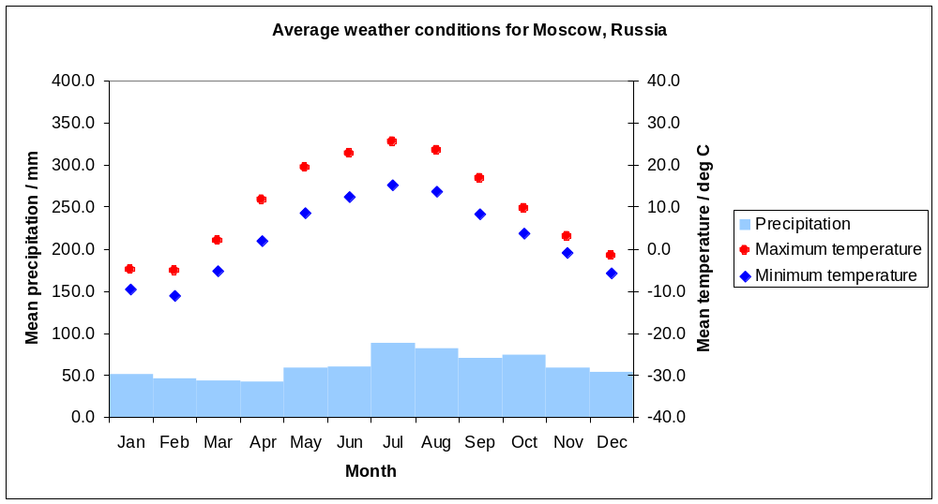

The exercise

You are going to be analyzing data for one or more of the ten destinations shown on the map below:

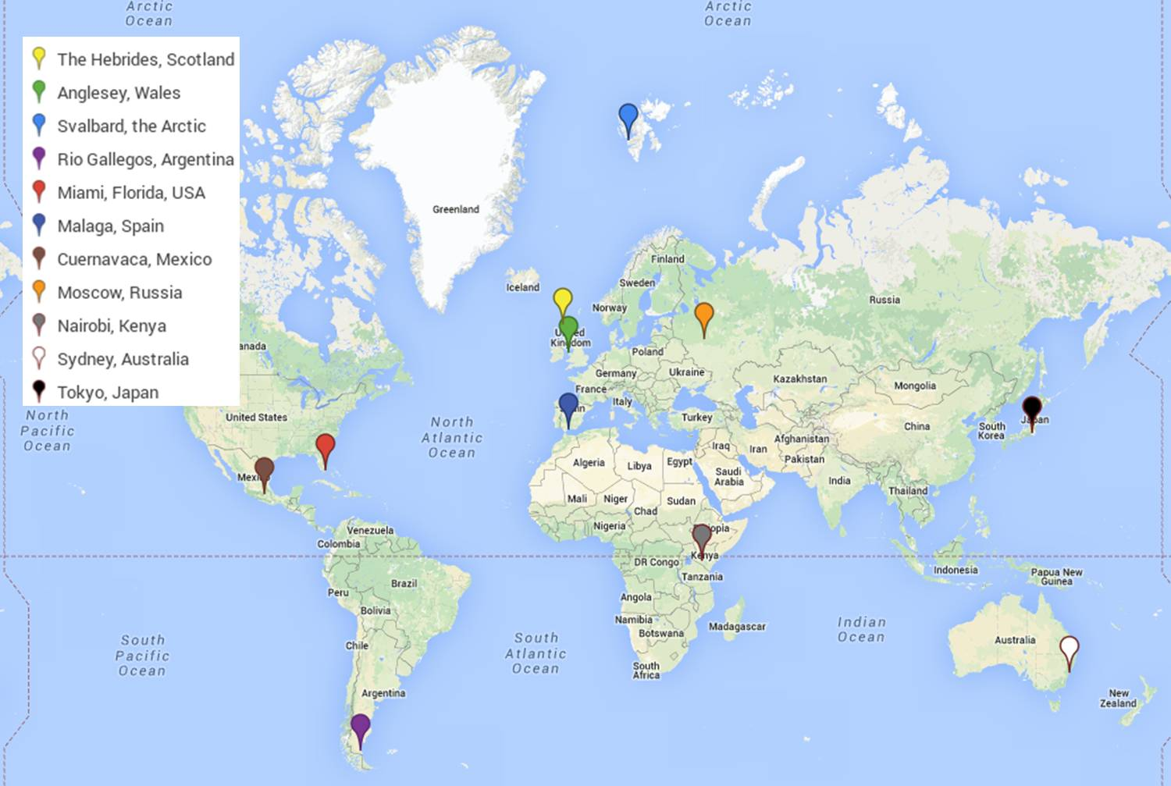

Your teacher will allocate a particular destination to you. The data are presented in three tables, each giving monthly values over a ten year period, 2004-2013. The tables are as follows:

- Mean daily precipitation
- Mean daily maximum temperature
- Mean daily minimum temperature

The data are arranged in rows and columns. All data for a particular month are in the same row, for example, the first cell in the ‘January’ row is for January 2004, the next cell is January 2005 etc. If you read down a column instead, you find all the data for a particular year, e.g. if you choose the ‘2004’ column, the first cell is for January 2004, the next is for February 2004, and so on. Have a look at the tables now and make sure you understand them.

You will notice that there are some blank columns on the right hand side, shaded grey. You are going to be calculating these missing values, and using them to draw a graph representing the average weather conditions at your destination. You will also be finding the range for each set of data. You can use a calculator or Excel to complete the exercise.

Calculate the mean and range

- Calculate the mean monthly precipitation for each month over the ten-year period.
Take care: If a value reads as ‘-999.0’, it means the real data are missing. Skip these values, and remember you need to take the mean over fewer points.
Round your values appropriately, and enter them into the ‘mean’ column.
- Find the minimum and maximum value for each row in the table, and enter these into the ‘range’ column.
- As above, calculate the mean maximum monthly temperature over the ten-year period, and find the range.
- As above, calculate the mean minimum monthly temperature over the ten-year period, and find the range.

The grey cells in all three tables should now be filled with your results.

Plot the graph

Use your results to plot a graph, like the one on the first page. You should set your graph up as follows:

- Draw a horizontal line at the bottom of your graph. Make it 12 squares long. Label square 1, ‘Jan’, square 2 ‘Feb’ and so on for all of the months. Label this axis ‘month’.
- On the right hand side, draw a vertical line, 8 squares long. Label the lines corresponding to -40, -30, -20, -10, 0, 10, 20, 30, 40. It meets the month axis at -40. This is the ‘temperature’ axis. Label this axis ‘Mean temperature / degrees C’.
- On the left hand side, draw another vertical line, again, 8 squares long. Label the lines corresponding to 0, 50, 150, 200, 250, 300, 350 and 400. Label this axis ‘Mean precipitation / mm’
- Now you are ready to plot your data. For the mean temperatures, you should use points. Perhaps you could use a red pencil to plot the maximum temperatures and a blue pencil to plot the minimum temperatures. Remember to relate your points to the axis on the right side.
- For the precipitation values, you should draw a bar chart, relating the heights to the left hand axis. You might like to colour your bar chart in light blue.
- Give your graph a title, perhaps ‘Average weather conditions for XXX’ where XXX is your holiday destination.

Your results

For your destination(s):

- What would you expect the weather to be like if you visited your destination today?
- When would you expect it to be hottest?
- When might it be coldest?
- When might it be wettest?
- When might it be driest?
- Have a look at the range for each row in your tables. What does it tell you about the representativeness of the mean in each case? Does the mean sit close to the middle of the range or is it particularly ‘skewed’ towards very hot/cold or wet/dry?
- Apart from your graph, the travel guide editor would like you to summarise the climate conditions and make a recommendation for the time(s) of year to travel to take advantage of the best weather. Make three statements about the climate at your destination, including any noteworthy observations you have made about your data (e.g. would you expect the temperature to vary much in the course of a day, or does your location sometimes experience very dry/wet weather?)
- If you analysed more than one destination, compare the graphs. Make three statements about any noteworthy similarities or differences between two or more of your chosen destinations.

Discuss the following with the other students in your class, and your teacher:

- Which location has the highest mean monthly precipitation? In which month does that occur?
- Which location has the lowest mean monthly precipitation? In which month did that occur?
- Which location has the highest mean maximum temperature? In which month did that occur?
- Which location has the lowest mean minimum temperature? In which month did that occur?

- Where would you most like to visit today? Why?
- Where would you least like to visit today? Why?

If you have access to the internet, why not visit the Met Office website to look up the weather for your destination* today? (direct link http://www.metoffice.gov.uk/public/weather/world-forecasts/ ). How does it compare with the average conditions you have calculated? Use a search engine to see if there are any interesting pages about the weather or climate for your chosen destination (e.g. try searching for ‘Tokyo climate’ or ‘Tokyo weather facts’). If there are any incidences of ‘extreme’ weather, are they visible in your data (e.g. droughts, fires, typhoons/hurricanes, storms, floods, etc.)?

*Hints: For Anglesey and the Hebrides, you will need the UK forecast on the Met Office homepage. Search for both by the given names, and choose the closest forecast location. It may be helpful to know that Svalbard is part of Norway. For Cuernavaca, choose Mexico City.

