Holiday Weather
Maths Resource: Key Stage 3

Information for Teachers

Overview

This activity has been designed to support the National Curriculum for Key Stages 3 & 4 by developing fluency, mathematical reasoning and real-world problem solving skills. The main mathematical content is statistical in nature but therein lies a significant amount of number work.

Curriculum Objectives

This activity seeks to provide opportunities for students to use mathematics in a real world context that has direct relevance to other subjects they may be learning in school (specifically ‘science’ and geography). The activity requires the use of many different mathematical skills, including the confident application of number skills and data handling. Owing to the size of the dataset (multiple variables in multiple locations), the opportunity to work collaboratively may present itself, if the activity is undertaken in a class setting. The nature of the activity lends itself well to the use of ICT (be it the use of spreadsheets or otherwise) and is provided in a format to readily facilitate this.

After successfully completing this activity, the student will have:
- used and understood positive (and in some cases, negative) decimal numbers.
- rounded numbers to an appropriate degree of accuracy.
- calculated at least one measure of central tendency (mean) and spread (range) for multiple data.
- described, interpreted, compared and presented tabulated data.
- constructed and interpreted a complex graph with two independent axes.
- (OPTIONAL) used a spreadsheet to manipulate, analyse and present data.

Aim

To calculate average weather conditions for a particular holiday destination, and to plot the results in a graph. Can be carried out using a calculator or Excel.
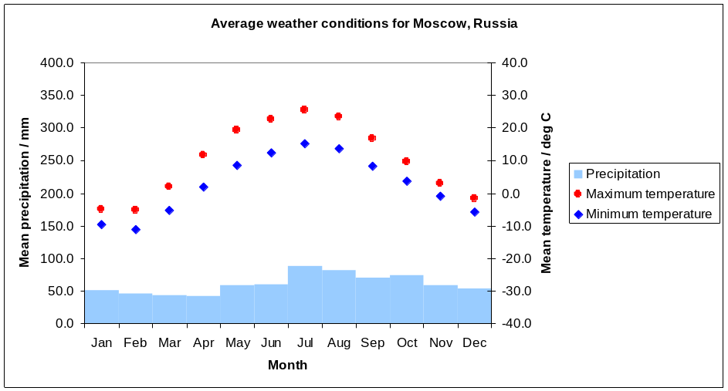

Pack contents

- Information for teachers (this document)
- Instructions for students
- Teachers’ spreadsheet (containing the data and solutions)
- Students’ spreadsheet version 1 – with automatic graphs
- Students’ spreadsheet version 2 – tables alone – print to make hard copy worksheets

The exercise

Students are given meteorological data for a particular holiday destination. Data tables are included for ten locations: The Hebrides, Scotland; Anglesey, Wales; Svalbard, the Arctic; Rio Gallegas, Argentina; Florida, USA; Malaga, Spain; Cuernavaca (Mexico City), Mexico; Nairobi, Kenya; Sydney, Australia and Tokyo, Japan. Moscow, Russia is used as an example.

The data are presented in a spreadsheet with a tab per destination. A particular destination tab contains three tables, each giving monthly values over a ten year period, 2004-2013. The tables are as follows:

- Mean daily precipitation
- Mean daily maximum temperature
- Mean daily minimum temperature

The data span a ten year period. Students should identify the readings for each month, and take the mean, to find the average daily conditions for that month during the ten year period. E.g. for December, they would identify the values for December 2003, 2004, 2005…..2013, and find the mean. They should also find the range of points used to calculate each mean value. Note: some datasets have missing values, which offers an additional challenge.

The calculated averages are then used to plot a graph of average weather conditions, rather like those found in travel guides.

Guidance Notes

The specific climate of a location will be determined by many factors, including, latitude, proximity to the sea, ocean currents, direction of prevailing winds, local topography (the shape of the land), sensitivity to natural climate variability (e.g. El Niño) and human activity. This section contains some notes for teachers to assist pupils in the interpretation of their data.

Latitude

Seasons on Earth are a result of the tilt of the Earth’s rotational axis relative to its orbit. As one hemisphere of the Earth is tilted towards the sun (summer), naturally the other one is tilted away from the sun (winter). Some of the locations chosen for this activity are in the southern hemisphere, viz. Sydney, Australia; Rio Gallegas, Argentina. Consequently, they experience their ‘summer’ in December, January, February, i.e. the northern hemisphere winter. This is referred to as the ‘austral summer’. Students should note this in their discussion of similarities/differences between locations. Similarly, students should find an equivalent relationship between the coldest winter months.

Tropical and equatorial locations such as Nairobi, Kenya and Mexico City, Mexico do not experience seasons in the same way that higher latitude locations do and their seasons are more likely to be referred to as ‘wet’ or ‘dry’, depending on precipitation rather than being based on temperature. For this reason, students may discover that there is an increasing amount of annual variation in temperature as they move to higher latitudes. In particular, Svalbard, an

archipelago in the Arctic ocean situated inside the Arctic circle (between 74 and 81 degrees North), experiences between 99 and 141 days of ‘midnight sun’, where the sun never sets (and between 84 and 128 days of ‘polar night’,
where the sun never rises above the horizon). The effect is that average temperatures in summer can be 20° Celsius greater than in the winter months.

Continentality

Proximity to the sea and/or ocean can have a strong effect on a location’s climate. Owing to its greater specific heat capacity than land, water temperature varies slowly. As a result, maritime locations, close to the sea/ocean, often experience smaller variations in temperature both over the year and during the day, as the sea will cool a relatively hot atmosphere but will warm a relatively cold one. Locations further away from the sea are more likely to be drier as much of the moisture in the air (of which the ocean/sea is likely to be a primary source) will have evaporated or precipitated out before arriving inland.

Ocean currents also affect the climate of a location by affecting the sea surface temperature (which in turn directly affects the air temperature of a location). The Gulf Stream (shown below), keeps the western coast of Europe (including the UK) significantly warmer than it would otherwise be, considering latitude alone (northern Scotland has approximately the same latitude as parts of Greenland and Alaska, which are far colder).

Students might notice that some locations have a larger difference in monthly minima compared with monthly maxima than others. This is the effect of ‘diurnal temperature variation’, the variation in temperature over the course of a day and may note that continental locations have larger variations of temperature than maritime locations which have a more stable temperature profile.

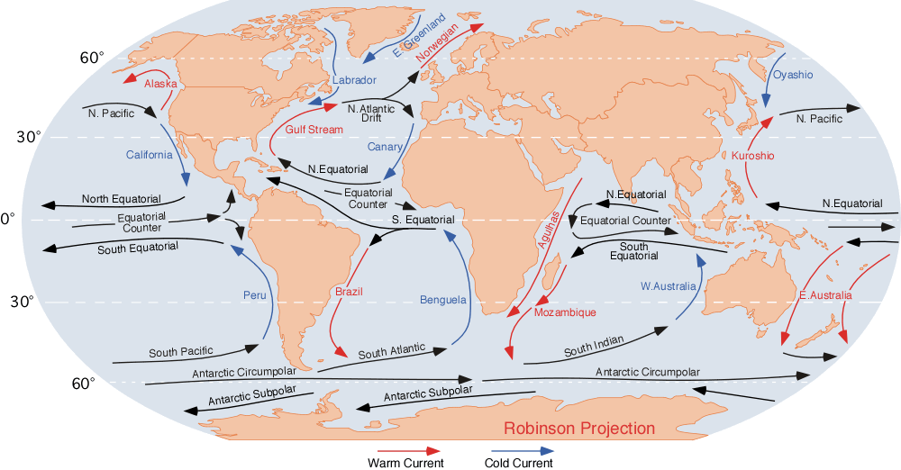

Pidwirny, M. (2006). "Surface and Subsurface Ocean Currents: Ocean Current Map". Fundamentals of Physical Geography, 2nd Edition. Accessed 10/03/2014. http://www.physicalgeography.net/fundamentals/8q_1.html

The shape of the land ('relief')

Climate can be affected by the shape of the land. Specifically, mountains disrupt the flow of air (and hence moisture and energy), forcing it to rise and cool which leads to increased precipitation on the ‘windward’ side of the mountain (that is, the side that the ‘weather’ is coming from). This can lead to a rain shadow and even relatively low hill ranges (such as the Lake District or the Pennines in England) are sufficient to cause a significant difference in the amount of rainfall experienced by two otherwise geographically close locations. For example, Keswick (Lake District) annual rainfall is typically around 1500 mm per year versus Durham’s average of around 650 mm – the two towns are separated by less than 75 miles. An even more stark contrast exists in the comparison between Seathwaite, also in the Lake District and the wettest inhabited place in England (averages over 3550mm of precipitation per year), and Keswick – they are less than 10 miles apart but Seathwaite nestles between some of the highest peaks in the country and Keswick lies in the valley.

Other Notes

Depending on their choice of location, students might notice that conditions are very similar from one year to the next or very variable. For example, October is often the wettest month in Tokyo, because the region is affected by typhoons which bring episodes of torrential rain but rainfall in June is far more consistent because the weather patterns are more consistent. Florida too is affected by the Atlantic hurricane season which runs roughly from June to October/November which can also be seen in the data. The two British locations, by comparison, have very consistent weather patterns.

Natural climate variability can, to some extent, be seen in these data too. Sydney and Miami, for example are strongly affected by El Niño and La Niña, two opposite phases of the so-called El Niño Southern Oscillation (ENSO) which refers to variations in the temperature of the surface of the tropical eastern Pacific Ocean over the course of around 5 years. The warmer water increases the amount of moisture in the atmosphere which can change rainfall patterns across the world. Indeed, many extreme weather events correlate to changes in ENSO. However, as students are averaging the data over a full decade, their sample mean may be a good estimator of the long-term mean climate and biases caused by natural climate oscillations might well be averaged out.

Extension work might consist of finding the standard deviation of the datasets and investigating the cause of the variance. Extreme weather events are often documented online by news websites or national meteorological service websites; these too are sometimes reflected in the data sets.

