Extreme weather homework activity
Resource sheet

Climate average maps

- Maps are available for several other variables, by region, during different time periods and by season or month.

Source: http://www.metoffice.gov.uk/public/weather/climate/#?region=uk

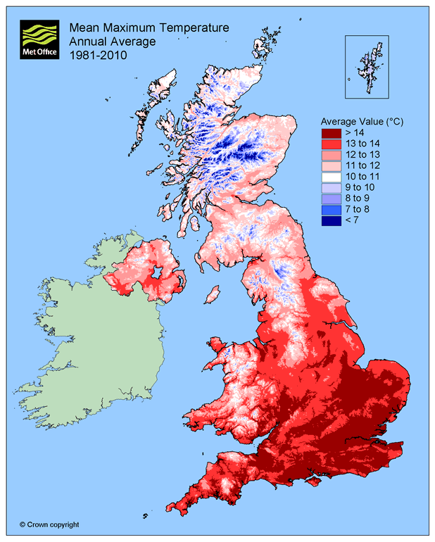

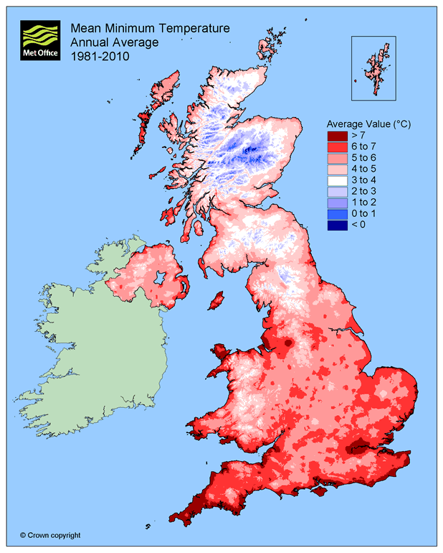

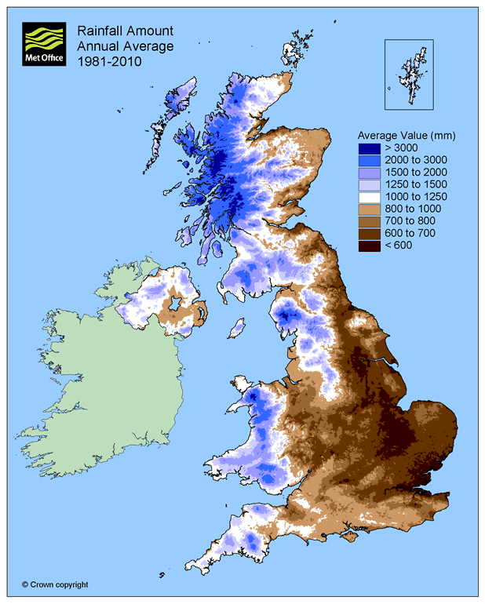
Climate anomaly maps

- These maps show the relative temperature difference in a given year to the long-term average between 1961-1990.
- Maps are also available by month and at a larger scale for any year.

Source: http://www.metoffice.gov.uk/public/weather/climate-anomalies/#?tab=climateAnomalies

