Measures of dispersion
Measures of central tendency tell you about how spread out (dispersed) or concentrated data are.

Open the Measures of data dispersion Excel workbook.

Conditional formatting
Excel allows you to format cells and text based on any formula you wish - Conditional Formatting.
Using data from Keswick, the tables below have been conditionally formatted to show the inter-quartile range of the data.
Temperature
Blue cells are the coldest 25%
Orange cells are the warmest 25%
Green cells are the interquartile range (middle 50%)
Rainfall
Light blue cells are the driest 25%
Dark blue cells are the wettest 25%
Green cells are the inter-quartile range (middle 50%)
White cells have no data
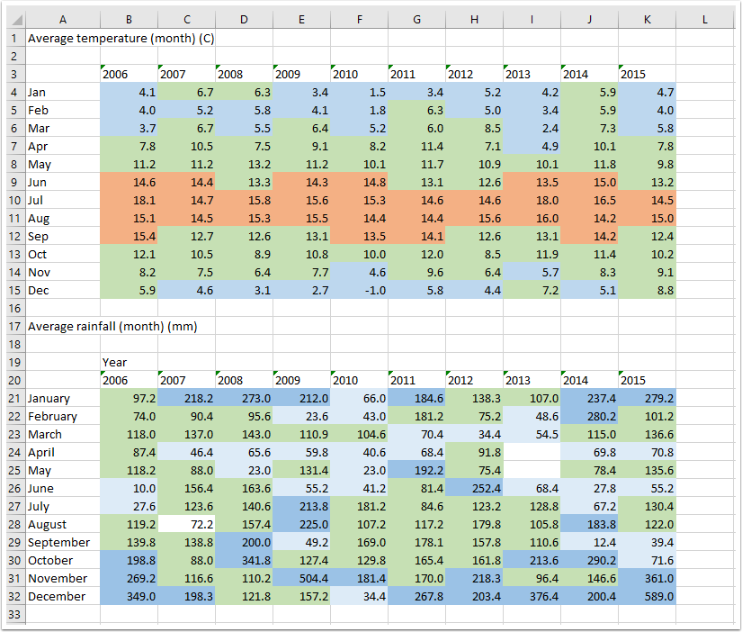

Calculating values
Excel can calculate measures of dispersion / central tendency very quickly and easily.
The examples below are from the temperature calculations on the spreadsheet.
- To find the first quartile, containing the bottom 25% of data, use =QUARTILE.INC(B4:K15,1). BK:K15 is the range of the data you're using, and 1 asks for the value of the first quartile.
- To find the third quartile, containing the top 25% of data, use =QUARTILE.INC(B4:K15,3). The range is the same, the 3 asks for the value of the third quartile.
- To calculate the inter-quartile range (IQR) that contains the middle 50% of the data you subtract the first quartile from the third quartile =O5-O4.
- To calculate the average use the formula =AVERAGE(B4:K15).
- To calculate the mode of the data use the formula =MODE.SNGL(B4:K15). The mode says #N/A because there is no modal value.
- To calculate the median of the data use the formula =MEDIAN(B4:K15).

Challenge Yourself – Standard Deviation
(this is not an examinable skill)
The Standard Deviation (SD) is a measure of how spread out the data are, i.e. how far away from the average (mean) value they go. To calculate SD the formula to use is =STDEV.P(B4:K15). If you were only using a sample of data (i.e. not all of it), you'd use =STDEV.S().
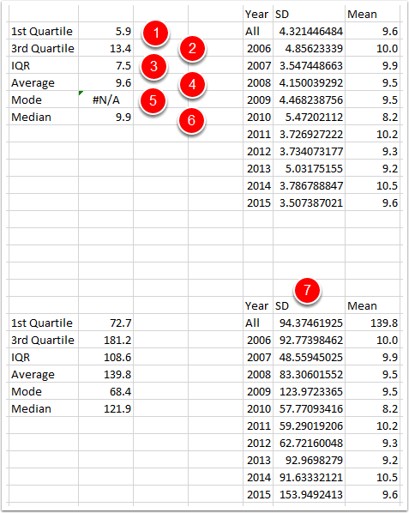

Interpreting Standard Deviation
The diagram below graphically represents how it works. Your data is all in the blue area.
68.2% of your data will be within one SD of the mean.
A further 27.2%, making 95% in total will be within two SD of the mean.
A further 4.2%, making 99.2% in total will be within three SD of the mean.
So, if you have data with a mean of 100, and a SD of 1, the data are very closely bunch together because over 99% are between 97 and 103.
If you have data with a mean of 100, and an SD of 30, the data are much more spread out. Only 68.2% of your data are between 70 and 130!
Be careful - you can't just remember that a small SD means data are bunched together and vice versa - you have to think about the size of the SD in relation to the mean.
