Exploring extreme weather with Excel

Your GCSE specification requires that you are able to construct graphs, present and communicate data through graphs, and extract, interpret, analyse and interpret information.

This activity develops your Excel abilities and introduces one approach of graphing the dispersion (spread) of data

You will be constructing line graphs, radial graphs and climate graphs.

You will have to calculate some of the data you use using Excel.

Plotting a climate graph

To begin, open the Excel file *Climate graph.*

The spreadsheet has two tables of data - monthly temperatures 2006-2015, and monthly rainfall 2006-2015.

Complete the empty average table.

Tip - Complete the cells for January (O4 and P4) using =average(), then select both cells, and drag the formula down (remember the black cross-hair cursor at the bottom right corner?) together to complete the rest in one go.

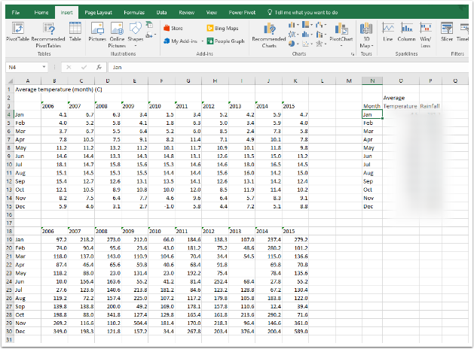

Graph the data

Select the data - include the column titles and the months (see picture).

Plot a 'clustered column' graph, then move it to a new sheet. Call it **Climate graph.**

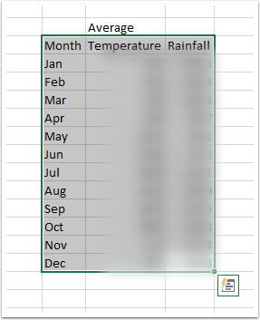

Creating a climate graph

A climate graph displays both temperature and rainfall data and has two different scales on the y-axis (one for temperature, and one for rainfall - usually with very different numbers on).

Although both scales can be displayed on one side of the graph, it's usual for there to be two axes - one on the right for temperature, and one on the left for rainfall.

Temperature data is displayed as a line; rainfall data is displayed as columns.

Your graph should look something like the picture below to begin with.

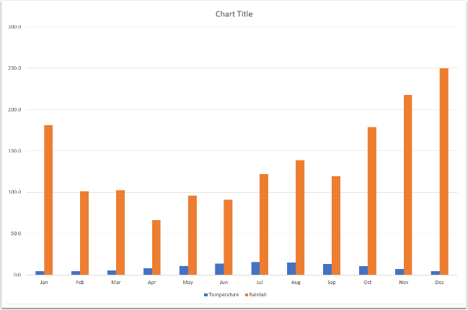

Change the chart type

Left-click on one of the columns to select it, then right-click and select **Change Series Chart Type...**

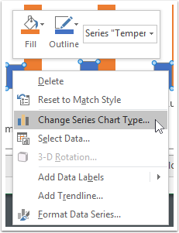

Choose different graphs for different data

For the temperature data, choose a line graph with markers. Make sure you tick the box for **Secondary axis**.

You can leave the rainfall graph unchanged.

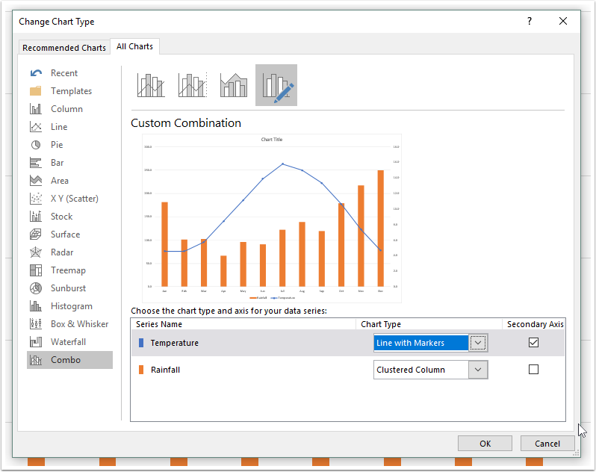

Choose appropriate colours.

It will make more intuitive sense if the rainfall graph is blue, and the temperature graph is red.

To change the graph colours, left-click to select the graph you want to change, then right click and choose **Fill**, then an appropriate colour.

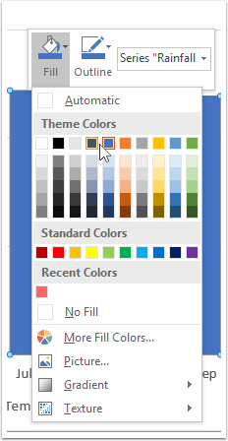

Complete your graph

As shown in activity 2, complete your graph by adding titles, gridlines, and a table of values.

The finished graph should look like the one overleaf.

**Task**

Using the same workbook, create a climate graph for Eastbourne.

