Choosing the right graph in Excel
Guide? | Presentation Level? | Graph type | Example | Application | Variants | Notes
(Y) |  | Column | 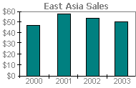 | - Shows data change over time  - Illustrates comparisons | - Clustered  Compares values across categories  - Stacked  Shows relationship of individual items to the whole across categories  - 100% stacked  Compares percentage a data contributes to a total across categories  - 3D  Compares data along two-axes | - Good for showing discharge, hydraulic radius – any set of values that change downstream
(Y) |  | Bar | 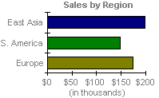 | - Illustrates comparisons between individual items | - Clustered  Compares values across categories. Categories are organised vertically, value horizontally - this places focus on comparing values.  - Stacked  Shows relationship of individual items to the whole across categories  - 100% stacked  Compares percentage a data contributes to a total across categories | - Good for showing how values change if comparison is the focus.
(Y) |  | Line | 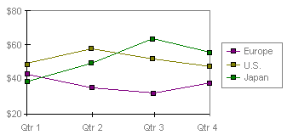 | - Shows trends in data at equal intervals. | - Stacked  Shows relationship of individual items to the whole across categories  - 100% stacked  Compares percentage a data contributes to a total across categories  - 3D  3D effect! | - If sample sites are equally spaced, could be used to show how variables change between sites.
(Y) |  | Pie | 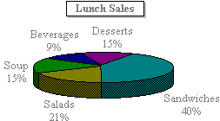 | - Shows the size of items that make up a data series  - Only shows one data series  - Can be 2D or 3D | - Exploded Pie  Emphasises individual values by separating sections of the chart (2D or 3D). | - Useful for emphasising something significant  - Use a doughnut chart if you have multiple-series of data to graph
(Y) |  | Pie of pie & Bar of pie | 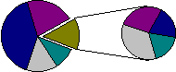 | - Useful for showing sub-sets of data or values too small to be clear on a pie chart | - Pie of pie  Specific values are extracted and shown in a second pie chart. Makes small slices of the main pie chart easier to see or shows subset of data  - Bar of Pie  As above by extracted data is used to draw a bar graph | - Chose to illustrate a specific point using a subset of data OR if values are too small to be clear on a normal pie chart
(Y) |  | Area | 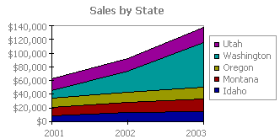 | - Emphasises magnitude of change over time  - Shows relationship of parts to whole | - Stacked  Shows relationship of individual items to the whole across categories  - 100% stacked  Compares percentage a data contributes to a total across categories | - Use to show how the value of a variable changes downstream.
 |  | Cylinder / cone / pyramid | 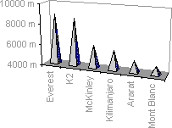 | - A variation of a column or bar chart | - Cylinder  Uses cylinders  - Cone  Uses cones  - Pyramid  Uses pyramids | - May be appropriate to reflect value being graphed, e.g. sharp things pyramids  - Probably unnecessary as doesn’t add anything beyond normal variant.
(Y) |  | Histogram | 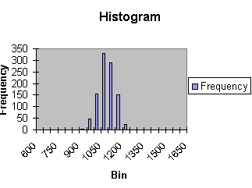 | - Plots data within specific intervals as a bar graph |  | - May be useful to illustrate bedload size/shape/angularity  - Sorts data into bins  - May look like a bar chart but isn’t!  - A little complicated to set up, then easy to use.
 |  | Gantt | 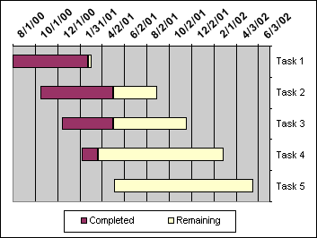 | - Illustrates a planning timeline |  | - Shows timeline of project  - Useful to illustrate structure of work in detail
 |  | Surface | 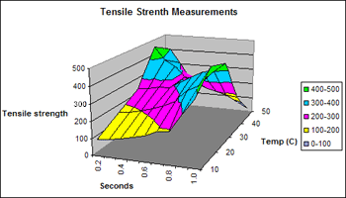 | - Creates topographic map using colour to show similar values. | - 3D Surface  Shows data across two dimensions in a continuous curve.  - Contour  A surface chart viewed from above. Colours represent specific ranges of values.
(Y) |  | Stock | 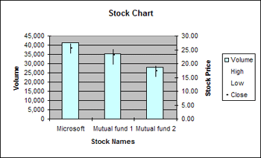 | - Plots average and range as bars from a point. | - High-Low-Close (HLC)  Needs three series of data, e.g. average/max./min., and will plot these as a point with a bar up to the max. and down to the min..  - Open-High-Low-Close  N/A  - Volume-High-Low-Close (VHLC)  Needs four series of data, e.g. discharge/average/min./max. bedload size. Will plot discharge as a bar graph in addition to HLC point and bars.  - Volume-Open-High-Low-Close  N/A | - Useful to show variation in data at a specific site (VLC)  - Can show two variables, including variation of one
(Y) |  | Bubble | 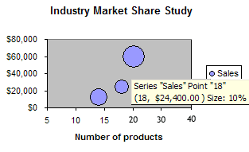 | - A variation of a scatter chart  - Use if you have three data series all containing values (no gaps)  - Plots data against two axes and by varying size of bubble. |  | - Can do multiple series.  - Can show proportionally-sized pies & error bars.
(Y) |  | Scatter | 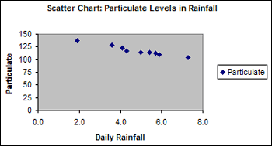 | - Similarities between sets of paired or grouped data | - Scatter with data points connected by lines  Smoothed or straight lines connect data points | - Don’t confuse with a line chart in which the data are evenly spaced.  - Can be used to show relationships/pattern/trends
 |  | Radar | 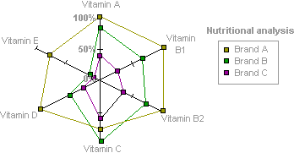 | - Compares aggregate values from several series of data  - Plots data relative to centre point | - Filled Radar  The area covered by a data series is filed with colour (may make illustration easier or differences more apparent). | - Discursive tool  - Data must already be processed.
 |  | Doughnut | 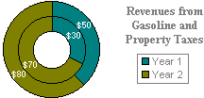 | - Shows the relationship for parts of whole by displaying data in rings.  - Able to show multiple data series on one graph | - Exploded doughnut  Like an exploded pie chart, can draw attention to size of each variable but can show more than one data series | - A doughnut chart shows several series a data; a pie-chart shows ONE series of data

