Exploring extreme weather with Excel - The basics
These activities will help to develop your data skills using Excel and explore extreme weather in the UK.

This activity introduces the basics of using Excel. Although it's written with Excel 2016, older versions will work in the same way though look a bit different.

To begin, Open Excel. It should start with a blank page called Book 1.

Save your Excel workbook immediately - Extreme weather with Excel - basics

A typical new Excel spreadsheet
- Menu + workbook title. Excel uses workbooks to organise sheets. The sheets are the pages that will contain your data. Tip- save your Workbook before you begin, then Autosave will make sure you never lose (much) work!
- The Ribbon (similar to Word)
- The spreadsheet
- Tabs for individual (spread)sheets in your current workbook.
- Scroll bar - in case your data goes off the edge of your screen.
- Zoom. Useful if you need to see more data on the screen.
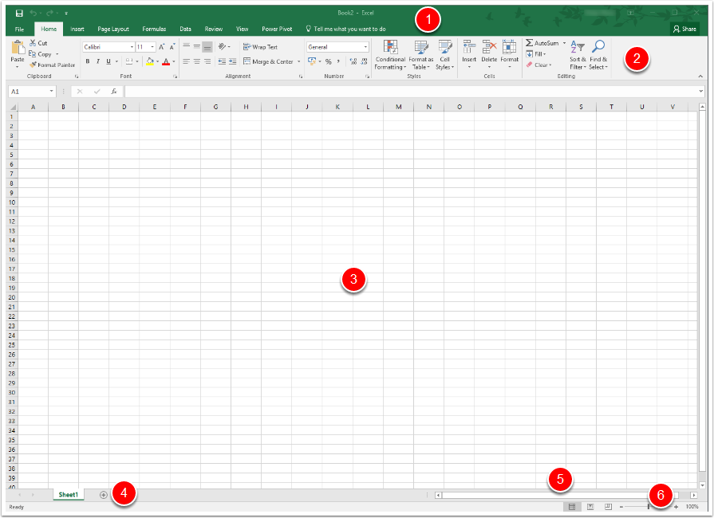

Cells
The workspace in Excel is made up of cells. Each cell is where a row and a column meet. Each row (1) has a number, and each column has a letter (2).
The currently selected cell has a cell reference made up of the column letter and row number. It is also shown in the name box (highlighted).
The selected cell below is A1.
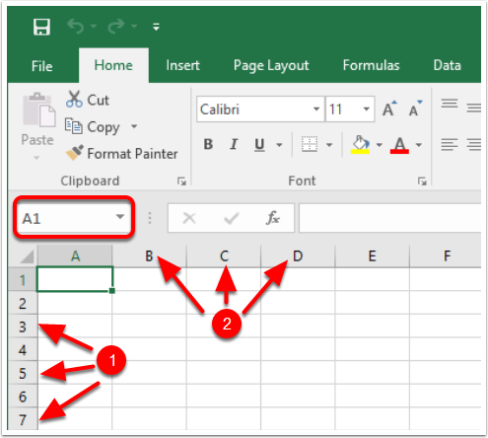
For example, the selected cells below are A1, C2, B4, B7 and E6.
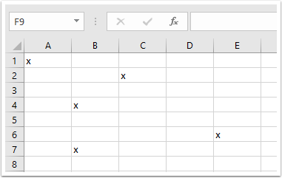

Entering a basic formula
In the example below, we have two numbers that we want to add together.
Although we could do this mentally, or on a calculator, it is as simple to do this for two numbers in Excel as for two thousand by using formulas.
Formulas will save you time as you start to analyse more and more data. They also automatically update so you don't have to re-do all of your calculations. (They can even do this once you've put the data into Word which can be really useful).
We're going to start with a simple formula - adding the two numbers together.
- To enter a formula, first click on the cell in which you want the answer to appear.
- Press the equals key (=)
- Click on the first cell (A2)
- Press the plus key (+)
- Click on the second cell (B2)
- Press Enter

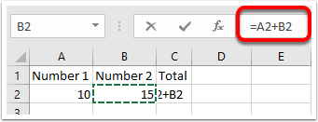
You will see the result appear. If you click on the result, you will also see the formula in the formula bar.
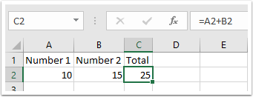

Finding a total with =SUM
Adding cells together manually is OK if there are only a few, but if you have a lot of data it's much easier to click and drag. =SUM lets you do that.
To add the two numbers as before, type =SUM( then click and drag the two numbers you want to add, type ) and then press enter.
In the example below, the formula you end up with is =SUM(A2:B2)
=SUM is the formula
(A2:B2) is the range of cells you are adding together - from A2 to B2)
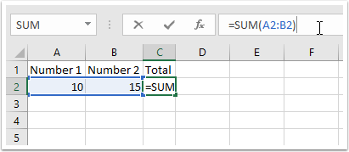

Copying a formula
If we had more data we could type the formula in for each row. It would be much quicker, though, to copy the formula.
Fill in a few rows of your own data.
Move the mouse to the bottom right corner of the cell with the formula in that you want to copy
The cursor will change to a black cross.
Click and drag it down to copy the formula.
When you release the mouse all of the calculations will complete at once.
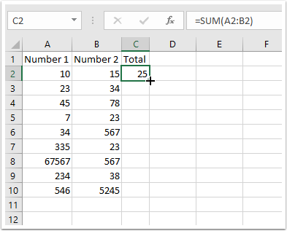

Adjusting cell width
One of the results seems to be just hashes - because the cell isn't wide enough to display all of the numbers.
The cell width needs to be adjusted.
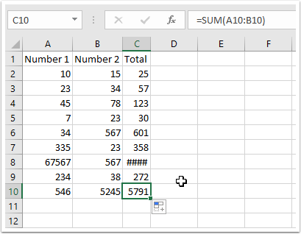
You can automatically fit the cell width to the cell contents by moving the cursor to the line between the cell letters and double-click when it changes to a line with two arrows).
You can also manually slide the cell boundary left and right by clicking and dragging.
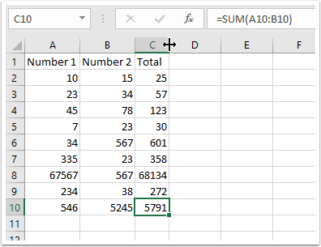

More formulas
When you were typing =SUM you might have noticed that Excel brings up a box of formulas based on what you're typing. Each formula also gives you a quick description of what it does.
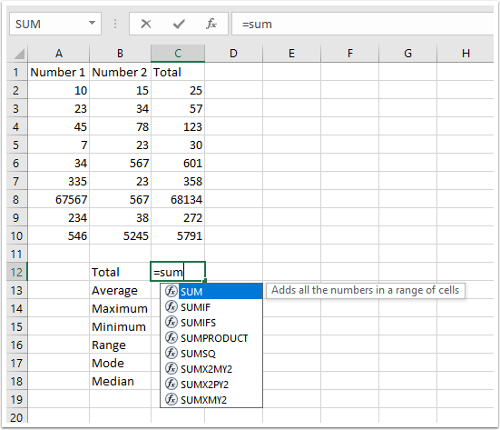

Find the mean with =AVERAGE
To find the Average (mean) of data, type =average(, click and drag the numbers you want to find the average for, type ) and then press Enter.
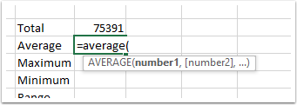

Find biggest and smallest with =MAX and =MIN , then use them to calculate range
To find the largest number the formula is =MAX, and to find the smallest =MIN
In the example below:
The formula to find the largest number from the totals would be =MAX(C2:C10) (find the largest number between cell C2 and C10)
The formula to find the smallest number from the totals would be =MIN(C2:C10) (find the smallest number between cell C2 and C10)
To calculate the range, use another formula to subtract the smallest number from the largest. The formula is =C14-C15
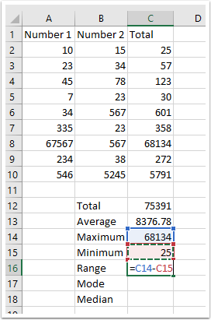

Find the mode (=MODE.SNGL)
To find the mode for a range of numbers, use the formula =MODE.SNGL
The formula to find the mode for the totals would be =MODE.SNGL(C2:C10)
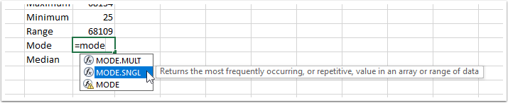

N/A?
The answer is #N/A because there is no modal number in the total column.
If we use the same formula in another column we can see it works.
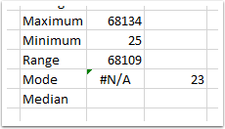

Find the median with =MEDIAN
=MEDIAN(C2:C10) gives the Median as 272.
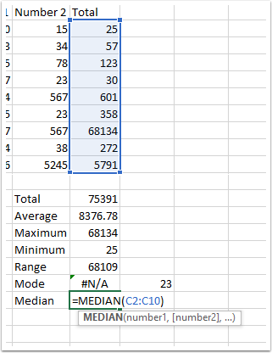

Selecting individual cells for a formula
Sometimes you may want to choose cells for a formula that are not next to one another (so you can't click and drag).
Type your formulas normal, then press and hold the CTRL key. You can then click and select whichever cells you want.
Each individual cell you select is separated with a comma in the formula, and has a different colour to help make things clearer.
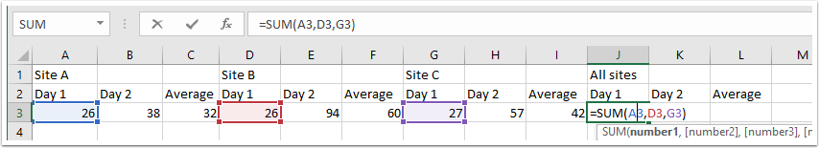

The Ribbon
You're probably used to using Microsoft Office so most of the ribbon will be quite familiar.
This is the Ribbon from Excel 2016 so yours may be different but the basics will be the same.
Have a look at the Formulas tab to see more examples of formulas, though if you want a formula the best way to find it is to Google it.
Two buttons you will need when presenting work are Increase/Decrease decimal (highlighted). These change the number of decimal places displayed without actually rounding the number up or down (i.e. they only change what you see, not the actual number stored). This is good for maintaining accuracy while being able to show that you know how many decimal places your data are accurate to.
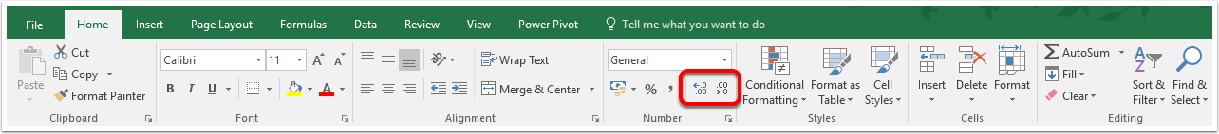

Finish
Make sure you save your workbook then close it. Save the file in a folder together with these instructions.

