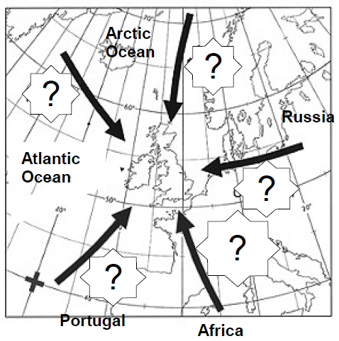

Polar Maritime | Arctic Maritime
Polar Continental | Tropical Maritime
Tropical Continental
Polar Maritime | Arctic Maritime
Polar Continental | Tropical Maritime
Tropical Continental

Polar Maritime | Arctic Maritime
Polar Continental | Tropical Maritime
Tropical Continental
Polar Maritime | Arctic Maritime
Polar Continental | Tropical Maritime
Tropical Continental

Polar Maritime | Arctic Maritime
Polar Continental | Tropical Maritime
Tropical Continental
Polar Maritime | Arctic Maritime
Polar Continental | Tropical Maritime
Tropical Continental

Polar Maritime | Arctic Maritime
Polar Continental | Tropical Maritime
Tropical Continental

Polar Maritime | Arctic Maritime
Polar Continental | Tropical Maritime
Tropical Continental

