Extreme Weather

Extreme weather is about the highest/lowest/biggest/smallest; anything but normal!

This exercise will improve your understanding of what ‘extreme’ means in different parts of the UK, and will help you link weather with larger scale ideas like air masses and global atmospheric circulation that you have studied, as well as making you think about other relationships such as with relief and land use.

It will also help you develop your data skills because you will have to interpret tables and do some simple calculations.

Resources

- Before you start, make sure you have a set of resource sheets (1-6) or the ‘PDF Resource sheets’ if you’re doing this online.
- You don’t need a calculator, but you might find one useful if you don’t enjoy mental maths.

Key
Min Minimum
Max Maximum

Questions

Section A – Site specifics (Resource sheet 5)

- Complete the table below using Tables 1 and 2. Find the largest/smallest value for each site across the year. Calculate the range by subtracting Min. from Max.

 | Temperature (ºC) |  |  | Rainfall (mm)
Site | Min. | Max. | Range | Min. | Max. | Range
Boulmer | -6.8 | 25.9 | 32.7 | 0 | 61.4 | 61.4
Eastbourne | -6.5 | 29.0 | 35.5 | 0 | 42.9 | 42.9
Keswick | -14.5 | 30.7 | 45.2 | 0 | 100.2 | 100.2
London | -5.3 | 34.7 | 40.0 | 0 | 36.0 | 36.0
Wattisham | -10.9 | 31.4 | 42.3 | 0 | 54.0 | 54.0

- Which site has the largest temperature range?
- Give 1 reason why this might be

- Which site has the smallest temperature range?
- Give 1 reason why this might be

- Which site has the most rainfall?
- Give 1 reason why this might be

- Which site has the least rainfall?
- Give 1 reason why this might be

- A which site(s) would a temperature of -5°C be least unusual?

Section B – explaining extremes

- Still referring to the table you completed in Section A, but now also looking at resource sheets 3 &4, can you describe and explain why both Keswick and Wattisham have lower minimum temperatures recorded compared to the other sites?

- Using Resource sheets 1 and 3 to help, can you explain why Keswick’s lowest temperature of -14.5ºC is so much lower than London’s lowest temperature of -5.3ºC during the same time period? Hint: you need to think about latitude, land use and landscape
Keswick is colder because

London is less cold because

- Eastbourne and Wattisham are both around 60 miles from London. Eastbourne is on the South coast, and Wattisham is East of London in Suffolk. Using Resource Sheet 1 to help, can you explain why their maximum temperatures are so different?

- Refer to Table 4. Identify the highest the highest daily rainfall recorded in London and the month it happened in. Explain what type of weather may have caused this? ?
Highest daily rainfall: Month:

- Why is the range a less useful measure of extreme weather for rainfall?

Section C – do averages hide extremes?

- The table below shows average figures for each site averaged across all days between 2006-2015 (i.e. 3652 measurements added together and divided by 3652 -there were two leap years!)
 | Temperature (°C) |  |  | Rainfall (mm)
Site | Min | Max | Range | Min | Max | Range
Boulmer | -0.8 | 20.8 | 21.6 | 0 | 32.6 | 32.6
Eastbourne | 1.0 | 21.7 | 20.7 | 0 | 31.2 | 31.2
Keswick | -4.2 | 21.9 | 26.1 | 0 | 57.2 | 57.2
London | 1.2 | 25.5 | 24.3 | 0 | 26.5 | 26.5
Wattisham | -3.0 | 23.7 | 26.8 | 0 | 28.5 | 28.5

Why are the average figures less extreme?

- If you used this table, would any of your answers for Section A change?

- If you answer(s) would change, give a reason for one of the changes

- Complete the table below using the data from Table 5 (Resource sheet 6)
Site | Wettest |  | Driest
 | Month | Rainfall (mm) | Month | Rainfall (mm)
Boulmer | November | 880 | April | 381
Eastbourne | November | 1081 | April | 348
Keswick | December | 2498 | April | 601
London | January | 628 | March | 329
Wattisham | August | 724 | April | 296

- Which are the wettest and driest sites?
Wettest: Driest:
- Can you suggest a reason for any surprising results?

Answer the following questions by drawing on the graphs overleaf/below. (You will need to locate the weather sites using Resource Sheet 1).

Tips for working with graphs
- Make sure you understand what the graph is showing – read the title, and make sure you understand what each axis is showing and the units it is using.
- If you are asked to find/describe patterns look for where numbers are rising, falling, staying the same, or changing at a certain point (a peak or a trough)? If there doesn’t seem to be a pattern, that’s a pattern itself – randomness!
- When describing graphs try to include at least one number you’ve ‘extracted’ from the graph in your answer.

Section D – working with graphs
- Draw a line of best fit for minimum temperatures at each site (use the middle of the end of each column). Describe any pattern you notice.

- Draw a line of best fit for maximum temperature at each site. Describe any pattern you notice.

- Circle any extreme temperatures you can see. Annotate one to very briefly explain why you chose it.
- In which site does the average temperature vary the most? (remember to read off the right-hand side of the graph – the left axis is min/max temperature). Can you explain why? (Hint – look at the location).

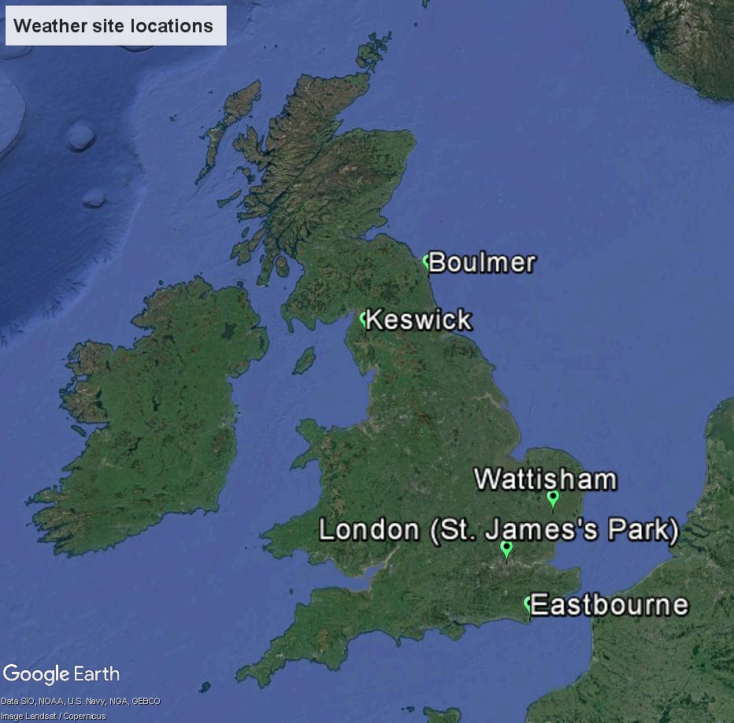
Resource sheet 1 - Weather station locations

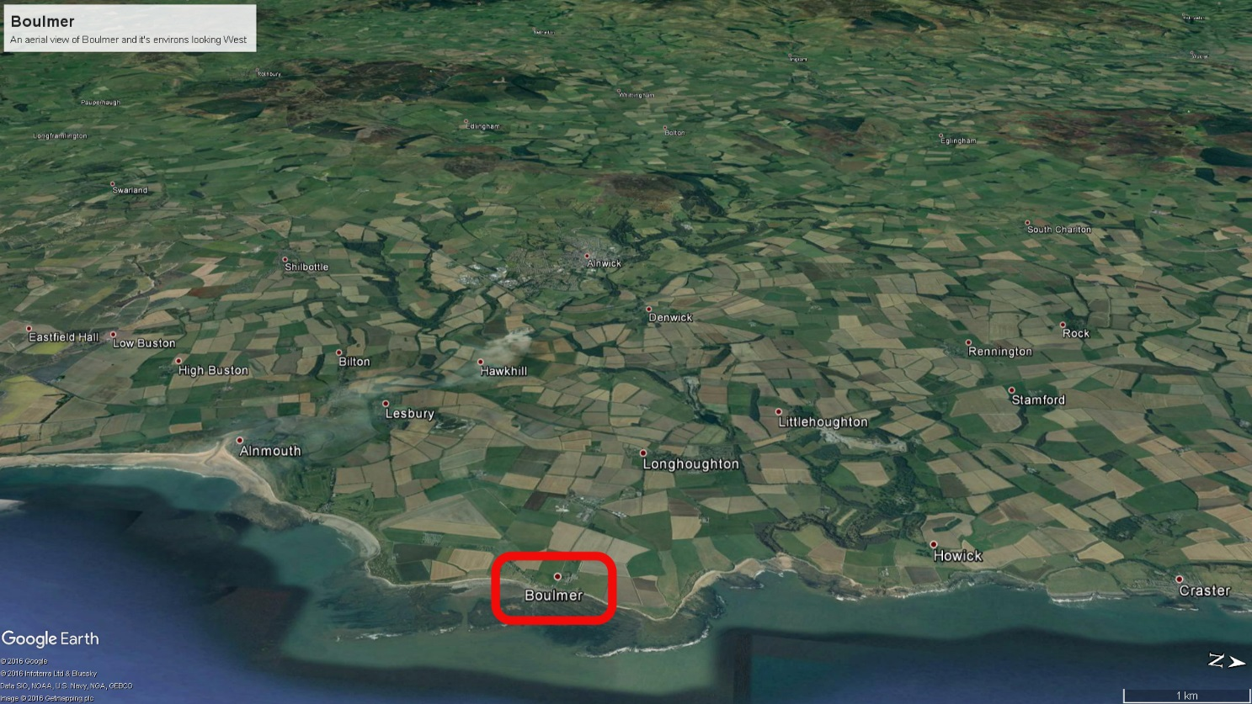
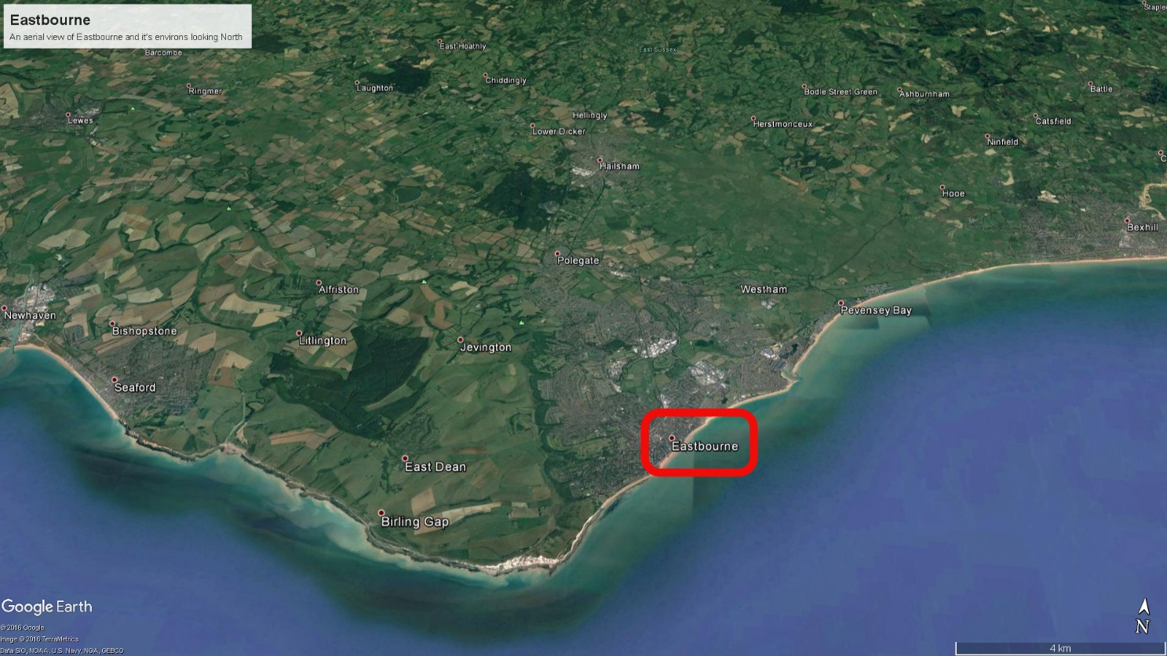
Resource sheet 2
Aerial views of Boulmer and Eastbourne weather stations
Resource sheet 3
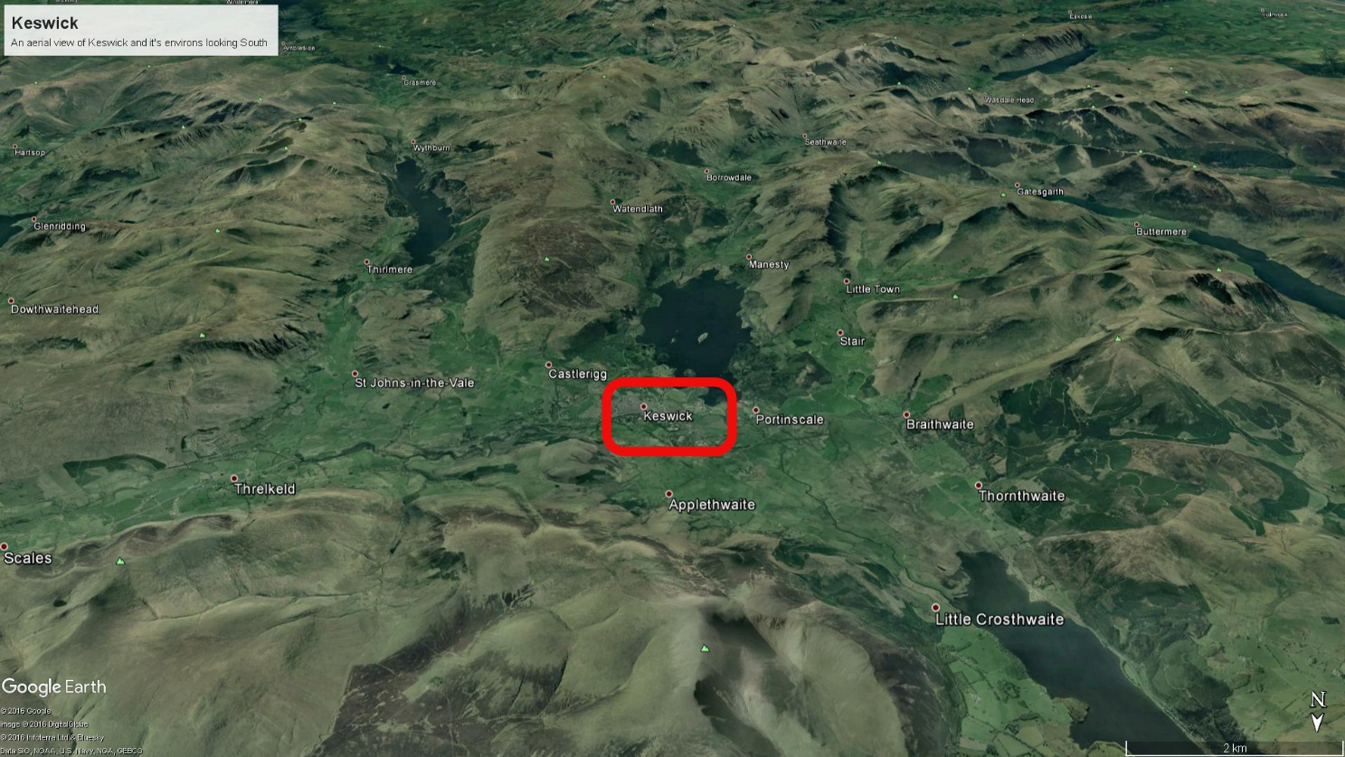
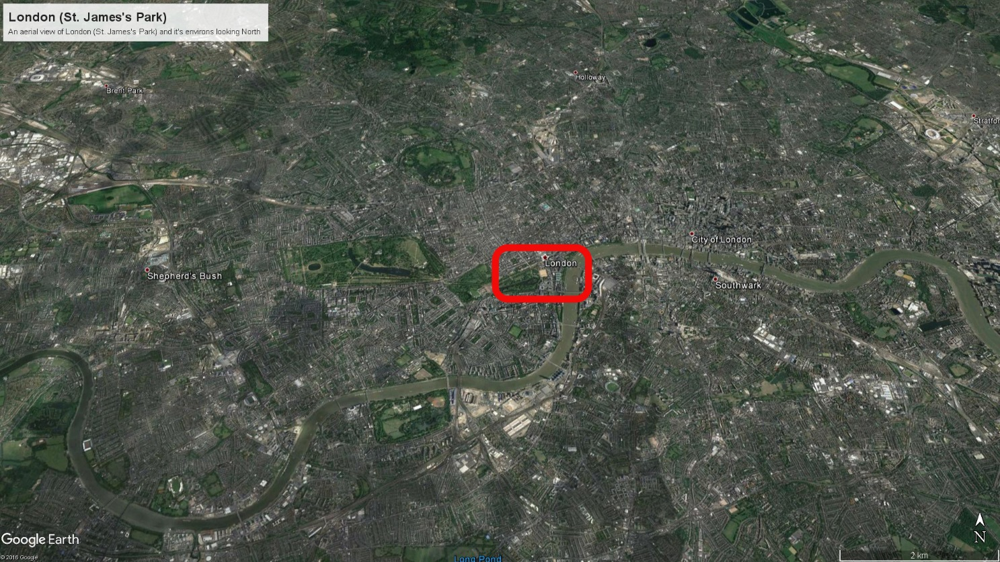
Aerial views of Keswick and London (St. James’s Park) weather stations
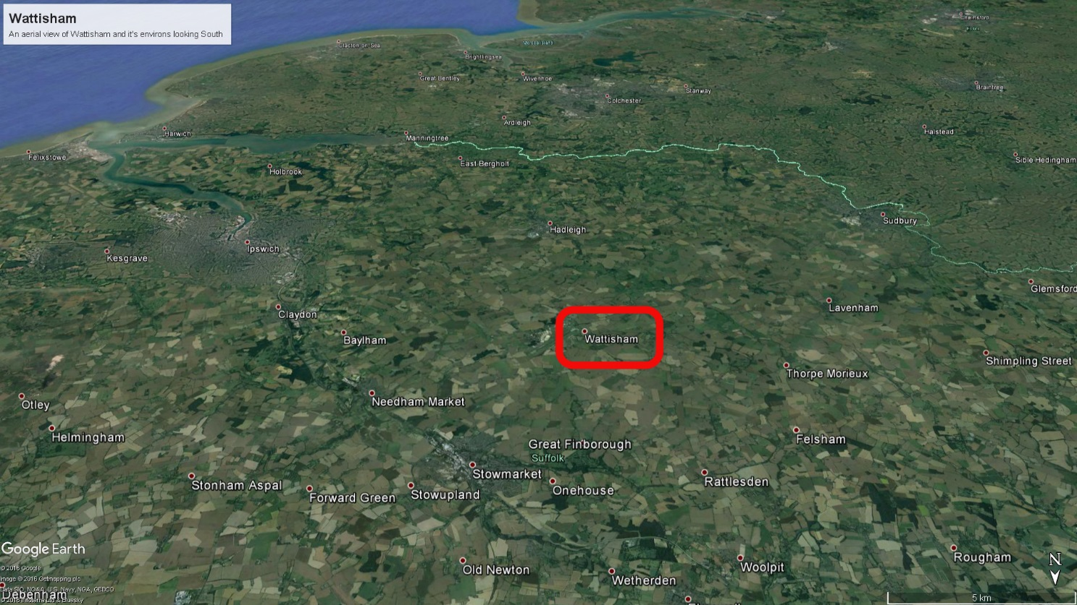
Resource sheet 4 – Aerial view of Wattisham weather station

Table 1 - Min. daily temperature (ºC) by month for the period 2006-2015
 | Jan | Feb | Mar | Apr | May | Jun | Jul | Aug | Sep | Oct | Nov | Dec
Boulmer | -6.3 | -5.5 | -4 | -1.4 | 0.3 | 3.1 | 6.5 | 5.1 | 2.5 | -0.3 | -2.5 | -6.8
Eastbourne | -5.5 | -5 | -2 | -1.5 | 2.5 | 7 | 10 | 8.4 | 6 | 0.8 | -2.5 | -6.5
Keswick | -9.6 | -7.1 | -8.2 | -4.7 | -3 | 2 | 4.3 | 3 | -0.8 | -4.1 | -7.4 | -14.5
London | -3.8 | -4.2 | -2.7 | -1 | 3.4 | 7 | 9.8 | 7.7 | 6.2 | 0.5 | -3.3 | -5.3
Wattisham | -10.9 | -9.6 | -7.1 | -3.3 | -1.1 | 2.4 | 5.4 | 4 | 2.6 | -2.2 | -5.8 | -10.6
Table 2 - Max. daily temperature (ºC) by month for the period 2006-2015
 | Jan | Feb | Mar | Apr | May | Jun | Jul | Aug | Sep | Oct | Nov | Dec
Boulmer | 15 | 16.6 | 21.1 | 21 | 21.2 | 25 | 25.5 | 25.9 | 24 | 20.2 | 17.5 | 16.5
Eastbourne | 13.8 | 13.5 | 19.2 | 25.5 | 26.1 | 26.5 | 29 | 27 | 25 | 22.6 | 17.1 | 14.5
Keswick | 14.4 | 16 | 21 | 23.5 | 25.8 | 27.5 | 30.7 | 24.3 | 25.6 | 20.6 | 17.8 | 15.4
London | 15.7 | 17.4 | 22.8 | 27.1 | 28.5 | 32 | 34.7 | 33 | 29.3 | 29.1 | 19 | 16.9
Wattisham | 14.3 | 16.8 | 19.6 | 25.6 | 25.8 | 30.4 | 31.4 | 30.8 | 29.7 | 28.2 | 17.3 | 14.9
Resource sheet 5 - Data tables for Min/Max temperature

Table 3 - Min. daily rainfall (mm) by month for the period 2006-2015
 | Jan | Feb | Mar | Apr | May | Jun | Jul | Aug | Sep | Oct | Nov | Dec
Boulmer | 0 | 0 | 0 | 0 | 0 | 0 | 0 | 0 | 0 | 0 | 0 | 0
Eastbourne | 0 | 0 | 0 | 0 | 0 | 0 | 0 | 0 | 0 | 0 | 0 | 0
Keswick | 0 | 0 | 0 | 0 | 0 | 0 | 0 | 0 | 0 | 0 | 0 | 0
London | 0 | 0 | 0 | 0 | 0 | 0 | 0 | 0 | 0 | 0 | 0 | 0
Wattisham | 0 | 0 | 0 | 0 | 0 | 0 | 0 | 0 | 0 | 0 | 0 | 0
Table 4 - Max. daily rainfall (mm) by month for the period 2006-2015
 | Jan | Feb | Mar | Apr | May | Jun | Jul | Aug | Sep | Oct | Nov | Dec
Boulmer | 22 | 25.2 | 28 | 21.8 | 18 | 21.6 | 61.4 | 38.6 | 31.4 | 41 | 47.8 | 34.6
Eastbourne | 23.5 | 40.3 | 23.9 | 17.1 | 26.2 | 39.7 | 26.9 | 42.9 | 26.1 | 42.7 | 32.4 | 32.2
Keswick | 51.6 | 36.2 | 53.4 | 29 | 35.2 | 88.6 | 42.6 | 33.6 | 45.6 | 76 | 94.6 | 100.2
London | 24.2 | 23.4 | 14 | 23.5 | 30.6 | 30 | 32.6 | 36 | 23.8 | 29.8 | 20 | 29.6
Wattisham | 13.2 | 22.2 | 24.8 | 17.6 | 54 | 23.8 | 40.2 | 45.8 | 29 | 34.6 | 17.2 | 19
Table 5 – Average total rainfall (mm) by month for the period 2006-2015.
 | Jan | Feb | Mar | Apr | May | Jun | Jul | Aug | Sep | Oct | Nov | Dec | Total
Boulmer | 638 | 436 | 414 | 381 | 512 | 578 | 861 | 771 | 507 | 700 | 880 | 677 | 7355
Eastbourne | 867 | 701 | 437 | 348 | 552 | 363 | 550 | 743 | 423 | 928 | 1081 | 934 | 7927
Keswick | 1813 | 1013 | 1024 | 601 | 865 | 912 | 1221 | 1390 | 1195 | 1788 | 2174 | 2498 | 16494
London | 628 | 517 | 329 | 375 | 545 | 454 | 469 | 562 | 345 | 504 | 568 | 585 | 5880
Wattisham | 522 | 509 | 392 | 296 | 662 | 458 | 623 | 724 | 432 | 674 | 648 | 533 | 6471
Resource sheet 6 – Data tables for Min/Max/Total rainfall

