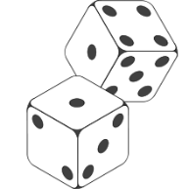 Weather or Climate?

|  |  |
| --- | --- |
| Total score | Tally |
| 2 |  |
| 3 |  |
| 4 |  |
| 5 |  |
| 6 |  |
| 7 |  |
| 8 |  |
| 9 |  |
| 10 |  |
| 11 |  |
| 12 |  |

