Prep Task
- Match the following types of clothing and items that you would most likely need if that air mass was strongest. For each option, choose from the following air masses, you may need to write more than one:
Polar Continental Tropical Continental Tropical Maritime
Polar Maritime Arctic Maritime

a) b) c)

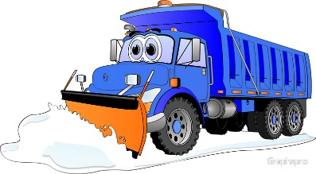
d) e) f)

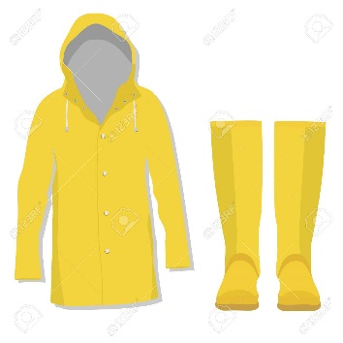
g) h) i)

- a) Which type of air mass would be best for having a barbeque?
b) Which type of air mass might cause flooding?
c) Which type of air mass would be best for ski resorts?
d) Which type of air mass might cause water shortages in summer?
The Beast from the East
The Beast from the East was a period of extreme weather at the end of February 2018 where large amounts of snow fell across Scotland. This unusual weather caused a large amount of disruption and had a big impact on many people across the country. In this short unit, we will explore what causes heavy snowfall in the UK, the weather that occurred during this time and the impact it had on people.

Air Masses
Aim: to be able to describe what causes heavy snowfall in the UK in winter
Heavy snowfall in the UK in winter is normally caused by certain air masses.
An air mass is a large volume of air that has the same characteristics. It has the same temperature and moisture. They are named according to where they come from.

Temperature Moisture
T – Tropical – warm air mass c – Continental – dry air mass
P – Polar – cold air mass m – Maritime – wet air mass
A/AA – Arctic or Antarctic – very cold air mass

There are five main air masses which affect the UK:
- Tropical continental
- Tropical maritime
- Polar maritime
- Arctic maritime
- Polar continental

At any one time, the strongest air mass will determine the type of weather the UK receives.

Tropical Continental
A tropical continental air mass is from North Africa. It is hot, dry air which brings hot weather in the summer.
Tropical Maritime
A tropical maritime air mass is from the Atlantic Ocean. Its warm, moist air brings clouds, rain and mild temperatures.
Polar Maritime
A polar maritime air mass is from Greenland and the Arctic Sea. Its wet, cold air brings cold temperatures, clouds and rain.
Arctic Maritime
An arctic maritime air mass is from the Arctic. Its wet, cold air brings very cold temperatures and snow in the winter.
Polar Continental
A polar continental air mass is from Central Europe and Russia. Its hot air brings dry summers but in winter it is very cold and brings heavy snow.
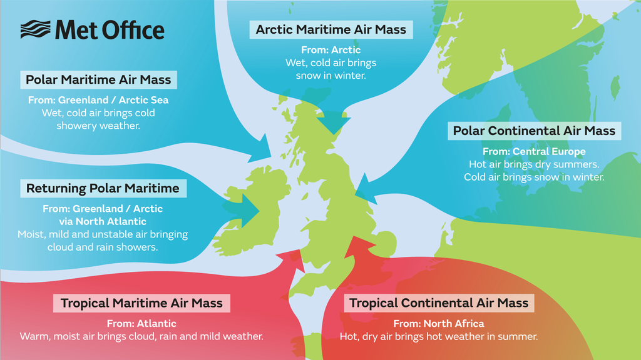
Polar Maritime Air Mass
From: Greenland/Arctic Sea
Wet, cold air brings cold temperatures, cloud and rain showers.

Task 1
Collect a copy of a blank map of the UK and stick it into your jotter in the middle of your page.
- Give your map a title – Air masses affecting the UK.
- Draw the warm air masses with a red arrow and the cold air masses with a blue arrow.
- Write the name of the air mass next to the arrow.
For a challenge…
- Write the type of weather the air mass brings.

Task 2
Answer the following questions in sentences.
- What was The Beast from the East?
- What is an air mass?
- How are air masses named?
- What is the name given to a warm air mass?
- What is the name given to a wet air mass?
- Which air mass is warm and dry?
- Which air mass is cold and wet?
- How many air masses affect the UK?
- Which air mass was responsible for bringing the heavy snow during The Beast from the East?
- Which type of air mass would you prefer? Why?

