Climate Change – Sun, Volcanoes and People
Name: Date:

This graph shows summer temperatures in England from 1200 to 2017. This data came from tree rings. The black dots show the ‘weather’ – the average summer temperature for each year, whereas the orange line shows the ‘climate’ – the summer weather averaged over 30 years.
The data in this graph comes from tree rings. Trees only grow in the summer and therefore can’t tell us about winter temperatures.

- In which century were the summer temperatures coldest? _________________________________(1 mark)
- How did the climate change between 1550 and 1600? ____________________________________(1 mark)
- How did the climate change between 1800 and 1820?_____________________________________(1 mark)
- How has the climate changed since 1900? ________________________________________________________________________________________________________________________________________________________________________________________________________________________________________________________________________________________________________________________________________________________(2 marks)

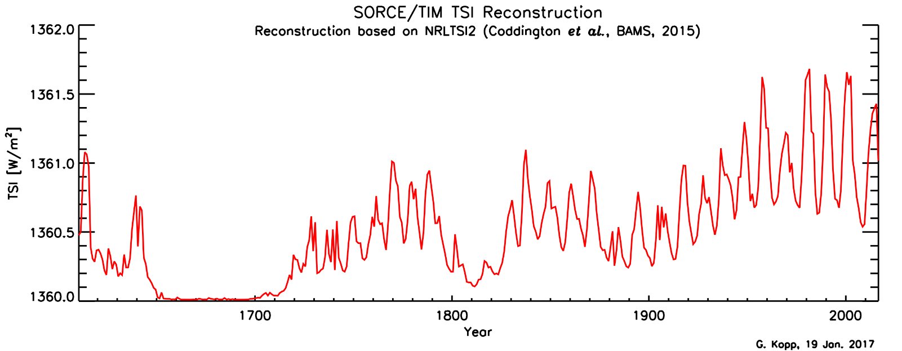
This graph shows how much energy the Earth has received from the Sun from 1600 to the present.
- Some people say that the increases in temperature we’ve seen over the last 100 years are due to changes in the Sun.
a) What evidence to support this is there in this graph?
____________________________________________________________________________________________________________________________________________________________________________________________________________________________________________________________________________________________________________________________________________________________________________________________________________________________________________________________________(3 marks)
b) What evidence to contradict this is there in this graph?
____________________________________________________________________________________________________________________________________________________________________________________________________________________________________________________________________________________________________________________________________________________________________________________________________________________________________________________________________(3 marks)
- Can the Sun be used to explain the climate changes between 1800 and 1820?
__________________________________________________________________________________________________________________________________________________________________________(1 mark)
- Can the Sun be used to explain the coldest century you identified in question 1? __________________________________________________________________________________________________________________________________________________________________________(1 mark)

This graph shows the total amount of volcanic material in the upper atmosphere. This sort of material can cool the climate.
- Which three periods do you think could have been most affected by volcanic activity? ________________________________________________________________________________________________________________________________________________________________________(2 marks)
- Is there any evidence that volcanic activity contributed to the temperature changes in England in:
- The coldest century? ____________________________________________________________(1 mark)
- Temperature changes in the 15th century? __________________________________________________________________________________________________________________________________________________________________ (2 marks)
- Between 1550 and 1600? ________________________________________________________(1 mark)
- Between 1800 and 1820?
___________________________________________________________________________________________________________________________________________________________________(1 mark)
- Since 1900? ________________________________________________________________________________________________________________________________________________________________________________________________________________________________________________________(2 marks)
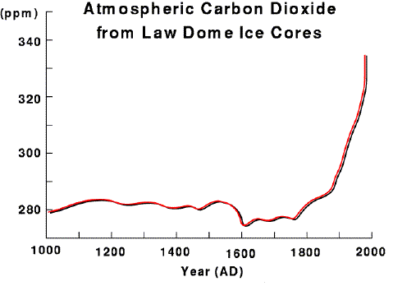
This graph shows the amount of carbon dioxide in the air, as measured from air bubbles trapped in ice at the Law Dome in Antarctica.
- Describe how the amount of carbon dioxide in the atmosphere has changed from 1000 – 2000AD
_________________________________________________________________________________________________________________________________________________________________________________________________________________________________________________________________(2 marks)
- Can the amount of carbon dioxide in the air explain the climate change between 1550 and 1600? _________________________________________________________________________________________________________________________________________________________________________________________________________________________________________________________________(2 marks)
- Can the amount of carbon dioxide in the air explain the climate change between 1800 and 1820?
_________________________________________________________________________________________________________________________________________________________________________________________________________________________________________________________________(2 marks)
- Can the amount of carbon dioxide in the air explain the climate change since 1900?
_________________________________________________________________________________________________________________________________________________________________________________________________________________________________________________________________________________________________________________________________________________________(4 marks)

- In your own words, summarise all the factors which had an impact on summer temperatures in England after 1900:
_______________________________________________________________________________________________________________________________________________________________________________________________________________________________________________________________________________________________________________________________________________________________________________________________________________________________________________________________________________________________________________________________________________________________________________________________________________________________________________________________________________________________________________________________________________________________________________________________________________(5 marks)_
Extension question:
“Pre-Columbian farmers of the Neotropical lowlands numbered an estimated 25 million by 1492, with at least 80% living within forest biomes. It is now well established that significant areas of Neotropical forests were cleared and burned to facilitate agricultural activities before the arrival of Europeans. Demographic pressure on forest resources—such as burning—increased steadily throughout the Late Holocene, peaking when Europeans arrived in the late fifteenth century.
The introduction of Old World diseases (such as small pox) led to recurrent epidemics and resulted in an unprecedented population crash throughout the Neotropics. The rapid demographic collapse was mostly complete by 1650, by which time it is estimated that about 95% of all indigenous inhabitants of the region had perished.
Neotropical lowlands went from being a net source of CO2 to the atmosphere before Columbus to a net carbon sink for several centuries following the Columbian encounter.”
Adapted from Annals of the Association of American Geographers, 100(4) 2010, pp. 755–771 C _ 2010

- Using all the evidence you’ve seen in the graphs above, explain how the climate changed in the 17th Century and the possible contributing factors.

