Climate Change – Sun, Volcanoes and People
Learning Objectives:
- The difference between weather and climate.
- The weather and climate are continuously changing.
- There have been colder and warmer periods in the past.
- The Sun, volcanoes and greenhouse gases have contributed to past climate change.
- Data skills – interpreting line graphs and figures.
- Critical thinking.

This graph shows summer temperatures in England from 1200 to 2017. This data came from tree rings. The black dots show the ‘weather’ – the average summer temperature for each year, whereas the orange line shows the ‘climate’ – the summer weather averaged over 30 years.
The data in this graph comes from tree rings. Trees only grow in the summer and therefore can’t tell us about winter temperatures.

- In which century were the summer temperatures coldest? ___The 17th Century was coldest (the 14th was also cold)___(1 mark)
- How did the climate change between 1550 and 1600? ___It got colder by about 1.7°C_____(1 mark)
- How did the climate change between 1800 and 1820?___It got colder by about 0.5°C ____(1 mark)
- How has the climate changed since 1900? The climate warmed in the first part of the twentieth century before cooling a little. Since about 1960, it has been warming again, with a slight drop in the first years of the 21st century. On the whole, it is about 0.5°C warmer than in 1900.___(2 marks)

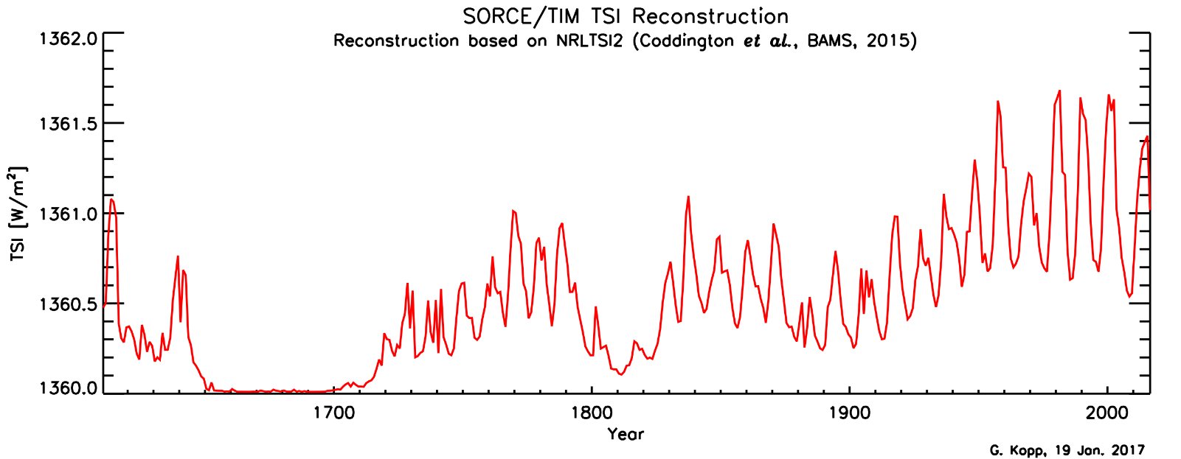
This graph shows how much energy the Earth has received from the Sun from 1600 to the present.
- Some people say that the increases in temperature we’ve seen over the last 100 years are due to changes in the Sun.
a) What evidence to support this is there in this graph?
_____The Sun got progressively more active over the period 1900 – 1960. If the Sun is more active, more light reaches the Earth’s surface, warming the land, plants and oceans. The warming coincides with the rise in summer temperatures in England from 1900-1950 seen in the previous graph. __________(3 marks)
b) What evidence to contradict this is there in this graph?
__The amount of energy the Earth received from the Sun remained steady and high from 1960-2000 and so doesn’t explain either the slight dip in temperatures in the middle of the last century or the subsequent warming._________________________(3 marks)
- Can the Sun be used to explain the climate changes between 1800 and 1820?
__Between 1800-1820, the Earth didn’t get very much energy from the Sun, this may have contributed to the colder summer temperatures in that period._____________________(1 mark)
- Can the Sun be used to explain the coldest century you identified in question 1? __Between 1640 and 1700, the Earth didn’t get very much energy from the Sun, this may have contributed to the colder temperatures in that period.________(1 mark)

This graph shows the total amount of volcanic material in the upper atmosphere. This sort of material can cool the climate.
- Which three periods do you think could have been most affected by volcanic activity? __approximately: 1160-1280, 1450-1500 and 1780-1840_____________(2 marks)
- Is there any evidence that volcanic activity contributed to the temperature changes in England in:
- The coldest century? _There were a few fairly large eruptions in the 17th century which could have contributed to the colder temperatures ___(1 mark)
- Temperature changes in the 15th century? _Although generally a warm century with very little volcanic activity in the first half, the large eruption in around 1450 clearly shows in the temperature record with rapid cooling. (2 marks)
- Between 1550 and 1600? ___Yes, there was an increase in volcanic activity towards the end of the century corresponding to the cooling temperatures._____(1 mark)
- Between 1800 and 1820?___Yes, there was an increase in volcanic activity corresponding to the cooling temperatures ____(1 mark)
- Since 1900? There has been very little volcanic activity since 1900, which corresponds with relatively warm temperatures. However, volcanoes didn’t contribute to the cooling in the middle of the 20th century.___(2 marks)
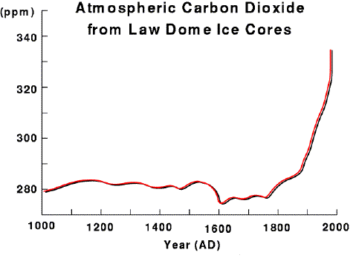
This graph shows the amount of carbon dioxide in the air, as measured from air bubbles trapped in ice at the Law Dome in Antarctica.
- Describe how the amount of carbon dioxide in the atmosphere has changed from 1000 – 2000AD
____The amount of carbon dioxide in the atmosphere remained relatively constant at about 280ppm until about 1550 when it fell a little. Since 1750 the amount of carbon dioxide has been rising at an ever increasing rate and was at about 340ppm in 2000._______(2 marks)
- Can the amount of carbon dioxide in the air explain the climate change between 1550 and 1600? _____Yes, with less carbon dioxide in the air you would expect it to be colder, as carbon dioxide is a greenhouse gas. The first graph showed temperatures in England falling by about 1.7°C in this time. (2 marks)
- Can the amount of carbon dioxide in the air explain the climate change between 1800 and 1820?
_____No, the temperature in England got colder in this time, but the carbon dioxide levels were rising. You would expect this to make it warmer.___(2 marks)
- Can the amount of carbon dioxide in the air explain the climate change since 1900?
____Carbon dioxide levels were rising since 1900. This can explain the rising temperatures after 1900, but doesn’t explain why it cooled in England from 1940 -1960, or why it cooled slightly after 2000. _____________________________________________________________________________(4 marks)

- In your own words, summarise all the factors which had an impact on summer temperatures in England after 1900:
_______________________________________________________________________________________________________________________________________________________________________________________________________________________________________________________________________________________________________________________________________________________________________________________________________________________________________________________________________________________________________________________________________________________________________________________________________________________________________________________________________________________________________________________________________________________________________________________________________________(5 marks)_
Extension question:
“Pre-Columbian farmers of the Neotropical lowlands numbered an estimated 25 million by 1492, with at least 80% living within forest biomes. It is now well established that significant areas of Neotropical forests were cleared and burned to facilitate agricultural activities before the arrival of Europeans. Demographic pressure on forest resources—such as burning—increased steadily throughout the Late Holocene, peaking when Europeans arrived in the late fifteenth century.
The introduction of Old World diseases (such as small pox) led to recurrent epidemics and resulted in an unprecedented population crash throughout the Neotropics. The rapid demographic collapse was mostly complete by 1650, by which time it is estimated that about 95% of all indigenous inhabitants of the region had perished.
Neotropical lowlands went from being a net source of CO₂ to the atmosphere before Columbus to a net carbon sink for several centuries following the Columbian encounter.”
Adapted from Annals of the Association of American Geographers, 100(4) 2010, pp. 755–771 C _ 2010

- Using all the evidence you’ve seen in the graphs above, explain how the climate changed in the 17th Century and the possible contributing factors.

