Spearman’s Rank Correlation Coefficient – Temperature and Tree Rings
Name: Date:
We expect trees to respond to the weather – when it is warmer in the summer, they grow more and the tree rings they produce are wider.
The data you have been given below comes from a long lived tree. We only have thermometer measurements from near where the tree grew for the last 14 years of the tree’s life. If you can prove that the tree’s rings correlate well with the measurements made by the thermometer, then we can use the older tree rings as a proxy thermometer.
In the table below, you are supplied with ‘tree ring width index’ rather than the actual tree ring width in mm. The tree ring width index takes into account the fact that trees tend to grow narrower rings as they get older.
Year | Tree ring width index | Summer Temperature (°C)
2003 | 141 | 19.0
2002 | 65 | 17.0
2001 | 68 | 11.9
2000 | 98 | 19.6
1999 | 42 | 14.8
1998 | 75 | 17.1
1997 | 55 | 14.7
1996 | 71 | 13.7
1995 | 89 | 13.9
1994 | 157 | 19.4
1993 | 184 | 18.7
1992 | 2 | 10.0
1991 | 79 | 16.3
1990 | 181 | 19.5

- First of all, produce a scattergraph of this data below.
- Draw a line of best fit through the data.
We will start with the null hypothesis that There is no significant relationship between the temperature and tree ring width for this tree. If we can disprove this hypothesis, then we can use older wood in this tree to get temperature records for before we had thermometers nearby to record the temperature.
- What other factors do you think might have an impact on tree ring width? ________________________________________________________________________________________________________________________________________________________________________________
The Spearman’s Rank Correlation Coefficient is given by
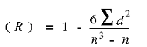
Where n is the number of points in the sample, and d is the difference between ranks.
- Complete the following table using the data in the table above:
Year | Tree ring width index | Rank | Summer Temperature (°C) | Rank | Difference between ranks (d) | d²
2003
2002
2001
2000
1999
1998
1997
1996
1995
1994
1993
1992
1991
1990
- Calculate the following:
∑d²= 6∑d²=
n³= n³-n=
(R) =

The closer R is to +1 or -1, the stronger the likely correlation. A perfect positive correlation is +1 and a perfect negative correlation is -1.
- Complete the following sentence: The tree ring width in this sample shows a strong/ weak
positive/ negative correlation with temperature.
We now need to test the significance of the relationship.
- The number of degrees of freedom in this sample is (n-2). Draw a vertical line at this value on the graph below. Draw a horizontal line at the R value which you obtained. Do the lines meet above or below the red lines?______________________________________________________________________

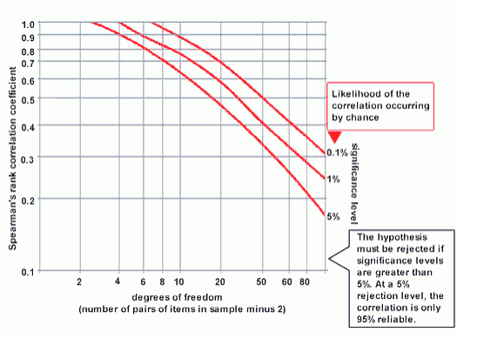
Taken from https://geographyfieldwork.com
- Select one of the following statements
- We can be 99.9% certain that tree ring width is related to temperature in this sample.
- We can be 99% certain that tree ring width is related to temperature in this sample.
- We can be 95% certain that tree ring width is related to temperature in this sample.
- We cannot say whether tree ring width is related to temperature or not.

- Would you use older wood in this tree as a proxy thermometer?____________________________

