Temperature, Precipitation and Photosynthesis
Learning Objectives:
- Revise the factors which limit photosynthesis
- Data skills – line graphs and bar graphs, averages (mean)
Circle the correct words in the following paragraph:
Trees absorb light using chlorophyll in their leaves/ bark. They also absorb carbon dioxide through their leaves/ roots and water through their leaves/ roots. The trees use the light to react carbon dioxide with water to make a sugar called glucose. This sugar is used for growth. In the spring and early summer, trees grow faster, forming larger cells which make the new wood look light/ dark. In the late summer and autumn, trees grow slower, forming smaller cells which make the new wood look light/ dark. One pair of light and dark rings represents one year’s growth. In cold places, trees can grow more when summer/ winter temperatures are warmer/ colder. In dry places, trees can grow more when there is more/ less rain in the summer/ winter.
- Tree growth and July temperatures

Complete the following sentence:
This graph shows that in warmer summers, the tree grows __more_____.
This sample was taken from a Scot’s pine tree growing in the U.K.
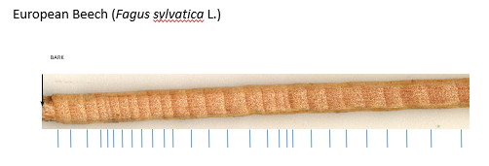
11mm
Create the following table, using a ruler to measure the ring width and the graph to convert ring width to temperature to the nearest degree. Year 1 (the oldest ring) is the first complete ring furthest from the bark – that has been measured as an example. Also calculate the average (mean) July temperature.
Year | Ring width (mm) | July Temperature (°C)
1 | 11 | 24
2 | 9 | 23
3 | 7 | 21
4 | 8 | 22
5 | 8 | 22
6 | 6 | 20
7 | 7 | 21
8 | 7 | 21
9 | 2 | 17
10 | 3 | 18
11 | 4 | 19
Average (mean) |  | 20.7

The tree grew most in year __1__ and least in year __9__.

- Tree growth and summer precipitation (rainfall)

Complete the following sentence:
This graph shows that_the tree grows faster when there is more rainfall in the summer. However, the tree responds more to differences in rainfall when the rainfall is low, than when it is high.___
This sample was taken from a Bristlecone Pine tree growing in the White Mountains in California.
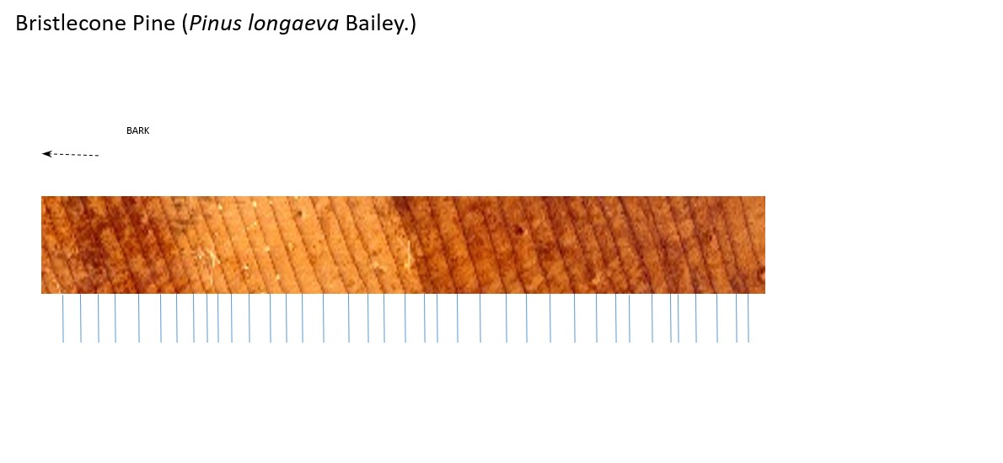
Create the following table, using a ruler to measure the ring width and the graph to convert ring width to precipitation (rainfall). Year 1 is the first complete ring furthest from the bark. Also calculate the average (mean) summer precipitation.
Year | Ring width (mm) | Summer Precipitation (mm)
1 | 3 | 4
2 | 4 | 6
3 | 5 | 9
4 | 4 | 6
5 | 2 | 3
6 | 4 | 6
7 | 5 | 9
8 | 3 | 4
9 | 4 | 6
10 | 5 | 9
11 | 6 | 12
12 | 6 | 12
13 | 5 | 9
14 | 6 | 12
Average (mean) |  | 7.6

Finally, draw a bar graph of summer precipitation for the 14 years:
YEAR
Precipitation (mm)

