Temperature, Precipitation and Photosynthesis
Name: Date:
Circle the correct words in the following paragraph:
Trees absorb light using chlorophyll in their leaves/ bark. They also absorb carbon dioxide through their leaves/ roots and water through their leaves/ roots. The trees use the light to react carbon dioxide with water to make a sugar called glucose. This sugar is used for growth. In the spring and early summer, trees grow faster, forming larger cells which make the new wood look light/ dark. In the late summer and autumn, trees grow slower, forming smaller cells which make the new wood look light/ dark. One pair of light and dark rings represents one year’s growth. In cold places, trees can grow more when summer/ winter temperatures are warmer/ colder. In dry places, trees can grow more when there is more/ less rain in the summer/ winter.
- Tree growth and July temperatures

Complete the following sentence:
This graph shows that________________________________________________________________.
This sample was taken from a Scot’s pine tree growing in the U.K.

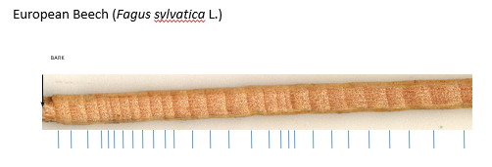
11mm
Create the following table, using a ruler to measure the ring width and the graph to convert ring width to temperature to the nearest degree. Year 1 is the first complete ring furthest from the bark – that has been measured as an example. Also calculate the average (mean) July temperature.
Year | Ring width (mm) | July Temperature (°C)
1 | 11 | 24
2
3
4
5
6
7
8
9
10
11
Average (mean)

The tree grew most in year ____ and least in year ____.

- Tree growth and summer precipitation (rainfall)

Complete the following sentence:
This graph shows that ___________________________________________________________________________________________________________________________________________________________________________________________.
This sample was taken from a Bristlecone Pine tree growing in the White Mountains in California.
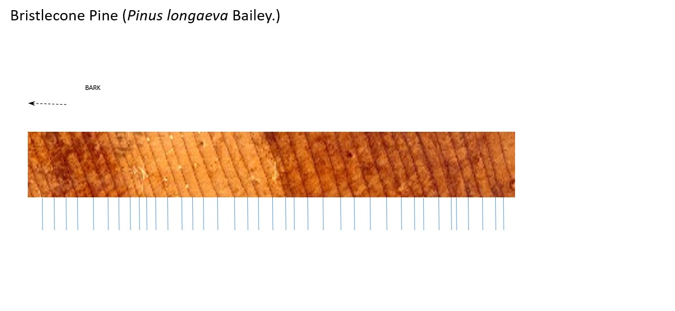
*

Create the following table, using a ruler to measure the ring width and the graph to convert ring width to precipitation (rainfall). Year 1 is the first complete ring furthest from the bark (*). Also calculate the average (mean) summer precipitation.

Year | Ring width (mm) | Summer Precipitation (mm)
1
2
3
4
5
6
7
8
9
10
11
12
13
14
Average (mean)

Finally, draw a bar graph of summer precipitation for the 14 years:
YEAR
Precipitation (mm)

