Water in the atmosphere

- Complete the following definitions
Evaporation of water is _____________
Condensation is ____________

- Where have you seen evaporation and condensation? __________________________________________________________________

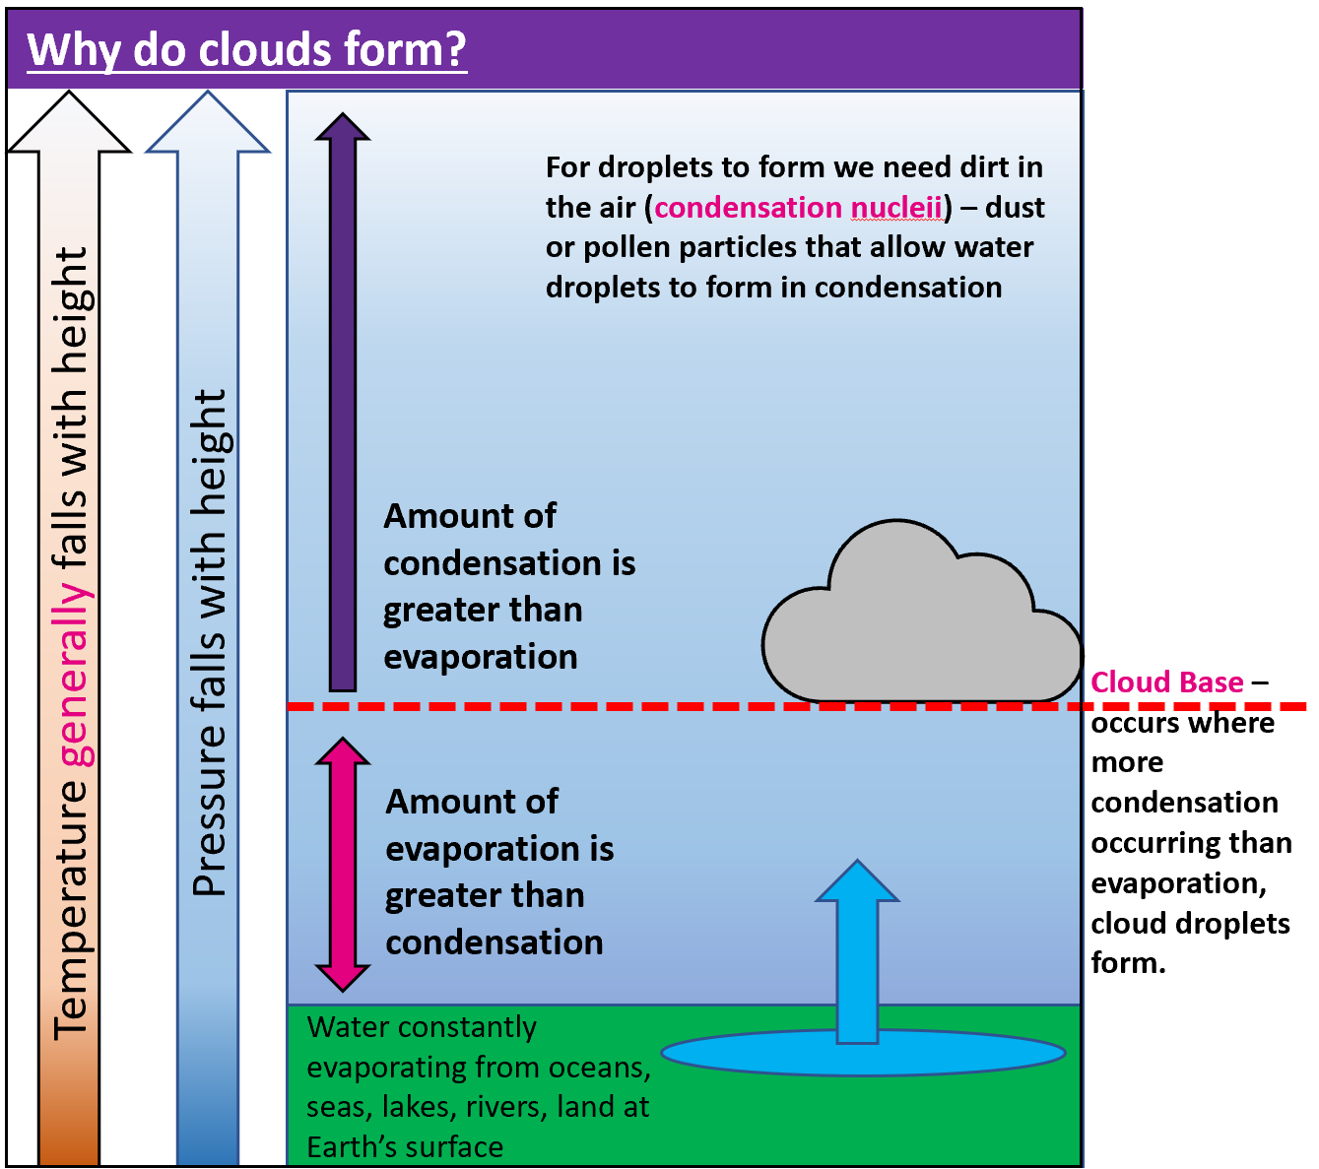
Why do clouds form?
- Using the diagram, write a paragraph on why clouds form.
- What would happen to cloud base on a hot day? Why?
- What would happen to cloud base on a cold day?

Relief Rainfall
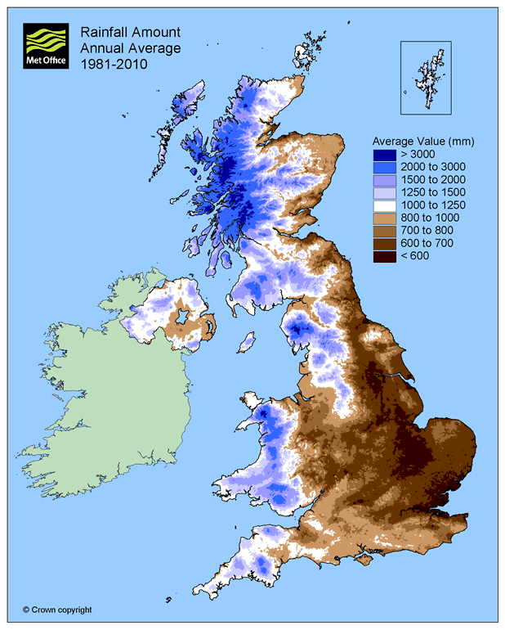
- Study the map of average rainfall amounts for the UK
© Crown copyright, Met Office
- Identify (using points of the compass & some data) on the map opposite:
- The wettest areas of the UK
- The driest areas of the UK
- Use your knowledge of relief rainfall to explain the patterns on the map. _____________________________________________________________ _ _____________________________________________________________________________________________________________________________________________________________________________________________________________________________________________

