Water in the atmosphere

- Complete the following definitions
Evaporation of water is
Condensation is
Where have you seen condensation and evaporation?

Video tasks (https://youtu.be/2i-vwooEC6g )
Answer the questions as the video plays
- What happens to temperature of air in the bottle as pressure goes up?
- What happens to temperature of air in the bottle as pressure goes down?
- Where can air pressure fall in the atmosphere?
The experiment:
- Complete the table to show the changes during the experiment
State of bottle | Pressure | Temperature | Evaporation greater or condensation?
At the start, with the cap off
Cap on, air pumped in
Cap removed and air released

5. When the smoke was added, the bottle was first pressurised then air released. Why do you think this was the case?
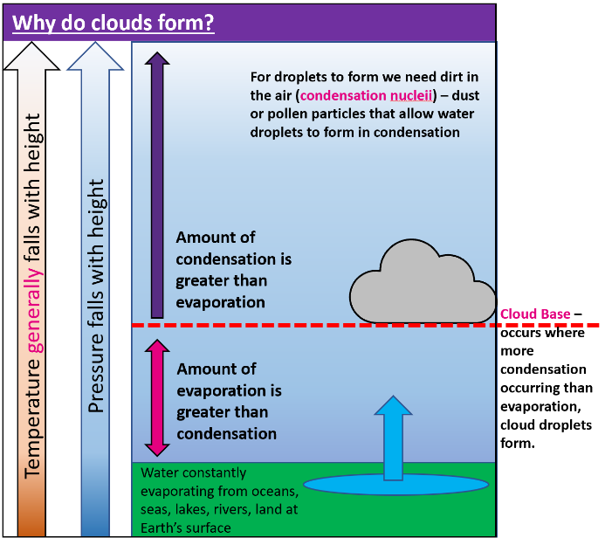
Why do clouds form?
- Using the diagram, write a paragraph on why clouds form.
- What would happen to cloud base on a hot day? Why?
- What would happen to cloud base on a cold day?
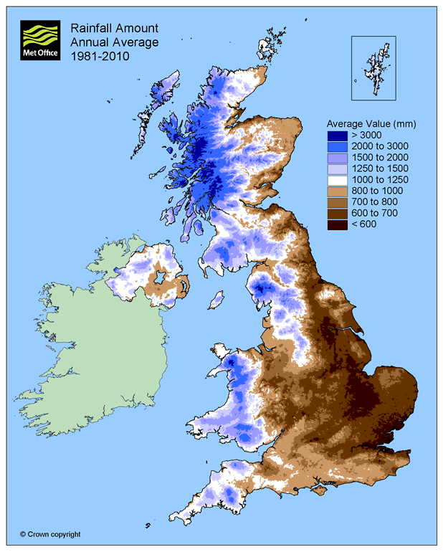
Relief Rainfall
- Study the map of average rainfall amounts for the UK
- Identify (using points of the compass & some data) on the map opposite:
- The wettest areas of the UK
- The driest areas of the UK
- Use your knowledge of relief rainfall to explain the patterns on the map.
© Crown copyright, Met Office

Convectional rainfall – Diagrams from text.
- Using the text below can you draw a diagram (or a series of 4 diagrams) to represent this type of cloud formation? I will read you a passage of text about Convectional rainfall.
- On a clear, hot sunny day, some parts of the land surface may heat up more than others – maybe because of their aspect (facing the Sun) or the surface colour.
- The air in contact with the ground will be warmed in turn and subsequently rise
- As it rises it will cool and reach a height where condensation is more important than evaporation
- This creates clouds and typically gives late afternoon thunderstorms (cumulonimbus clouds). This is known as convectional rainfall.

