**Wind compass Rose diagrams**

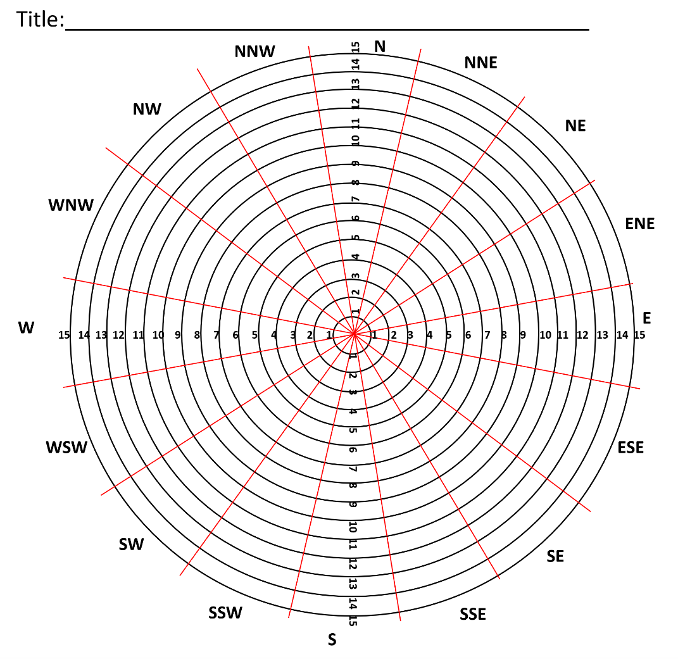

|  |  |
| --- | --- |
| Compass direction | % |
| North | 2 |
| North North East (NNE) | 3 |
| North East (NE) | 6 |
| East North East (ENE) | 4 |
| East | 3 |
| East South East (ESE) | 3 |
| South East (SE) | 2 |
| South South East (SSE) | 2 |
| South | 4 |
| South South West (SSW) | 7 |
| South West (SW) | 14 |
| West South West (WSW) | 13 |
| West | 11 |
| West North West (WNW) | 15 |
| North West (NW) | 8 |
| North North West | 3 |

1. **Plot the compass rose diagram using the data in the table**
2. **What does the diagram reveal to you about the most common wind direction?**
3. **Which air masses could this be?**