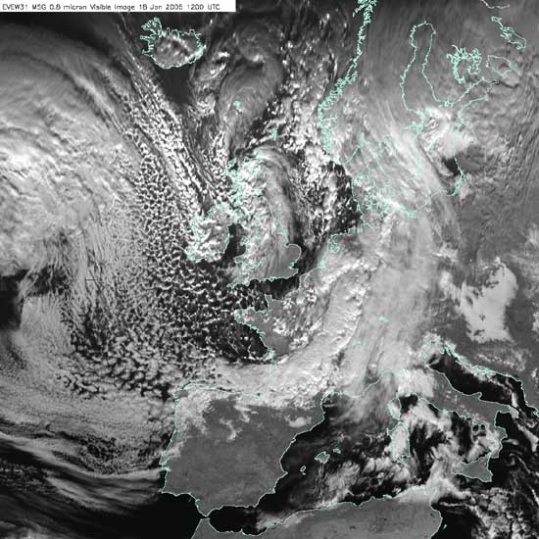
Polar Maritime air
This is air that has flowed out of a High-Pressure area in the Arctic around Eastern Canada and Greenland (northwest of the UK), and arrives at our west coast from around the west.

As the air started off in the Arctic, it starts off cold, but then warms as it travelled south over increasingly warm waters – as the air temperature rises it is more likely to rise – so you would expect to see convection (warm air rising).

The clouds we associate with convection are cumulus clouds – the puffy clouds in which you can often watch the rising air currents changing the clouds shape on a fine day. As the air passes over the ocean, it picks up water vapour, so there will be cloud and rainfall out at sea – and over the first bit of land the wind meets – the west coast.
Figure 1 This satellite image is typical for Pm air. The puffy cumulus clouds to the west of the UK, with a more solid bank of cloud over the west coast.
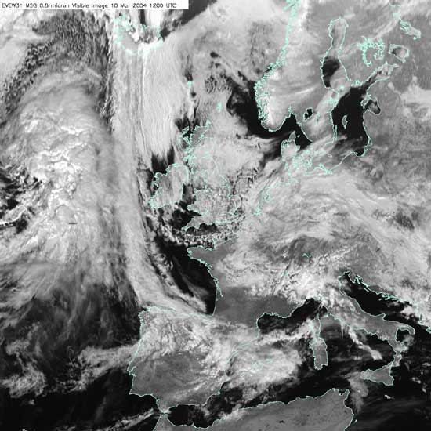
Polar Continental air
Polar continental (Pc) air will similarly be cold to start with and get progressively warmer as it moves south, we would expect some air to rise through convection.

The air will be very dry as it passes over continental Europe on its journey from Eastern Europe or Siberia, so little cloud will form.

The UK is a set of islands though and to reach us, the air must pass over the North Sea, picking up water vapour as it does so. The cloud and precipitation (typically snow in winter) it brings therefore primarily affect the east coast.
Figure 2 This satellite image is typical for Pc air – you can see the cloud free areas immediately to the west of the land masses, with cloud forming further east.

Arctic Maritime air

An Arctic maritime air mass has its origins over the North Pole and the Arctic Ocean. As the air moves south it warms slightly and picks up moisture over the Arctic Ocean. That means that this air mass can sometimes lead to widespread and heavy snowfall in the North, with isolated showers further south.

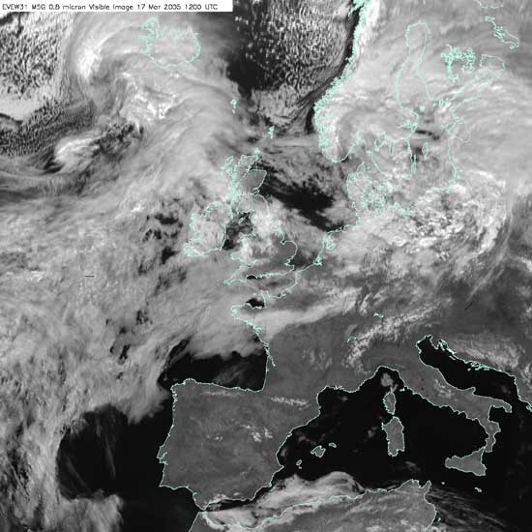
Tropical Maritime air
This is warm air, which is being cooled from below as it moves north. You therefore wouldn’t expect any convection with air rising, cooling and forming cloud.

However, the air is being cooled just by moving north and so eventually may reach the temperature at which cloud forms – flat, featureless sheets of stratus cloud because the air is staying at the same level.

As it is maritime air, there is plenty of water vapour available to form cloud droplets. However, the processes which give us big, fat raindrops are mainly associated with the vertical air motions and circulations in cumulus clouds.
Figure 3 The satellite image shows the extensive sheet of stratus cloud over the Atlantic associated with Tm air.

So Tm air at best gives a persistent drizzle.

In the UK, the weather fronts associated with depressions usually separate Polar and Tropical maritime air.

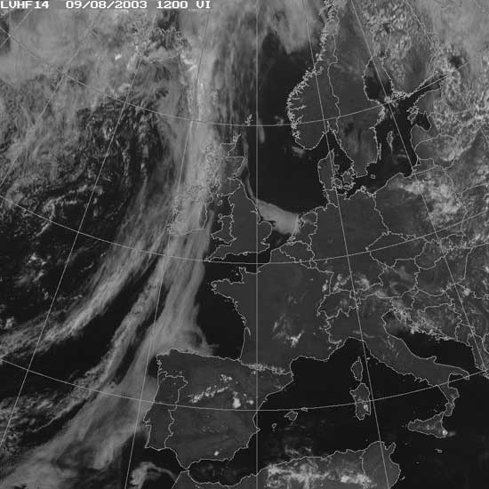
Tropical Continental
We rarely experience Tropical Continental air – air that flows up from the Sahara over continental Europe.

If we do, it can bring Saharan dust with it. This is the warmest and driest air we can get – any moisture picked up over the Mediterranean will be rained out before it reaches us.

Tc air gives clear skies – in the summer, this can mean that some areas get particularly warm – maybe because of their colour (dark) or aspect (facing the Sun) – giving rise to late afternoon localised thunderstorms – ringed in the image opposite.
Figure 4 The satellite image shows clear skies over much of Europe associated with Tc air.

