Past Climate Change
HISTORICAL CHANGES
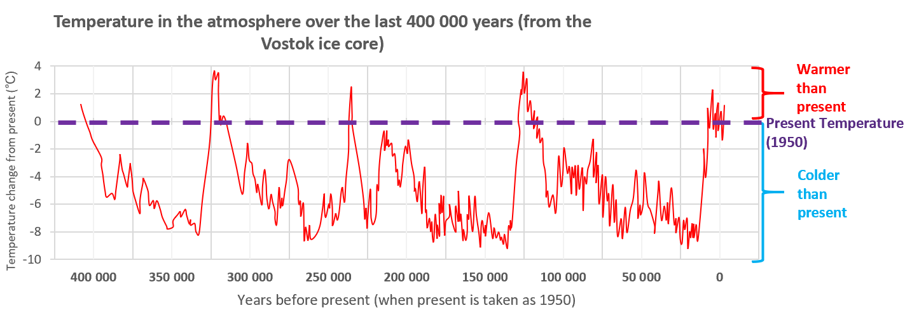

- This whole period is part of the current ongoing Ice Age. Try to answer the questions below using the graph
- How much warmer than the present temperature was it 125,000 years ago?
- How much warmer than the present temperature was it 325,000 years ago?
- How much colder than the present temperature was it 350,000 years ago?
- What is the lowest temperature change recorded on the graph? When was it?
- How many periods on the graph are above the present temperature line?
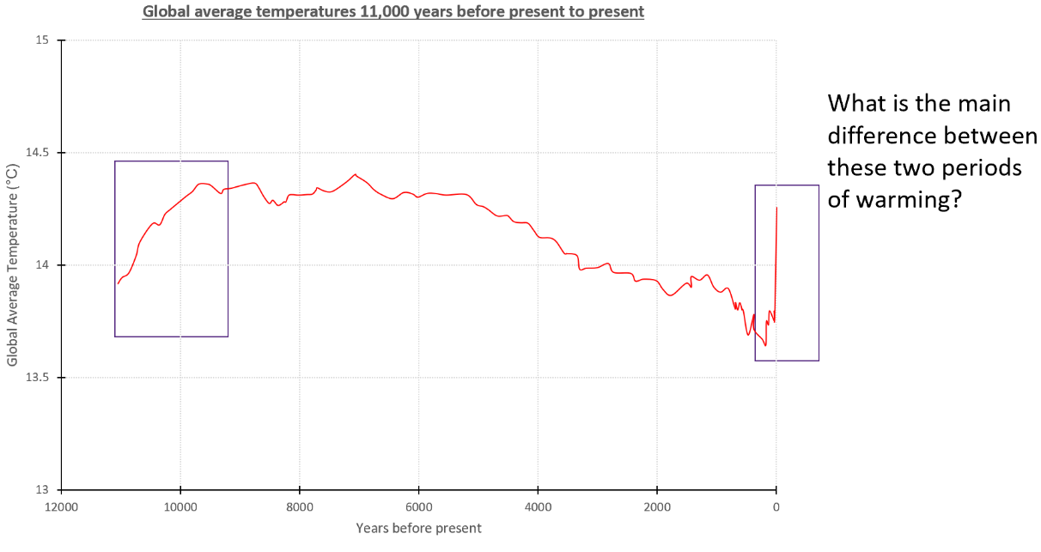
- How have global temperatures changed over the last 11,000 years?
- What is the main difference between these two periods of warming?

CAUSES OF THE CHANGE
Volcanic eruptions can cause our climate to change.
- Reorder the statements as the video plays to explain how
Sequence order number
These particles reflect some sunlight back into space, and the surface below cools.
Eruptions spew out not just lava and ash, but also gases—indeed it is these gases, trapped under great pressure in molten rock, that give an eruption its explosive power.
In the year after Tambora’s eruption, scientists estimate the stratosphere's sulphate veil caused a 3% drop in rainfall and cooled the planet by 1°C.
Two hundred years ago, Tambora, a volcano in Indonesia, blew its top in the most violent eruption in recent history.
For the climate, the key gas is sulphur dioxide.
Once it gets into the stratosphere, sulphur dioxide from a volcano mingles with water, forming tiny sulphate particles.

- Label 3 sketches to show how changes to the Earth’s orbit around the Sun can change the climate on our planet. You could use the sketch diagrams below as your base:

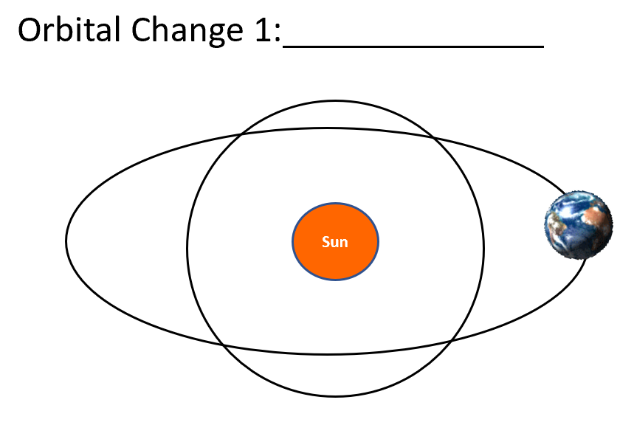
Orbit A | Orbit B

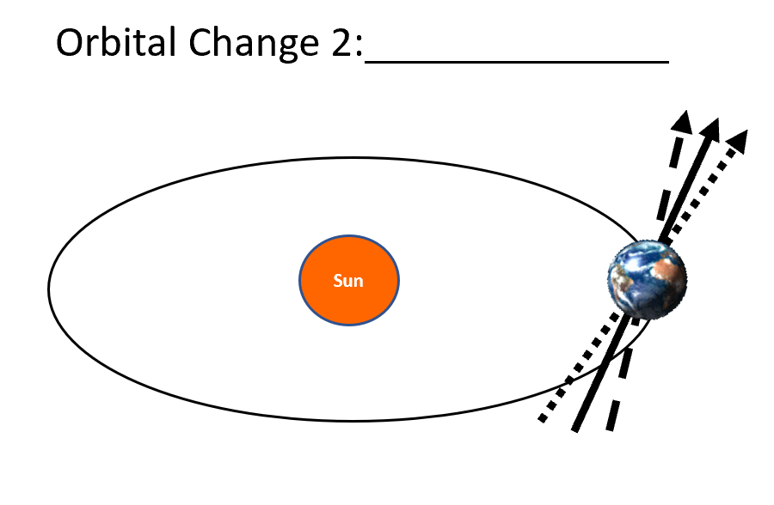
Orbit A | Orbit B

