The Little Ice Age Mystery
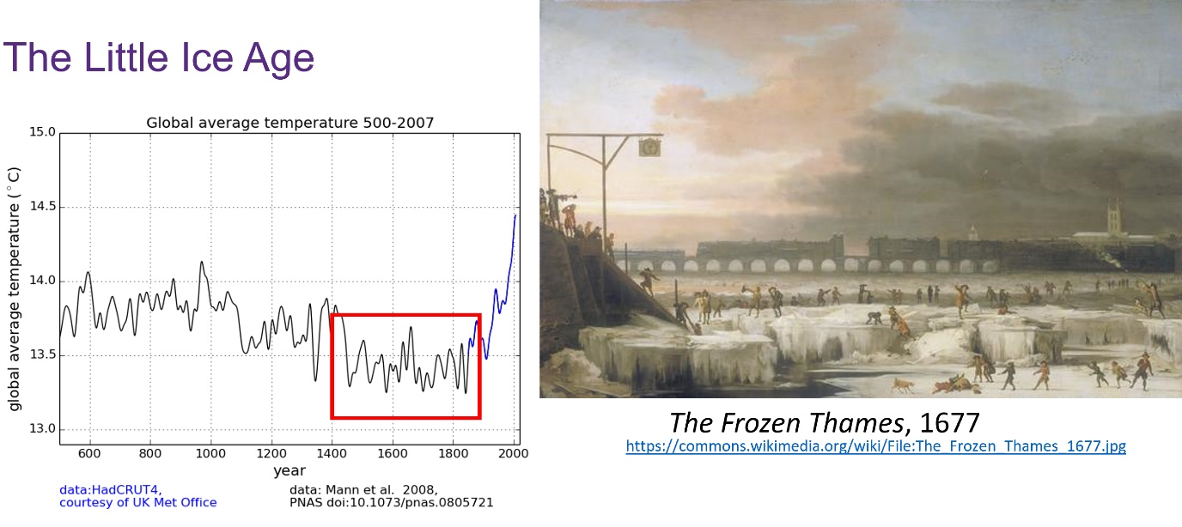
The Little Ice Age:
- Is a period between about 1300 and 1870 during which Europe and North America were subjected to much colder winters than during the 20th Century.
- Mountain glaciers expanded but it is not known as an Ice Age.
- There were frost fairs on the River Thames during this period.

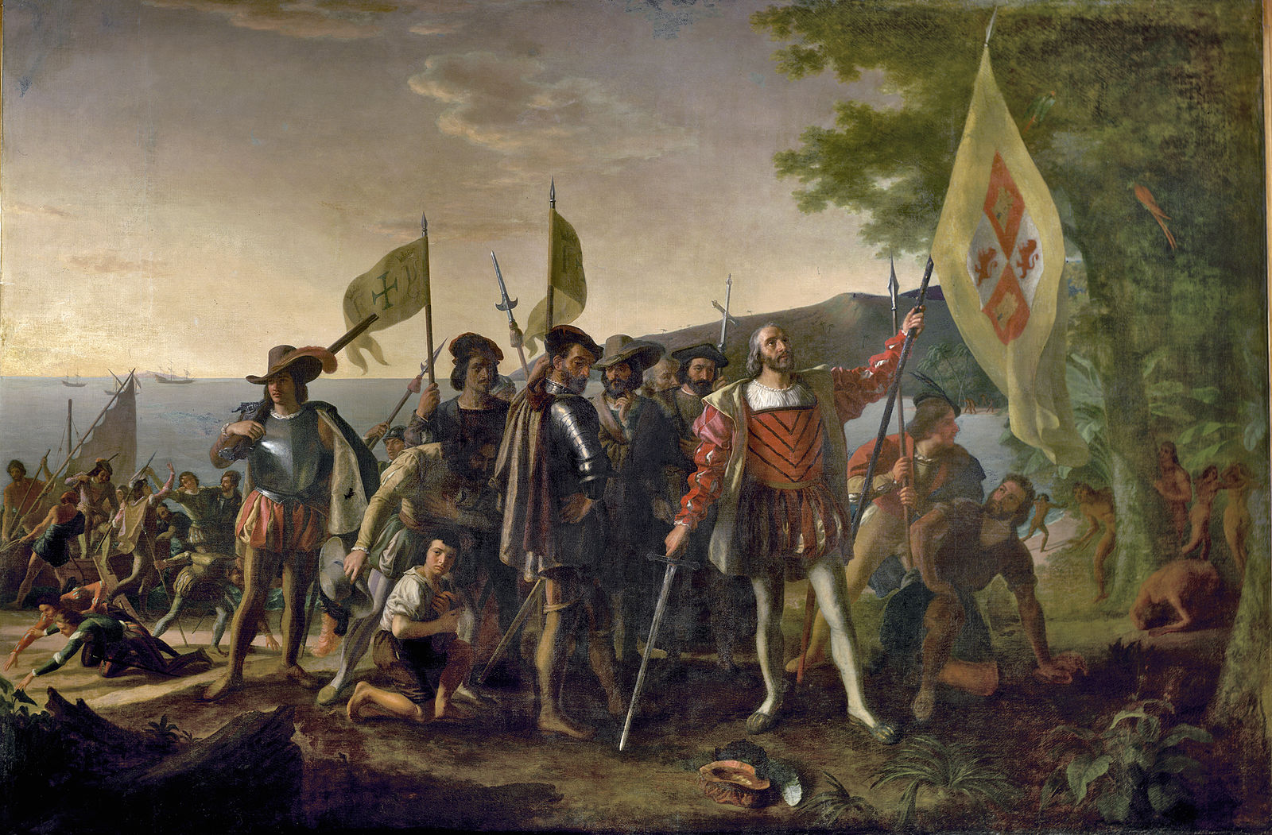
The Landing of Columbus
By John Vanderlyn / Public domain https://commons.wikimedia.org/wiki/File:Landing_of_Columbus_(2).jpg

Christopher Columbus is charged with causing the Little Ice Age! Find the evidence to prove or exonerate him!
- Read carefully through the information in the table about the time when Christopher Colombus went to South America and the impact that it had.
- Colour code the information using the following table and use it as a key;
About Christopher Colombus
CAUSE – changes to Earth’s orbit
CAUSE – Volcanic eruptions
About the Little Ice Age
CAUSE& EFFECT – Fewer people and less farming
EFFECT – The impact of colonisation in indigenous peoples
EFFECT – on atmosphere and climate

Christopher Columbus and the crew of the Santa Maria arrived in the Americas in 1492 | Natural vegetation stores more carbon than farmed plants | Solar change and, volcanic eruptions have cooled the Earth’s climate in the past
Sulphur from volcanoes can block the Sun’s rays if it reaches the upper atmosphere | In the “Great Dying” in the 100 or so years after 1492 - 55 million people died– around 90% of the Indigenous Peoples | The Little Ice Age (LIA) was a generally colder period of climate between 1450-1850.
Across the Americas land use for agriculture fell on average 90% | Small changes to the Sun and the Earth’s orbit around the Sun could also have cooled the climate | Volcanic ash can block out some of the Sun’s energy
When a volcano erupts, its ash reaches high into the atmosphere and can spread to cover the whole earth | Within the Little Ice Age, there were some isolated colder events, which occurred at different places at different times. | In the Northern Hemisphere, temperatures were less than 1°C colder during the LIA than during the late 20th Century.
Changes in atmospheric carbon of 7-10 parts per million would lower global surface temperatures by 0.15°C | In 1520, a single smallpox epidemic killed 30-50% of the indigenous population of Mexico. | It is thought that the Americas took in much of atmospheric CO₂ during the LIA worth 3.5ppm
The Indigenous Peoples of the Americas had many ways of managing the land through farming and forestry | Fewer people means fewer fires used to clear land for fields, natural vegetation started to grow back | As the number of people fell in the Americas, the area of land being farmed reduced
When carbon levels fall in the atmosphere the climate cools | Indigenous peoples died as a result of epidemics of diseases such as smallpox & measles, plus war and enslavement | The amount of carbon stored in the soil increases as natural plants regrow
In 1492 60.5 million people lived in the Americas | Ice cores reveal that atmospheric carbon dioxide levels fell by 7-10ppm in the late 16th and early 17th centuries | Columbus was sponsored by the Catholic Kings and Queens of Spain
Christopher Columbus was an Italian explorer who completed four voyages across the Atlantic Ocean that opened the New World for conquest. | Throughout the Little Ice Age, there was increased volcanic activity.
- Draw a simple flow diagram OR create a story board to show how Columbus’ arrival in the Americas affected global climate – use the text below to do so:

A. Natural vegetation starts to grow back
B. The climate cools
C. Natural vegetation takes in more carbon than farmed crops
D. There is less farming
E. 90% of indigenous peoples die

Blank story board

- Was Christopher Columbus responsible for causing the Little Ice Age? Yes/ No
- Explain your answer: ____________________________________

