Global climate types and ecosystems homework

- Using the diagram below - What sort of pressure zones coincide with deserts?
- What sort of pressure is there for Tropical climates?

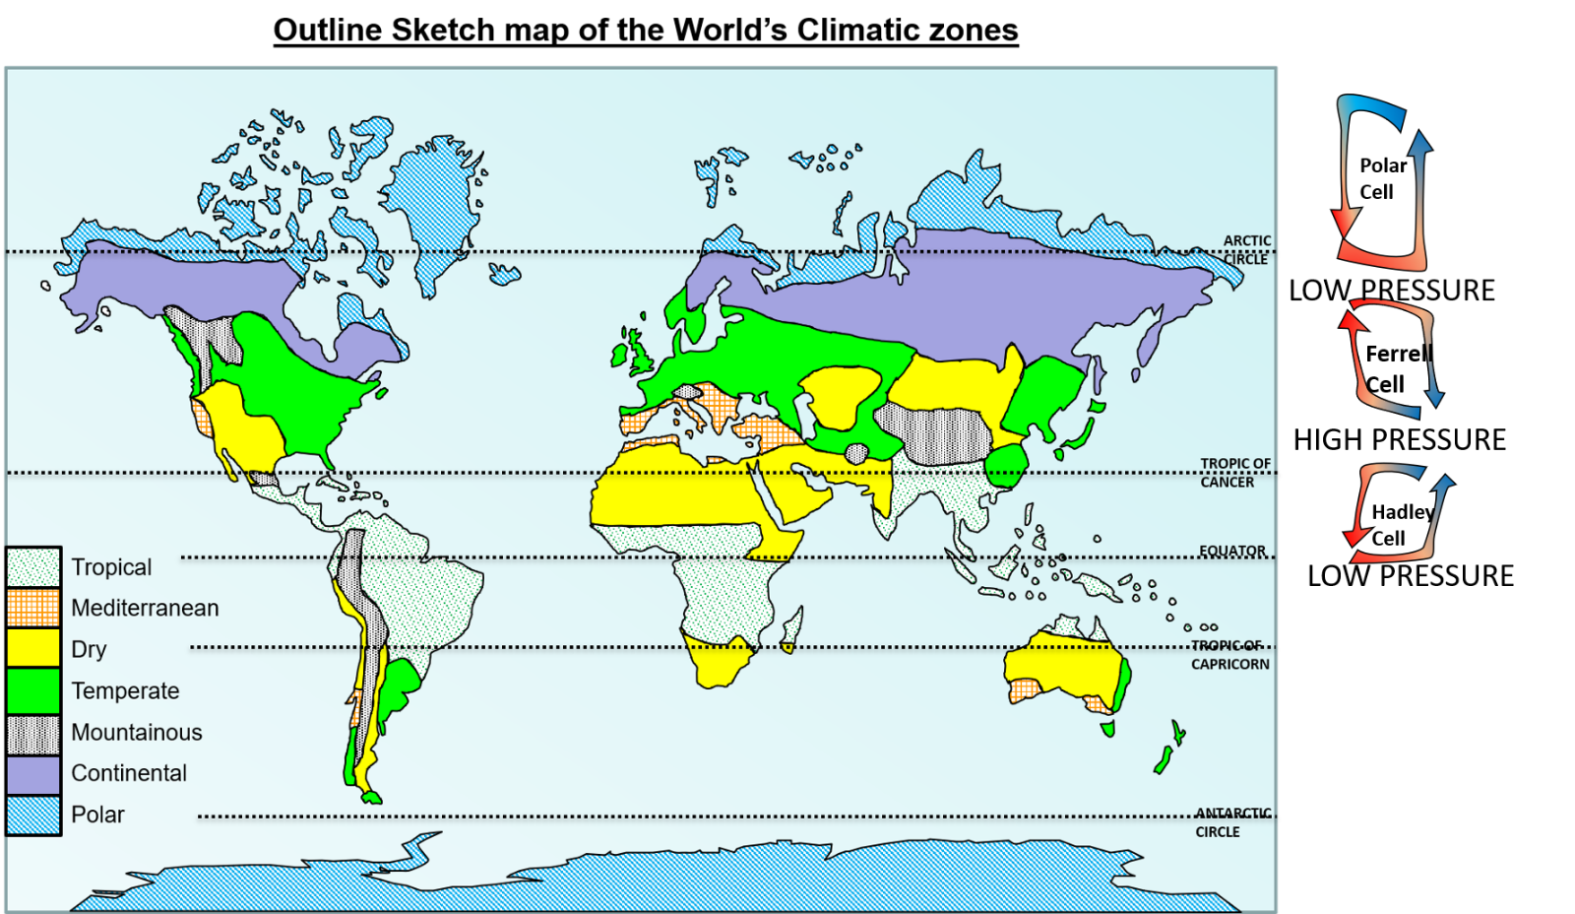

- Which climate types do we find along the Equator?
- What is the climate type of the UK?
- Which climate does this describe “These climates vary seasonally and have hot, dry summers and cooler, wetter winters”?
- Which climate type would you most like to live in and why?

