|  |  |  |
| --- | --- | --- |
| Climate name | Climate Description | Photograph? |
|  | These climates are home to the world's rainforests, where rainfall and humidity are high. Temperatures are generally 25-35 °C and vary little through the year. |  |
|  | The dry regions are linked to the High pressure, cloud free belts at the edges of the Hadley cells. Cold ocean currents can contribute to reduced availability of rainfall. The temperature range in these areas can be large, regularly exceeding 45 °C by day in summer and often falling to below freezing overnight in winter. |  |
|  | These climates vary seasonally and have hot, dry summers and cooler, wetter winters. |  |
|  | Far from the effect of the oceans, these climates are characteristic of the interior of large land masses of middle latitudes; the main climate features are large ranges of air temperature through the year and through each day, with low rainfall a further characteristic feature. |  |
|  | Linked to the Polar Cell, these climates can be subdivided into Tundra and ice cap/frost depending on whether the mean temperature of the warmest month is above or below 0°C. The Arctic climate is moderated by the relatively warm Atlantic Ocean. In the Antarctic, the distance from the ocean and a source of water vapour can mean that it is truly too cold to snow. |  |
|  | These climate zones lie between the tropics and the polar circles in the westerlies of the Ferrell cell. The changes in these regions between summer and winter are generally subtle (warm or cool), rather than extreme (hot or freezing cold) and all of these regions have four distinct seasons. These climates can have very highly variable weather. One day it may be sunny, the next it may be raining. These climate can have a maritime influence. |  |

1. Read the climate descriptions carefully above.
2. Complete column 1 by adding the correct climate name from the list below to the box to match the climate description

**Mediterranean Polar Temperate Tropical Continental Dry**

1. Add the correct photograph to the photograph column by cutting out the photograph and glueing it to your sheet

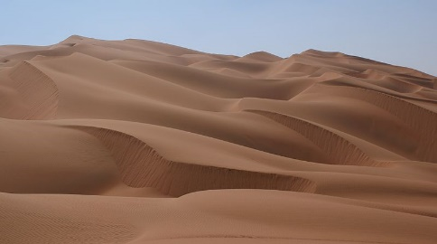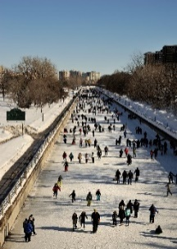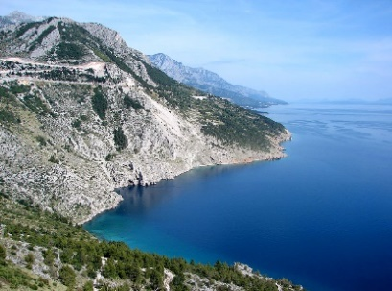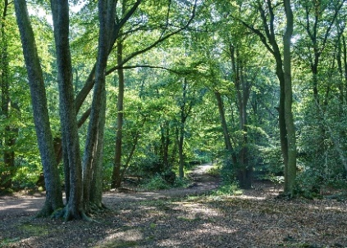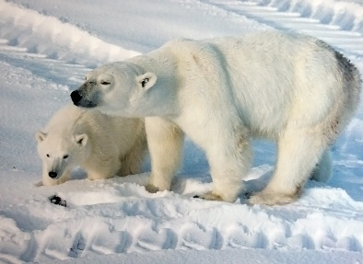

A

B

C

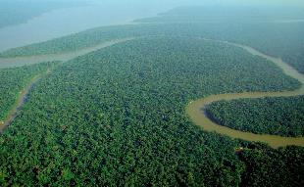

F

**E**

D

Sources

* Tropical Rainforests image – Iubasi CC-BY-SA 2.0
* [Rub' al Khali](https://en.wikipedia.org/wiki/Rub'_al_Khali) or *Empty Quarter* is the largest sand desert on earth.

By Nepenthes (Own work) [CC BY-SA 3.0 (http://creativecommons.org/licenses/by-sa/3.0) or GFDL (http://www.gnu.org/copyleft/fdl.html)], via Wikimedia Commons

* Polar Bears - Brocken Inaglory / CC BY-SA (<https://creativecommons.org/licenses/by-sa/3.0>) <https://commons.wikimedia.org/wiki/File:Ursus_maritimus_mother_with_cub.jpg>
* Image from Ottawa By Saffron Blaze - Own work, Resolution restricted-by-sa, <https://commons.wikimedia.org/w/index.php?curid=32552370>
* Epping forest By Diliff - Own work, CC BY-SA 3.0, <https://commons.wikimedia.org/w/index.php?curid=4896990>
* Makaraska Riviera - Mike / CC BY (<https://creativecommons.org/licenses/by/2.0>) <https://commons.wikimedia.org/wiki/File:Makarska_riviera.jpg>

**Blank Outline Sketch map of the World’s Climatic zones**

**1**

**1**

**1**

**1**

**1**

**1**

**1**

**1**

**1**

**1**

**1**

**1**

**1**

**2**

**3**

**3**

**3**

**3**

**3**

**2**

**2**

**3**

**3**

**4**

**4**

**4**

**4**

**4**

**4**

**4**

**4**

**4**

**4**

**4**

**4**

**5**

**5**

**5**

**5**

**5**

**5**

**5**

**5**

**5**

**6**

**6**

**6**

**6**

**6**

**6**

**6**

**6**

**6**

**7**

**7**

**7**

**7**

**7**

**7**

**7**

**7**

**7**

**4**

**4**

**5**

Tropical

Mediterranean

Dry

Temperate

Mountainous

Continental

Polar

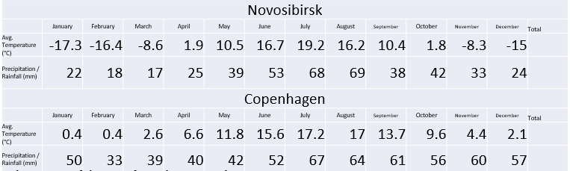

**The impact of distance from the sea on climate**

1. Calculate the total rainfall for the 2 cities shown
2. Calculate the temperature range for the 2 cities shown
3. Overall summarise the differences between the climate of the 2 cities

______________________________________________________________________________________________________________________________________________________________________________________________________________________________________________________________________________________________________________________________________________________________________________________________________

1. Which place has the MOST EXTREME climate?______________________
2. Which city has a maritime climate?_______________________________
3. Which city has a continental climate?_____________________________