Global Atmospheric and Oceanic Circulation
How Does Changing Latitude Affect the Climate?

- Draw a simple labelled sketch of the diagram opposite

- In a paragraph explain why it generally gets colder as we move from the equator to the poles

__ ______ ___________________________________________________________________ __ __________________ ___________________________________________________________________ __ __________________ ______________________________________________________________________________

Answer these questions as the video plays https://youtu.be/7fd03fBRsuU

- What impact does the CURVE of the EARTH have on how much radiation is received by different parts of the Earth? _________________________
- Where receives most radiation? ______________________________________________________
- Where receives least radiation? __________________
- What does the global circulation system do? __________________________________________________________________
- What would happen if there were no global circulation system? __ ___________________________________________________________________

TASKS - DESCRIBING
- Draw a SIMPLE SKETCH of the model

- In 3 sentences, describe how the atmosphere moves air around the Northern Hemisphere

________________________________________________ __________________________________________________________________ ___________________________________________________________________
Water sinks in the Arctic because…
________________________________________________ __________________________________________________________________

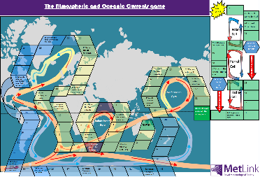

Complete the table below as you complete the dice game

Dice roll number | What was written on the square? | What impact did it have on your progress?
1
2
3
4
5
6
7
8
9
10
11
12
13
14
15
16

