Global atmospheric circulation – Homework task

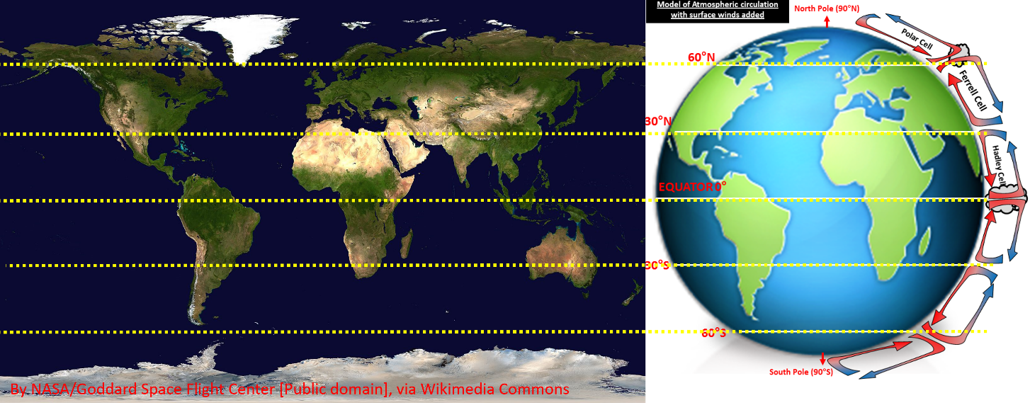

Look at the satellite image of the world above from NASA via Wikimedia Commons.
- What is the vegetation cover like at the Equator?
- Using the diagram above can you suggest why that is? (also use the info in the table below) ____________
- What is the vegetation cover like at 30°N and S of the Equator?
- Using the diagram can you suggest why that is?
- What is the vegetation cover like in the UK?
- Using the diagram can you suggest why that is?

Where air is sinking to the Earth’s surface | Where air is rising away from the Earth’s surface
The pressure rises and the air warms. More water vapour can be evaporated into the air than condenses so cloud formation is less likely – these areas are DRIER. | The pressure falls and the air cools. Less water vapour can be evaporated into the air than condenses so cloud formation is likely – these areas are WETTER.

